Reading Material 1: Digital Workspace Basics
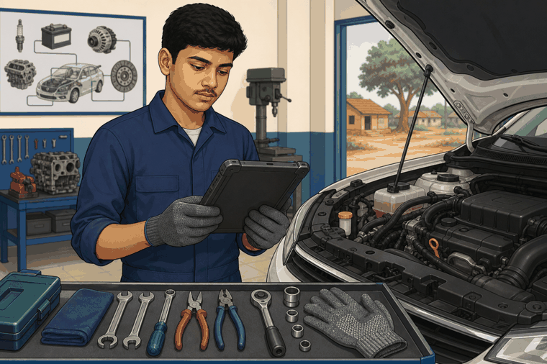
The contents of this document help learners understand the topic in simple language and connect it with class, lab, and workshop situations.

What is a Digital Workspace?
A digital workspace is the place where work information is created, saved, found, and shared using a computer, tablet, mobile device, or workshop system.
In a vehicle workshop, it may include job cards, service history, inspection photos, diagnostic scan reports, parts details, checklists, and messages from the supervisor.

Why it matters in a workshop
A mechanic works with tools, machines, and information. If the information is wrong or missing, the repair can become slow or unsafe.
Example: A learner sees a job card that says “engine starting problem”. Before opening parts, the learner checks the complaint, previous service note, battery reading, and instructor instruction.
Use this in Class/Lab
Open a sample job card. Identify: customer complaint, vehicle details, date, assigned work, and safety note. Then explain what you will check first.

Good digital habits
• Name files clearly, such as jobcard_engine_starting_problem.
• Keep photos and reports in the correct folder.
• Do not delete workshop records without permission.
• Verify information before using it for repair decisions.
• Do not share customer information outside the workshop.
Key Takeaways
Digital workspace means organised digital information for work. A mechanic should know how to find, read, save, and verify workshop information.

