Reading Material 2: Using Digital Information Safely
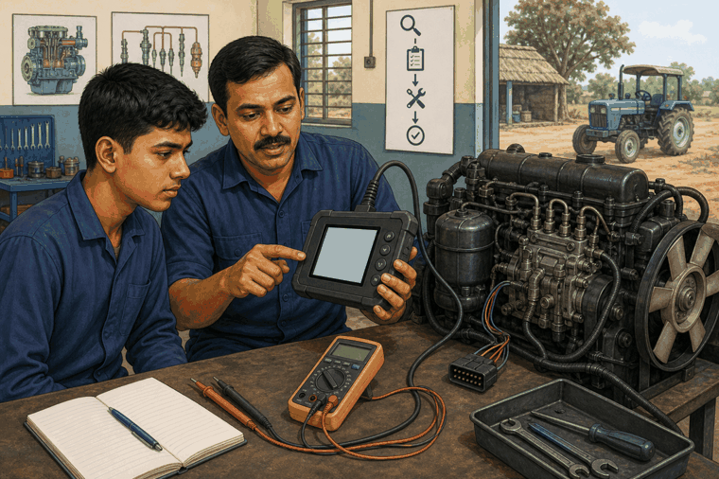
The contents of this document help learners understand the topic in simple language and connect it with class, lab, and workshop situations.

Reading digital workshop information
A diagnostic scan report, service history, or part record can support a mechanic. But digital output is not a final answer by itself. It gives clues. The mechanic must verify the clue with observation, measurement, manual, and instructor guidance.
Use Case 1: Diagnostic report as a clue
A scan report shows a sensor-related fault. A learner should not replace the sensor immediately. First check wiring, connector condition, battery voltage, and whether the fault returns after clearing. This saves time and avoids unnecessary replacement.
Use Case 2: Finding the right service record
A vehicle returns with the same complaint. The mechanic checks previous job notes and sees that a related check was already done. This helps the workshop avoid repeating the same work and plan the next check properly.
Use Case 3: Parts information
A part may look similar but have different specifications. The learner checks the part record and confirms with the instructor before selecting it.
Think & Reflect
What can go wrong if a mechanic follows a digital report without checking the actual vehicle? Write two points.
Key Takeaways
Digital information helps only when it is organised, understood, and verified. A good mechanic combines digital clues with practical checking.

