Section S2: Multiple Regression Analysis Supplemental 141A Final Project

Zheyuan

12/14/2020

# --- Data processing and viz ---  
library(tidyverse)

## -- Attaching packages --------------------------------------- tidyverse 1.3.0 --

## v ggplot2 3.3.2 v purrr 0.3.4  
## v tibble 3.0.4 v dplyr 1.0.2  
## v tidyr 1.1.2 v stringr 1.4.0  
## v readr 1.4.0 v forcats 0.5.0

## -- Conflicts ------------------------------------------ tidyverse_conflicts() --  
## x dplyr::filter() masks stats::filter()  
## x dplyr::lag() masks stats::lag()

library(broom)  
library(gridExtra)

##   
## Attaching package: 'gridExtra'

## The following object is masked from 'package:dplyr':  
##   
## combine

library(RColorBrewer)  
# --- Stats---  
library(corrplot)

## corrplot 0.84 loaded

library(boot)  
library(mclust)

## Package 'mclust' version 5.4.7  
## Type 'citation("mclust")' for citing this R package in publications.

##   
## Attaching package: 'mclust'

## The following object is masked from 'package:purrr':  
##   
## map

library(PCAtools)

## Loading required package: ggrepel

##   
## Attaching package: 'PCAtools'

## The following objects are masked from 'package:stats':  
##   
## biplot, screeplot

library(MASS)

##   
## Attaching package: 'MASS'

## The following object is masked from 'package:dplyr':  
##   
## select

library(Hmisc)

## Loading required package: lattice

##   
## Attaching package: 'lattice'

## The following object is masked from 'package:boot':  
##   
## melanoma

## Loading required package: survival

##   
## Attaching package: 'survival'

## The following object is masked from 'package:boot':  
##   
## aml

## Loading required package: Formula

##   
## Attaching package: 'Hmisc'

## The following objects are masked from 'package:dplyr':  
##   
## src, summarize

## The following objects are masked from 'package:base':  
##   
## format.pval, units

library(caret)

##   
## Attaching package: 'caret'

## The following object is masked from 'package:survival':  
##   
## cluster

## The following object is masked from 'package:purrr':  
##   
## lift

# --- Spatial Analysis ---> Let's simplify our life haha  
library(tmap)  
library(leaflet)  
#library(sp)  
library(sf)

## Linking to GEOS 3.8.0, GDAL 3.0.4, PROJ 6.3.1

### — Step 0: Packages to mess with –

if (!requireNamespace('BiocManager', quietly = TRUE))  
 install.packages('BiocManager')  
  
 BiocManager::install('PCAtools')

### — Step 1: Data loading and procressing —

## --- Part a: Upload Metadata for samples ---  
#path_data<-file.path(getwd(),"data")  
path_data = "C:/Users/yzy/OneDrive/Documents/stats141A-FinalProject/data"  
META_DATA<-as_tibble(read.csv(file.path(path_data,"IMPROVE_metadata.csv")))  
## --- Filter samples from Korea and Canada ---  
US_META<-META_DATA %>% filter(Country %nin% c("KR","CA"))  
  
  
## --- Filter stats not in continental US ---  
US_META<-META_DATA %>% filter(State %nin% c("HI","AK","VI"))  
  
## -- Use Mississippi River as a dividing point for WEst-East US --  
MR_coords<-c(47.239722, -95.2075)  
POS_Sampler<-as.numeric(US_META$Longitude <MR_coords[2])  
# --- 1 are WEst US, 0 are East  
US_META<-add_column(US_META,WE_US = POS_Sampler)  
  
## --- Part b: Load samples data ---  
DATA<-as_tibble(read.csv(file.path(path_data,"IMPROVE_2015_data_w_UNC_v2.csv")))  
  
## --- Part c: Select samples from SW given site identifiers from SW_META table ("Code")  
US_DATA_all<-as_tibble(DATA %>% filter(SiteCode %in% US_META$Code))

# Let's identify any samples that (grossly) violate PM2.5 mass balances  
# PM2.5 (=Y) cannot be negative!  
# Since there's some probability that PM2.5 is negative due to errors at low concentration, we may use PM2.5 uncertainties to remove samples that fall outside -3*PM2.5_UNC.  
# In this way, we don't risk censoring the data but do remove likely erroneous data.  
US_DATA_all<-US_DATA_all %>% dplyr::filter(PM2.5 > -3*PM2.5_UNC)

exclude<-c("PM10","POC","ammNO3","ammSO4","SOIL","SeaSalt","OC1","OC2","OC3","OC4","EC1","EC2","EC3","fAbs_MDL","fAbs")  
US_DATA_LRG<- US_DATA_all %>% dplyr::select(!contains(exclude) & !matches("_UNC") | matches("PM2.5_UNC"))  
any(is.na(US_DATA_LRG))

## [1] TRUE

US_DATA_LRG<-US_DATA_LRG[which(complete.cases(US_DATA_LRG)),]  
any(is.na(US_DATA_LRG))

## [1] FALSE

## --- Instead of random partitioning, I will partition by first sorting samples by SiteCode and DATE (already done) and place every other sample in the test set.  
# --- This data has seasonality. Sorting by date therefore ensures seasonality is equivalent between datasets  
n<-nrow(US_DATA_LRG)  
ind_test<-seq(1,n,2)  
US_DATA_LRG_test<-US_DATA_LRG[ind_test,]  
US_DATA_LRG<-US_DATA_LRG[-ind_test,]

#Rgression Analysis

#First order model  
fit = lm(PM2.5 ~ EC + OC + OP + AL + AS + BR + CA + CL + CR + CU + FE + PB + MG + MN + NI + N2 + P + K + RB + SE + SI + NA. + SR + S + TI + V + ZN + ZR + NO3 + SO4, data = US_DATA_LRG)  
summary(fit)

##   
## Call:  
## lm(formula = PM2.5 ~ EC + OC + OP + AL + AS + BR + CA + CL +   
## CR + CU + FE + PB + MG + MN + NI + N2 + P + K + RB + SE +   
## SI + NA. + SR + S + TI + V + ZN + ZR + NO3 + SO4, data = US_DATA_LRG)  
##   
## Residuals:  
## Min 1Q Median 3Q Max   
## -10.3934 -0.2615 0.0169 0.2508 29.1786   
##   
## Coefficients:  
## Estimate Std. Error t value Pr(>|t|)   
## (Intercept) -0.21256 0.01491 -14.256 < 2e-16 ***  
## EC -0.11101 0.08255 -1.345 0.17874   
## OC 1.93476 0.01933 100.074 < 2e-16 ***  
## OP 0.22448 0.05640 3.980 6.94e-05 ***  
## AL -0.58137 0.49521 -1.174 0.24043   
## AS 16.62336 16.38978 1.014 0.31049   
## BR 5.48740 6.90699 0.794 0.42694   
## CA 1.91323 0.25723 7.438 1.12e-13 ***  
## CL 3.45763 0.10375 33.325 < 2e-16 ***  
## CR -148.03756 58.86488 -2.515 0.01193 *   
## CU -26.39870 5.83226 -4.526 6.08e-06 ***  
## FE 3.65516 0.75521 4.840 1.32e-06 ***  
## PB 24.95061 5.76302 4.329 1.51e-05 ***  
## MG -0.03643 0.76443 -0.048 0.96199   
## MN -20.57501 10.10126 -2.037 0.04169 *   
## NI 49.78920 78.64428 0.633 0.52669   
## N2 0.04225 0.33241 0.127 0.89886   
## P 44.97508 9.19560 4.891 1.02e-06 ***  
## K 2.96531 0.29044 10.210 < 2e-16 ***  
## RB 62.93135 42.41997 1.484 0.13797   
## SE 144.02218 36.45795 3.950 7.87e-05 ***  
## SI 2.99262 0.26512 11.288 < 2e-16 ***  
## NA. 0.11404 0.17508 0.651 0.51484   
## SR -14.43224 5.46132 -2.643 0.00824 **   
## S 3.92478 0.16637 23.591 < 2e-16 ***  
## TI 17.30420 5.30792 3.260 0.00112 **   
## V 25.86340 21.44322 1.206 0.22780   
## ZN -0.55866 1.58575 -0.352 0.72462   
## ZR 9.27636 10.84616 0.855 0.39243   
## NO3 1.22060 0.01208 101.025 < 2e-16 ***  
## SO4 0.39605 0.05671 6.984 3.09e-12 ***  
## ---  
## Signif. codes: 0 '***' 0.001 '**' 0.01 '*' 0.05 '.' 0.1 ' ' 1  
##   
## Residual standard error: 0.7764 on 8616 degrees of freedom  
## Multiple R-squared: 0.9763, Adjusted R-squared: 0.9762   
## F-statistic: 1.182e+04 on 30 and 8616 DF, p-value: < 2.2e-16

#Assumption check  
plot(fit)

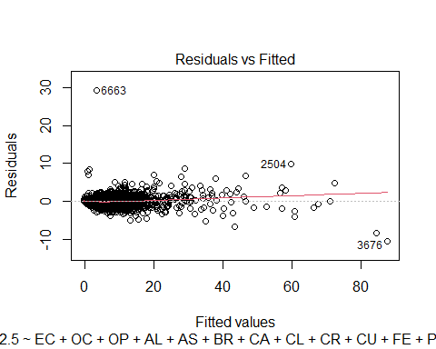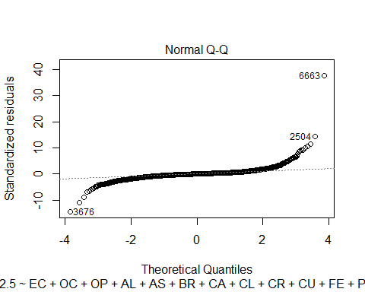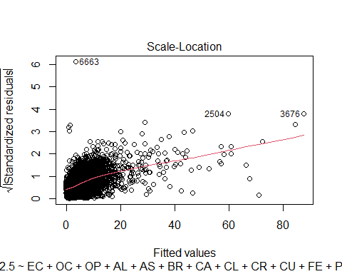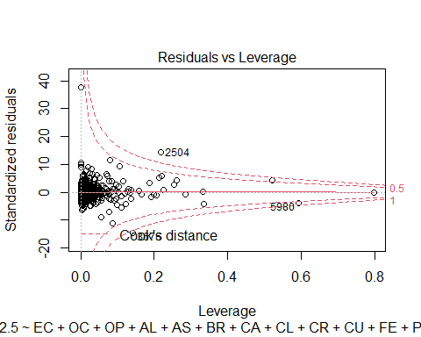

#Box Cox Procedure  
min(US_DATA_LRG$PM2.5)

## [1] -0.093

fit.b = lm(PM2.5 + 0.26 ~ EC + OC + OP + AL + AS + BR + CA + CL + CR + CU + FE + PB + MG + MN + NI + N2 + P + K + RB + SE + SI + NA. + SR + S + TI + V + ZN + ZR + NO3 + SO4, data = US_DATA_LRG)  
boxcox(fit.b)

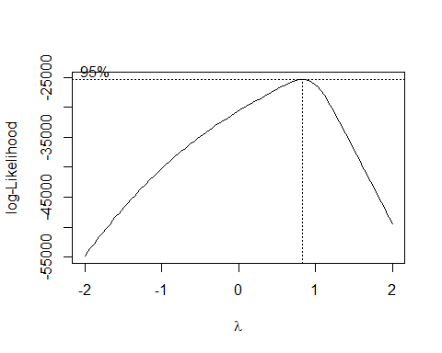 #The QQ plot looks strange, but that just because there are several outliers. The lambda value in Box Cox procedure is very close to 1, which means we do not need to transform PM2.5 to make it more normal. The assumption of homoscedasticity and nonlinearity are valid, too.

#model selection  
fit0 = lm(PM2.5 ~ 1, data = US_DATA_LRG)  
#forward selection on AIC  
mod1 = stepAIC(fit0, scope = list(upper = fit, lower = fit0), direction = "forward", k = 2, trace = FALSE)  
#backward elimination on AIC  
mod2 = stepAIC(fit, scope = list(upper = fit, lower = fit0), direction = "backward", k = 2, trace = FALSE)  
#forward stepwise on AIC  
mod3 = stepAIC(fit0, scope = list(upper = fit, lower = fit0), direction = "both", k = 2, trace = FALSE)  
#backward stepwise on AIC  
mod4 = stepAIC(fit, scope = list(upper = fit, lower = fit0), direction = "forward", k = 2, trace = FALSE)  
#forward selection on BIC  
mod5 = stepAIC(fit0, scope = list(upper = fit, lower = fit0), direction = "forward", k = log(n), trace = FALSE)  
#backward elimination on BIC  
mod6 = stepAIC(fit, scope = list(upper = fit, lower = fit0), direction = "backward", k = log(n), trace = FALSE)  
#forward stepwise on BIC  
mod7 = stepAIC(fit0, scope = list(upper = fit, lower = fit0), direction = "both", k = log(n), trace = FALSE)  
#backward stepwise on BIC  
mod8 = stepAIC(fit, scope = list(upper = fit, lower = fit0), direction = "forward", k = log(n), trace = FALSE)  
summary(mod1)

##   
## Call:  
## lm(formula = PM2.5 ~ OC + SO4 + FE + NO3 + CL + SI + S + K +   
## CA + CU + PB + P + OP + TI + SE + V + CR + SR + MN + RB,   
## data = US_DATA_LRG)  
##   
## Residuals:  
## Min 1Q Median 3Q Max   
## -10.3521 -0.2623 0.0182 0.2524 29.1815   
##   
## Coefficients:  
## Estimate Std. Error t value Pr(>|t|)   
## (Intercept) -0.20458 0.01387 -14.754 < 2e-16 ***  
## OC 1.92315 0.01473 130.522 < 2e-16 ***  
## SO4 0.39926 0.05640 7.079 1.56e-12 ***  
## FE 3.71932 0.69901 5.321 1.06e-07 ***  
## NO3 1.22098 0.01175 103.883 < 2e-16 ***  
## CL 3.53683 0.05907 59.880 < 2e-16 ***  
## SI 2.76513 0.13729 20.141 < 2e-16 ***  
## S 3.91824 0.16341 23.978 < 2e-16 ***  
## K 2.95832 0.27518 10.750 < 2e-16 ***  
## CA 2.02114 0.22873 8.836 < 2e-16 ***  
## CU -26.07097 5.64571 -4.618 3.93e-06 ***  
## PB 26.11871 4.86269 5.371 8.02e-08 ***  
## P 45.10306 9.17202 4.917 8.93e-07 ***  
## OP 0.23829 0.05158 4.619 3.90e-06 ***  
## TI 15.02221 4.34099 3.461 0.000542 ***  
## SE 146.77176 36.11467 4.064 4.87e-05 ***  
## V 38.32761 11.37525 3.369 0.000757 ***  
## CR -154.91486 53.38461 -2.902 0.003719 **   
## SR -15.10595 5.36982 -2.813 0.004917 **   
## MN -22.34431 9.61670 -2.323 0.020176 *   
## RB 63.64680 42.02435 1.515 0.129930   
## ---  
## Signif. codes: 0 '***' 0.001 '**' 0.01 '*' 0.05 '.' 0.1 ' ' 1  
##   
## Residual standard error: 0.7763 on 8626 degrees of freedom  
## Multiple R-squared: 0.9763, Adjusted R-squared: 0.9762   
## F-statistic: 1.774e+04 on 20 and 8626 DF, p-value: < 2.2e-16

summary(mod2)

##   
## Call:  
## lm(formula = PM2.5 ~ OC + OP + CA + CL + CR + CU + FE + PB +   
## MN + P + K + RB + SE + SI + SR + S + TI + V + NO3 + SO4,   
## data = US_DATA_LRG)  
##   
## Residuals:  
## Min 1Q Median 3Q Max   
## -10.3521 -0.2623 0.0182 0.2524 29.1815   
##   
## Coefficients:  
## Estimate Std. Error t value Pr(>|t|)   
## (Intercept) -0.20458 0.01387 -14.754 < 2e-16 ***  
## OC 1.92315 0.01473 130.522 < 2e-16 ***  
## OP 0.23829 0.05158 4.619 3.90e-06 ***  
## CA 2.02114 0.22873 8.836 < 2e-16 ***  
## CL 3.53683 0.05907 59.880 < 2e-16 ***  
## CR -154.91486 53.38461 -2.902 0.003719 **   
## CU -26.07097 5.64571 -4.618 3.93e-06 ***  
## FE 3.71932 0.69901 5.321 1.06e-07 ***  
## PB 26.11871 4.86269 5.371 8.02e-08 ***  
## MN -22.34431 9.61670 -2.323 0.020176 *   
## P 45.10306 9.17202 4.917 8.93e-07 ***  
## K 2.95832 0.27518 10.750 < 2e-16 ***  
## RB 63.64680 42.02435 1.515 0.129930   
## SE 146.77176 36.11467 4.064 4.87e-05 ***  
## SI 2.76513 0.13729 20.141 < 2e-16 ***  
## SR -15.10595 5.36982 -2.813 0.004917 **   
## S 3.91824 0.16341 23.978 < 2e-16 ***  
## TI 15.02221 4.34099 3.461 0.000542 ***  
## V 38.32761 11.37525 3.369 0.000757 ***  
## NO3 1.22098 0.01175 103.883 < 2e-16 ***  
## SO4 0.39926 0.05640 7.079 1.56e-12 ***  
## ---  
## Signif. codes: 0 '***' 0.001 '**' 0.01 '*' 0.05 '.' 0.1 ' ' 1  
##   
## Residual standard error: 0.7763 on 8626 degrees of freedom  
## Multiple R-squared: 0.9763, Adjusted R-squared: 0.9762   
## F-statistic: 1.774e+04 on 20 and 8626 DF, p-value: < 2.2e-16

summary(mod3)

##   
## Call:  
## lm(formula = PM2.5 ~ OC + SO4 + FE + NO3 + CL + SI + S + K +   
## CA + CU + PB + P + OP + TI + SE + V + CR + SR + MN + RB,   
## data = US_DATA_LRG)  
##   
## Residuals:  
## Min 1Q Median 3Q Max   
## -10.3521 -0.2623 0.0182 0.2524 29.1815   
##   
## Coefficients:  
## Estimate Std. Error t value Pr(>|t|)   
## (Intercept) -0.20458 0.01387 -14.754 < 2e-16 ***  
## OC 1.92315 0.01473 130.522 < 2e-16 ***  
## SO4 0.39926 0.05640 7.079 1.56e-12 ***  
## FE 3.71932 0.69901 5.321 1.06e-07 ***  
## NO3 1.22098 0.01175 103.883 < 2e-16 ***  
## CL 3.53683 0.05907 59.880 < 2e-16 ***  
## SI 2.76513 0.13729 20.141 < 2e-16 ***  
## S 3.91824 0.16341 23.978 < 2e-16 ***  
## K 2.95832 0.27518 10.750 < 2e-16 ***  
## CA 2.02114 0.22873 8.836 < 2e-16 ***  
## CU -26.07097 5.64571 -4.618 3.93e-06 ***  
## PB 26.11871 4.86269 5.371 8.02e-08 ***  
## P 45.10306 9.17202 4.917 8.93e-07 ***  
## OP 0.23829 0.05158 4.619 3.90e-06 ***  
## TI 15.02221 4.34099 3.461 0.000542 ***  
## SE 146.77176 36.11467 4.064 4.87e-05 ***  
## V 38.32761 11.37525 3.369 0.000757 ***  
## CR -154.91486 53.38461 -2.902 0.003719 **   
## SR -15.10595 5.36982 -2.813 0.004917 **   
## MN -22.34431 9.61670 -2.323 0.020176 *   
## RB 63.64680 42.02435 1.515 0.129930   
## ---  
## Signif. codes: 0 '***' 0.001 '**' 0.01 '*' 0.05 '.' 0.1 ' ' 1  
##   
## Residual standard error: 0.7763 on 8626 degrees of freedom  
## Multiple R-squared: 0.9763, Adjusted R-squared: 0.9762   
## F-statistic: 1.774e+04 on 20 and 8626 DF, p-value: < 2.2e-16

summary(mod4)

##   
## Call:  
## lm(formula = PM2.5 ~ EC + OC + OP + AL + AS + BR + CA + CL +   
## CR + CU + FE + PB + MG + MN + NI + N2 + P + K + RB + SE +   
## SI + NA. + SR + S + TI + V + ZN + ZR + NO3 + SO4, data = US_DATA_LRG)  
##   
## Residuals:  
## Min 1Q Median 3Q Max   
## -10.3934 -0.2615 0.0169 0.2508 29.1786   
##   
## Coefficients:  
## Estimate Std. Error t value Pr(>|t|)   
## (Intercept) -0.21256 0.01491 -14.256 < 2e-16 ***  
## EC -0.11101 0.08255 -1.345 0.17874   
## OC 1.93476 0.01933 100.074 < 2e-16 ***  
## OP 0.22448 0.05640 3.980 6.94e-05 ***  
## AL -0.58137 0.49521 -1.174 0.24043   
## AS 16.62336 16.38978 1.014 0.31049   
## BR 5.48740 6.90699 0.794 0.42694   
## CA 1.91323 0.25723 7.438 1.12e-13 ***  
## CL 3.45763 0.10375 33.325 < 2e-16 ***  
## CR -148.03756 58.86488 -2.515 0.01193 *   
## CU -26.39870 5.83226 -4.526 6.08e-06 ***  
## FE 3.65516 0.75521 4.840 1.32e-06 ***  
## PB 24.95061 5.76302 4.329 1.51e-05 ***  
## MG -0.03643 0.76443 -0.048 0.96199   
## MN -20.57501 10.10126 -2.037 0.04169 *   
## NI 49.78920 78.64428 0.633 0.52669   
## N2 0.04225 0.33241 0.127 0.89886   
## P 44.97508 9.19560 4.891 1.02e-06 ***  
## K 2.96531 0.29044 10.210 < 2e-16 ***  
## RB 62.93135 42.41997 1.484 0.13797   
## SE 144.02218 36.45795 3.950 7.87e-05 ***  
## SI 2.99262 0.26512 11.288 < 2e-16 ***  
## NA. 0.11404 0.17508 0.651 0.51484   
## SR -14.43224 5.46132 -2.643 0.00824 **   
## S 3.92478 0.16637 23.591 < 2e-16 ***  
## TI 17.30420 5.30792 3.260 0.00112 **   
## V 25.86340 21.44322 1.206 0.22780   
## ZN -0.55866 1.58575 -0.352 0.72462   
## ZR 9.27636 10.84616 0.855 0.39243   
## NO3 1.22060 0.01208 101.025 < 2e-16 ***  
## SO4 0.39605 0.05671 6.984 3.09e-12 ***  
## ---  
## Signif. codes: 0 '***' 0.001 '**' 0.01 '*' 0.05 '.' 0.1 ' ' 1  
##   
## Residual standard error: 0.7764 on 8616 degrees of freedom  
## Multiple R-squared: 0.9763, Adjusted R-squared: 0.9762   
## F-statistic: 1.182e+04 on 30 and 8616 DF, p-value: < 2.2e-16

summary(mod5)

##   
## Call:  
## lm(formula = PM2.5 ~ OC + SO4 + FE + NO3 + CL + SI + S + K +   
## CA + CU + PB + P + OP + TI + SE, data = US_DATA_LRG)  
##   
## Residuals:  
## Min 1Q Median 3Q Max   
## -10.2069 -0.2578 0.0215 0.2512 29.2244   
##   
## Coefficients:  
## Estimate Std. Error t value Pr(>|t|)   
## (Intercept) -0.20680 0.01373 -15.065 < 2e-16 ***  
## OC 1.93015 0.01466 131.678 < 2e-16 ***  
## SO4 0.42689 0.05485 7.783 7.92e-15 ***  
## FE 2.26146 0.58252 3.882 0.000104 ***  
## NO3 1.22387 0.01164 105.154 < 2e-16 ***  
## CL 3.53975 0.05901 59.987 < 2e-16 ***  
## SI 2.99026 0.13068 22.882 < 2e-16 ***  
## S 3.86775 0.16145 23.957 < 2e-16 ***  
## K 2.43625 0.22489 10.833 < 2e-16 ***  
## CA 1.91137 0.22327 8.561 < 2e-16 ***  
## CU -29.52848 5.33513 -5.535 3.21e-08 ***  
## PB 24.50111 4.41828 5.545 3.02e-08 ***  
## P 47.15010 9.16384 5.145 2.73e-07 ***  
## OP 0.22895 0.05157 4.439 9.14e-06 ***  
## TI 18.45628 4.19983 4.395 1.12e-05 ***  
## SE 141.35127 35.87357 3.940 8.20e-05 ***  
## ---  
## Signif. codes: 0 '***' 0.001 '**' 0.01 '*' 0.05 '.' 0.1 ' ' 1  
##   
## Residual standard error: 0.7777 on 8631 degrees of freedom  
## Multiple R-squared: 0.9762, Adjusted R-squared: 0.9761   
## F-statistic: 2.357e+04 on 15 and 8631 DF, p-value: < 2.2e-16

summary(mod6)

##   
## Call:  
## lm(formula = PM2.5 ~ OC + OP + CA + CL + CR + CU + FE + PB +   
## P + K + SE + SI + S + TI + V + NO3 + SO4, data = US_DATA_LRG)  
##   
## Residuals:  
## Min 1Q Median 3Q Max   
## -10.2598 -0.2620 0.0178 0.2521 29.1899   
##   
## Coefficients:  
## Estimate Std. Error t value Pr(>|t|)   
## (Intercept) -0.20364 0.01382 -14.737 < 2e-16 ***  
## OC 1.92904 0.01465 131.712 < 2e-16 ***  
## OP 0.23141 0.05158 4.486 7.34e-06 ***  
## CA 1.87043 0.22448 8.332 < 2e-16 ***  
## CL 3.53383 0.05896 59.932 < 2e-16 ***  
## CR -170.07023 53.03200 -3.207 0.001346 **   
## CU -25.86852 5.46109 -4.737 2.20e-06 ***  
## FE 3.00058 0.61958 4.843 1.30e-06 ***  
## PB 25.30822 4.47082 5.661 1.56e-08 ***  
## P 45.47777 9.16990 4.959 7.20e-07 ***  
## K 2.56550 0.22996 11.156 < 2e-16 ***  
## SE 141.90823 35.99421 3.943 8.13e-05 ***  
## SI 2.89006 0.13273 21.774 < 2e-16 ***  
## S 3.89311 0.16287 23.903 < 2e-16 ***  
## TI 15.80104 4.25261 3.716 0.000204 ***  
## V 37.01644 11.37785 3.253 0.001145 **   
## NO3 1.22619 0.01165 105.220 < 2e-16 ***  
## SO4 0.40972 0.05620 7.290 3.38e-13 ***  
## ---  
## Signif. codes: 0 '***' 0.001 '**' 0.01 '*' 0.05 '.' 0.1 ' ' 1  
##   
## Residual standard error: 0.7769 on 8629 degrees of freedom  
## Multiple R-squared: 0.9762, Adjusted R-squared: 0.9762   
## F-statistic: 2.084e+04 on 17 and 8629 DF, p-value: < 2.2e-16

summary(mod7)

##   
## Call:  
## lm(formula = PM2.5 ~ OC + SO4 + FE + NO3 + CL + SI + S + K +   
## CA + CU + PB + P + OP + TI + SE, data = US_DATA_LRG)  
##   
## Residuals:  
## Min 1Q Median 3Q Max   
## -10.2069 -0.2578 0.0215 0.2512 29.2244   
##   
## Coefficients:  
## Estimate Std. Error t value Pr(>|t|)   
## (Intercept) -0.20680 0.01373 -15.065 < 2e-16 ***  
## OC 1.93015 0.01466 131.678 < 2e-16 ***  
## SO4 0.42689 0.05485 7.783 7.92e-15 ***  
## FE 2.26146 0.58252 3.882 0.000104 ***  
## NO3 1.22387 0.01164 105.154 < 2e-16 ***  
## CL 3.53975 0.05901 59.987 < 2e-16 ***  
## SI 2.99026 0.13068 22.882 < 2e-16 ***  
## S 3.86775 0.16145 23.957 < 2e-16 ***  
## K 2.43625 0.22489 10.833 < 2e-16 ***  
## CA 1.91137 0.22327 8.561 < 2e-16 ***  
## CU -29.52848 5.33513 -5.535 3.21e-08 ***  
## PB 24.50111 4.41828 5.545 3.02e-08 ***  
## P 47.15010 9.16384 5.145 2.73e-07 ***  
## OP 0.22895 0.05157 4.439 9.14e-06 ***  
## TI 18.45628 4.19983 4.395 1.12e-05 ***  
## SE 141.35127 35.87357 3.940 8.20e-05 ***  
## ---  
## Signif. codes: 0 '***' 0.001 '**' 0.01 '*' 0.05 '.' 0.1 ' ' 1  
##   
## Residual standard error: 0.7777 on 8631 degrees of freedom  
## Multiple R-squared: 0.9762, Adjusted R-squared: 0.9761   
## F-statistic: 2.357e+04 on 15 and 8631 DF, p-value: < 2.2e-16

summary(mod8)

##   
## Call:  
## lm(formula = PM2.5 ~ EC + OC + OP + AL + AS + BR + CA + CL +   
## CR + CU + FE + PB + MG + MN + NI + N2 + P + K + RB + SE +   
## SI + NA. + SR + S + TI + V + ZN + ZR + NO3 + SO4, data = US_DATA_LRG)  
##   
## Residuals:  
## Min 1Q Median 3Q Max   
## -10.3934 -0.2615 0.0169 0.2508 29.1786   
##   
## Coefficients:  
## Estimate Std. Error t value Pr(>|t|)   
## (Intercept) -0.21256 0.01491 -14.256 < 2e-16 ***  
## EC -0.11101 0.08255 -1.345 0.17874   
## OC 1.93476 0.01933 100.074 < 2e-16 ***  
## OP 0.22448 0.05640 3.980 6.94e-05 ***  
## AL -0.58137 0.49521 -1.174 0.24043   
## AS 16.62336 16.38978 1.014 0.31049   
## BR 5.48740 6.90699 0.794 0.42694   
## CA 1.91323 0.25723 7.438 1.12e-13 ***  
## CL 3.45763 0.10375 33.325 < 2e-16 ***  
## CR -148.03756 58.86488 -2.515 0.01193 *   
## CU -26.39870 5.83226 -4.526 6.08e-06 ***  
## FE 3.65516 0.75521 4.840 1.32e-06 ***  
## PB 24.95061 5.76302 4.329 1.51e-05 ***  
## MG -0.03643 0.76443 -0.048 0.96199   
## MN -20.57501 10.10126 -2.037 0.04169 *   
## NI 49.78920 78.64428 0.633 0.52669   
## N2 0.04225 0.33241 0.127 0.89886   
## P 44.97508 9.19560 4.891 1.02e-06 ***  
## K 2.96531 0.29044 10.210 < 2e-16 ***  
## RB 62.93135 42.41997 1.484 0.13797   
## SE 144.02218 36.45795 3.950 7.87e-05 ***  
## SI 2.99262 0.26512 11.288 < 2e-16 ***  
## NA. 0.11404 0.17508 0.651 0.51484   
## SR -14.43224 5.46132 -2.643 0.00824 **   
## S 3.92478 0.16637 23.591 < 2e-16 ***  
## TI 17.30420 5.30792 3.260 0.00112 **   
## V 25.86340 21.44322 1.206 0.22780   
## ZN -0.55866 1.58575 -0.352 0.72462   
## ZR 9.27636 10.84616 0.855 0.39243   
## NO3 1.22060 0.01208 101.025 < 2e-16 ***  
## SO4 0.39605 0.05671 6.984 3.09e-12 ***  
## ---  
## Signif. codes: 0 '***' 0.001 '**' 0.01 '*' 0.05 '.' 0.1 ' ' 1  
##   
## Residual standard error: 0.7764 on 8616 degrees of freedom  
## Multiple R-squared: 0.9763, Adjusted R-squared: 0.9762   
## F-statistic: 1.182e+04 on 30 and 8616 DF, p-value: < 2.2e-16

plot(mod1, which = c(1,2))

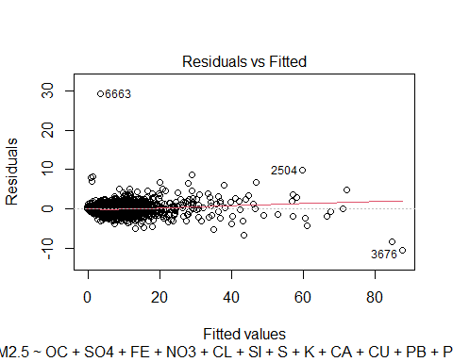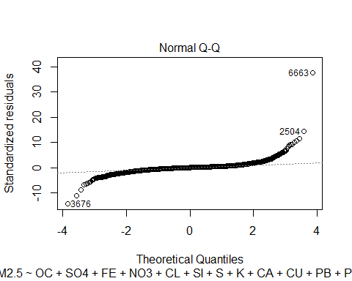

plot(mod2, which = c(1,2))

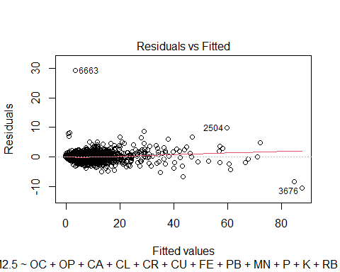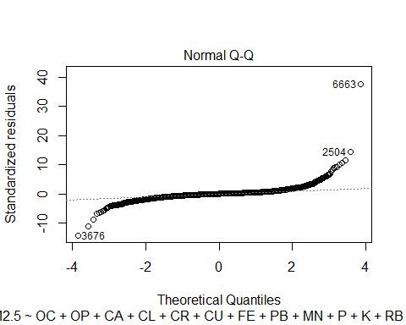

plot(mod3, which = c(1,2))



plot(mod4, which = c(1,2))



plot(mod5, which = c(1,2))

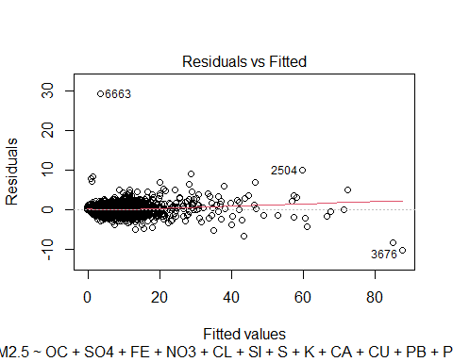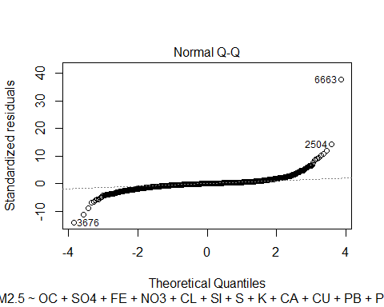

plot(mod6, which = c(1,2))

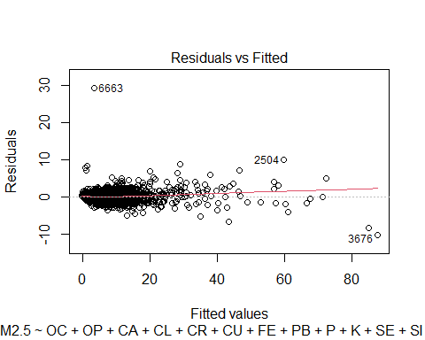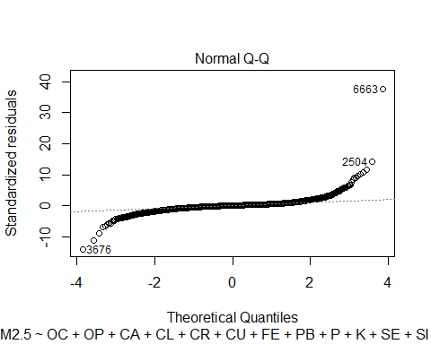

plot(mod7, which = c(1,2))



plot(mod8, which = c(1,2))



#model1  
prediction = mod1 %>% predict(US_DATA_LRG_test)  
data.frame( R2 = R2(prediction, US_DATA_LRG_test$PM2.5),  
 RMSE = RMSE(prediction, US_DATA_LRG_test$PM2.5),  
 MAE = MAE(prediction, US_DATA_LRG_test$PM2.5))

## R2 RMSE MAE  
## 1 0.9780208 0.7720496 0.432098

#model2  
prediction = mod2 %>% predict(US_DATA_LRG_test)  
data.frame( R2 = R2(prediction, US_DATA_LRG_test$PM2.5),  
 RMSE = RMSE(prediction, US_DATA_LRG_test$PM2.5),  
 MAE = MAE(prediction, US_DATA_LRG_test$PM2.5))

## R2 RMSE MAE  
## 1 0.9780208 0.7720496 0.432098

#model3  
prediction = mod3 %>% predict(US_DATA_LRG_test)  
data.frame( R2 = R2(prediction, US_DATA_LRG_test$PM2.5),  
 RMSE = RMSE(prediction, US_DATA_LRG_test$PM2.5),  
 MAE = MAE(prediction, US_DATA_LRG_test$PM2.5))

## R2 RMSE MAE  
## 1 0.9780208 0.7720496 0.432098

#model4  
prediction = mod4 %>% predict(US_DATA_LRG_test)  
data.frame( R2 = R2(prediction, US_DATA_LRG_test$PM2.5),  
 RMSE = RMSE(prediction, US_DATA_LRG_test$PM2.5),  
 MAE = MAE(prediction, US_DATA_LRG_test$PM2.5))

## R2 RMSE MAE  
## 1 0.9779738 0.7728304 0.432242

#model5  
prediction = mod5 %>% predict(US_DATA_LRG_test)  
data.frame( R2 = R2(prediction, US_DATA_LRG_test$PM2.5),  
 RMSE = RMSE(prediction, US_DATA_LRG_test$PM2.5),  
 MAE = MAE(prediction, US_DATA_LRG_test$PM2.5))

## R2 RMSE MAE  
## 1 0.9780446 0.7717444 0.4316845

#model6  
prediction = mod6 %>% predict(US_DATA_LRG_test)  
data.frame( R2 = R2(prediction, US_DATA_LRG_test$PM2.5),  
 RMSE = RMSE(prediction, US_DATA_LRG_test$PM2.5),  
 MAE = MAE(prediction, US_DATA_LRG_test$PM2.5))

## R2 RMSE MAE  
## 1 0.9780007 0.7724435 0.431843

#model7  
prediction = mod7 %>% predict(US_DATA_LRG_test)  
data.frame( R2 = R2(prediction, US_DATA_LRG_test$PM2.5),  
 RMSE = RMSE(prediction, US_DATA_LRG_test$PM2.5),  
 MAE = MAE(prediction, US_DATA_LRG_test$PM2.5))

## R2 RMSE MAE  
## 1 0.9780446 0.7717444 0.4316845

#model8  
prediction = mod8 %>% predict(US_DATA_LRG_test)  
data.frame( R2 = R2(prediction, US_DATA_LRG_test$PM2.5),  
 RMSE = RMSE(prediction, US_DATA_LRG_test$PM2.5),  
 MAE = MAE(prediction, US_DATA_LRG_test$PM2.5))

## R2 RMSE MAE  
## 1 0.9779738 0.7728304 0.432242

#8 models were produced based on 8 different processes. They have similar adjusted coefficient of determination and their assumptions are valid. When testing their predictive ability, all of them have high R2 value and low Root Mean Squared Error (RMSE) and Mean Absolute Error (MAE) value.

#consistency of regression coefficient  
valid1 = lm(PM2.5 ~ OC + SO4 + FE + NO3 + CL + SI + S + K + CA + CU + PB + P + OP + TI + SE + V + CR + SR + MN + RB, data = US_DATA_LRG)  
valid2 = lm(PM2.5 ~ OC + OP + CA + CL + CR + CU + FE + PB + MN + P + K + RB + SE + SI + SR + S + TI + V + NO3 + SO4, data = US_DATA_LRG)  
valid3 = lm(PM2.5 ~ OC + SO4 + FE + NO3 + CL + SI + S + K + CA + CU + PB + P + OP + TI + SE + V + CR + SR + MN + RB, data = US_DATA_LRG)  
valid4 = lm(PM2.5 ~ EC + OC + OP + AL + AS + BR + CA + CL + CR + CU + FE + PB + MG + MN + NI + N2 + P + K + RB + SE + SI + NA. + SR + S + TI + V + ZN + ZR + NO3 + SO4, data = US_DATA_LRG)  
valid5 = lm(PM2.5 ~ OC + SO4 + FE + NO3 + CL + SI + S + K + CA + CU + PB + P + OP + TI + SE, data = US_DATA_LRG)  
valid6 = lm(PM2.5 ~ OC + OP + CA + CL + CR + CU + FE + PB + P + K + SE + SI + S + TI + V + NO3 + SO4, data = US_DATA_LRG)  
valid7 = lm(PM2.5 ~ OC + SO4 + FE + NO3 + CL + SI + S + K + CA + CU + PB + P + OP + TI + SE, data = US_DATA_LRG)  
valid8 = lm(PM2.5 ~ EC + OC + OP + AL + AS + BR + CA + CL + CR + CU + FE + PB + MG + MN + NI + N2 + P + K + RB + SE + SI + NA. + SR + S + TI + V + ZN + ZR + NO3 + SO4, data = US_DATA_LRG)  
cbind(coef(summary(mod1))[,1], coef(summary(valid1))[,1])

## [,1] [,2]  
## (Intercept) -0.2045776 -0.2045776  
## OC 1.9231454 1.9231454  
## SO4 0.3992574 0.3992574  
## FE 3.7193158 3.7193158  
## NO3 1.2209776 1.2209776  
## CL 3.5368317 3.5368317  
## SI 2.7651292 2.7651292  
## S 3.9182363 3.9182363  
## K 2.9583179 2.9583179  
## CA 2.0211397 2.0211397  
## CU -26.0709656 -26.0709656  
## PB 26.1187091 26.1187091  
## P 45.1030623 45.1030623  
## OP 0.2382850 0.2382850  
## TI 15.0222095 15.0222095  
## SE 146.7717588 146.7717588  
## V 38.3276088 38.3276088  
## CR -154.9148578 -154.9148578  
## SR -15.1059510 -15.1059510  
## MN -22.3443123 -22.3443123  
## RB 63.6468034 63.6468034

cbind(coef(summary(mod2))[,1], coef(summary(valid2))[,1])

## [,1] [,2]  
## (Intercept) -0.2045776 -0.2045776  
## OC 1.9231454 1.9231454  
## OP 0.2382850 0.2382850  
## CA 2.0211397 2.0211397  
## CL 3.5368317 3.5368317  
## CR -154.9148578 -154.9148578  
## CU -26.0709656 -26.0709656  
## FE 3.7193158 3.7193158  
## PB 26.1187091 26.1187091  
## MN -22.3443123 -22.3443123  
## P 45.1030623 45.1030623  
## K 2.9583179 2.9583179  
## RB 63.6468034 63.6468034  
## SE 146.7717588 146.7717588  
## SI 2.7651292 2.7651292  
## SR -15.1059510 -15.1059510  
## S 3.9182363 3.9182363  
## TI 15.0222095 15.0222095  
## V 38.3276088 38.3276088  
## NO3 1.2209776 1.2209776  
## SO4 0.3992574 0.3992574

cbind(coef(summary(mod3))[,1], coef(summary(valid3))[,1])

## [,1] [,2]  
## (Intercept) -0.2045776 -0.2045776  
## OC 1.9231454 1.9231454  
## SO4 0.3992574 0.3992574  
## FE 3.7193158 3.7193158  
## NO3 1.2209776 1.2209776  
## CL 3.5368317 3.5368317  
## SI 2.7651292 2.7651292  
## S 3.9182363 3.9182363  
## K 2.9583179 2.9583179  
## CA 2.0211397 2.0211397  
## CU -26.0709656 -26.0709656  
## PB 26.1187091 26.1187091  
## P 45.1030623 45.1030623  
## OP 0.2382850 0.2382850  
## TI 15.0222095 15.0222095  
## SE 146.7717588 146.7717588  
## V 38.3276088 38.3276088  
## CR -154.9148578 -154.9148578  
## SR -15.1059510 -15.1059510  
## MN -22.3443123 -22.3443123  
## RB 63.6468034 63.6468034

cbind(coef(summary(mod4))[,1], coef(summary(valid4))[,1])

## [,1] [,2]  
## (Intercept) -0.21256462 -0.21256462  
## EC -0.11101415 -0.11101415  
## OC 1.93475697 1.93475697  
## OP 0.22447699 0.22447699  
## AL -0.58136572 -0.58136572  
## AS 16.62335672 16.62335672  
## BR 5.48740356 5.48740356  
## CA 1.91323246 1.91323246  
## CL 3.45763092 3.45763092  
## CR -148.03755914 -148.03755914  
## CU -26.39870378 -26.39870378  
## FE 3.65516332 3.65516332  
## PB 24.95061278 24.95061278  
## MG -0.03643026 -0.03643026  
## MN -20.57501447 -20.57501447  
## NI 49.78919714 49.78919714  
## N2 0.04224962 0.04224962  
## P 44.97507876 44.97507876  
## K 2.96531018 2.96531018  
## RB 62.93135116 62.93135116  
## SE 144.02217877 144.02217877  
## SI 2.99261731 2.99261731  
## NA. 0.11403627 0.11403627  
## SR -14.43223775 -14.43223775  
## S 3.92477661 3.92477661  
## TI 17.30420427 17.30420427  
## V 25.86339643 25.86339643  
## ZN -0.55865933 -0.55865933  
## ZR 9.27635580 9.27635580  
## NO3 1.22060219 1.22060219  
## SO4 0.39604787 0.39604787

cbind(coef(summary(mod5))[,1], coef(summary(valid5))[,1])

## [,1] [,2]  
## (Intercept) -0.2067957 -0.2067957  
## OC 1.9301502 1.9301502  
## SO4 0.4268946 0.4268946  
## FE 2.2614638 2.2614638  
## NO3 1.2238739 1.2238739  
## CL 3.5397484 3.5397484  
## SI 2.9902615 2.9902615  
## S 3.8677503 3.8677503  
## K 2.4362540 2.4362540  
## CA 1.9113693 1.9113693  
## CU -29.5284818 -29.5284818  
## PB 24.5011139 24.5011139  
## P 47.1500977 47.1500977  
## OP 0.2289468 0.2289468  
## TI 18.4562834 18.4562834  
## SE 141.3512728 141.3512728

cbind(coef(summary(mod6))[,1], coef(summary(valid6))[,1])

## [,1] [,2]  
## (Intercept) -0.2036429 -0.2036429  
## OC 1.9290377 1.9290377  
## OP 0.2314089 0.2314089  
## CA 1.8704291 1.8704291  
## CL 3.5338299 3.5338299  
## CR -170.0702343 -170.0702343  
## CU -25.8685233 -25.8685233  
## FE 3.0005846 3.0005846  
## PB 25.3082208 25.3082208  
## P 45.4777712 45.4777712  
## K 2.5654955 2.5654955  
## SE 141.9082334 141.9082334  
## SI 2.8900618 2.8900618  
## S 3.8931129 3.8931129  
## TI 15.8010448 15.8010448  
## V 37.0164352 37.0164352  
## NO3 1.2261903 1.2261903  
## SO4 0.4097229 0.4097229

cbind(coef(summary(mod7))[,1], coef(summary(valid7))[,1])

## [,1] [,2]  
## (Intercept) -0.2067957 -0.2067957  
## OC 1.9301502 1.9301502  
## SO4 0.4268946 0.4268946  
## FE 2.2614638 2.2614638  
## NO3 1.2238739 1.2238739  
## CL 3.5397484 3.5397484  
## SI 2.9902615 2.9902615  
## S 3.8677503 3.8677503  
## K 2.4362540 2.4362540  
## CA 1.9113693 1.9113693  
## CU -29.5284818 -29.5284818  
## PB 24.5011139 24.5011139  
## P 47.1500977 47.1500977  
## OP 0.2289468 0.2289468  
## TI 18.4562834 18.4562834  
## SE 141.3512728 141.3512728

cbind(coef(summary(mod8))[,1], coef(summary(valid8))[,1])

## [,1] [,2]  
## (Intercept) -0.21256462 -0.21256462  
## EC -0.11101415 -0.11101415  
## OC 1.93475697 1.93475697  
## OP 0.22447699 0.22447699  
## AL -0.58136572 -0.58136572  
## AS 16.62335672 16.62335672  
## BR 5.48740356 5.48740356  
## CA 1.91323246 1.91323246  
## CL 3.45763092 3.45763092  
## CR -148.03755914 -148.03755914  
## CU -26.39870378 -26.39870378  
## FE 3.65516332 3.65516332  
## PB 24.95061278 24.95061278  
## MG -0.03643026 -0.03643026  
## MN -20.57501447 -20.57501447  
## NI 49.78919714 49.78919714  
## N2 0.04224962 0.04224962  
## P 44.97507876 44.97507876  
## K 2.96531018 2.96531018  
## RB 62.93135116 62.93135116  
## SE 144.02217877 144.02217877  
## SI 2.99261731 2.99261731  
## NA. 0.11403627 0.11403627  
## SR -14.43223775 -14.43223775  
## S 3.92477661 3.92477661  
## TI 17.30420427 17.30420427  
## V 25.86339643 25.86339643  
## ZN -0.55865933 -0.55865933  
## ZR 9.27635580 9.27635580  
## NO3 1.22060219 1.22060219  
## SO4 0.39604787 0.39604787

#The regression coefficients are consistency between training data and testing data in all of these models.

#Complexity of models  
length(coef(summary(mod1))[,1])

## [1] 21

length(coef(summary(mod2))[,1])

## [1] 21

length(coef(summary(mod3))[,1])

## [1] 21

length(coef(summary(mod4))[,1])

## [1] 31

length(coef(summary(mod5))[,1])

## [1] 16

length(coef(summary(mod6))[,1])

## [1] 18

length(coef(summary(mod7))[,1])

## [1] 16

length(coef(summary(mod8))[,1])

## [1] 31