Hiya! (again).
These are little character designs I have made, together with my closest friend Shelly Locker.
Some of the designs here are for Beer and Lights in the Cleft, whereas others are for another project, made by Shelly and me, and called Steve's Failure Show (it is not out yet).
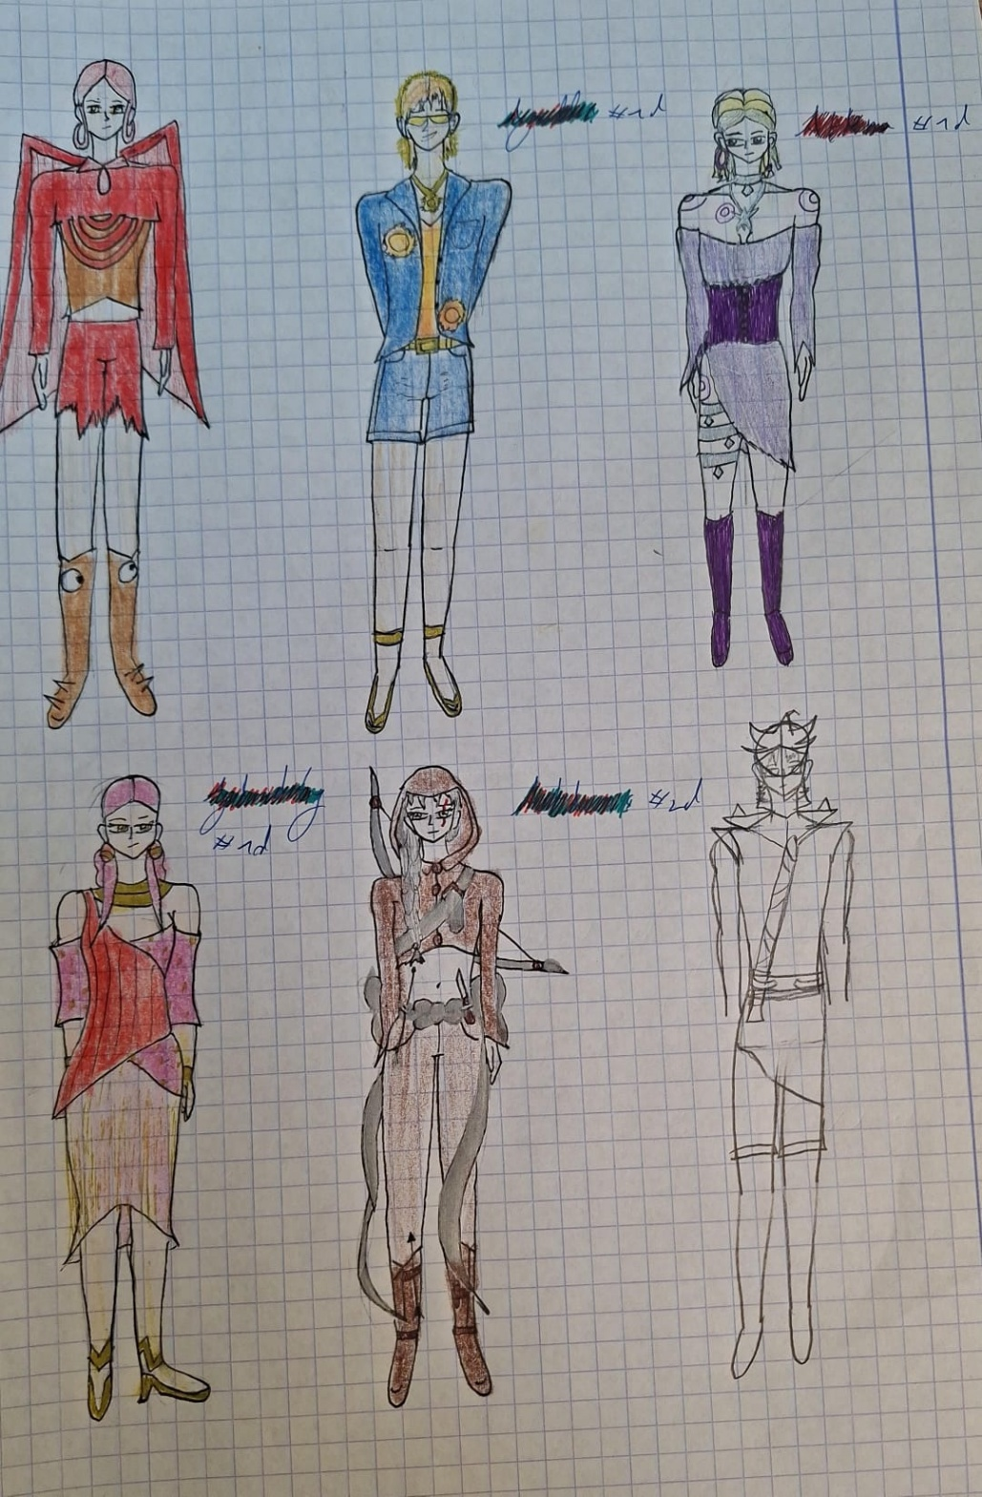
Note: The silver-haired woman was an optional design for Abyeter.
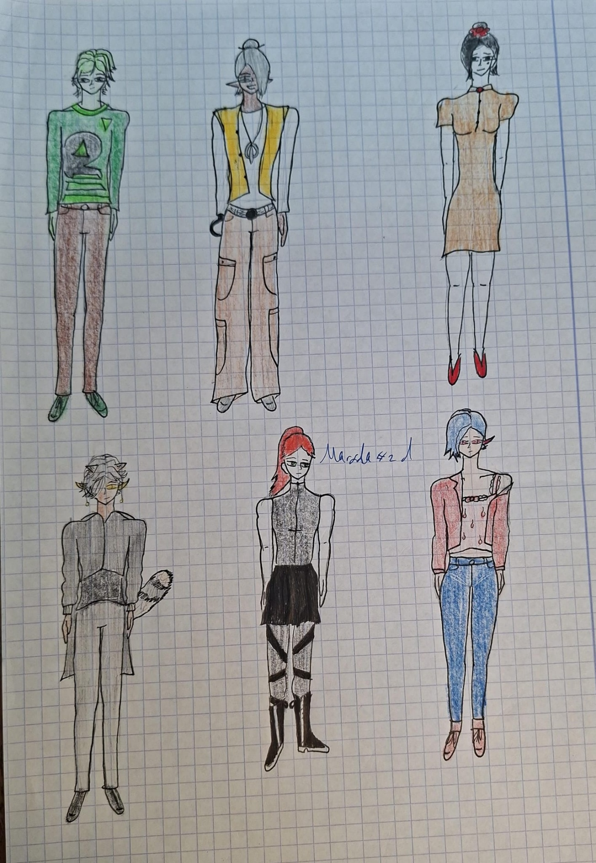

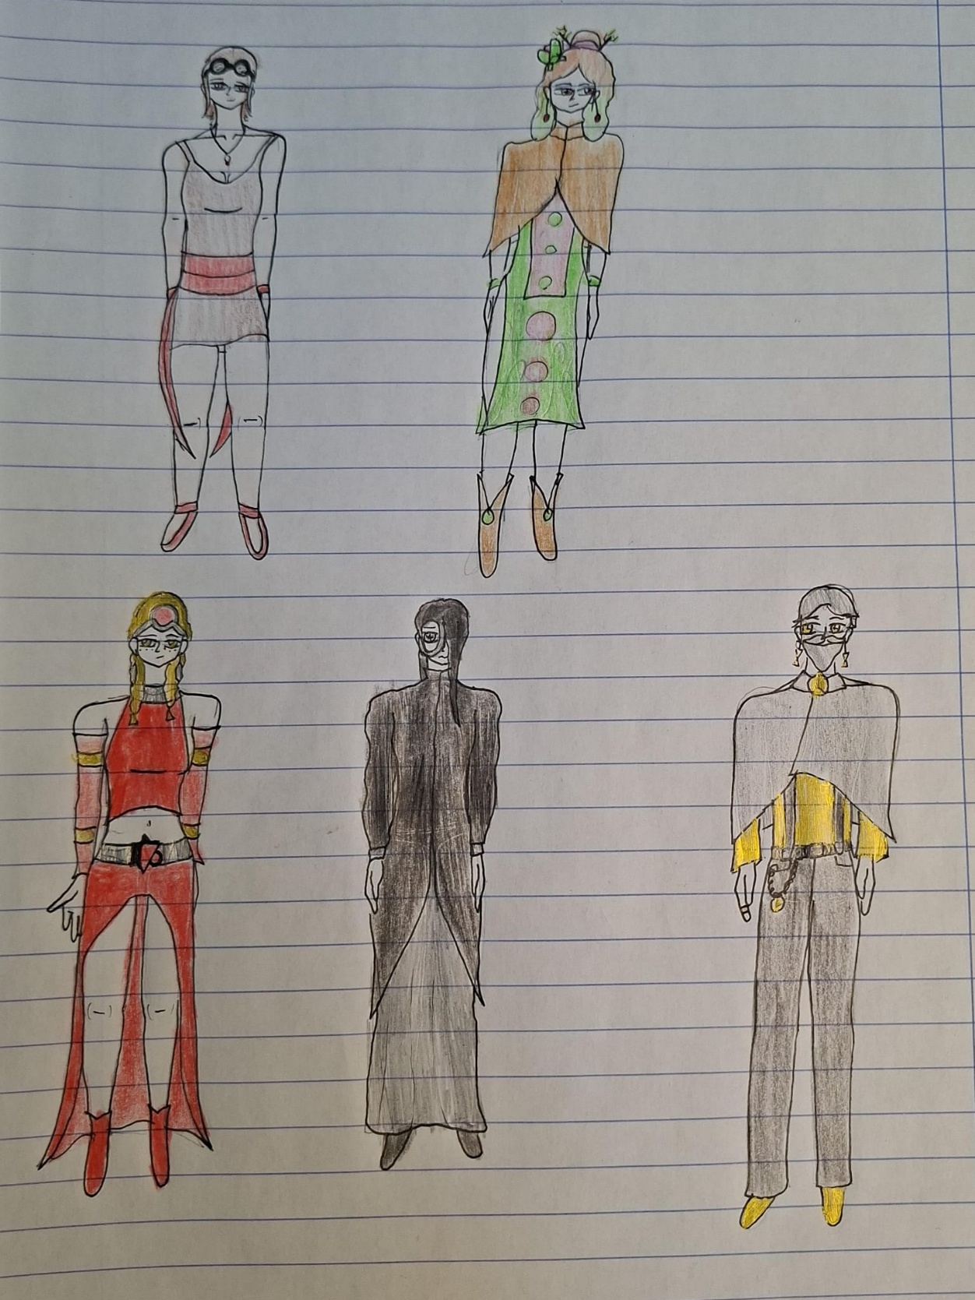

Note: the black-haired woman was my first design for Tenebrae, and the woman with the green dress was an optional design for Abyeter.

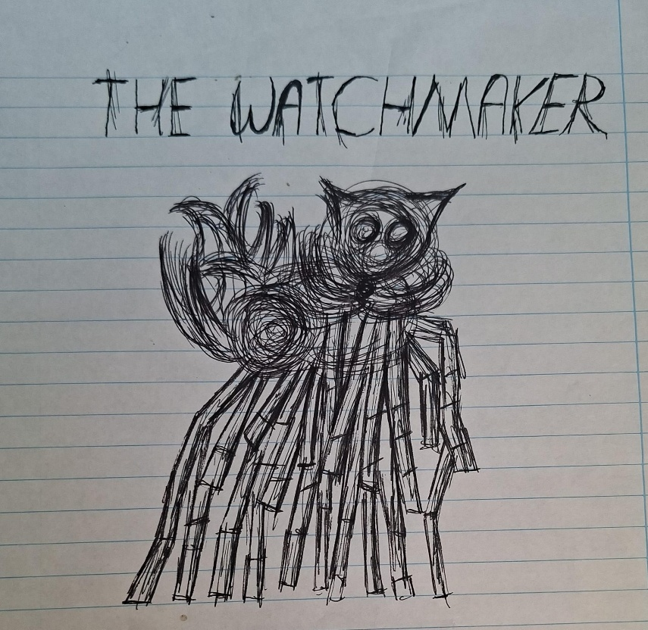
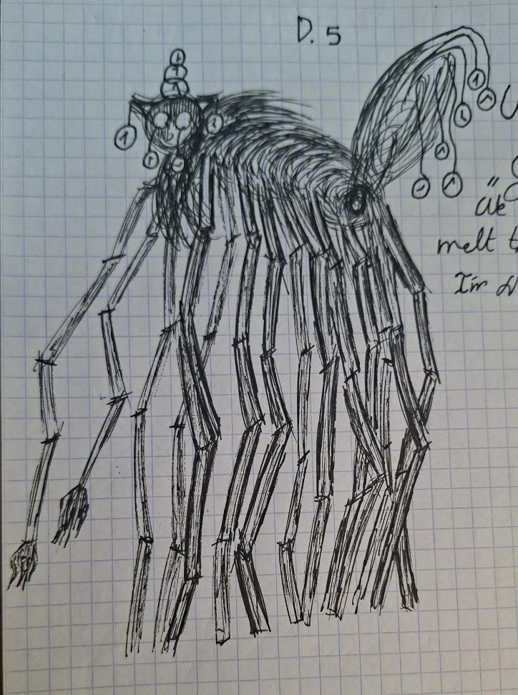

Note: The Watchmaker is my favourite Steven Wilson song.

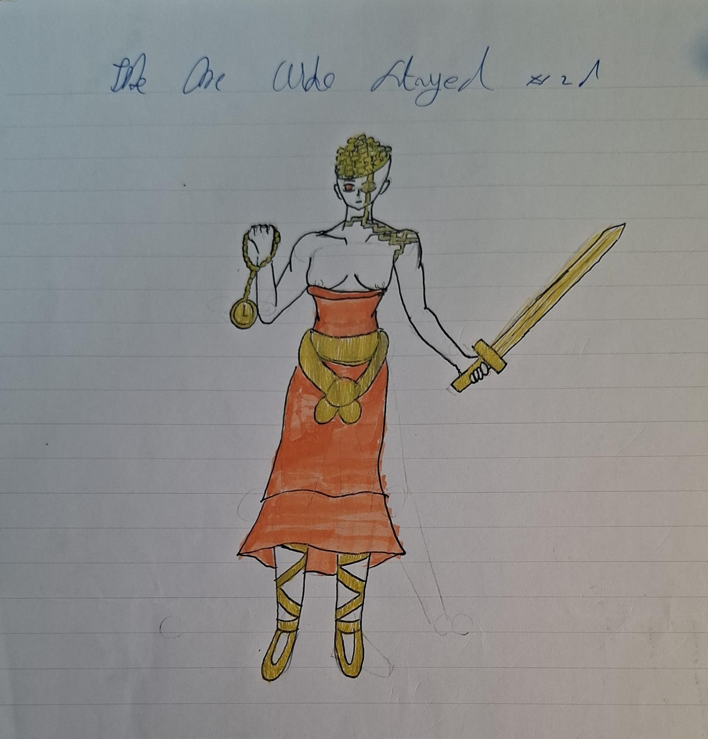

Note: The One Who Stayed's name was supposed to be The One Who Waits, after my favourite The Secret Sea song, The One Who Waits. She is a character for Steve's Failure Show Part 7.

