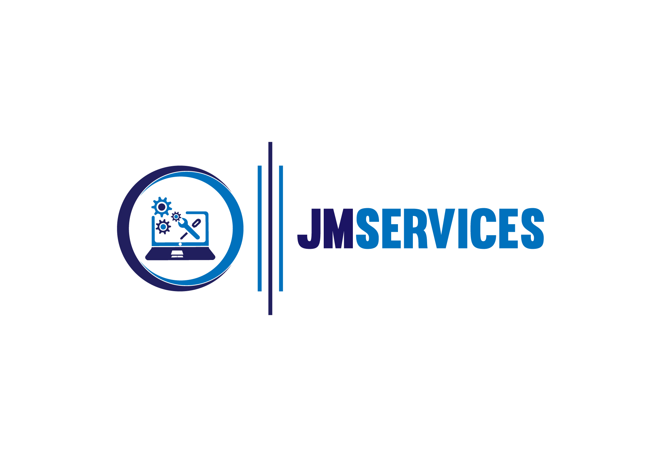Tutoring Scheme Syllabus

2021

|  |  |
| --- | --- |
| Instructor | Email |
| **Joshua Malemba** | joshmalemba@gmail.com |

# General Information About Program

## Description

This tutoring program will introduce and dive the clients to the world of computer programming and various aspects of software development. On a superficial overview this will involve various fundamental concepts, with a close-off project of the clients’ choice, ranging from addictive 2D Game projects, and opportunities to develop efficient personal-use software.

## Expectations and Goals

By the end of this program, I expect the clients to be equipped with an industry demand programming language that can differentiate them from competing candidates for corporate jobs, regardless of the industry space.

Clients will have a competent grasp on the essential concepts, well and capable to hone their attention on avenues of interest, whether this be data science, web development, software engineering, game engineering and development, and more, widening their career prospects by a milestone.

# Course Materials

## Installation Pre-Requisites – Will Be Installed Live With Client

* Python 3.6 (Programming Environment) – Laptop, PC, Mac

## Recommended Books

**Python Crash Course – A Hands on Project Based Introduction to Programming (Eric Matthes)**

# Course Schedule

| Topics |  |  | Exercises |
| --- | --- | --- | --- |
| Program Computation |  |  | Provided in Session |
| Data Structures |  |  | Provided in Session |
| Automated Decision Making |  |  | Provided in Session |
| Object Design and Behavior |  |  | Provided in Session |
| Software Project |  |  | Provided in Session |