Telescopes

A journey through the ages

Telescopes. One of mankind’s greatest inventions which has expanded our knowledge of the universe far beyond what we ever imagined. I am sure you are aware of what the general purpose of a telescope is, but have you ever stopped and wondered how they came to be the marvels of engineering we are familiar with today?

# Optical Telescopes

## The Discovery of the Refracting Telescope

It’s a common misconception that the telescope was invented by the great Italian physicist and astronomer **Galileo Galilei** in 1609. In fact, the first patent for a telescope was applied for by Dutch lens maker **Hans Lippershey**. It consisted of a concave lens as the eyepiece and a convex objective lens. This first telescope could magnify objects to thrice their original size. Upon hearing about this invention, Galileo made vast improvements to the same, making a telescope which could produce 20x magnification. He called his telescope a “*Perspicillum*”. The word telescope was coined by the mathematician **Giovanni Demisiani** in 1611. Galileo was the first to use the telescope to observe the sky, making him “The Father of Observational Astronomy”. Further advancements were made by multiple great scientists, most notably **Johannes Kepler** who designed a telescope which used 2 convex lenses. This widened the field of view and produced a real image (upside down). **Christiaan Huygens** used a **23 foot**[**[1]**](https://history.aip.org/exhibits/cosmology/tools/tools-first-telescopes.htm#:~:text=A%20typical%20astronomical%20telescope%20of%20this%20time%20was%20the%20one%20made%20in%201656%20by%20Christiaan%20Huygens%2C%20a%20Dutch%20mathematician%20and%20astronomer%2C%20and%20his%20brother%20Constantine.%2023%20feet%20long%2C%20it%20magnified%20objects%20about%20a%20hundred%20times%2C%20and%20still%20had%20a%20considerable%20field%20of%20view.)long refracting telescope and independently discovered the **Orion Nebula**[**[2]**](http://www.messier.seds.org/xtra/Bios/huygens.html#:~:text=he%20made%20important,the%20Trapezium%20cluster.) in 1656. For context, the original Galilean telescopes were only about 4-5 feet long.You might have noticed that all these telescopes use a combination of lenses to magnify objects. This is the reason they are called **refracting telescopes.** An interesting form of the refracting telescopes of the 17th Century is [**Aerial Telescopes**](https://en.wikipedia.org/wiki/Aerial_telescope).

## Reflecting Telescopes – A major landmark

Fast forward to 1663 and we have the first ever design for the **Reflecting Telescope** given by Scottish mathematician **James Gregory**. The first functioning reflecting telescope was designed by **Sir Isaac Newton** which had a magnification of about **40x**[**[3]**](https://history.aip.org/exhibits/cosmology/tools/tools-early-reflectors.htm#:~:text=It%20had%20a%20magnification%20of,it%20remained%20largely%20a%20curiosity.). This is a major landmark in the development of telescopes as reflecting telescopes dominated astronomy till the 20th century. How are reflecting telescopes any different from refracting telescopes, you ask? Reflecting telescopes are easier to maintain, removes the problem of [**spherical aberration**](https://en.wikipedia.org/wiki/Spherical_aberration) observed in refracting telescopes and are generally superior to their refracting counterparts. Continuing our journey, the next major development was brought by **John Hadley** whose Newtonian telescope was said to have a magnification of about **200x**[**[4]**](https://history.aip.org/exhibits/cosmology/tools/tools-early-reflectors.htm#:~:text=Records%20from%20the%20meeting%20say%20that%20it%20was%20powerful%20enough%20to%20%22enlarge%20an%20object%20near%20two%20hundred%20times.%22). The man responsible for the further development of reflecting telescopes was American **George Ellery Hale.** He was a key figure in the planning and development of several leading telescopes of the world, most notably a 60 inch at Mount Wilson, a 100 inch at Mount Wilson and a 200 inch at Palomar. These telescopes were extremely successful and popular with scientists of the time and they are still facilitating scientific discovery even today. The use of the 200-inch telescope led to correction of distance estimates to the Andromeda galaxy. New measurements showed that the galaxy was twice as far as previously thought. To an astronomer, the size of the Universe had just **doubled**[**[5]**](https://sites.astro.caltech.edu/palomar/about/telescopes/hale.html#:~:text=Once%20the%20200,had%20just%20doubled.). This is just a single example of the great impact these telescopes had on our knowledge of the universe.

# Non-Optical and Space Telescopes

**Non-optical telescopes** are telescopes which are used to observe wavelengths of electromagnetic radiation outside the visible light spectrum. This includes UV, Infrared, Radiowaves, Gamma rays and microwaves. These help us observe the universe with a depth and precision far greater than just using visible light. Many important telescopes nowadays work with Infrared.

## What are space telescopes and why use them?

The rapid development in rocket technology opened many exciting new avenues for us, including the development of **Space-Based Observatories** or **Space Telescopes**. These are the telescopes we are most familiar with today. They have provided us with a wealth of scientific data and images of unparalleled beauty, some of which I am sure you have seen. The only major drawback of space telescopes is that they can not be properly maintained and they are extremely expensive to launch and operate. You might ask, why do we need to spend so much on these space telescopes when we already have extremely sophisticated ground based instruments. The answer is simple. The quality of images and data obtained from space-based telescopes is simply way better than ground-based telescopes can ever manage. This is because in addition to blocking certain wavelengths of light altogether, Earth’s atmosphere is made up of shifting pockets of air that cause the twinkling appearance of stars in the night sky. This motion blurs images captured by telescopes on the ground[**[6]**](https://www.nasa.gov/content/discoveries-why-a-space-telescope#:~:text=In%20addition%20to%20blocking%20certain%20wavelengths%20of%20light%20altogether%2C%20Earth%E2%80%99s%20atmosphere%20is%20made%20up%20of%20shifting%20pockets%20of%20air%20that%20cause%20the%20twinkling%20appearance%20of%20stars%20in%20the%20night%20sky.%20This%20motion%20blurs%20images%20captured%20by%20telescopes%20on%20the%20ground.). The first space telescope was the **Uhuru X-ray Explorer Satellite**, launched off the coast of Kenya in the early 1970s[**[7]**](https://www.cfa.harvard.edu/facilities-technology/telescopes-instruments/uhuru#:~:text=The%20Uhuru%20X%2Dray%20Explorer%20Satellite%20was%20the%20first%20spacecraft%20dedicated%20to%20X%2Dray%20astronomy.%20During%20its%20mission%20in%20the%20early%201970s%2C%20Uhuru%20mapped%20the%20X%2Dray%20sky.) marked the beginning of a golden era for astronomy as a whole.

## Hubble Space Telescope

The Hubble Space telescope is the first major optical telescope placed in space. Since its launch on April 24th 1990, it has been providing stunning and iconic images of the universe, including the famous “Pillars of Creation” photograph and the Hubble Deep Field and Ultra Deep Field images, which provided images of the farthest known objects in the universe[**[8]**](https://esahubble.org/science/deep_fields/#:~:text=One%20of%20the,the%20Big%20Bang.). Even though Hubble had an estimated life of 15 years, it is still operational and providing an unobstructed view of the universe.

## James Webb Space Telescope – The Future

The launch of the James Webb Space Telescope on Christmas Day of 2021 marks the beginning of the future for space-based astronomy. The 10 Billion Dollar instrument is the largest and most sophisticated to ever be launched. It utilizes the Infrared spectrum to make its observations. It promised to be the greatest telescope in history and in the short time its been operational, it has already started delivering on this promise. A look at the pictures obtained in its 1 year operation time is enough to convince anyone of this. There will undoubtedly be more developments to telescope technology in the upcoming years but for now, we end our journey here. Thank you!

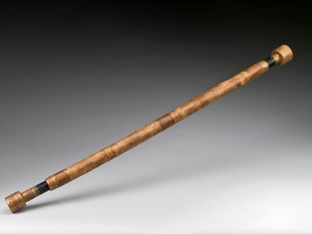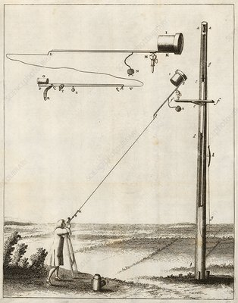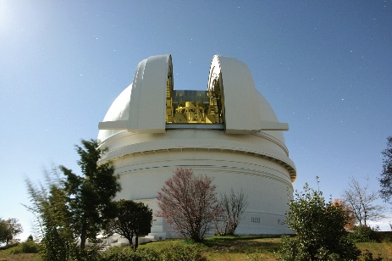

Galileo's Telescope An Early Aerial Telescope The Hale 200’’ Telescope

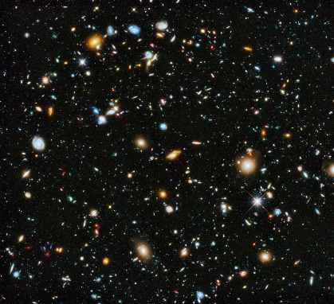

A Hubble Deep Field Image

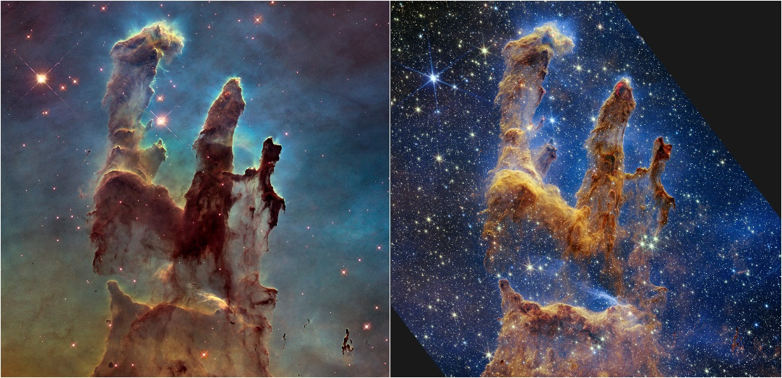

Hubble “Pillars of Creation”(Left) Vs JWST (right)

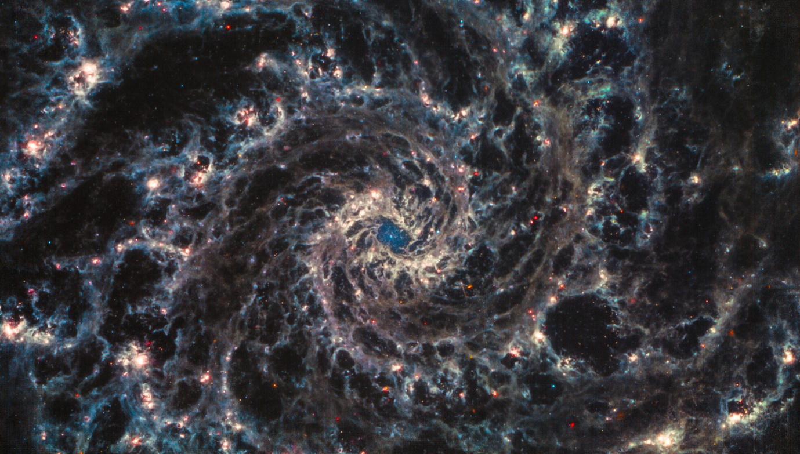

JWST Image of a Spiral Galaxy