Date: 12-30-11

Subject: PICPCAP Version 4 Release Notes

Re: Version 4

From: JGH

# Summary

The following lists a summary of the changes:

* Added the new decoding algorithms. Currently fixed at up to 8 touches, can be adjusted to do less or more, RAM dependent. The new decoding algorithms are less sensitive to thresholds
* The new source code can be compiled for processors PIC18F, PIC24F, and PIC32MX. The source contains three projects, one for each
* The majority of the code is generic to PCAP, these projects allow us to make general changes to the functionality of PCAP code across all processors without editing each processor type independently keeping all PCAP code the same
* Processor specific code is now located in pcap_hardware_processor.c, pcap_hardware_processor.h, and sensor_processor.h. Any changes specific to the processor you are using should be located in the file specific to your processor. Create a new project and files for additional processors
* ROM lookup tables (LUT) for each processor are employed making setting up new processors and using current ones much simpler
* Memory models are flat meaning all processors now use the same RAM structures and two dimensional arrays
* Not all features are currently implemented for all processor types, these will be added as the projects mature
* All sensor specific settings are located in the processor specific header file sensor_processor.h

# Base Projects

The projects are based on the following base processor/hardware; refer to appendix A for the schematics:

* PIC18F46K22
* PIC24FJ64GB106
* PIC32MX250F128D

The following table lists current support for each processor, a check mark indicates it is included.

|  |  |  |  |  |  |  |  |
| --- | --- | --- | --- | --- | --- | --- | --- |
| Processor | I2C | UART | USB | EEPROM | Sleep | Short Checking | Sensor Support |
| PIC18F | √ | √ |  | √ |  | √ | AMT P3002 |
| PIC24F | √ |  | √ | √ |  |  | AMT P3002 |
| PIC32MX | √ |  |  |  |  |  | AMT P3002 |

# Setting up and Building a Project

To setup and build a project do the following:

* Open one of the project files based on your processor and hardware. There are 3 of them: PIC18PCAP, PIC24PCAP, and PIC32PCAP
* At the top of main.h define the processor you are using, there are 3: PCAPPIC18F, PCAPPIC24F, and PCAPPIC32MX

The projects are shown in figure 1.

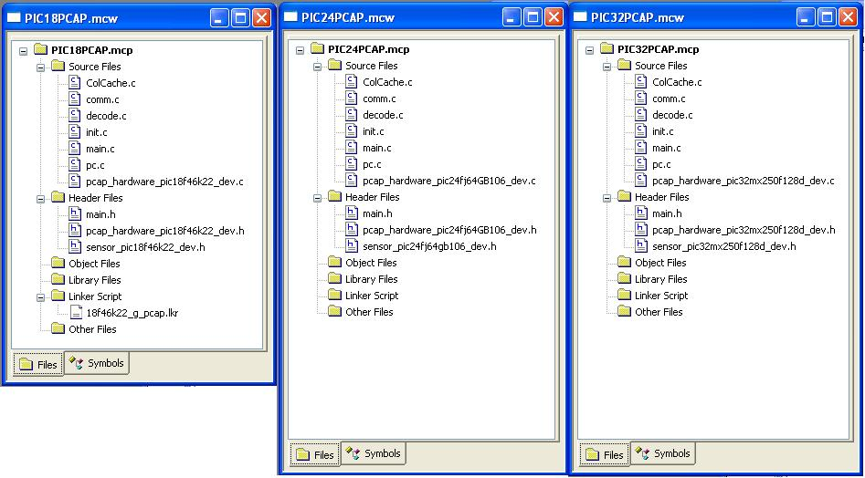

Figure 1. Projects

Note each project is the same other than 3 files: pcap_hardware_processor_dev.c, _hardware_processor_dev.h, and sensor_processor_dev.h. Note also the addition of the linker script for the PIC18F project. The linker script removes the dependence on banked memory an the PIC18F allowing generic RAM defines across all processors.

# Processor Specific Files

The processor specific files are used to contain any differences between the processor types such as initialization and timers. As mentioned before, the actual PCAP code is generic, the specifics of setting up and acquiring the PCAP signals are dependent on the hardware and processor type.

## Macros

Keep macros short, they are difficult to read and difficult to debug. Macros are typically used when setting up things like timers, CTMU, and communications. For example to set timer 1 on a PIC24 uses the instruction T1CONbits.TON = 1 and on a PIC32 the instruction T1CONSET = 0x00008000. This is a good use of a macro.

## C files

The specific C file, pcap_hardware_processor_dev.c, contains function specific to a processor such as setup and acquiring the PCAP signal. These files contain functions used for each processor type.

## RAM memory Sizes

Be careful when defining new variable sizes, an unsigned int on a PIC32 is 32 bits while on a PIC18 or PIC24 it is 16 bits.

## Flat RAM Model

The PIC24 and PIC32 already use a flat memory model, the PIC18 requires a modified linker script exposing all RAM as flat memory. Be aware of the linker script when moving to other processors in the 18F and 16F domain.

# Appendix A

