Building CSALT (Linux)
A quick guide to building the CSALT test problem application
July 20, 2017

This outline shows the steps that a programmer should follow to build the CSALT library and test problem driver application.
- Setup a copy of the CSALT code. There are 2 ways to do this:
  - Unpack a CSALT repository archive
or
  - Clone the CSALT repository, and check out the CplusPlusMigration branch.
- Setup the dependencies that CSALT uses, boost and snopt.
The cmake file looks for the dependency files in the CplusPlus/depends folder. On my systems, I set up the dependencies using symbolic links. I have boost in the ~/boost_1_62_0 folder, and SNOPT (7.5) in the ~/snopt7 folder. SNOPT needs to have been compiled at this point, and you should have SNOPT libraries in lib folder (or maybe in lib/.libs). Then symbolic links can be set and checked like this:
djc@eagleswing:~/BuildCsalt/CSALT$ cd CplusPlus/depends/
djc@eagleswing:~/BuildCsalt/CSALT/CPlusPlus/depends$ ln -s ~/boost_1_62_0/ boost
djc@eagleswing:~/BuildCsalt/CSALT/CPlusPlus/depends$ ln -s ~/snopt7/ snopt
djc@eagleswing:~/BuildCsalt/CSALT/CPlusPlus/depends$ ls -l
total 0
lrwxrwxrwx 1 djc djc 23 Jul 20 14:01 boost -> /home/djc/boost_1_62_0/
lrwxrwxrwx 1 djc djc 17 Jul 20 14:01 snopt -> /home/djc/snopt7/
- Run cmake-gui
  - Point the source code to the top level code folder (~/BuildCsalt/CSALT for me)
  - Set a path for the build files and binaries (I use ~/BuildCsalt/CSALT/Release for release builds, and ~/BuildCsalt/CSALT/Debug for debug builds)
  - Press the Configure button. Here’s what I see as the result (after expanding the tree entries):
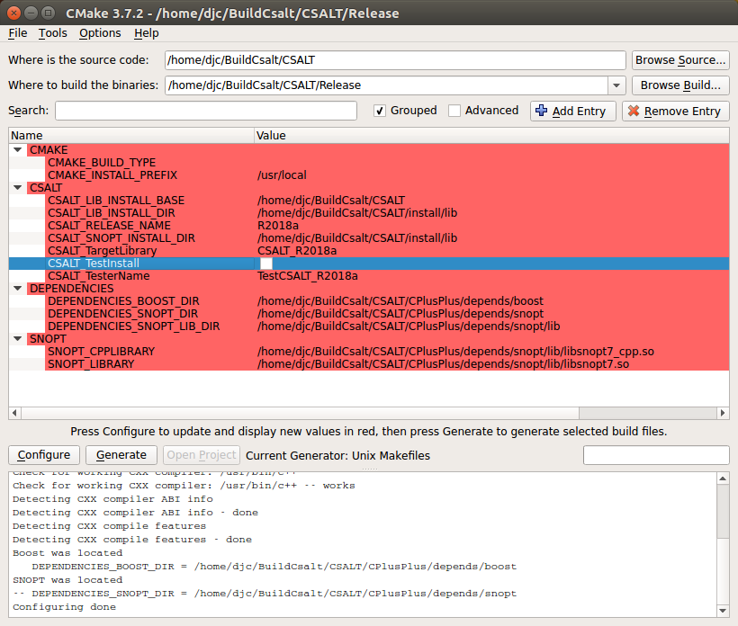
Figure 1: CSALT setup in CMAKE
  - Press the Generate button.
  - Build CSALT:|
djc@eagleswing:~/BuildCsalt/CSALT/CPlusPlus/depends$ cd ../../Release/
djc@eagleswing:~/BuildCsalt/CSALT/Release$ make -j32
Scanning dependencies of target CSALT_R2018a
[ 0%] Building CXX object CmakeFiles/CSALT_R2018a.dir/…
…
[100%] Linking CXX executable /home/djc/BuildCsalt/LowThrustBinary/bin/TestCSALT_R2018a
[100%] Built target TestCSALT_R2018a
Note: The build will fail for you because of the SNOPT 7.5 → 7.6 issue unless you make adjestments in the code to account for the SNOPT interface changes. Sigh.
  - Run the test program:
djc@eagleswing:~/BuildCsalt/CSALT/Release$ cd ../../LowThrustBinary/bin/
  - djc@eagleswing:~/BuildCsalt/LowThrustBinary/bin$ ls
  - TestCSALT_R2018a
  - djc@eagleswing:~/BuildCsalt/LowThrustBinary/bin$ ./TestCSALT_R2018a
********************************************
TestOptCtrl
********************************************
Select a test case:
0. Exit TestOptCtrl
…
That’s it!

