UWCUBE
Active Sprint Team Projects — Overview

Team 1 — Daily Workflow Management App
Partner: Tesoro
Segment: Productivity / Workflow Management (Web App)
Product Name: TaskPilot
Overview
Team 1 is designing a web app that integrates your inbox, calendar, and projects to help you manage competing requests throughout the day.
Project Focus
- Set daily priorities and key tasks each working session
- Get contextual summaries and smart scheduling suggestions for incoming messages
- "Focus" mode to filter notifications and stay on track
Team Members
Sophie Kim | Project Lead
Emma Jadon | Project Member
Zaina Khan | Project Member
Amy Wang | Project Member
Josh Sanicharan | Project Member
Design Reference
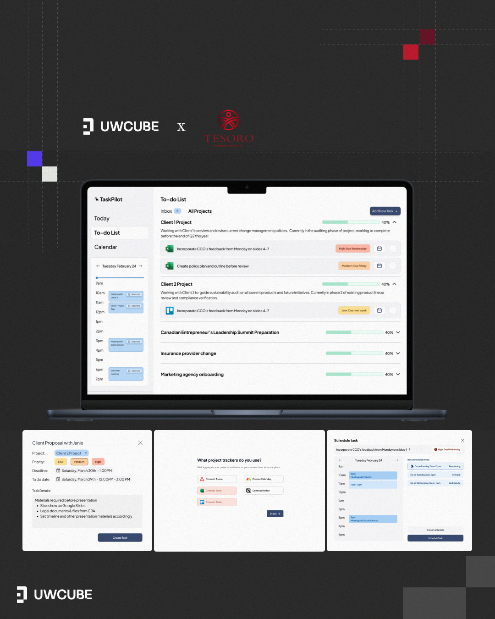

Team 2 — Centralized Donation Platform
Partner: Tesoro
Segment: Charitable Giving / Fintech-for-Nonprofits
Overview
Team 2 is designing a centralized donation platform that simplifies charitable giving in Canada.
Project Focus
- Browse, donate, and track your giving history in one place
- Manage tax receipts and see where your money went
- Discover new causes and stay connected to the ones you care about
Team Members
Jason Pham | Project Lead
Vivaan Patel | Project Member
Preta Mathivarnan | Project Member
Anna | Project Member
Katherine Chen | Project Member
Design Reference
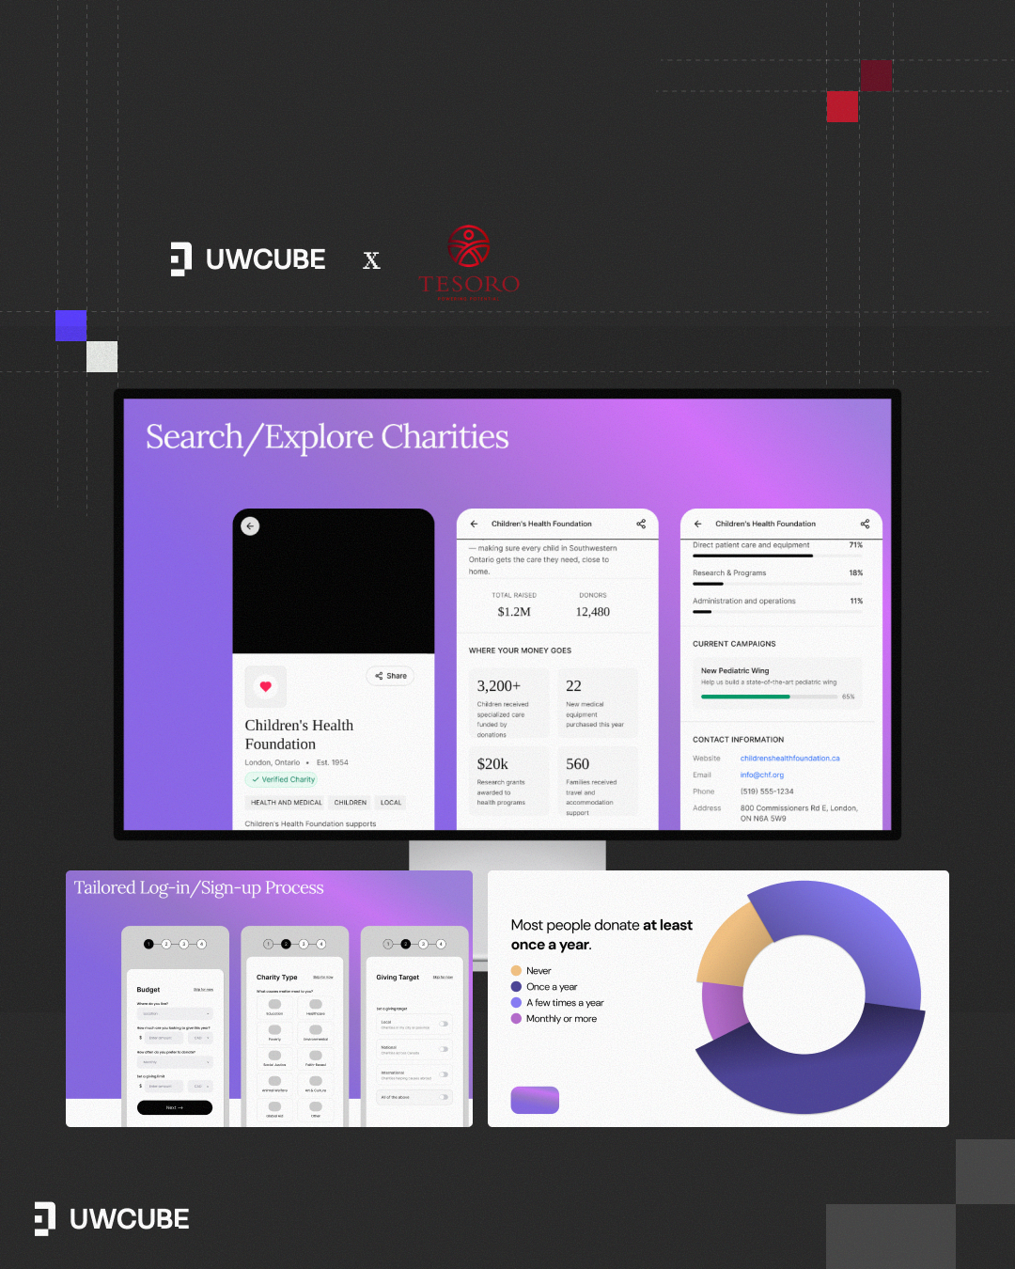

Team 3 — Health-Tech Triage Application
Partner: University of Waterloo Healthcare Symposium
Segment: Health-Tech / Care Navigation
Overview
Team 3 is designing a Health-Tech Triage Application that helps people with non-critical conditions decide where to get care before they leave home.
Project Focus
- An AI symptom chatbot for high-level triage guidance
- Estimated wait times at nearby clinics and hospitals
- An interactive map to compare and filter care options
Team Members
Jiya Anadkat | Project Lead
Brianne Woon | Project Member
Jeffrey Wai | Project Member
Natalie Yu | Project Member
Bhavya Goel | Project Member
Design Reference
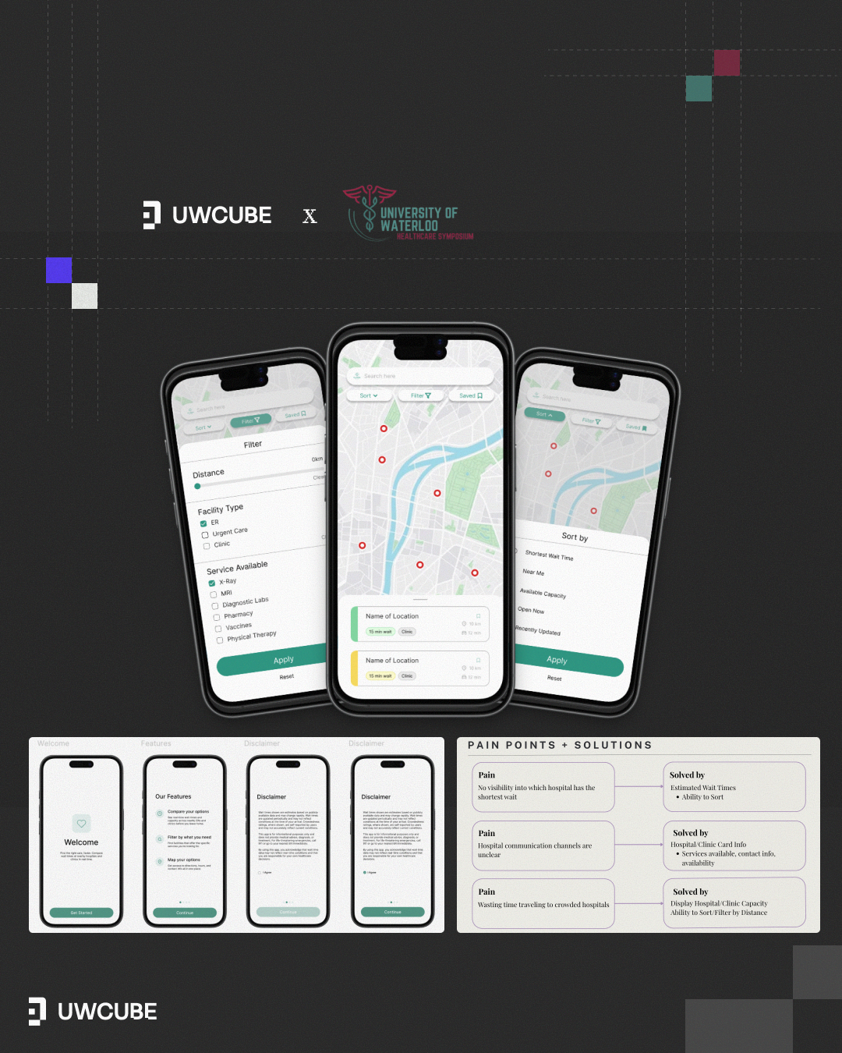

Team 4 — Health-Tech Privacy Application
Partner: University of Waterloo Healthcare Symposium
Segment: Health-Tech / Data Privacy
Product Name: Securra
Overview
Team 4 is designing a privacy-first healthcare app that puts users in control of their own medical data.
Project Focus
- Reimagining onboarding to replace complex legal jargon with clear, intuitive tools
- Making data transparency and consent accessible to all users, regardless of technical background
- Embedding privacy as a core part of the experience, not just a setting
Team Members
Simone Behl | Project Lead
Eshaal Iqbal | Project Member
Lucas Vu | Project Member
Nimisha Jain | Project Member
Ellie Chan | Project Member
Design Reference
