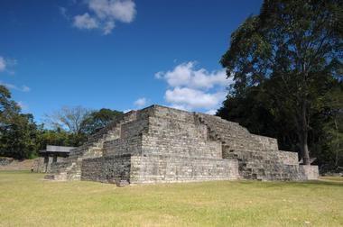

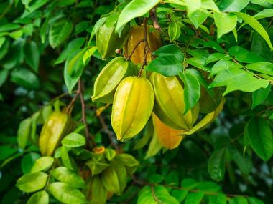

**Pic. 1-Image of the Maya ruins**

**Pic. 2-Image of Carambola Gardens**

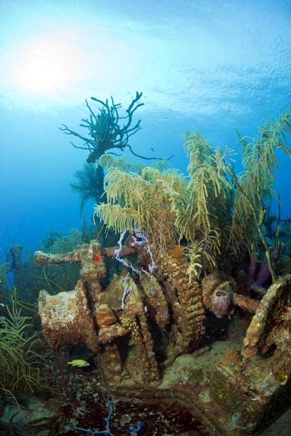

**Pic. 2-Image of Bay Island Underwater Museum**

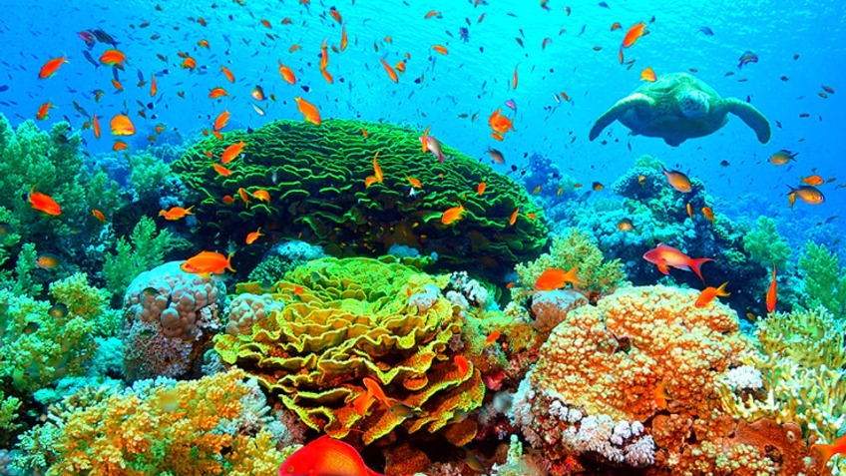

**Image of the Coral reef**

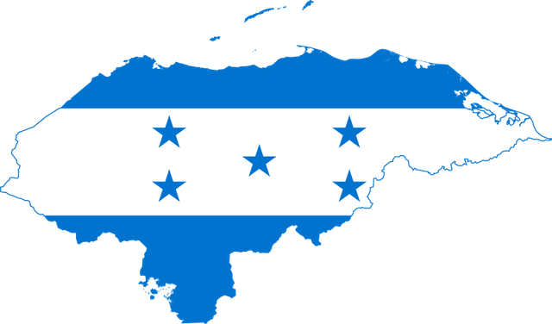

**Map and Flag**

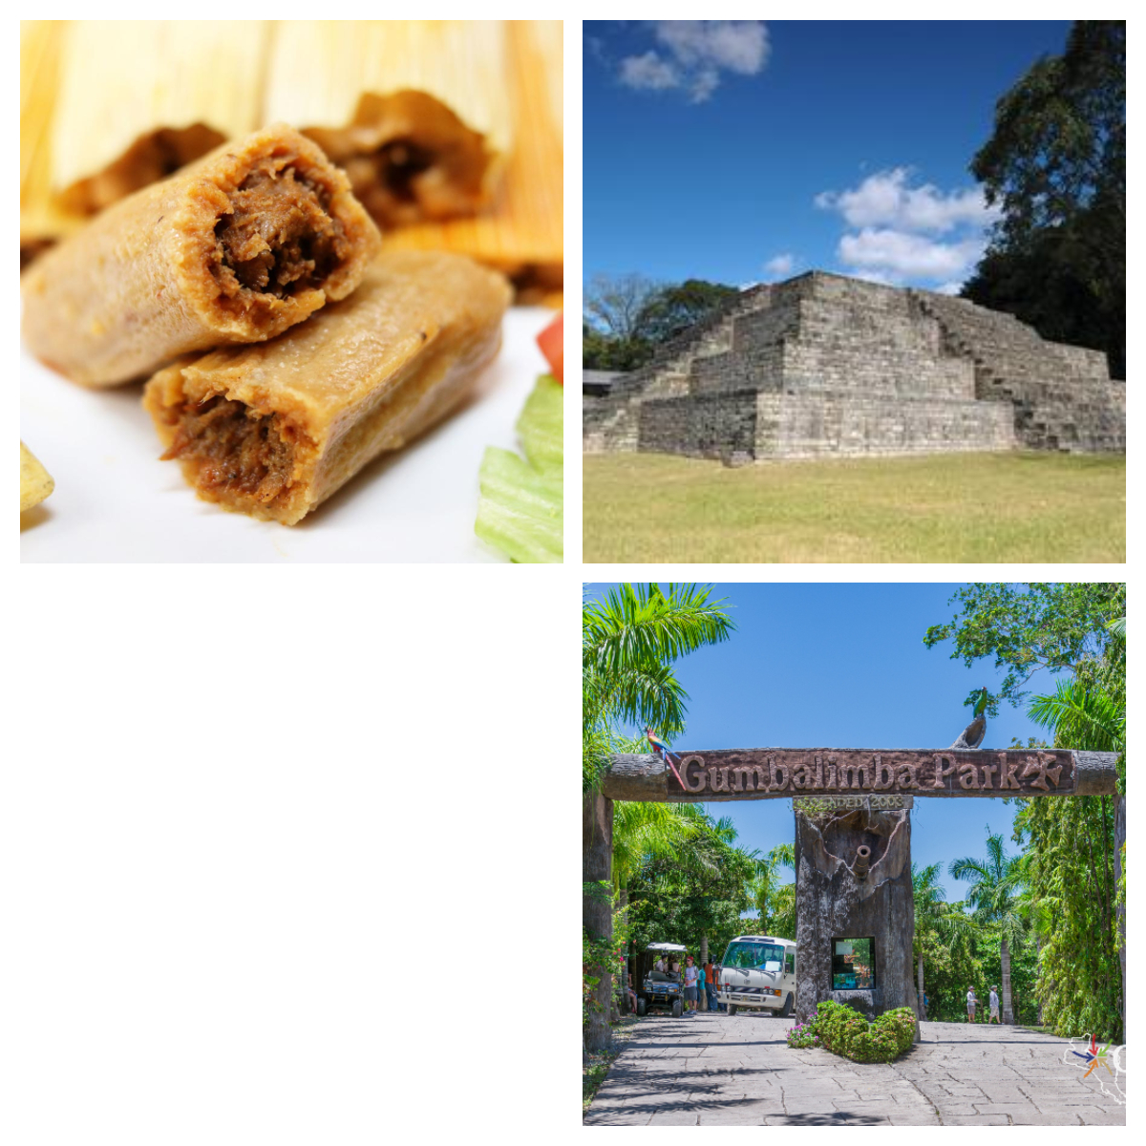

**Image of Flyer 2**