Caitlyn Nelson
Abinet Deresebachew
Paul Orion Weaver
Juan Bell
Ahmed Alshehir
Nathaniel Baker

Rock and Roll Rides Auto Club

NEED: The auto club needs a database to manage members and their vehicles. Should be user friendly, and provide all information needed to add, edit, or look up individual members and autos. Each member can have one or more vehicles, and a vehicle can be owned by just one member.

(SDLC Process)

ANALYSIS PHASE: User Requirements (Forms, Reports, & Perceptions)

Input Forms
frmMemberInfo – to add, edit or look up members
frmMembersSubform – to add, edit, or lookup up autos

Output Reports
rptMembers - a list of existing members
rptAuto - a list of existing autos
rptIndvAutos1 - a more detailed list of autos focusing on individual autos

DESIGN PHASE: Relational Database Design Process Database Structure

Table Name
Field Name(Data Type, Field Size):

tblMembers
MemberID (Primary Key, Short Text, 50)
LastName (Short Text, 50)
FirstName (Short Text, 50)
Phone (Short Text, 50, with Input Mask)
Address (Short Text, 50)
City (Short Text, 50)
State (Short Text, 50)
Zip (Short Text, 50)
Specialty (Short Text, 50)

tblAutos
AutoID (Primary Key, Short Text, 50)
Year (Number [for comparisions], long integer)
Brand (Short Text, 50)
Model (Short Text, 50)
Engine (Short Text, 50)
Body (Short Text, 50)
Color (Short Text, 50)
Condition (Short Text, 50)
Modifications (Short Text, 50)
Pictures (Attachment)
MemberID (Short Text, 50)
Relationships:
tblMembers (one to many) tblAutos

Reports:
rptMembers - a list of existing members
rptAuto - a list of existing autos
rptIndvAutos1 - a more detailed list of autos focusing on individual autos

Queries:
qryBartlettMembers – Shows only members location within Bartlett
qryCarsAfter1960 – Shows only cars after the year 1960
qryCarsBefore1960 – Shows only cars dated before 1960
qryMembersSpecialty – Shows only members with a specialty
qryModifications – Shows only autos with modifications

Prototype:

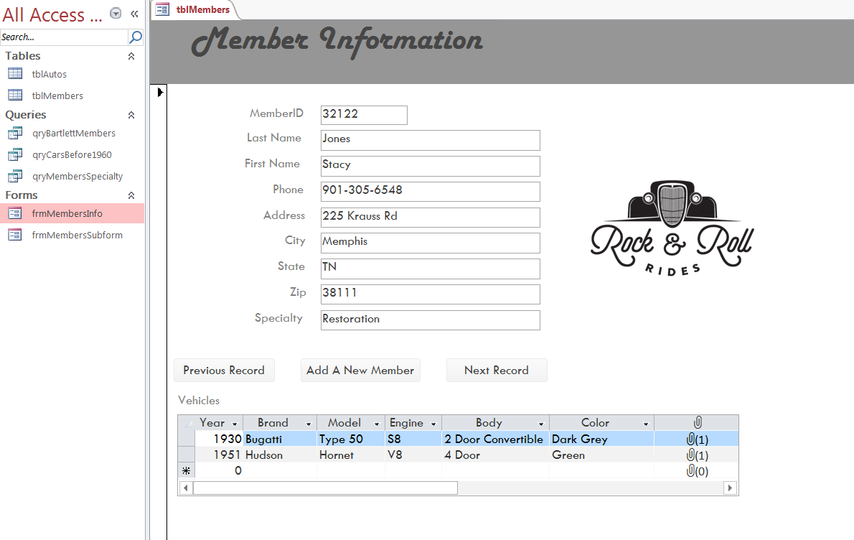

IMPLEMENTATION PHASE:
