**Project Report**

***Business Requirements***

**Requirement Scope**

* Create an application for restaurant, so users can order food online
* Support only pickup orders
* User pays during pickup
* Restaurant should be able to have a menu and also add more menu’s in future
* Each menu has multiple menu-items
* User should be able to view menu items in the application
* User should be able to pick and choose the menu items
* User should be able to review the order and provide user details
* User details should include name, email and/or phone number
* At the end user should be shown a confirmation page where the order details should be shown along with the estimated finish time and a confirmation number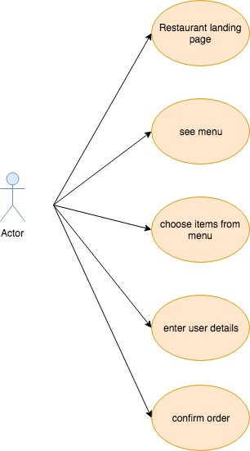

***Technical Requirements***

* Design a restaurant food ordering micro service
* Use python as the programming language
* Use python flask, sqlalchemy, marshmallow dependencies
* Use SqlLite as the database
* Use swagger to design API spec
* Postman to test the API
* Docker as the containerization tool

**Python Libraries**

* Flask
* SqlAlchemy
* Marshmallow

**Setup code**

* migrations.py
  + Used to setup DB
* run.py
  + Where the app begins
* app module
  + Has all the application code

**Architecture**

**High Level *API***

| URL | Request Object | Response | Description |
| --- | --- | --- | --- |
| GET  /restaurents |  | ListOfRestaurants | Used for future when we want to use this same application for multiple orders |
| GET  /restaurants/{restaurantId} |  | RestaurantInfo | Return restaurant information for a single restaurant |
| GET  /restaurants/{restaurantId}/photos |  | RestaurantPhotosInfo | Returns all the photos associated to the restaurant, which doesn’t include specific menu item photos |
| GET  /restaurants/{restaurantId}/menu |  | RestaurantMenu | Return restaurant menu |
| POST  /restaurants/{restaurantId}/orders | OrderRequest | OrderInfo | Place an order and return order information back which includes confirmation number and estimated time |

***Sequence Diagrams***

***Get Restaurant Info***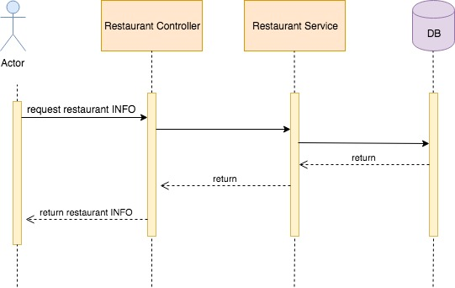

**Get Restaurant Photos**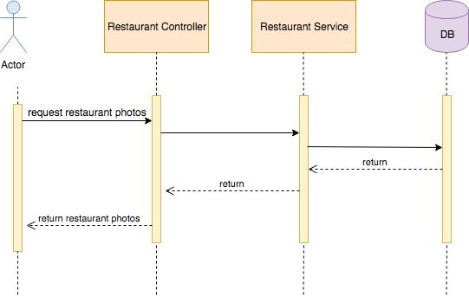

**Get Restaurant Menu**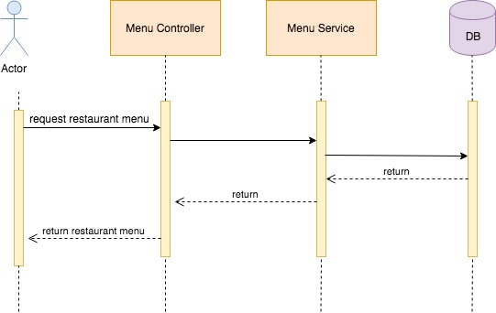

**Place Order**

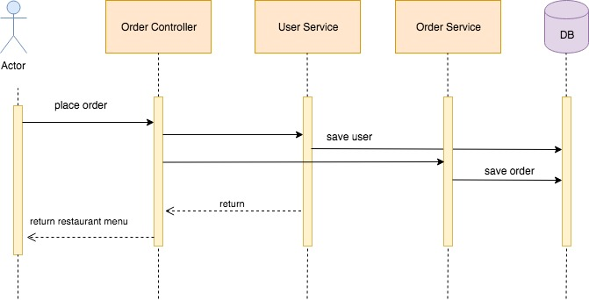

**Conclusions**

* Expandable
  + The API is designed to extend and add additional features like
    - Add multiple restaurants
    - Add multiple menu’s per restaurant
    - Text reminder regarding the order
* What we learnt
  + We learnt to build an application end-to-end application using python flask, jquery and bootstrap.