**1**

**a)**

**<!-- Write a HTML program, to explain the working of hyperlinks using <a> tag and href target Attributes. -->**

<html>

<body>

<h1>To demonstrate HyperLinks</h1>

<a href='https://www.google.com/'>To open Google(Defaulf)</a> <br>

<a href='https://www.google.com/' target='_blank'>To open Google in new tab.</a> <br>

<a href='https://www.google.com/' target='_self'>To open Google in same tab.</a> <br>

</body>

</html>

**1b)**

**<!--Write a program to embed internal and external JavaScript in a web page-->**

<html>

<body>

<p id='internal_js'></p>

<p id='external_js'></p>

<script>

document.getElementById('internal_js').innerHTML = 'This is from internal JS.';

</script>

<script src='script.js' ></script>

</body>

</html>

**Script.js**

document.getElementById('external_js').innerHTML = 'This is from external JS.';

**2**

**a)**

**<!--Write a program to demonstrate the various ways you can reference a color in CSS.-->**

<html>

<body>

<p style='color:red' >This is using direct color name.</p>

<p style='color:#333'>This is using hex code.</p>

<p style='color:rgb(0,255,0)' >This is using rgb.</p>

<p style='color:rgba(0,0,255,0.5)'>This is using rgba.</p>

<p style='color:hsl(300,100%,50%)'>This is using hsl.</p>

<p style='color:hsl(300,100%,50%,0.5)'>This is using hsla.</p>

</body>

</html>

**b)**

**<!-- Write a program using document object properties and methods -->**

<html>

<body>

<form></form> <form></form>

<a href="#"></a> <a href="#"></a> <a href="#"></a>

<p id='p1'></p>

<script>

document.getElementById('p1').innerHTML += 'Hello World ';

document.write('Current URL : ' + document.URL **+ '<br>'**);

document.write('No of forms : ' + document.forms.length + '<br>');

document.write('No of Links : ' + document.links.length + '<br>');

var newPara=document.createElement('p');

newPara.textContent = 'Dynamically added Paragraph';

document.body.appendChild(newPara);

**document.body.style.backgroundColor = 'red' ;**

</script>

</body>

</html>

**3**

**a)**

**<!-- Write a HTML program, to explain the working of tables. (use tags: <table>, <tr>, <th>, <td> and attributes: border, rowspan, colspan) -->**

<html>

<body>

<table border='1'>

<tr>

<th rowspan='2'>S.no</th>

<th colspan='2'>Name</th>

<th rowspan='2'>Per</th>

</tr>

<tr>

<th>First Name</th>

<th>Last Name </th>

</tr>

<tr>

<td>1</td>

<td>Adi</td>

<td>Satti</td>

<td>90</td>

</tr>

</table>

</body>

</html>

**b)**

**<!-- Write a program to display week days using switch case. -->**

<html>

<body>

<script>

var num = parseInt(prompt('Enter a number : '));

var day;

switch(num) **input:4**

{

case 1 : day='monday'**;** break;

case 2 : day='tuesday'**;** break;

case 3 : day='wednesday'; break;

case 4 : day='thursday'; break;

case 5 : day='Friday'; break;

case 6 : day='saturday'; break;

case 7 : day='sunday'; break;

default : day='not a valid day' ;

}

**document.write(day);**

</script>

</body>

</html>

**4)**

**a)**

**<!-- Write a program using the following terms related to CSS font and text:**

**i. font-size ii. font-weight iii. font-style -->**

<html>

<body>

<p style='font-size: **25px** ; ' >This text is large in size.</p> --No quotes for px.

<p style='font-weight: bolder;'>This text is bolder.</p>

<p style='font-style: italic;'>This text is italic.</p>

</body>

</html>

**b)**

**<!-- Write a program using window object properties and methods -->**

<html>

<body>

<script>

window.alert('Hello,World');

var name = window.prompt('Enter your name : ');

var confirm = window.confirm('Do you want to view delete the files ?');

document.write('Window Width : ' + window.innerWidth + '<br>');

document.write('Window Height : ' + window.innerHeight + '<br>');

document.write('Current URL : ' + window.location.href + '<br>');

document.write('Screen Height : ' + **window.screen.height** + '<br>');

document.write('Screen Width : ' + **window.screen.width** + '<br>');

window.open('https://www.google.com/','_blank',"width=400px; height=400px;")

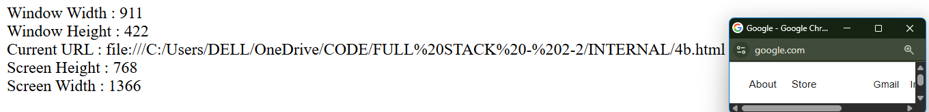 </script>

</body>

</html>

5)

**a)**

**<!-- Write a HTML program, in such a way that, rather than placing large images on a page,**

**the preferred technique is to use thumbnails by setting the height and width parameters to**

**something like to 100*100 pixels. Each thumbnail image is also a link to a full sized**

**version of the image. Create an image gallery using this technique. -->**

<html>

<body>

<a href="img1.jpg"> <img src="img1.jpg" width="100px" height="100px"></a>

<a href="img2.jpg"> <img src="img2.jpg" width="100px" height="100px"></a>

</body>

</html>

**b)<!-- Write a program to print 1 to 10 numbers using for, while and do-while loops. -->**

<html>

<body>

<script>

document.write("Using for loop" + "<br><br>");

for(var i=1;i<=10;i++)

document.write(i+" ");

var i=1;

document.write("<br><br>"+ "Using While loop" +"<br> <br>");

while(i<=10){

document.write(i+" ");

i++;

}

i=1;

document.write("<br><br>"+ "Using do-while loop" + "<br><br>");

do{

document.write(i+" ");

i++;

}while(i<=10);

</script>

</body>

</html>

**6)**

**a) <!-- Write a program to apply different types of selector forms pseudo-element selector, combinator selector. -->**

<html>

<head>

<style>

pre::first-letter{ font-size : 2.5em;}

pre::first-line{font-weight : bold;}

h1::before{content : '❤️';}

h1::after{content : '🥹';}

::selection{background-color:red}

**div p { color: blue; } /* Descendant Selector */**

**div > p { font-weight: bold; } /* Child Selector */**

**h2 + p { color: red; } /* Adjacent Sibling Selector */**

**h2 ~ p { text-decoration: underline; } /* General Sibling Selector */**

</style>

</head>

<body>

<h1>Pseudo Element Selector</h1>

<pre>First Line of para. <br> Second Line of para.</pre><br>

**<div>**

**<p>Inside a div (descendant).</p>**

**<p>Direct child of div.</p>**

**<section>**

**<p>Not a direct child of div,so it not bold.</p>**

**</section>**

**</div>**

**<h2>Heading</h2>**

**<p>Immediately after h2.</p>**

**<p>Another paragraph after h2.</p>**

</body>

</html>

**b)**

**<!-- Write a program using math object properties and methods -->**

<html>

<body>

<script>

document.write('PI value : ' + Math.PI + "<br>");

document.write('Random value : ' + Math.random() +"<br>" );

document.write('Min Value : '+ Math.min(10,1,20) +"<br>");

document.write('Max Value : '+ Math.max(10,1,20) +"<br>");

document.write('Abs Value : '+ Math.abs(-25) +"<br>");

document.write('Square root(64) : '+ Math.sqrt(64) +"<br>");

document.write('Power(2,3) : '+ Math.pow(2,3) +"<br>");

document.write('Floor(22.4) : '+ Math.floor(22.4)+ "<br>");

document.write('Ceil(22.4) : '+ Math.ceil(22.4) +"<br>");

</script>

</body>

</html>

**7)**

**a)<!-- Create a HTML document that has your image and your friend’s image with a specific**

**height and width. Also when clicked on the images it should navigate to their respective**

**profiles. -->**

<html>

<body>

<a href="myprofile.html"><img src="my_image.jpg" alt="my_image" width="100px" height="100px"></a>

<a href="friendprofile.html"><img src="friend_image.jpg" alt="friend_image" width="100px" height="100px"></a>

</body>

</html>

**myprofile.html**

<html>

<body>

<h1>My Profile</h1>

<p> Name : Adi <br> Age : 18 </p>

</body>

</html>

**friendprofile.html**

<html>

<body>

<h1>Friend Profile</h1>

<p> Name : Easwar <br> Age : 19 </p>

</body>

</html>

**b)**

**<!-- Develop a program to determine whether a given number is an ‘ARMSTRONG NUMBER’ or not. -->**

<html>

<body>

<script>

var num = parseInt(prompt('Enter a number : '));

var temp=num,sum=0;

while(temp>0)

{

var digit = temp%10;

sum = sum + Math.pow(digit,num.toString().length);

temp=Math.floor(temp/10);

}

if(sum==num)

document.write('Armstrong Number');

else

document.write('Not an armstrong Number');

</script>

</body>

</html> **for input : 153 , o/p:**

**8)**

**a)** **<!--Write a HTML program, that makes use of <article>, <aside>, <figure>, <figcaption>,**

**<footer>, <header>, <main>, <nav>, <section>, <div>, <span> tags -->**

<html>

<body style='text-align:center;'>

<header>My First Blog</header>

<nav> <a href="#">Home</a> | <a href="#">News</a> | <a href="#">Login</a> </nav>

<main>

<div>

<section>

<article>

<p>This my first Article</p>

<p><**span>Technology</span>** is leading enpowerment in the current era</p>

<figure>

<img src="img1.jpg">

<figcaption>Technology</figcaption>

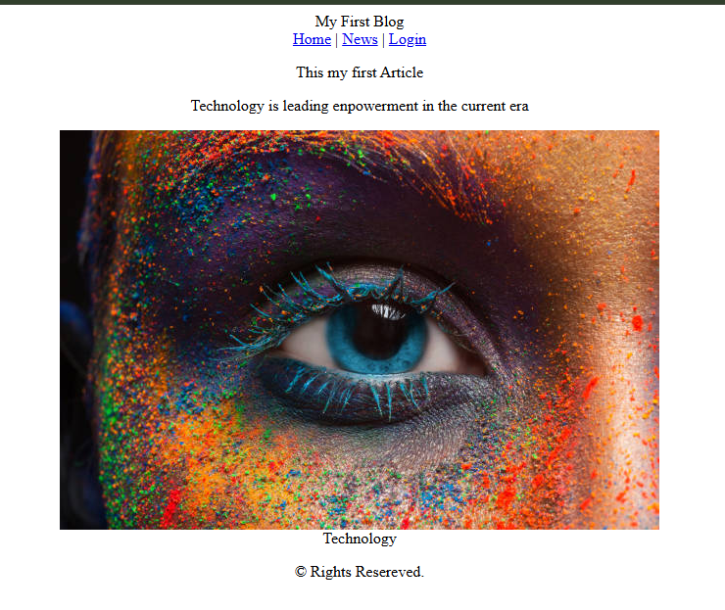 </figure>

</article>

</section>

</div>

</main>

<footer> &copy Rights Resereved. </footer>

</body>

</html>

**b)**

**<!-- Write a program using string object properties and methods -->**

<html>

<body>

<script>

**var text=" JavaScript is Awesome ";**

document.write("Length : " + text.length + "<br>");

document.write("UpperCase : " + text.toUpperCase() + "<br>");

document.write("LowerCase : " + text.toLowerCase() + "<br>");

document.write("Replaced Text : " + text.replace('Awesome','Web development language') + "<br>");

document.write("Trim : " + text.trim() + "<br>");

document.write("Index of 'Script' : " + text.indexOf('Script') + "<br>");

document.write("Char At index 5 : " + text.charAt(5) + "<br>");

document.write("SubString(1,12) : " + text.substring**(1,12)** + "<br>"); /*start and end index*/

**var concat = text.concat('I love it!') ;**

**document.write("Concat : " + concat);**

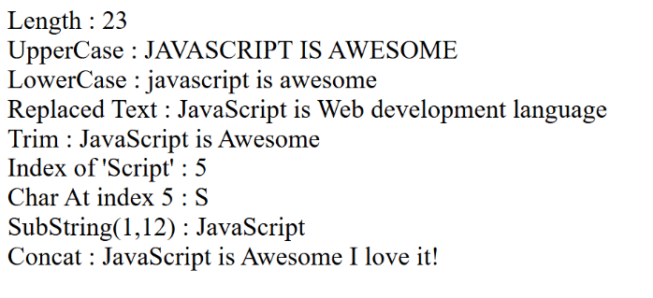

</script>

</body>

</html>

**9)**

**a)**

<!-- Write a program, to explain the importance of CSS Box model using

i. Content ii. Border iii. Margin iv. Padding -->

<html>

<head>

<style>

div{

width: 200px;

height: 200px;

background-color : red;

border : 2px solid black;

margin : 10px;

padding : 50px;

}

</style>

</head>

<body>

<div>This is content.</div>

</body>

</html>

**b)**

**<!-- Write a program to display the denomination of the amount deposited in the bank in terms**

**of 100’s, 50’s, 20’s, 10’s, 5’s, 2’s & 1’s. (Eg: If deposited amount is Rs.163, the output**

**should be 1-100’s, 1-50’s, 1- 10’s, 1-2’s & 1-1’s) -->**

<html>

<body>

<script>

var amount = parseInt(prompt("Enter Amount :"));

var denomination = [100,50,20,10,5,2,1];

var result = "<table border='1'> ";

**for(var denom of denomination)**

{

var temp = Math.floor(amount/denom);

result += "<tr> <td> " + denom + " </td> <td>" + temp + " </td> </tr>";

amount = amount %denom;

}

result += "</table>";

document.write(result);

</script>

</body>

</html>

10)

a) **<!--**

**Write a program to apply different types of selector forms**

**i. Simple selector (element, id, class, group, universal)**

**ii. Pseudo-class selector**

**iii. Pseudo-element selector**

**-->**

<html>

<head>

<style>

*{font-style:italic;}

h3{color:red;}

#para-1{color:blue;}

.para-2{color:green;}

h3,.para-2{text-decoration: underline double;}

a:unvisited{color:blue; }

a:hover{color:green;}

a:active{color:violet;}

a:visited{color:red;}

pre::first-letter{ font-size : 2.5em;}

pre::first-line{font-weight : bold;}

h1::before{content : '❤️';}

h1::after{content : '🥹';}

::selection{background-color:red}

</style>

</head>

<body>

<h3>This is heading</h3>

<p id="para-1">This is para-1</p>

<p class="para-2">This is para-2</p>

<a href="#">Click Me</a>

<h1>Pseudo Element Selector</h1>

<pre>First Line of para. <br> Second Line of para.</pre><br>

</body>

</html>

**b)** **<!-- Write a program using date object properties and methods -->**

<html>

<body>

<script>

var d = new Date();

document.write('Year : ' + d.getFullYear() + "<br>");

**var month = d.getMonth() + 1;**

**document.write('Month : ' + month + "<br>");**

document.write('Date : ' + d.getDate() + "<br>");

document.write('Day : ' + d.getDay() + "<br>");

document.write('Hours : ' + d.getHours() + "<br>");

document.write('Minutes : ' + d.getMinutes() + "<br>");

document.write('Seconds : ' + d.getSeconds() + "<br>");

document.write('MilliSeconds : ' + **d.getMilliseconds()** + "<br>");

</script>

</body>

</html>

**11)**

**a) <!-- Write a HTML program, to explain the working of lists. -->**

<html>

<body>

Branches

<ol>

<li>CSE</li>

<li>CSM</li>

<li>CIC</li>

</ol>

Branches

<ul>

<li>CSE</li>

<li>CSM</li>

<li>CIC</li>

</ul>

Courses

<ol>

<li>B.Tech

<ul>

<li>CSE</li>

<li>CSM</li>

<li>CIC</li>

</ul>

</li>

<li>M.B.A</li>

</ol>

Branches

<dl>

<dt>CSE</dt>

<dd>Computer Science & Engineering</dd>

<dt>IT</dt>

<dd>Information Technology</dd>

</dl>

</body>

</html>

**b)**

**<!-- Write a program to print data in object using for-in, for-each, and for-of loops. -->**

<html>

<body>

<script>

document.write('Using for-in loop' + "<br>");

**var student = {**

**name : 'Adi',**

**regd_no : '23K61A05G5',**

**course : 'B.Tech'**

**};**

for(var key in student)

document.write(key + " : " + student[key] + "<br>");

document.write('Using forEach() loop' + "<br>");

**Object.entries(student).forEach(entry);**

function entry([key,value]){

document.write(key + " : " + value + "<br>");

}

document.write('Using for-of loop' + "<br>");

**for(var value of Object.entries(student))**

document.write(**value[0] + " : " + value[1]** + "<br>");

</script>

</body>

</html>

**12)**

**a)** **<!-- Write a HTML program to explain the working of tables by preparing a time table. -->**

<html>

<body>

<table border="1" style="text-align:center;">

<tr>

<th></th>

<th>9:00-11:00</th>

<th>11:00-12:00</th>

<th>12:00-1:00</th>

<th>1:00-:3:00</th>

<th>3:00-4:00</th>

</tr>

<tr>

<th>Mon</th>

<td>Maths</td>

<td>Physics</td>

**<td rowspan="6">LUNCH</td>**

<td colspan="2">Chemistry</td>

</tr>

<tr>

<th>Tue</th>

<td colspan="2">C</td>

<td>C++</td>

<td>Java</td>

</tr>

<tr>

<th>Wed</th>

<td>Maths</td>

<td>Physics</td>

<td colspan="2">Chemistry</td>

</tr>

<tr>

<th>Thur</th>

<td colspan="2">C</td>

<td>C++</td>

<td>Java</td>

</tr>

<tr>

<th>Fri</th>

<td>Maths</td>

<td>Physics</td>

<td colspan="2">Chemistry</td>

</tr>

<tr>

<th>Sat</th>

<td colspan="2">C</td>

<td>C++</td>

<td>Java</td>

</tr>

</table>

</body>

</html>

**b)** **<!--Write a program to explain different ways for taking input and displaying output. -->**

<html>

<body>

<p id="para-1"></p>

<script>

var name = window.prompt("Enter Your Name : ");

var age = parseInt(prompt("Enter Your Age : "));

var per = parseFloat(prompt("Enter your Per : "));

window.alert('View your Details here');

document.getElementById('para-1').innerHTML = "Your Details are : ";

document.write("Hi ," + name + "<br>");

document.write("Your age is " + age + "<br>");

document.write("You got " + per + "<br>");

console.log('Thank You');

</script>

</body>

</html>

**13)**

**a)** **<!-- Write a HTML program, in such a way that, rather than placing large images on a page, the preferred technique is to use thumbnails by setting the height and width parameters to something like to 100*100 pixels. Each thumbnail image is also a link to a full sized version of the image. Create an image gallery using this technique. -->**

<html>

<body>

<a href="img1.jpg"> <img src="img1.jpg" width="100px" height="100px"></a>

<a href="img2.jpg"> <img src="img2.jpg" width="100px" height="100px"></a>

</body>

</html>

**b) <!-- Write a program using regex and string object properties and methods. -->**

<html>

<body>

<script>

var regex = /hello/ig;

var text = 'Hello Everyone , Hello to World ';

document.write('RegEx Source : ' + regex.source + "<br>");

document.write('RegEx Flags : ' + **regex.flags** + "<br>");

document.write('RegEx Global : ' + **regex.global** + "<br>");

document.write('Does "Hello" Present in the text ? : "' + **regex.test(text)** + "<br>");

var result = regex.exec(text);

document.write('First Match Found at index : ' + **result.index** + "<br>");

document.write('Matched with the content : ' + **result[0]** + "<br>");

var replacedText = text.replace(regex,"Hi");

document.write("Replaced Text : " + replacedText + "<br><br>");

var text=" JavaScript is Awesome ";

document.write("Length : " + text.length + "<br>");

document.write("UpperCase : " + text.toUpperCase() + "<br>");

document.write("LowerCase : " + text.toLowerCase() + "<br>");

document.write("Replaced Text : " + text.replace('Awesome','Web development language') + "<br>");

document.write("Trim : " + text.trim() + "<br>");

document.write("Index of 'Script' : " + text.indexOf('Script') + "<br>");

document.write("Char At index 5 : " + text.charAt(5) + "<br>");

document.write("SubString(2.13) : " + text.substring(1,12) + "<br>"); /*start and end index*/

**var concat = text.concat('I love it!') ;**

**document.write("Concat : " + concat);**

</script>

</body>

</html>

**14)**

**a)** **<!-- Design a appropriate function should be called to display "Factorial of that number"-->**

<html>

<body>

<script>

function factorial(n)

{

if(n==0 || n==1)

return 1;

else

return n*factorial(n-1)

}

var num = parseInt(prompt('Enter a number : '));

document.write('Factorial of ' + num + ' is ' + factorial(num))

</script>

</body>

</html>

**b)** **<!-- Design a appropriate function should be called to display "Fibonacci Series upto that number"-->**

<html>

<body>

<script>

function fibonacci(n)

{

var a=0,b=1,c=0;

document.write('Fibonacci Series upto ' + n + ' is ');

document.write(a + " " + b);

c=a+b;

while(c<=n)

{

document.write(" "+ c);

a=b;

b=c;

c=a+b;

}

}

var num = parseInt(prompt('Enter a number : '));

fibonacci(num);

</script>

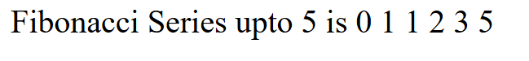</body>

</html>