**1. Introduction and Background**

a. Introduce yourself and explain the purpose of the interview - How art can be combined with charity and the impact it brings.

I am Zhang Zheng, an artist. I graduated from Central Academy of Fine Arts with a major in Sculpture.

b. Explain your interest in art and charity, and why you believe that combining the two can have a positive impact on society. (For example: By combining art and charity, a powerful synergy is created. Art possesses unique abilities and influence to inspire, evoke empathy, and spark discussions, thereby generating broader attention and support for charitable causes. Art can break through societal indifference and apathy by providing aesthetic experiences and emotional resonance, enabling deeper understanding and concern for social issues. Additionally, art can offer creative and innovative solutions for charitable organizations and projects, using artistic forms and mediums to disseminate information, change attitudes, and behaviors.)

Compared with other public media, art is a channel with a more unique personal tone. It facilitates a distinctive way of expressing an artist’s own understanding of this world through visual means. The combination between art and public welfare carries artists’ willingness to raise awareness for social and societal issues through their unique artistic style and creative perspective. Artists transmit information, arouse empathy through their work, and encourage people to participate in the action of solving these problems. Public welfare also includes organizing art exhibits, cultural activities, and public art programs to facilitate the process of community cohesion, cultural heritage, and social participation.

Personally speaking, being able to combine art and charity highlights the social responsibility of artists themselves, allowing the power of art to induce positive impact and renovation.

**2．Artists’ Charity Experience**

a. Can you share examples of some charity programs or organizations that you have personally participated? And can you provide some background information?

In 2022, I did a project at an abandoned old state-owned ceramics factory in Jingdezhen. Using disposed materials, I created a large public sculpture space, hoping to modify local ruins space with my personal artistic language while directing the attention of more audience to the remains of the past eras.

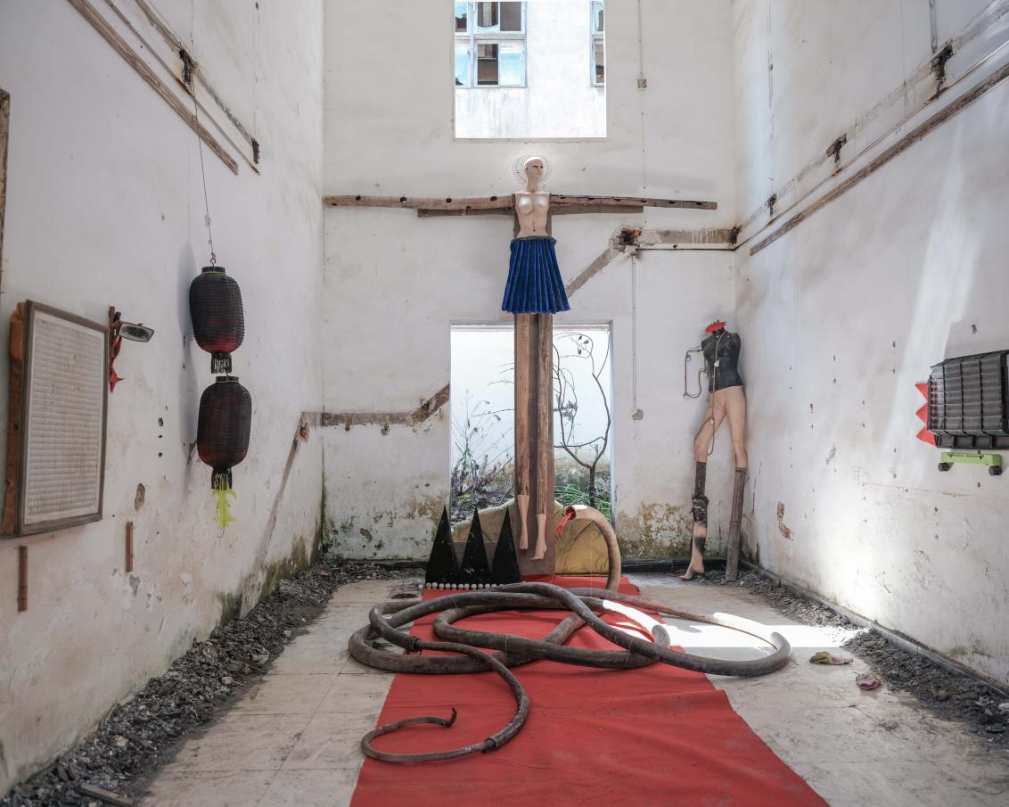《废墟纪念堂》2022年 江西景德镇 中国

Ruins Memorial, 2022, Jingdezhen, Jiangxi, China

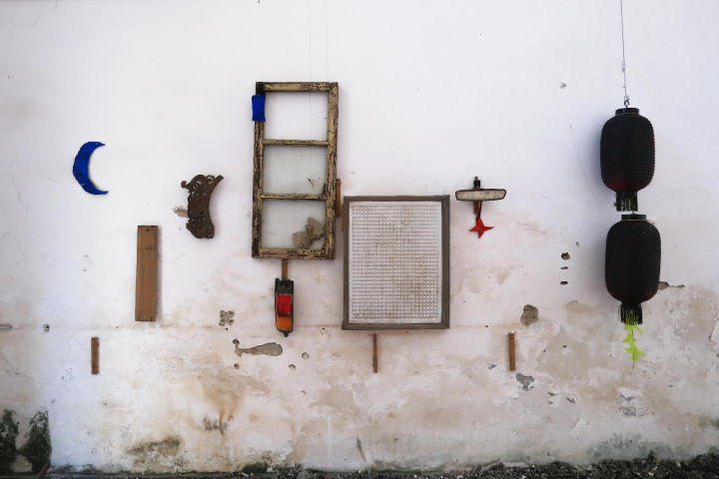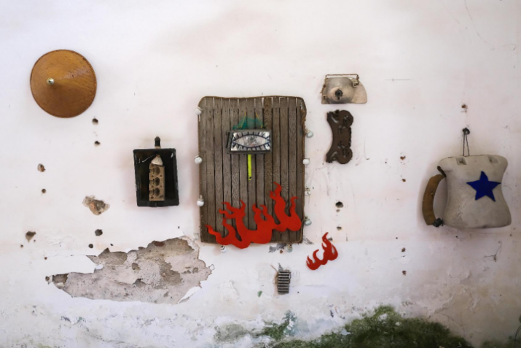

《废墟纪念堂》2022 左墙局部

Ruins Memorial, 2022, part of the right side of the wall

Ruins Memorial, 2022, part of the right side of the wall

《废墟纪念堂》2022 右墙局部

Ruins Memorial, 2022, part of the right side of the wall

Beside myself, friends and local art fans also participated in the transformation process of the ruins.

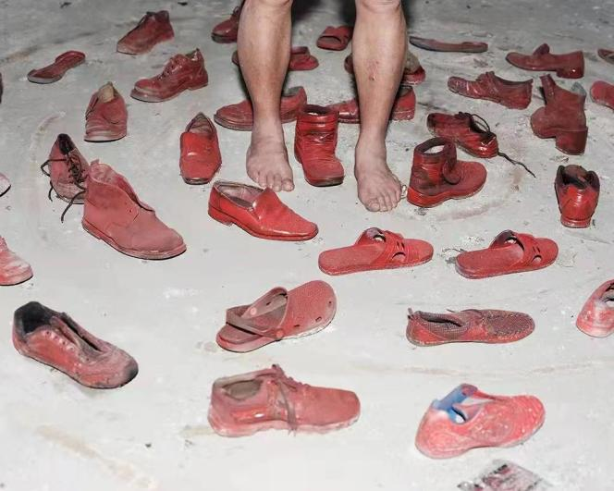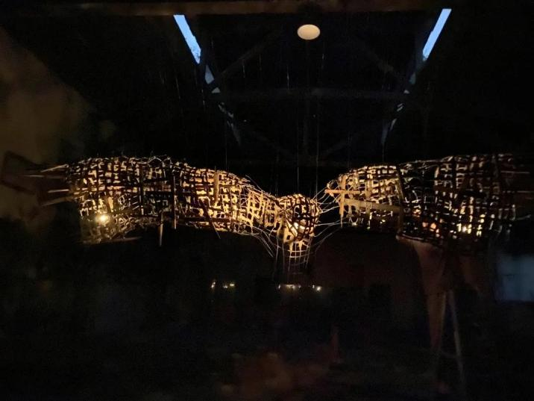 （Works of Other Artists）

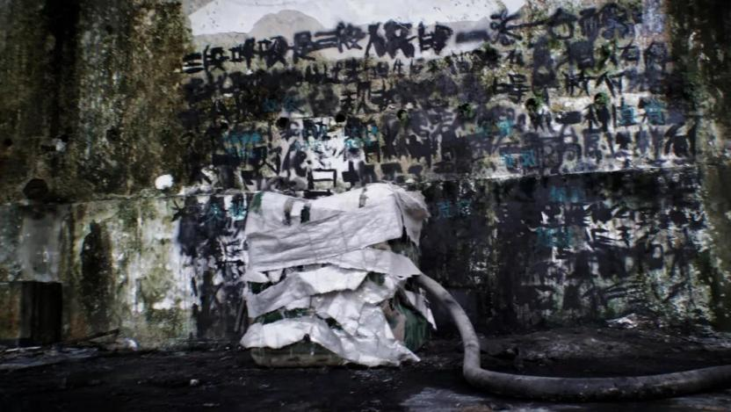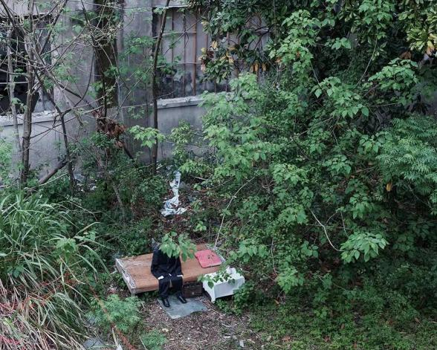

（Works of Other Artists）

b. What promoted your engagement in charity work? Why did you decide to pursue the combination of art and charity?

As an artist, I believe that a sense of social responsibility should be added to the process of creating art. These products could better socialize with the general public in public spaces. Traditionally speaking, the arts are mostly presented at galleries and museums for people to appreciate. However, modern art increasingly strengthens the concept of bringing art into public space and people’s daily lives. Charity plays an important role in this case. The combination of charity and art is not only a personal expression but also an interactive medium with society. This form could largely inspire people to think, create, and contribute to social development.

I personally hope that I can introduce my art works into public spaces, share them with more people, and encourage conversational interactions. My efforts will contribute to accelerating and generalizing art education, social participation, and art’s positive impacts in society.

c. What is the goal and motivation for your participation in charity work? Through art, what kind of changes do you hope to bring to the local community or specific groups?

After seeing traces of the past eras there, I was truly inspired to do something to express my then-feelings. The place that hosted all these relics was an enormous industrial park.The factories there were Soviet-style, left over from the last century. As the renovations of the government-owned enterprises continued, old, nationally owned ceramics factories were gradually eliminated because of their poor earnings and lack of modern elements. Workers were laid off. Even today, some still live in abandoned buildings without water or electricity. However, they stayed strong. They grew their own vegetables, used public toilets for water, and used hidden places for urination and defecation. Yet, on the other side of the wall was the most popular place in Jingde Zhen, Letian Market, where ceramic artists worldwide sell their products. This contrast truly aligns with those anti-Utopian scenes in scientific fiction.

废墟内的一些场景 废墟“钉子户”们 一墙之隔的乐天市集

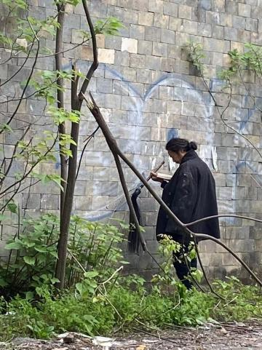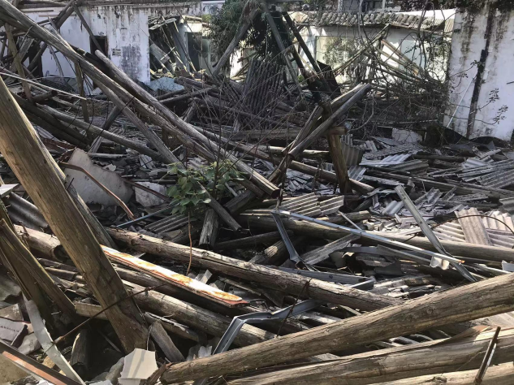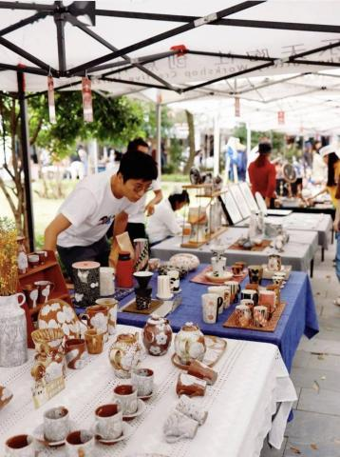Scenes at the Relics | Residents at the Relics | Letian Market

Among these old buildings, there are some scenes of disharmony, such as several brand new buildings developed by commercial real estate owners to be the new commercial district. Due to a lack of funding, these programs were halted. Therefore, these demolished office buildings become the relics among the relics. When people walk into these new buildings, they feel the huge contract between the tall space, transparent windows, clean walls, and the sunlight coming in from the old buildings. This feeling is like coming into a place of order from the wild chaos. I therefore suddenly had the idea of creating a space among these relics—a newborn above the corpse in ruins. It is like a museum that collects relics and traces of the past, a “memorial” to document the trails of this era.

Through the artistic renovation with the purpose of charity, local teenagers do not just consume at the market but feel the power of time while walking in these relics. The difference between the two sides of the wall will lead to people’s thoughts on ears and time.

**3. The Integration of Art and Charity**

a. How have you integrated your art with charitable goals?

First of all, it’s important to define your goal, which for me is to realize charity’s purpose through art. Second of all, I consider my own thoughts and analysis of social problems. Lastly, I think about how to tell a good story through my artistic language. In the process of merging artistic form and social questions, artists need to dispose of external, complicated elements, taking advantage of “subtractions” to form a clear artistic logic to obtain a succinct and easily comprehensible presentation.

b. What type of artistic form and medium did you use in your charity program? Why did you choose such formats?

In this program, I utilized the form of installation sculpture for existing goods. This format fits very well with the topic of my art, as it takes relics to rebuild space. Sculpture, with its materiality and powerful scene feeling, is a great artistic form to produce field association with relics, producing the effect of “one plus one is more than two”, strengthening the audience’s artistic experience on site. Meanwhile, it persists like a monument and becomes a symbolic existence in the local space.

c. While doing charity, what kind of challenges do you face? How did you overcome them?

Funding was the biggest challenge. I needed to obtain help from various parties. Meanwhile, my creation process sometimes led to conflicts with local homeless people. Therefore, I had to imitate Italy’s arte povera by choosing relatively worthless materials or cheap materials to complete my creation, which put a lot of limitations on my art. Of course, it was a challenge for my personal capabilities, urging my team to think about how to deliver the most accurate expressions within a certain constraint.

1. **Impact of Public Art**

a. What achievements and impacts have you made in your charitable projects?

This program was publicized on media platforms like Tiktok and Little Red Book, successfully attracting many teenagers to visit the artistic relics, take pictures there, and follow up with secondary creations. Later, art lovers started hosting other activities at this special place, which has gradually evolved into a wild art creation space different from the traditionally white-box gallery or regular galleries. It provides a ton of new opportunities for art practitioners to create and express themselves.

b. Can you share some unforgettable public art stories or experiences? How does art change people’s lives or communities?

During my creation process, the residents of the old buildings later joined us in our creation and living. They shared with us their own stories and started their own creations, which also changed their old lives by bringing new elements into their lives.

**5. Inspirations for Teenagers**

a. What kind of advice do you have for teenagers to encourage them to pursue public art?

First of all, it’s important to inspire children and teenagers’ interest in social issues and guide them to research and understand different social topics. Through this form of art, we could encourage them to deepen their exploration of social issues, think about how to transfer information, and build empathy through artistic creations. Meanwhile, I would encourage society to provide more opportunities for teenagers to participate in community services, such as organizing art-related community activities and programs, so that children could participate themselves. For example, we could collaborate with non-profit organizations to make art works for the local community or lead teenagers to participate in behavioral art shows. These experiences and participation will successfully inspire children’s social responsibility and sense of charity. In this process, artistic guidance and mentorship should be provided by roles like successful artists, social activists, or experts in the realm of public welfare. These types of guidance and inspirations will help them understand public art better while encouraging their creative power and social impacts. Lastly, public art communities and social networks should be created to provide a place for more people to share and exchange experiences. A community like this can provide support, inspiration, and collaboration, allowing children to make connections with each other and make an impact through the process of connecting with public welfare.

b. How do you think young people can participate in charitable activities through different art forms? What avenues and approaches are available?

One good project is to make changes to their own living environment and community because children grow there as a part of their communities. They think and feel, and they can better put their observations into lively and emotional artistic creations.

c. What kind of personal growth and inspiration do you believe young people can gain from art and charity?

Public art activities are meaningful to children and teenagers. They can not only culture their creativity but also encourage their unique thoughts, opinions, and creativity, urging them to seek unique ways to solve problems. Besides, through participating in public art, they could realize the existence of various social issues and think about the change and impacts brought by art, as well as grow their social responsibility and sense of citizenship. Through public art, teenagers could more deeply understand different cultures and social topics. Art can also help teenagers explore their unique cultural identities and have conversations with people from other cultures. Public art gives them opportunities to be exposed to social groups and problems, increasing their understandings of social diversity and justice. These experiences are definitely inspiring and impactful on the long-term maturity of children and teenagers.

**Suggest deletion:**

**6. Conclusion**

a. Summarize the key points of the interview and express gratitude for the interviewee's time and insights.

b. If there are further questions, kindly leave contact information for future communication.