**BOOTSTRAP**

* box-sizing

* {  
 *box-sizing*: **border-box**;  
}

html font-size font-family text-size-adjust

html {  
 *font-size*: 10**px**;

*font-family*: **sans-serif**;  
 ***text-size-adjust*: 100%;**  
}

body margin font-size font-family line-height color background-color

margin继承性：no

body {

*margin*: 0;

*font-size*: 14**px**;  
 *font-family*: "Helvetica Neue", Helvetica, Arial, **sans-serif**;  
 *line-height*: 1.42857143;  
 *color*: #333;  
 *background-color*: #fff;  
}

.container {

*margin*: 0 **auto**;  
 *padding*: 0 15**px**;  
}  
@media (*min-width*: 768**px**) {  
 .container {  
 *width*: 750**px**;  
 }  
}  
@media (*min-width*: 992**px**) {  
 .container {  
 *width*: 970**px**;  
 }  
}  
@media (*min-width*: 1200**px**) {  
 .container {  
 *width*: 1170**px**;  
 }  
}

.container:before,  
.container:after {  
 *display*: **table**;  
 *content*: "";  
}

.container:after {  
 *clear*: **both**;  
}

.container-fluid {

*margin*: 0 **auto**;  
 *padding*: 0 15**px**;  
}

.container-fluid:before,  
.container-fluid:after {  
 *display*: **table**;  
 *content*: "";  
}

.container-fluid:after {  
 *clear*: **both**;  
}

.row {  
 *margin*: 0 -15**px**;  
}

.row:before,  
.row:after, {  
 *display*: **table**;  
 *content*: " ";  
}

.row:after {  
 *clear*: **both**;  
}

.col-xs-1, .col-sm-1, .col-md-1, .col-lg-1, .col-xs-2, .col-sm-2, .col-md-2, .col-lg-2, .col-xs-3, .col-sm-3, .col-md-3, .col-lg-3, .col-xs-4, .col-sm-4, .col-md-4, .col-lg-4, .col-xs-5, .col-sm-5, .col-md-5, .col-lg-5, .col-xs-6, .col-sm-6, .col-md-6, .col-lg-6, .col-xs-7, .col-sm-7, .col-md-7, .col-lg-7, .col-xs-8, .col-sm-8, .col-md-8, .col-lg-8, .col-xs-9, .col-sm-9, .col-md-9, .col-lg-9, .col-xs-10, .col-sm-10, .col-md-10, .col-lg-10, .col-xs-11, .col-sm-11, .col-md-11, .col-lg-11, .col-xs-12, .col-sm-12, .col-md-12, .col-lg-12 {  
 *position*: **relative**;  
 *min-height*: 1**px**;  
 *padding*: 0 15**px**;  
}  
.col-xs-1, .col-xs-2, .col-xs-3, .col-xs-4, .col-xs-5, .col-xs-6, .col-xs-7, .col-xs-8, .col-xs-9, .col-xs-10, .col-xs-11, .col-xs-12 {  
 *float*: **left**;  
}  
.col-xs-12 {  
 *width*: 100%;  
}  
.col-xs-11 {  
 *width*: 91.66666667%;  
}  
.col-xs-10 {  
 *width*: 83.33333333%;  
}  
.col-xs-9 {  
 *width*: 75%;  
}  
.col-xs-8 {  
 *width*: 66.66666667%;  
}  
.col-xs-7 {  
 *width*: 58.33333333%;  
}  
.col-xs-6 {  
 *width*: 50%;  
}  
.col-xs-5 {  
 *width*: 41.66666667%;  
}  
.col-xs-4 {  
 *width*: 33.33333333%;  
}  
.col-xs-3 {  
 *width*: 25%;  
}  
.col-xs-2 {  
 *width*: 16.66666667%;  
}  
.col-xs-1 {  
 *width*: 8.33333333%;  
}  
.col-xs-pull-12 {  
 *right*: 100%;  
}  
.col-xs-pull-11 {  
 *right*: 91.66666667%;  
}  
.col-xs-pull-10 {  
 *right*: 83.33333333%;  
}  
.col-xs-pull-9 {  
 *right*: 75%;  
}  
.col-xs-pull-8 {  
 *right*: 66.66666667%;  
}  
.col-xs-pull-7 {  
 *right*: 58.33333333%;  
}  
.col-xs-pull-6 {  
 *right*: 50%;  
}  
.col-xs-pull-5 {  
 *right*: 41.66666667%;  
}  
.col-xs-pull-4 {  
 *right*: 33.33333333%;  
}  
.col-xs-pull-3 {  
 *right*: 25%;  
}  
.col-xs-pull-2 {  
 *right*: 16.66666667%;  
}  
.col-xs-pull-1 {  
 *right*: 8.33333333%;  
}  
.col-xs-pull-0 {  
 *right*: **auto**;  
}  
.col-xs-push-12 {  
 *left*: 100%;  
}  
.col-xs-push-11 {  
 *left*: 91.66666667%;  
}  
.col-xs-push-10 {  
 *left*: 83.33333333%;  
}  
.col-xs-push-9 {  
 *left*: 75%;  
}  
.col-xs-push-8 {  
 *left*: 66.66666667%;  
}  
.col-xs-push-7 {  
 *left*: 58.33333333%;  
}  
.col-xs-push-6 {  
 *left*: 50%;  
}  
.col-xs-push-5 {  
 *left*: 41.66666667%;  
}  
.col-xs-push-4 {  
 *left*: 33.33333333%;  
}  
.col-xs-push-3 {  
 *left*: 25%;  
}  
.col-xs-push-2 {  
 *left*: 16.66666667%;  
}  
.col-xs-push-1 {  
 *left*: 8.33333333%;  
}  
.col-xs-push-0 {  
 *left*: **auto**;  
}  
.col-xs-offset-12 {  
 *margin-left*: 100%;  
}  
.col-xs-offset-11 {  
 *margin-left*: 91.66666667%;  
}  
.col-xs-offset-10 {  
 *margin-left*: 83.33333333%;  
}  
.col-xs-offset-9 {  
 *margin-left*: 75%;  
}  
.col-xs-offset-8 {  
 *margin-left*: 66.66666667%;  
}  
.col-xs-offset-7 {  
 *margin-left*: 58.33333333%;  
}  
.col-xs-offset-6 {  
 *margin-left*: 50%;  
}  
.col-xs-offset-5 {  
 *margin-left*: 41.66666667%;  
}  
.col-xs-offset-4 {  
 *margin-left*: 33.33333333%;  
}  
.col-xs-offset-3 {  
 *margin-left*: 25%;  
}  
.col-xs-offset-2 {  
 *margin-left*: 16.66666667%;  
}  
.col-xs-offset-1 {  
 *margin-left*: 8.33333333%;  
}  
.col-xs-offset-0 {  
 *margin-left*: 0;  
}  
@media (*min-width*: 768**px**) {  
 .col-sm-1, .col-sm-2, .col-sm-3, .col-sm-4, .col-sm-5, .col-sm-6, .col-sm-7, .col-sm-8, .col-sm-9, .col-sm-10, .col-sm-11, .col-sm-12 {  
 *float*: **left**;  
 }  
 .col-sm-12 {  
 *width*: 100%;  
 }  
 .col-sm-11 {  
 *width*: 91.66666667%;  
 }  
 .col-sm-10 {  
 *width*: 83.33333333%;  
 }  
 .col-sm-9 {  
 *width*: 75%;  
 }  
 .col-sm-8 {  
 *width*: 66.66666667%;  
 }  
 .col-sm-7 {  
 *width*: 58.33333333%;  
 }  
 .col-sm-6 {  
 *width*: 50%;  
 }  
 .col-sm-5 {  
 *width*: 41.66666667%;  
 }  
 .col-sm-4 {  
 *width*: 33.33333333%;  
 }  
 .col-sm-3 {  
 *width*: 25%;  
 }  
 .col-sm-2 {  
 *width*: 16.66666667%;  
 }  
 .col-sm-1 {  
 *width*: 8.33333333%;  
 }  
 .col-sm-pull-12 {  
 *right*: 100%;  
 }  
 .col-sm-pull-11 {  
 *right*: 91.66666667%;  
 }  
 .col-sm-pull-10 {  
 *right*: 83.33333333%;  
 }  
 .col-sm-pull-9 {  
 *right*: 75%;  
 }  
 .col-sm-pull-8 {  
 *right*: 66.66666667%;  
 }  
 .col-sm-pull-7 {  
 *right*: 58.33333333%;  
 }  
 .col-sm-pull-6 {  
 *right*: 50%;  
 }  
 .col-sm-pull-5 {  
 *right*: 41.66666667%;  
 }  
 .col-sm-pull-4 {  
 *right*: 33.33333333%;  
 }  
 .col-sm-pull-3 {  
 *right*: 25%;  
 }  
 .col-sm-pull-2 {  
 *right*: 16.66666667%;  
 }  
 .col-sm-pull-1 {  
 *right*: 8.33333333%;  
 }  
 .col-sm-pull-0 {  
 *right*: **auto**;  
 }  
 .col-sm-push-12 {  
 *left*: 100%;  
 }  
 .col-sm-push-11 {  
 *left*: 91.66666667%;  
 }  
 .col-sm-push-10 {  
 *left*: 83.33333333%;  
 }  
 .col-sm-push-9 {  
 *left*: 75%;  
 }  
 .col-sm-push-8 {  
 *left*: 66.66666667%;  
 }  
 .col-sm-push-7 {  
 *left*: 58.33333333%;  
 }  
 .col-sm-push-6 {  
 *left*: 50%;  
 }  
 .col-sm-push-5 {  
 *left*: 41.66666667%;  
 }  
 .col-sm-push-4 {  
 *left*: 33.33333333%;  
 }  
 .col-sm-push-3 {  
 *left*: 25%;  
 }  
 .col-sm-push-2 {  
 *left*: 16.66666667%;  
 }  
 .col-sm-push-1 {  
 *left*: 8.33333333%;  
 }  
 .col-sm-push-0 {  
 *left*: **auto**;  
 }  
 .col-sm-offset-12 {  
 *margin-left*: 100%;  
 }  
 .col-sm-offset-11 {  
 *margin-left*: 91.66666667%;  
 }  
 .col-sm-offset-10 {  
 *margin-left*: 83.33333333%;  
 }  
 .col-sm-offset-9 {  
 *margin-left*: 75%;  
 }  
 .col-sm-offset-8 {  
 *margin-left*: 66.66666667%;  
 }  
 .col-sm-offset-7 {  
 *margin-left*: 58.33333333%;  
 }  
 .col-sm-offset-6 {  
 *margin-left*: 50%;  
 }  
 .col-sm-offset-5 {  
 *margin-left*: 41.66666667%;  
 }  
 .col-sm-offset-4 {  
 *margin-left*: 33.33333333%;  
 }  
 .col-sm-offset-3 {  
 *margin-left*: 25%;  
 }  
 .col-sm-offset-2 {  
 *margin-left*: 16.66666667%;  
 }  
 .col-sm-offset-1 {  
 *margin-left*: 8.33333333%;  
 }  
 .col-sm-offset-0 {  
 *margin-left*: 0;  
 }  
}  
@media (*min-width*: 992**px**) {  
 .col-md-1, .col-md-2, .col-md-3, .col-md-4, .col-md-5, .col-md-6, .col-md-7, .col-md-8, .col-md-9, .col-md-10, .col-md-11, .col-md-12 {  
 *float*: **left**;  
 }  
 .col-md-12 {  
 *width*: 100%;  
 }  
 .col-md-11 {  
 *width*: 91.66666667%;  
 }  
 .col-md-10 {  
 *width*: 83.33333333%;  
 }  
 .col-md-9 {  
 *width*: 75%;  
 }  
 .col-md-8 {  
 *width*: 66.66666667%;  
 }  
 .col-md-7 {  
 *width*: 58.33333333%;  
 }  
 .col-md-6 {  
 *width*: 50%;  
 }  
 .col-md-5 {  
 *width*: 41.66666667%;  
 }  
 .col-md-4 {  
 *width*: 33.33333333%;  
 }  
 .col-md-3 {  
 *width*: 25%;  
 }  
 .col-md-2 {  
 *width*: 16.66666667%;  
 }  
 .col-md-1 {  
 *width*: 8.33333333%;  
 }  
 .col-md-pull-12 {  
 *right*: 100%;  
 }  
 .col-md-pull-11 {  
 *right*: 91.66666667%;  
 }  
 .col-md-pull-10 {  
 *right*: 83.33333333%;  
 }  
 .col-md-pull-9 {  
 *right*: 75%;  
 }  
 .col-md-pull-8 {  
 *right*: 66.66666667%;  
 }  
 .col-md-pull-7 {  
 *right*: 58.33333333%;  
 }  
 .col-md-pull-6 {  
 *right*: 50%;  
 }  
 .col-md-pull-5 {  
 *right*: 41.66666667%;  
 }  
 .col-md-pull-4 {  
 *right*: 33.33333333%;  
 }  
 .col-md-pull-3 {  
 *right*: 25%;  
 }  
 .col-md-pull-2 {  
 *right*: 16.66666667%;  
 }  
 .col-md-pull-1 {  
 *right*: 8.33333333%;  
 }  
 .col-md-pull-0 {  
 *right*: **auto**;  
 }  
 .col-md-push-12 {  
 *left*: 100%;  
 }  
 .col-md-push-11 {  
 *left*: 91.66666667%;  
 }  
 .col-md-push-10 {  
 *left*: 83.33333333%;  
 }  
 .col-md-push-9 {  
 *left*: 75%;  
 }  
 .col-md-push-8 {  
 *left*: 66.66666667%;  
 }  
 .col-md-push-7 {  
 *left*: 58.33333333%;  
 }  
 .col-md-push-6 {  
 *left*: 50%;  
 }  
 .col-md-push-5 {  
 *left*: 41.66666667%;  
 }  
 .col-md-push-4 {  
 *left*: 33.33333333%;  
 }  
 .col-md-push-3 {  
 *left*: 25%;  
 }  
 .col-md-push-2 {  
 *left*: 16.66666667%;  
 }  
 .col-md-push-1 {  
 *left*: 8.33333333%;  
 }  
 .col-md-push-0 {  
 *left*: **auto**;  
 }  
 .col-md-offset-12 {  
 *margin-left*: 100%;  
 }  
 .col-md-offset-11 {  
 *margin-left*: 91.66666667%;  
 }  
 .col-md-offset-10 {  
 *margin-left*: 83.33333333%;  
 }  
 .col-md-offset-9 {  
 *margin-left*: 75%;  
 }  
 .col-md-offset-8 {  
 *margin-left*: 66.66666667%;  
 }  
 .col-md-offset-7 {  
 *margin-left*: 58.33333333%;  
 }  
 .col-md-offset-6 {  
 *margin-left*: 50%;  
 }  
 .col-md-offset-5 {  
 *margin-left*: 41.66666667%;  
 }  
 .col-md-offset-4 {  
 *margin-left*: 33.33333333%;  
 }  
 .col-md-offset-3 {  
 *margin-left*: 25%;  
 }  
 .col-md-offset-2 {  
 *margin-left*: 16.66666667%;  
 }  
 .col-md-offset-1 {  
 *margin-left*: 8.33333333%;  
 }  
 .col-md-offset-0 {  
 *margin-left*: 0;  
 }  
}  
@media (*min-width*: 1200**px**) {  
 .col-lg-1, .col-lg-2, .col-lg-3, .col-lg-4, .col-lg-5, .col-lg-6, .col-lg-7, .col-lg-8, .col-lg-9, .col-lg-10, .col-lg-11, .col-lg-12 {  
 *float*: **left**;  
 }  
 .col-lg-12 {  
 *width*: 100%;  
 }  
 .col-lg-11 {  
 *width*: 91.66666667%;  
 }  
 .col-lg-10 {  
 *width*: 83.33333333%;  
 }  
 .col-lg-9 {  
 *width*: 75%;  
 }  
 .col-lg-8 {  
 *width*: 66.66666667%;  
 }  
 .col-lg-7 {  
 *width*: 58.33333333%;  
 }  
 .col-lg-6 {  
 *width*: 50%;  
 }  
 .col-lg-5 {  
 *width*: 41.66666667%;  
 }  
 .col-lg-4 {  
 *width*: 33.33333333%;  
 }  
 .col-lg-3 {  
 *width*: 25%;  
 }  
 .col-lg-2 {  
 *width*: 16.66666667%;  
 }  
 .col-lg-1 {  
 *width*: 8.33333333%;  
 }  
 .col-lg-pull-12 {  
 *right*: 100%;  
 }  
 .col-lg-pull-11 {  
 *right*: 91.66666667%;  
 }  
 .col-lg-pull-10 {  
 *right*: 83.33333333%;  
 }  
 .col-lg-pull-9 {  
 *right*: 75%;  
 }  
 .col-lg-pull-8 {  
 *right*: 66.66666667%;  
 }  
 .col-lg-pull-7 {  
 *right*: 58.33333333%;  
 }  
 .col-lg-pull-6 {  
 *right*: 50%;  
 }  
 .col-lg-pull-5 {  
 *right*: 41.66666667%;  
 }  
 .col-lg-pull-4 {  
 *right*: 33.33333333%;  
 }  
 .col-lg-pull-3 {  
 *right*: 25%;  
 }  
 .col-lg-pull-2 {  
 *right*: 16.66666667%;  
 }  
 .col-lg-pull-1 {  
 *right*: 8.33333333%;  
 }  
 .col-lg-pull-0 {  
 *right*: **auto**;  
 }  
 .col-lg-push-12 {  
 *left*: 100%;  
 }  
 .col-lg-push-11 {  
 *left*: 91.66666667%;  
 }  
 .col-lg-push-10 {  
 *left*: 83.33333333%;  
 }  
 .col-lg-push-9 {  
 *left*: 75%;  
 }  
 .col-lg-push-8 {  
 *left*: 66.66666667%;  
 }  
 .col-lg-push-7 {  
 *left*: 58.33333333%;  
 }  
 .col-lg-push-6 {  
 *left*: 50%;  
 }  
 .col-lg-push-5 {  
 *left*: 41.66666667%;  
 }  
 .col-lg-push-4 {  
 *left*: 33.33333333%;  
 }  
 .col-lg-push-3 {  
 *left*: 25%;  
 }  
 .col-lg-push-2 {  
 *left*: 16.66666667%;  
 }  
 .col-lg-push-1 {  
 *left*: 8.33333333%;  
 }  
 .col-lg-push-0 {  
 *left*: **auto**;  
 }  
 .col-lg-offset-12 {  
 *margin-left*: 100%;  
 }  
 .col-lg-offset-11 {  
 *margin-left*: 91.66666667%;  
 }  
 .col-lg-offset-10 {  
 *margin-left*: 83.33333333%;  
 }  
 .col-lg-offset-9 {  
 *margin-left*: 75%;  
 }  
 .col-lg-offset-8 {  
 *margin-left*: 66.66666667%;  
 }  
 .col-lg-offset-7 {  
 *margin-left*: 58.33333333%;  
 }  
 .col-lg-offset-6 {  
 *margin-left*: 50%;  
 }  
 .col-lg-offset-5 {  
 *margin-left*: 41.66666667%;  
 }  
 .col-lg-offset-4 {  
 *margin-left*: 33.33333333%;  
 }  
 .col-lg-offset-3 {  
 *margin-left*: 25%;  
 }  
 .col-lg-offset-2 {  
 *margin-left*: 16.66666667%;  
 }  
 .col-lg-offset-1 {  
 *margin-left*: 8.33333333%;  
 }  
 .col-lg-offset-0 {  
 *margin-left*: 0;  
 }  
}

.hidden {  
 *display*: **none** !important;  
}

@media (*max-width*: 767**px**) {  
 .hidden-xs {  
 *display*: **none** !important;  
 }  
}  
@media (*min-width*: 768**px**) and (*max-width*: 991**px**) {  
 .hidden-sm {  
 *display*: **none** !important;  
 }  
}  
@media (*min-width*: 992**px**) and (*max-width*: 1199**px**) {  
 .hidden-md {  
 *display*: **none** !important;  
 }  
}  
@media (*min-width*: 1200**px**) {  
 .hidden-lg {  
 *display*: **none** !important;  
 }

p margin

p {  
 *margin*: 0 0 10**px** 0;  
}

a color text-decoration

a {  
 *color*: #337ab7;  
 *text-decoration*: **none**;  
}

ul,ol margin

ul,  
ol {  
 *margin*: 0 0 10**px** 0;  
}

img border max-width vertical-align

img {  
 *border*: 0;

*max-width*: 100% !important;

*vertical-align*: **middle**;  
}

table border-collapse border-spacing

table {

*border-collapse*: **collapse**;  
 *border-spacing*: 0;  
}

h1 font-size margin

h1 {  
 *font-size*: 36**px**;

*margin*: 20**px** 0 10**px** 0;  
}

h2 font-size margin

h2 {  
 *font-size*: 30**px**;

*margin*: 20**px** 0 10**px** 0;  
}

h3 font-size margin

h3 {  
 *font-size*: 24**px**;

*margin*: 20**px** 0 10**px** 0;  
}

h4 font-size margin

h4 {  
 *font-size*: 18**px**;

*margin*: 10**px** 0 10**px** 0;  
}

h5 font-size margin

h5 {  
 *font-size*: 14**px**;

*margin*: 10**px** 0 10**px** 0;  
}

h6 font-size margin

h6 {  
 *font-size*: 12**px**;

*margin*: 10**px** 0 10**px** 0;  
}

.btn display padding text-align vertical-align cursor border border-radius

.btn {  
 *display*: **inline-block**;

*padding*: 6**px** 12**px**;  
 *text-align*: **center**;  
 *vertical-align*: **middle**;  
 *cursor*: **pointer**;  
 *border*: 1**px solid transparent**;  
 *border-radius*: 4**px**;  
}

白底灰字

.btn-default {  
 *color*: #333;  
 *background-color*: #fff;  
 *border-color*: #ccc;  
}

红底白字

.btn-danger {  
 *color*: #fff;  
 *background-color*: #d9534f;  
 *border-color*: #d43f3a;  
}

黄底白字

.btn-warning {  
 *color*: #fff;  
 *background-color*: #f0ad4e;  
 *border-color*: #eea236;  
}

绿底白字

.btn-success {  
 *color*: #fff;  
 *background-color*: #5cb85c;  
 *border-color*: #4cae4c;  
}

浅蓝底白字

.btn-info {  
 *color*: #fff;  
 *background-color*: #5bc0de;  
 *border-color*: #46b8da;  
}

深蓝底白字

.btn-primary {  
 *color*: #fff;  
 *background-color*: #337ab7;  
 *border-color*: #2e6da4;  
}

.btn-lg,  
.btn-group-lg > .btn {  
 *padding*: 10**px** 16**px**;  
 *font-size*: 18**px**;  
 *line-height*: 1.3333333;  
 *border-radius*: 6**px**;  
}  
.btn-sm,  
.btn-group-sm > .btn {  
 *padding*: 5**px** 10**px**;  
 *font-size*: 12**px**;  
 *line-height*: 1.5;  
 *border-radius*: 3**px**;  
}  
.btn-xs,  
.btn-group-xs > .btn {  
 *padding*: 1**px** 5**px**;  
 *font-size*: 12**px**;  
 *line-height*: 1.5;  
 *border-radius*: 3**px**;  
}  
.btn-block {  
 *display*: **block**;  
 *width*: 100%;  
}  
.btn-block + .btn-block {  
 *margin-top*: 5**px**;  
}

.img-rounded {  
 *border-radius*: 6**px**;  
}  
.img-thumbnail {  
 *display*: **inline-block**;  
 *max-width*: 100%;  
 *padding*: 4**px**;  
 *border*: 1**px solid** #ddd;  
 *border-radius*: 4**px**;  
 *transition*: **all** .2**s ease-in-out**;  
}  
.img-circle {  
 *border-radius*: 50%;  
}

.img-responsive {  
 *display*: **block**;  
 *max-width*: 100%;  
 *height*: **auto**;  
}

.list-unstyled {  
 *padding-left*: 0;  
 *list-style*: **none**;  
}  
.list-inline {  
 *padding-left*: 0;  
 *list-style*: **none**;

*margin-left*: -5**px**;  
}  
.list-inline > li {  
 *display*: **inline-block**;  
 *padding*: 0 5**px**;  
}

.text-danger {  
 *color*: #a94442;  
}

.text-warning {  
 *color*: #8a6d3b;  
}

.text-success {  
 *color*: #3c763d;  
}

.text-info {  
 *color*: #31708f;  
}

.text-primary {  
 *color*: #337ab7;  
}

.text-muted {  
 color: #777;  
}

.bg-danger {  
 *background-color*: #f2dede;  
}

.bg-warning {  
 *background-color*: #fcf8e3;  
}

.bg-success {  
 *background-color*: #dff0d8;  
}

.bg-info {  
 *background-color*: #d9edf7;  
}

.bg-primary {  
 *color*: #fff;  
 *background-color*: #337ab7;  
}

.text-left {  
 *text-align*: **left**;  
}  
.text-right {  
 *text-align*: **right**;  
}  
.text-center {  
 *text-align*: **center**;  
}  
.text-justify {  
 *text-align*: **justify**;  
}

.text-lowercase {  
 *text-transform*: **lowercase**;  
}  
.text-uppercase {  
 *text-transform*: **uppercase**;  
}  
.text-capitalize {  
 *text-transform*: **capitalize**;  
}

.pull-right {  
 *float*: **right** !important;  
}  
.pull-left {  
 *float*: **left** !important;  
}  
.hide {  
 *display*: **none** !important;  
}  
.show {  
 *display*: **block** !important;  
}

.center-block display margin

.center-block {  
 *display*: **block**;  
 *margin*: 0 **auto**;  
}

.close float font-size font-weight color opacity

.close {  
 *float*: **right**;  
 *font-size*: 21**px**;  
 *font-weight*: **bold**;  
 *color*: #000;  
 *opacity*: .2;  
}

.form-control display width height padding font-size color background-color border border-radius

.form-control {  
 *display*: **block**;  
 *width*: 100%;  
 *height*: 34**px**;  
 *padding*: 6**px** 12**px**;  
 *font-size*: 14**px**;  
 *color*: #555;  
 *background-color*: #fff;  
 *border*: 1**px solid** #ccc;  
 *border-radius*: 4**px**;  
}

.caret display width height margin-left vertical-align border-top border-right border-bottom border-left

.caret {  
 *display*: **inline-block**;  
 *width*: 0;  
 *height*: 0;  
 *margin-left*: 2**px**;  
 *vertical-align*: **middle**;  
 *border-top*: 4**px solid #000**;

*border-right*: 4**px solid transparent**;

*border-bottom*: 4**px solid transparent**;

*border-left*: 4**px solid transparent**;  
}

window.navigator.userAgent;

IE "Mozilla/4.0 (compatible; MSIE 8.0; Windows NT 6.1; WOW64; Trident/4.0; SLCC2; .NET CLR 2.0.50727; .NET CLR 3.5.30729; .NET CLR 3.0.30729; Media Center PC 6.0; .NET4.0C; .NET4.0E; InfoPath.3)"

Firefox "Mozilla/5.0 (Windows NT 6.1; Win64; x64; rv:56.0) Gecko/20100101 Firefox/56.0"

Chrome "Mozilla/5.0 (Windows NT 6.1; WOW64) AppleWebKit/537.36 (KHTML, like Gecko) Chrome/63.0.3239.132 Safari/537.36"

Safari "Mozilla/5.0 (Windows NT 6.1; WOW64) AppleWebKit/534.57.2 (KHTML, like Gecko) Version/5.1.7 Safari/534.57.2"

Opera "Mozilla/5.0 (Windows NT 6.1; WOW64) AppleWebKit/537.36 (KHTML, like Gecko) Chrome/61.0.3163.91 Safari/537.36 OPR/48.0.2685.32"

**form元素是块级元素。**

**默认表单**

.form-group {  
 *margin-bottom*: 15**px**;  
}

.form-control {  
 *display*: **block**;  
 *width*: 100%;  
 *height*: 34**px**;  
 *padding*: 6**px** 12**px**;  
 *font-size*: 14**px**;  
 *line-height*: 1.42857143;  
 *color*: #555;  
 *background-color*: #fff;  
 *background-image*: **none**;  
 *border*: 1**px solid** #ccc;  
 *border-radius*: 4**px**;  
}

.help-block {  
 *display*: **block**;  
 *margin-top*: 5**px**;  
 *margin-bottom*: 10**px**;  
 *color*: #737373;  
}

.radio,  
.checkbox {  
 *position*: **relative**;  
 *display*: **block**;  
 *margin-top*: 10**px**;  
 *margin-bottom*: 10**px**;  
}  
.radio label,  
.checkbox label {  
 *min-height*: 20**px**;  
 *padding-left*: 20**px**;  
 *margin-bottom*: 0;  
 *font-weight*: **normal**;  
 *cursor*: **pointer**;  
}

**行内表单**

@media (*min-width*: 768**px**) {  
 .form-inline .form-group {  
 *display*: **inline-block**;  
 *margin-bottom*: 0;  
 *vertical-align*: **middle**;  
 }  
 .form-inline .form-control {  
 *display*: **inline-block**;  
 *width*: **auto**;  
 *vertical-align*: **middle**;  
 }  
 .form-inline .radio,  
 .form-inline .checkbox {  
 *display*: **inline-block**;  
 *margin-top*: 0;  
 *margin-bottom*: 0;  
 *vertical-align*: **middle**;  
 }  
 .form-inline .radio label,  
 .form-inline .checkbox label {  
 *padding-left*: 0;  
 }  
 .form-inline .radio input[type="radio"],  
 .form-inline .checkbox input[type="checkbox"] {  
 *position*: **relative**;  
 *margin-left*: 0;  
 }  
}

.sr-only {  
 *position*: **absolute**;  
 *width*: 1**px**;  
 *height*: 1**px**;  
 *padding*: 0;  
 *margin*: -1**px**;  
 *overflow*: **hidden**;  
 *clip*: rect(0, 0, 0, 0);  
 *border*: 0;  
}

**水平表单**

.form-horizontal .form-group {  
 *margin-right*: -15**px**;  
 *margin-left*: -15**px**;  
}

@media (*min-width*: 768**px**) {  
 .form-horizontal .control-label {  
 *padding-top*: 7**px**;  
 *margin-bottom*: 0;  
 *text-align*: **right**;  
 }  
}

.table {  
 *width*: 100%;  
 *max-width*: 100%;  
 *margin-bottom*: 20**px**;  
}

.table > thead > tr > th,  
.table > tbody > tr > th,  
.table > tfoot > tr > th,  
.table > thead > tr > td,  
.table > tbody > tr > td,  
.table > tfoot > tr > td {  
 *padding*: 8**px**;  
 *line-height*: 1.42857143;  
 *vertical-align*: **top**;  
 *border-top*: 1**px solid** #ddd;  
}  
.table > thead > tr > th {  
 *vertical-align*: **bottom**;  
 *border-bottom*: 2**px solid** #ddd;  
}  
.table > caption + thead > tr:first-child > th,  
.table > colgroup + thead > tr:first-child > th,  
.table > thead:first-child > tr:first-child > th,  
.table > caption + thead > tr:first-child > td,  
.table > colgroup + thead > tr:first-child > td,  
.table > thead:first-child > tr:first-child > td {  
 *border-top*: 0;  
}

.table-striped > tbody > tr:nth-child(odd) {  
 *background-color*: #f9f9f9;  
}

.table-bordered > thead > tr > th,  
.table-bordered > tbody > tr > th,  
.table-bordered > tfoot > tr > th,  
.table-bordered > thead > tr > td,  
.table-bordered > tbody > tr > td,  
.table-bordered > tfoot > tr > td {  
 *border*: 1**px solid** #ddd;  
}  
.table-bordered > thead > tr > th,  
.table-bordered > thead > tr > td {  
 *border-bottom-width*: 2**px**;  
}

.table-hover > tbody > tr:hover {  
 *background-color*: #f5f5f5;  
}

.table-responsive {  
 *min-height*: .01%;  
 *overflow-x*: **auto**;  
}  
@media **screen** and (*max-width*: 767**px**) {  
 .table-responsive {  
 *width*: 100%;  
 *margin-bottom*: 15**px**;  
 *overflow-y*: **hidden**;  
 *border*: 1**px solid** #ddd;  
 }  
 .table-responsive > .table > thead > tr > th,  
 .table-responsive > .table > tbody > tr > th,  
 .table-responsive > .table > tfoot > tr > th,  
 .table-responsive > .table > thead > tr > td,  
 .table-responsive > .table > tbody > tr > td,  
 .table-responsive > .table > tfoot > tr > td {  
 *white-space*: **nowrap**;  
 }  
}

.dropdown {  
 *position*: **relative**;  
}

.dropdown-menu {  
 *position*: **absolute**;  
 *top*: 100%;  
 *left*: 0;  
 *z-index*: 1000;  
 *display*: **none**;  
 *float*: **left**;  
 *min-width*: 160**px**;  
 *padding*: 5**px** 0;  
 *margin*: 2**px** 0 0;  
 *font-size*: 14**px**;  
 *text-align*: **left**;  
 *list-style*: **none**;  
 *background-color*: #fff;  
 *-webkit-background-clip*: **padding-box**;  
 *background-clip*: **padding-box**;  
 *border*: 1**px solid** #ccc;  
 *border*: 1**px solid** rgba(0, 0, 0, .15);  
 *border-radius*: 4**px**;  
 *-webkit-box-shadow*: 0 6**px** 12**px** rgba(0, 0, 0, .175);  
 *box-shadow*: 0 6**px** 12**px** rgba(0, 0, 0, .175);  
}

/* ========================================================================  
 * Bootstrap: dropdown.js v3.3.5  
 * http://getbootstrap.com/javascript/#dropdowns  
 * ========================================================================  
 * Copyright 2011-2015 Twitter, Inc.  
 * Licensed under MIT (https://github.com/twbs/bootstrap/blob/master/LICENSE)  
 * ======================================================================== */  
  
  
+function (*$*) {  
 'use strict';  
  
 // DROPDOWN CLASS DEFINITION  
 // =========================  
  
 var backdrop = '.dropdown-backdrop'  
 var toggle = '[data-toggle="dropdown"]'  
 var Dropdown = function (*element*) {  
 *$*(*element*).on('click.bs.dropdown', this.toggle)  
 }  
  
 Dropdown.VERSION = '3.3.5'  
  
 function getParent(*$this*) {  
 var selector = *$this*.attr('data-target')  
  
 if (!selector) {  
 selector = *$this*.attr('href')  
 selector = selector && /#[A-Za-z]/.test(selector) && selector.replace(/.*(?=#[^\s]*$)/, '') // strip for ie7  
 }  
  
 var $parent = selector && *$*(selector)  
  
 return $parent && $parent.length ? $parent : *$this*.parent()  
 }  
  
 function clearMenus(*e*) {  
 if (*e* && *e*.which === 3) return  
 *$*(backdrop).remove()  
 *$*(toggle).each(function () {  
 var $this = *$*(this)  
 var $parent = getParent($this)  
 var relatedTarget = { relatedTarget: this }  
  
 if (!$parent.hasClass('open')) return  
  
 if (*e* && *e*.type == 'click' && /input|textarea/i.test(*e*.target.tagName) && *$*.contains($parent[0], *e*.target)) return  
  
 $parent.trigger(*e* = *$*.Event('hide.bs.dropdown', relatedTarget))  
  
 if (*e*.isDefaultPrevented()) return  
  
 $this.attr('aria-expanded', 'false')  
 $parent.removeClass('open').trigger('hidden.bs.dropdown', relatedTarget)  
 })  
 }  
  
 Dropdown.prototype.toggle = function (*e*) {  
 var $this = *$*(this)  
  
 if ($this.is('.disabled, :disabled')) return  
  
 var $parent = getParent($this)  
 var isActive = $parent.hasClass('open')  
  
 clearMenus()  
  
 if (!isActive) {  
 if ('ontouchstart' in document.documentElement && !$parent.closest('.navbar-nav').length) {  
 // if mobile we use a backdrop because click events don't delegate  
 *$*(document.createElement('div'))  
 .addClass('dropdown-backdrop')  
 .insertAfter(*$*(this))  
 .on('click', clearMenus)  
 }  
  
 var relatedTarget = { relatedTarget: this }  
 $parent.trigger(*e* = *$*.Event('show.bs.dropdown', relatedTarget))  
  
 if (*e*.isDefaultPrevented()) return  
  
 $this  
 .trigger('focus')  
 .attr('aria-expanded', 'true')  
  
 $parent  
 .toggleClass('open')  
 .trigger('shown.bs.dropdown', relatedTarget)  
 }  
  
 return false  
 }  
  
 Dropdown.prototype.keydown = function (*e*) {  
 if (!/(38|40|27|32)/.test(*e*.which) || /input|textarea/i.test(*e*.target.tagName)) return  
  
 var $this = *$*(this)  
  
 *e*.preventDefault()  
 *e*.stopPropagation()  
  
 if ($this.is('.disabled, :disabled')) return  
  
 var $parent = getParent($this)  
 var isActive = $parent.hasClass('open')  
  
 if (!isActive && *e*.which != 27 || isActive && *e*.which == 27) {  
 if (*e*.which == 27) $parent.find(toggle).trigger('focus')  
 return $this.trigger('click')  
 }  
  
 var desc = ' li:not(.disabled):visible a'  
 var $items = $parent.find('.dropdown-menu' + desc)  
  
 if (!$items.length) return  
  
 var index = $items.index(*e*.target)  
  
 if (*e*.which == 38 && index > 0) index-- // up  
 if (*e*.which == 40 && index < $items.length - 1) index++ // down  
 if (!~index) index = 0  
  
 $items.eq(index).trigger('focus')  
 }  
  
  
 // DROPDOWN PLUGIN DEFINITION  
 // ==========================  
  
 function Plugin(*option*) {  
 return this.each(function () {  
 var $this = *$*(this)  
 var data = $this.data('bs.dropdown')  
  
 if (!data) $this.data('bs.dropdown', (data = new Dropdown(this)))  
 if (typeof *option* == 'string') data[*option*].call($this)  
 })  
 }  
  
 var old = *$*.fn.dropdown  
  
 *$*.fn.dropdown = Plugin  
 *$*.fn.dropdown.Constructor = Dropdown  
  
  
 // DROPDOWN NO CONFLICT  
 // ====================  
  
 *$*.fn.dropdown.noConflict = function () {  
 *$*.fn.dropdown = old  
 return this  
 }  
  
  
 // APPLY TO STANDARD DROPDOWN ELEMENTS  
 // ===================================  
  
 *$*(document)  
 .on('click.bs.dropdown.data-api', clearMenus)  
 .on('click.bs.dropdown.data-api', '.dropdown form', function (*e*) { *e*.stopPropagation() })  
 .on('click.bs.dropdown.data-api', toggle, Dropdown.prototype.toggle)  
 .on('keydown.bs.dropdown.data-api', toggle, Dropdown.prototype.keydown)  
 .on('keydown.bs.dropdown.data-api', '.dropdown-menu', Dropdown.prototype.keydown)  
  
}(jQuery);

.has-feedback {  
 *position*: **relative**;  
}  
.has-feedback .form-control {  
 *padding-right*: 42.5**px**;  
}  
.form-control-feedback {  
 *position*: **absolute**;  
 *top*: 0;  
 *right*: 0;  
 *z-index*: 2;  
 *display*: **block**;  
 *width*: 34**px**;  
 *height*: 34**px**;  
 *line-height*: 34**px**;  
 *text-align*: **center**;  
 *pointer-events*: **none**;  
}

Bootstrap常用组件

搜索框



<div class="form-group has-feedback">  
 <input type="text" class="form-control">  
 <span class="form-control-feedback glyphicon glyphicon-search"></span>  
</div>

.form-group {  
 *margin-bottom*: 15**px**;  
}

.has-feedback {  
 *position*: **relative**;  
}  
.has-feedback .form-control {  
 *padding-right*: 42.5**px**;  
}

.form-control {  
 *display*: **block**;  
 *width*: 100%;  
 *height*: 34**px**;  
 *padding*: 6**px** 12**px**;  
 *font-size*: 14**px**;  
 *line-height*: 1.42857143;  
 *color*: #555;  
 *background-color*: #fff;  
 *background-image*: **none**;  
 *border*: 1**px solid** #ccc;  
 *border-radius*: 4**px**;  
}

.form-control-feedback {  
 *position*: **absolute**;  
 *top*: 0;  
 *right*: 0;  
 *z-index*: 2;  
 *display*: **block**;  
 *width*: 34**px**;  
 *height*: 34**px**;  
 *line-height*: 34**px**;  
 *text-align*: **center**;  
 *pointer-events*: **none**;  
}

列表组

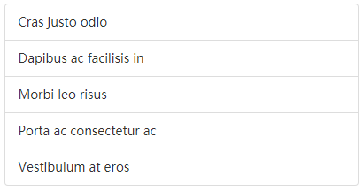

<ul class="list-group">

<li class="list-group-item">Cras justo odio</li>

<li class="list-group-item">Dapibus ac facilisis in</li>

<li class="list-group-item">Morbi leo risus</li>

<li class="list-group-item">Porta ac consectetur ac</li>

<li class="list-group-item">Vestibulum at eros</li>

</ul>

若li元素被a元素代替则有悬停效果。

.list-group {  
 *padding-left*: 0;  
 *margin-bottom*: 20**px**;  
}

.list-group-item {  
 *position*: **relative**;  
 *display*: **block**;  
 *padding*: 10**px** 15**px**;  
 *margin-bottom*: -1**px**;  
 *background-color*: #fff;  
 *border*: 1**px solid** #ddd;  
}

.list-group-item:first-child {  
 *border-top-left-radius*: 4**px**;  
 *border-top-right-radius*: 4**px**;  
}  
.list-group-item:last-child {  
 *margin-bottom*: 0;  
 *border-bottom-right-radius*: 4**px**;  
 *border-bottom-left-radius*: 4**px**;  
}

<!DOCTYPE html>

<html lang="en">

<head>

<meta charset="UTF-8">

<title>Document</title>

</head>

<body>

<ul>

<li>apple</li>

<li>banana</li>

<li>orange</li>

</ul>

</body>

</html>

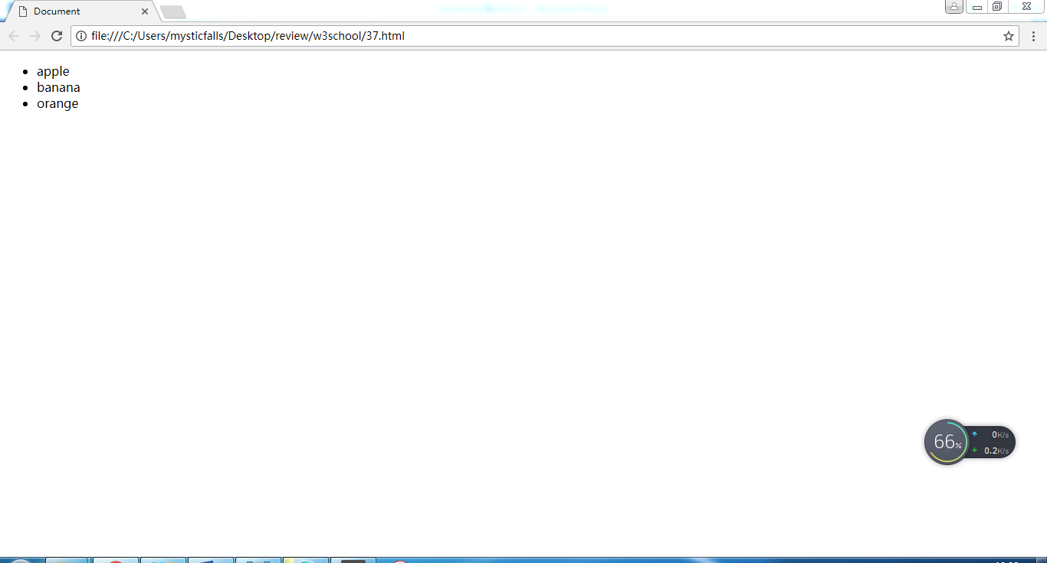

<!DOCTYPE html>

<html lang="en">

<head>

<meta charset="UTF-8">

<title>Document</title>

<style>

ul{

padding-left: 0;

}

</style>

</head>

<body>

<ul>

<li>apple</li>

<li>banana</li>

<li>orange</li>

</ul>

</body>

</html>

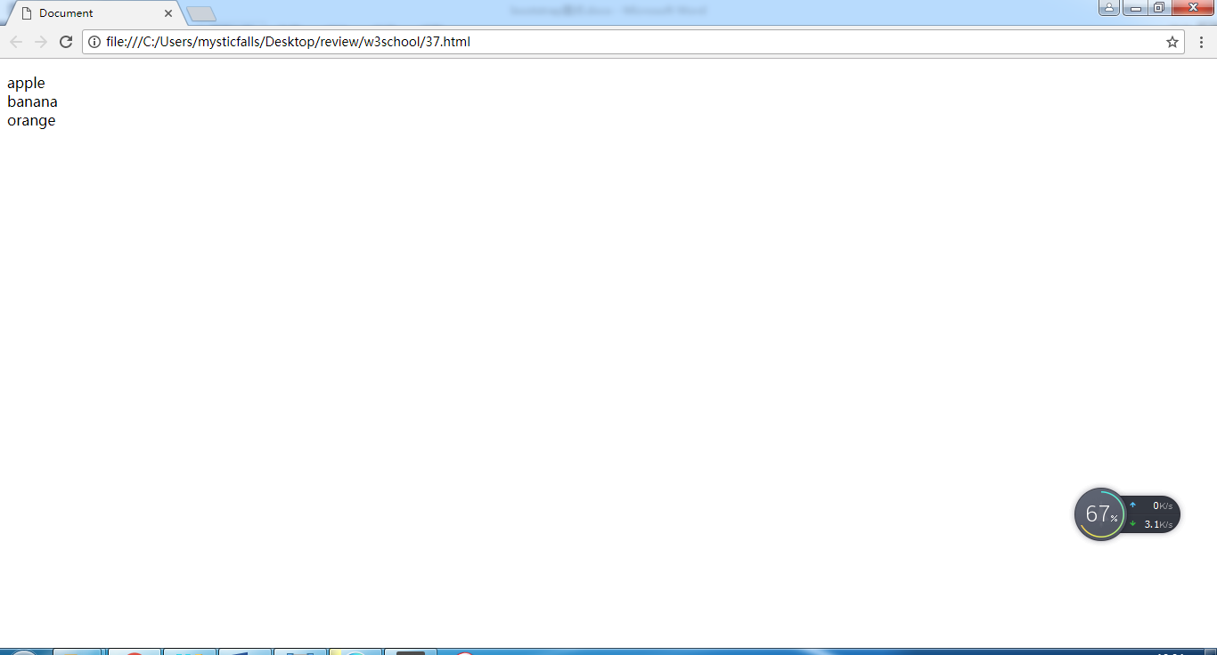

媒体对象

<!DOCTYPE html>

<html lang="en">

<head>

<meta charset="UTF-8">

<title>Document</title>

<link rel="stylesheet" href="css/bootstrap.css">

</head>

<body>

<div class="media">

<div class="media-left media-middle">

<img class="media-object" src="img/p0281.jpg">

</div>

<div class="media-body">

<h3>【酸甜开胃虾】</h3>

<p>主要食料：明虾、番茄酱、白糖、白醋、葱、姜、淀粉</p>

<p class="text-danger">￥36</p>

</div>

</div>

</body>

</html>

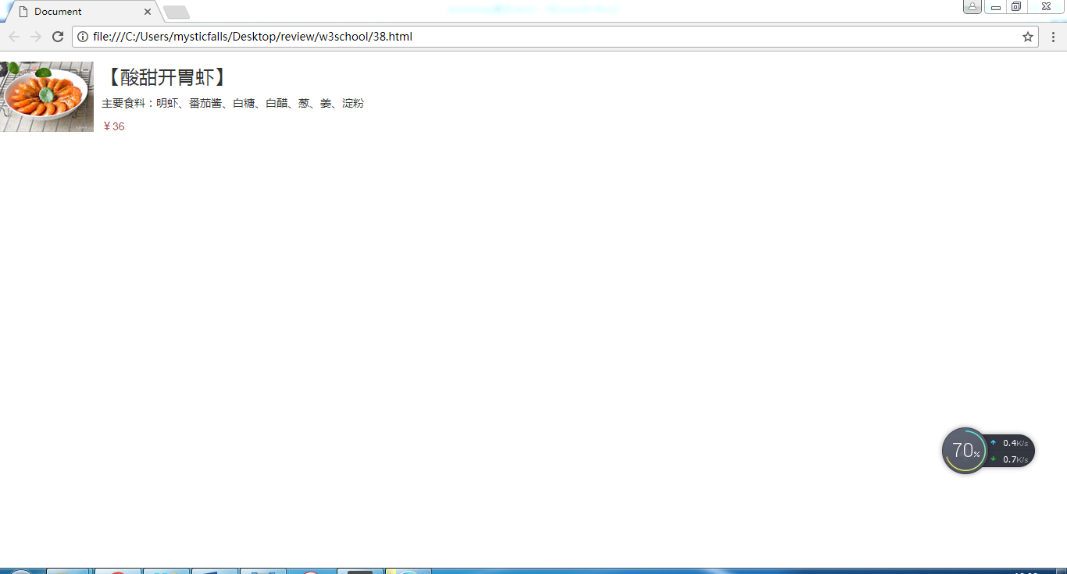

.media {  
 *margin-top*: 15**px**;  
}  
.media:first-child {  
 *margin-top*: 0;  
}

.media-left {  
 *display*: **table-cell**;  
}

.media-middle {  
 *vertical-align*: **middle**;  
}

.media-body {  
 *display*: **table-cell**;  
}

.media-object {  
 *display*: **block**;  
}

路径导航

<!DOCTYPE html>

<html lang="en">

<head>

<meta charset="UTF-8">

<title>Document</title>

<link rel="stylesheet" href="css/bootstrap.css">

</head>

<body>

<div class="container">

<ul class="breadcrumb">

<li><a href="#">Home</a></li>

<li><a href="#">Library</a></li>

<li class="active">Data</li>

</ul>

</div>

</body>

</html>

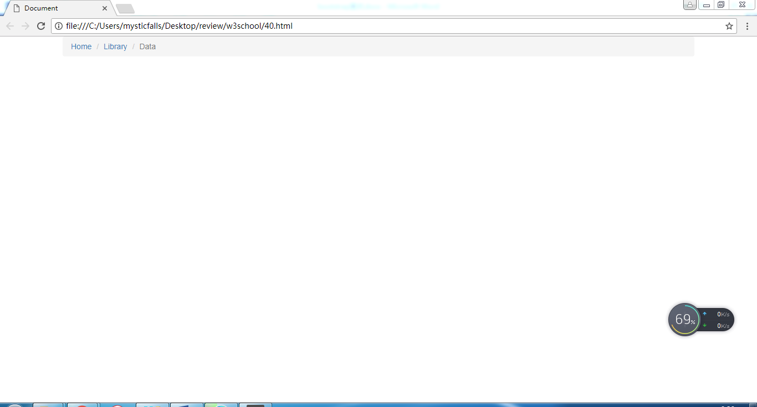

块级按钮

<!DOCTYPE html>

<html lang="en">

<head>

<meta charset="UTF-8">

<title>Document</title>

<link rel="stylesheet" href="css/bootstrap.css">

</head>

<body>

<div class="container">

<button class="btn btn-default btn-block">submit</button>

</div>

</body>

</html>

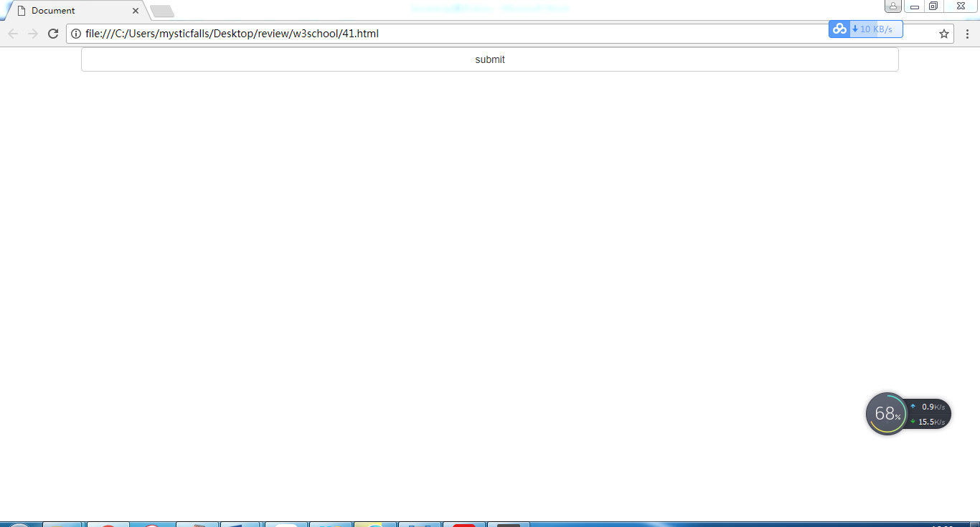

模态框

模态框尽量作为body元素的直接子元素，习惯上，模态框的 HTML代码放在</body>的前面。如果不需要模态框出现和消失时的动画效果，删掉 .fade 类即可。

<!DOCTYPE html>  
<html lang="en">  
<head>  
 <meta charset="UTF-8">  
 <title>模态框</title>  
 <link rel="stylesheet" href="css/bootstrap.css"/>  
 <script src="js/jquery-1.11.3.js"></script>  
 <script src="js/bootstrap.js"></script>  
</head>  
<body>  
 <div class="container">  
 <button type="button" class="btn btn-primary" data-toggle="modal" data-target="#myModal">Launch demo modal</button>  
 </div>  
  
 <div class="modal fade" id="myModal">  
 <div class="modal-dialog">  
 <div class="modal-content">  
 <div class="modal-header">  
 <button type="button" class="close" data-dismiss="modal">**&times;**</button>  
 <h4 class="modal-title">Modal title</h4>  
 </div>  
 <div class="modal-body">Lorem ipsum dolor sit amet, consectetur adipisicing elit. Doloremque eaque eos expedita incidunt laborum minus molestias nam nostrum provident ratione saepe soluta, ut. Aperiam dignissimos distinctio est sunt veritatis voluptatibus.</div>  
 <div class="modal-footer">  
 <button type="button" class="btn btn-default" data-dismiss="modal">Close</button>  
 <button type="button" class="btn btn-primary">Save changes</button>  
 </div>  
 </div>  
 </div>  
 </div>  
</body>  
</html>

.modal {  
 position: fixed;  
 top: 0;  
 right: 0;  
 bottom: 0;  
 left: 0;  
 z-index: 1050;  
 display: none;  
 overflow: hidden;  
 -webkit-overflow-scrolling: touch;  
 outline: 0;  
}

.fade {  
 opacity: 0;  
 -webkit-transition: opacity .15s linear;  
 -o-transition: opacity .15s linear;  
 transition: opacity .15s linear;  
}  
.fade.in {  
 opacity: 1;  
}

.modal-backdrop {  
 position: fixed;  
 top: 0;  
 right: 0;  
 bottom: 0;  
 left: 0;  
 z-index: 1040;  
 background-color: #000;  
}  
.modal-backdrop.fade {  
 filter: alpha(opacity=0);  
 opacity: 0;  
}  
.modal-backdrop.in {  
 filter: alpha(opacity=50);  
 opacity: .5;  
}

.modal-dialog {  
 position: relative;  
 width: auto;  
 margin: 10px;  
}

.modal-content {  
 position: relative;  
 background-color: #fff;  
 -webkit-background-clip: padding-box;  
 background-clip: padding-box;  
 border: 1px solid #999;  
 border: 1px solid rgba(0, 0, 0, .2);  
 border-radius: 6px;  
 outline: 0;  
 -webkit-box-shadow: 0 3px 9px rgba(0, 0, 0, .5);  
 box-shadow: 0 3px 9px rgba(0, 0, 0, .5);  
}

**@media** (min-width: 768px) {  
 .modal-dialog {  
 width: 600px;  
 margin: 30px auto;  
 }  
 .modal-content {  
 -webkit-box-shadow: 0 5px 15px rgba(0, 0, 0, .5);  
 box-shadow: 0 5px 15px rgba(0, 0, 0, .5);  
 }  
 .modal-sm {  
 width: 300px;  
 }  
}

.modal-header {  
 min-height: 16.42857143px;  
 padding: 15px;  
 border-bottom: 1px solid #e5e5e5;  
}

.modal-header .close {  
 margin-top: -2px;  
}

.close {  
 float: right;  
 font-size: 21px;  
 font-weight: bold;  
 line-height: 1;  
 color: #000;  
 text-shadow: 0 1px 0 #fff;  
 filter: alpha(opacity=20);  
 opacity: .2;  
}  
.close:hover,  
.close:focus {  
 color: #000;  
 text-decoration: none;  
 cursor: pointer;  
 filter: alpha(opacity=50);  
 opacity: .5;  
}  
button.close {  
 -webkit-appearance: none;  
 padding: 0;  
 cursor: pointer;  
 background: transparent;  
 border: 0;

.modal-title {  
 margin: 0;  
 line-height: 1.42857143;  
}

.modal-body {  
 position: relative;  
 padding: 15px;  
}  
.modal-footer {  
 padding: 15px;  
 text-align: right;  
 border-top: 1px solid #e5e5e5;  
}

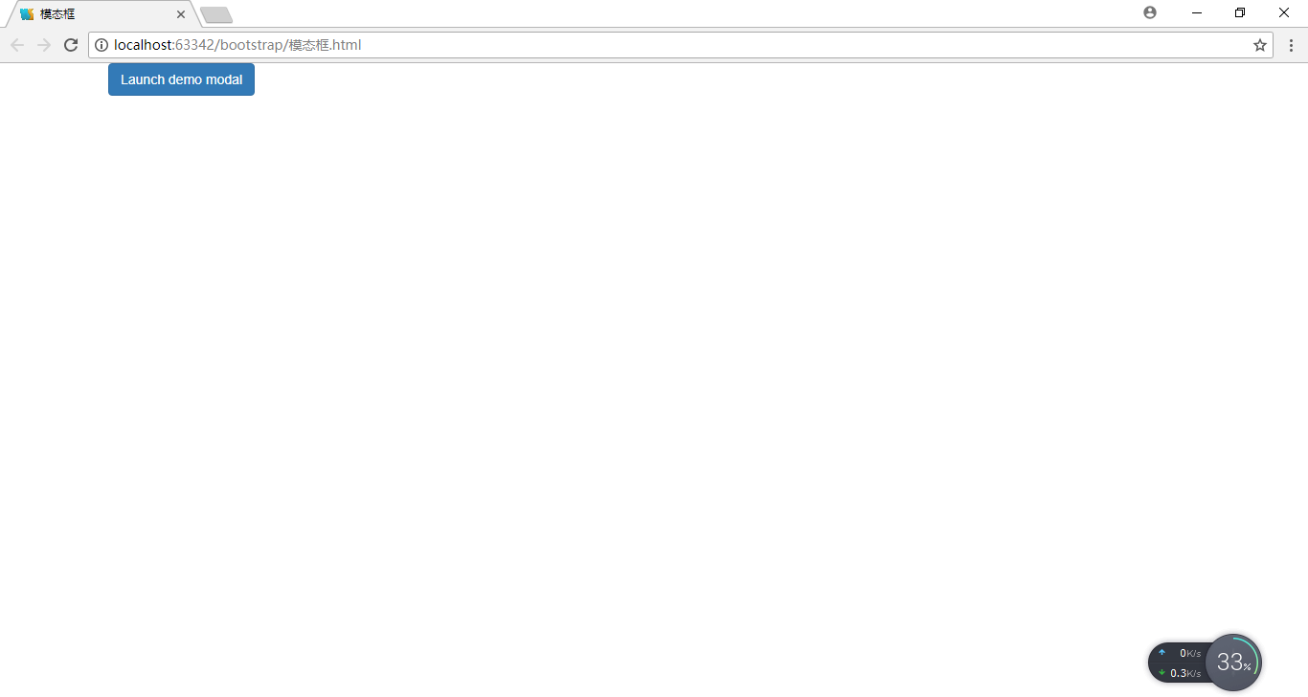

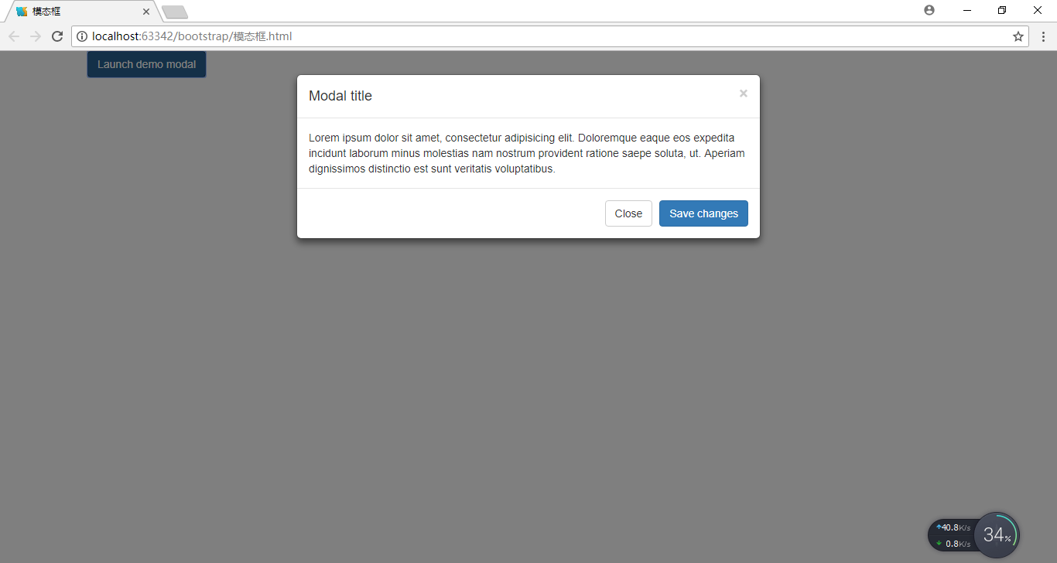

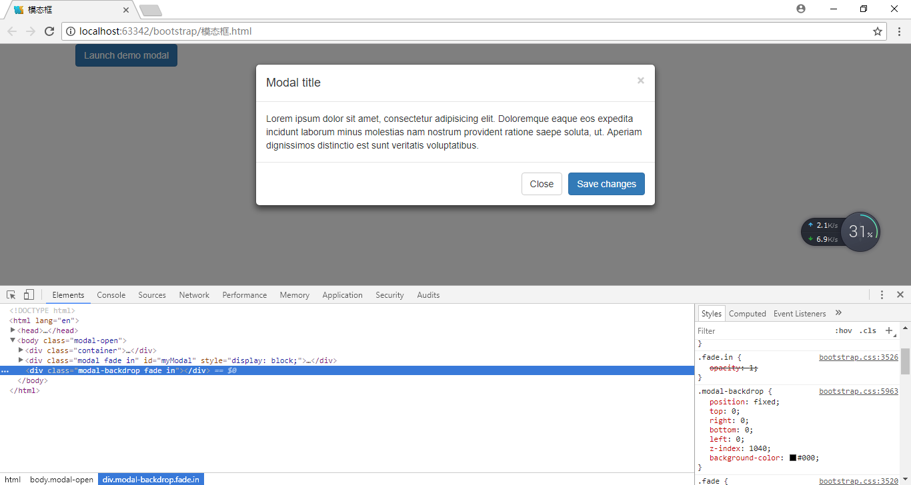

图像轮播（carousel）

<!DOCTYPE html>  
<html lang="en">  
<head>  
 <meta charset="UTF-8">  
 <title>图像轮播</title>  
 <link rel="stylesheet" href="css/bootstrap.css"/>  
 <script src="js/jquery-1.11.3.js"></script>  
 <script src="js/bootstrap.js"></script>  
 <style>  
 /*当轮播图像的容器宽度大于图像的宽度时，一般需要自己写额外的css控制整个轮播图像的宽度并使其居中对齐*/  
 div.carousel {  
 width: 950px;/*根据图像的宽度确定此处像素值*/  
 /*使图像轮播居中对齐*/  
 margin-left: auto;  
 margin-right: auto;  
 }  
 </style>  
</head>  
<body>  
<div class="container">  
 <div class="carousel slide" data-ride="carousel" id="myCarousel" data-interval="3000"><!--.slide可有可无，若有则图像轮播时有动画效果，若无则图像轮播时无动画效果。扩张属性data-interval控制图像轮播时本张图像出现到下一张图片出现的间隔时间，默认值为5000--。还有其他的扩展属性可参考文档。>  
 <!--div.carousel-inner是必须的-->  
 <div class="carousel-inner">  
 <!--div.item里有图像及其说明，说明是可有可无的-->  
 <div class="item active">  
 <img src="img/p1.jpg">  
 <div class="carousel-caption">  
 <h3>First slide picture</h3>  
 <p>Lorem ipsum dolor sit amet, consectetur adipisicing elit. Architecto corporis deserunt dolorum,  
 eius est facilis inventore iusto maiores nobis optio pariatur quam repudiandae sunt, vel veniam  
 voluptas voluptatibus. Adipisci, nobis!</p>  
 </div>  
 </div>  
 <div class="item">  
 <img src="img/p2.jpg">  
 <div class="carousel-caption">  
 <h3>Second slide picture</h3>  
 <p>Lorem ipsum dolor sit amet, consectetur adipisicing elit. Architecto corporis deserunt dolorum,  
 eius est facilis inventore iusto maiores nobis optio pariatur quam repudiandae sunt, vel veniam  
 voluptas voluptatibus. Adipisci, nobis!</p>  
 </div>  
 </div>  
 <div class="item">  
 <img src="img/p3.jpg">  
 <div class="carousel-caption">  
 <h3>Third slide picture</h3>  
 <p>Lorem ipsum dolor sit amet, consectetur adipisicing elit. Architecto corporis deserunt dolorum,  
 eius est facilis inventore iusto maiores nobis optio pariatur quam repudiandae sunt, vel veniam  
 voluptas voluptatibus. Adipisci, nobis!</p>  
 </div>  
 </div>  
 </div>  
 <!--div.carousel-indicators对图像轮播时辅助性的，不是必须的，主要作用是快速切换到某个图像-->  
 <ul class="carousel-indicators">  
 <li data-target="#myCarousel" data-slide-to="0" class="active"></li>  
 <li data-target="#myCarousel" data-slide-to="1"></li>  
 <li data-target="#myCarousel" data-slide-to="2"></li>  
 </ul>  
 <!--a.arousel-control对图像轮播时辅助性的，不是必须的，主要作用是快速切换到当前图像的上一张图像或下一张图像-->  
 <a class="carousel-control left" href="#myCarousel" data-slide="prev">  
 <span class="glyphicon glyphicon-chevron-left"></span>  
 </a>  
 <a class="carousel-control right" href="#myCarousel" data-slide="next">  
 <span class="glyphicon glyphicon-chevron-right"></span>  
 </a>  
 </div>  
</div>  
</body>  
</html>

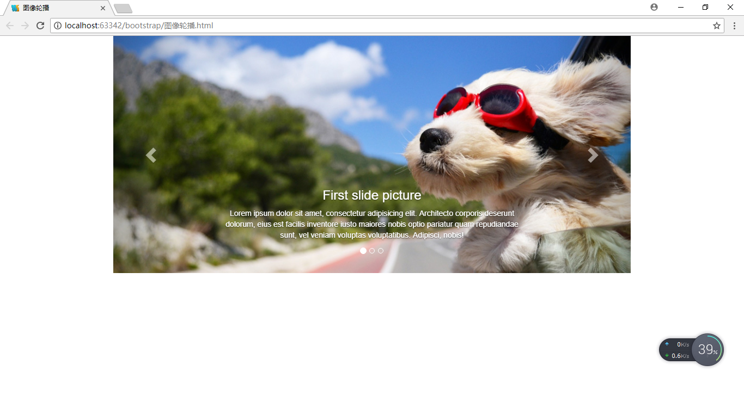

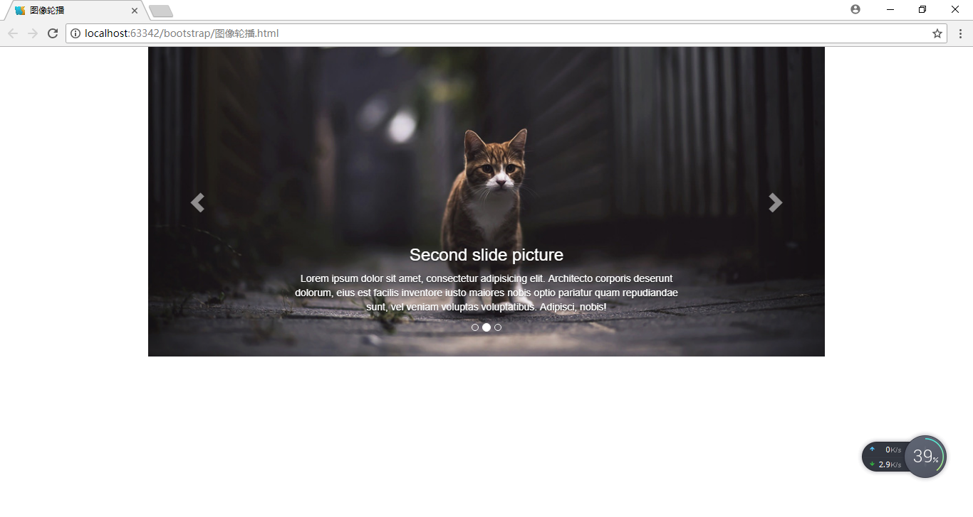

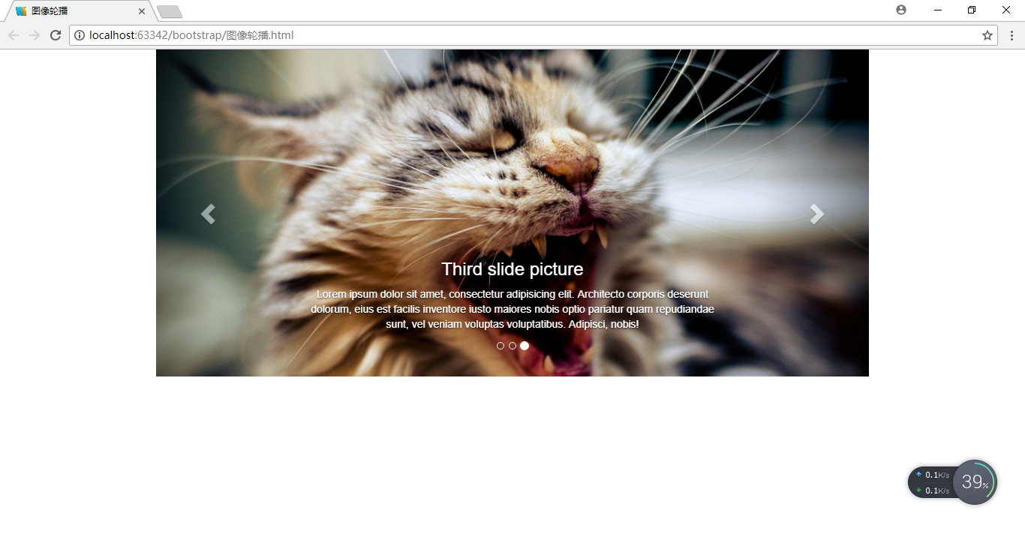

折叠

<!DOCTYPE html>  
<html lang="en">  
<head>  
 <meta charset="UTF-8">  
 <title>折叠</title>  
 <link rel="stylesheet" href="css/bootstrap.css"/>  
 <script src="js/jquery-1.11.3.js"></script>  
 <script src="js/bootstrap.js"></script>  
</head>  
<body>  
 <div class="container">  
 <a class="btn btn-primary" data-toggle="collapse" href="#myCollapse1">Link with href</a>  
 <div class="collapse in" id="myCollapse1">  
 <div class="well">Lorem ipsum dolor sit amet, consectetur adipisicing elit. Animi, architecto atque, cum delectus deleniti ducimus ea eaque exercitationem expedita incidunt molestiae nemo officiis omnis quaerat qui quod recusandae reiciendis sed.</div>  
 </div>  
 <br/>  
 <button type="button" class="collapsed btn btn-primary" data-toggle="collapse" data-target="#myCollapse2">Button with data-target</button>  
 <div class="collapse" id="myCollapse2">  
 <div class="well">Lorem ipsum dolor sit amet, consectetur adipisicing elit. Animi, architecto atque, cum delectus deleniti ducimus ea eaque exercitationem expedita incidunt molestiae nemo officiis omnis quaerat qui quod recusandae reiciendis sed.</div>  
 </div>  
 </div>  
</body>  
</html>

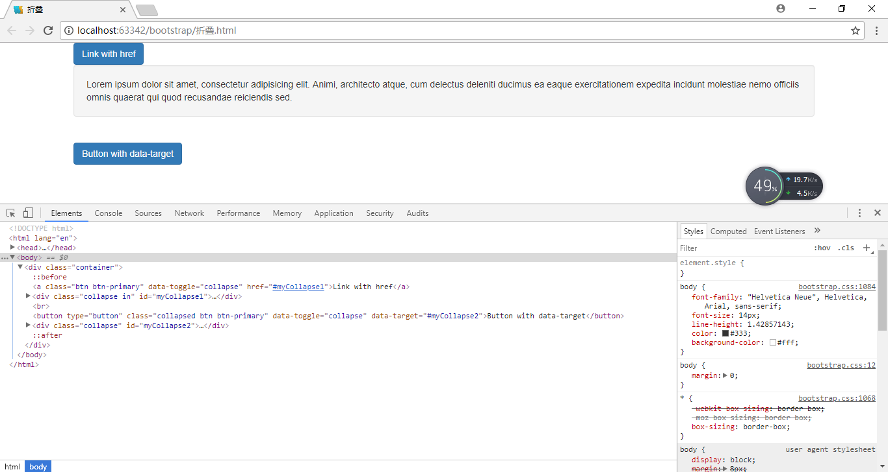

.collapse {  
 display: none;  
}  
.collapse.in {  
 display: block;  
}

.collapsing {  
 position: relative;  
 height: 0;  
 overflow: hidden;  
 -webkit-transition-timing-function: ease;  
 -o-transition-timing-function: ease;  
 transition-timing-function: ease;  
 -webkit-transition-duration: .35s;  
 -o-transition-duration: .35s;  
 transition-duration: .35s;  
 -webkit-transition-property: height, visibility;  
 -o-transition-property: height, visibility;  
 transition-property: height, visibility;  
}

.well {  
 min-height: 20px;  
 padding: 19px;  
 margin-bottom: 20px;  
 background-color: #f5f5f5;  
 border: 1px solid #e3e3e3;  
 border-radius: 4px;  
 -webkit-box-shadow: inset 0 1px 1px rgba(0, 0, 0, .05);  
 box-shadow: inset 0 1px 1px rgba(0, 0, 0, .05);  
}

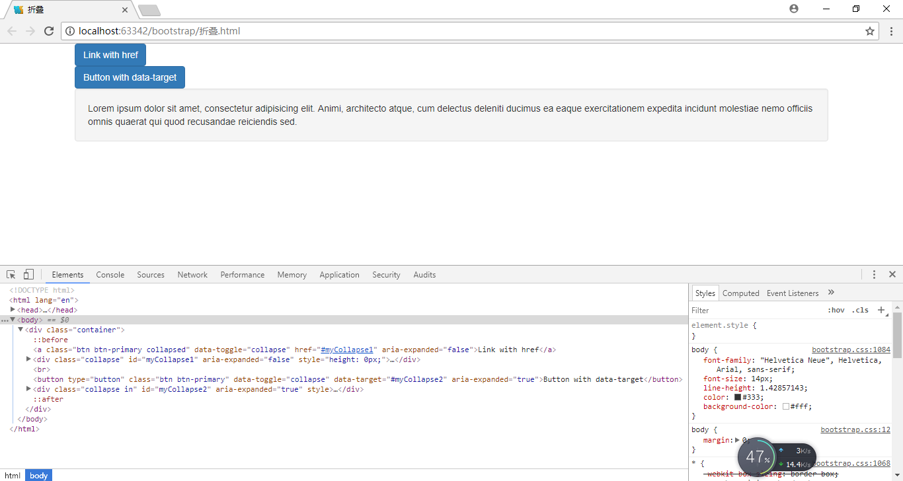

手风琴

本质是折叠和多个面板相互嵌套作用形成的面板组（id属性值是必须的）。

<!DOCTYPE html>  
<html lang="en">  
<head>  
 <meta charset="UTF-8">  
 <title>手风琴</title>  
 <link rel="stylesheet" href="css/bootstrap.css"/>  
 <script src="js/jquery-1.11.3.js"></script>  
 <script src="js/bootstrap.js"></script>  
</head>  
<body>  
<div class="container">  
 <div class="panel-group" id="myAccordion">  
 <div class="panel panel-default">  
 <div class="panel-heading">  
 <h4 class="panel-title">  
 <a href="#myCollapse1" class="btn btn-primary" data-toggle="collapse" data-parent="#myAccordion">myCollapse1 title</a>  
 </h4>  
 </div>  
 <div class="panel-collapse collapse in" id="myCollapse1">  
 <div class="panel-body">Lorem ipsum dolor sit amet, consectetur adipisicing elit. Accusantium aspernatur  
 assumenda dolorum nemo nisi. Ab accusamus accusantium, amet aperiam asperiores atque cupiditate  
 delectus eligendi fugiat labore laboriosam maiores nobis officia.  
 </div>  
 </div>  
 </div>  
 <div class="panel panel-default">  
 <div class="panel-heading">  
 <h4 class="panel-title">  
 <a href="#myCollapse2" class="collapsed btn btn-primary" data-toggle="collapse" data-parent="#myAccordion">myCollapse2 title</a>  
 </h4>  
 </div>  
 <div id="myCollapse2" class="panel-collapse collapse">  
 <div class="panel-body">Lorem ipsum dolor sit amet, consectetur adipisicing elit. Accusantium  
 asperiores, aut commodi, deserunt explicabo iste iusto odit quaerat quidem recusandae reprehenderit  
 temporibus velit voluptatum. Maiores mollitia nulla optio quo veniam.  
 </div>  
 </div>  
 </div>  
 <div class="panel panel-default">  
 <div class="panel-heading">  
 <h4 class="panel-title">  
 <a href="#myCollapse3" class="collapsed btn btn-primary" data-toggle="collapse" data-parent="#myAccordion">myCollapse3 title</a>  
 </h4>  
 </div>  
 <div id="myCollapse3" class="panel-collapse collapse">  
 <div class="panel-body">Lorem ipsum dolor sit amet, consectetur adipisicing elit. Dolorum error expedita  
 molestias natus, optio porro quidem tenetur. Aliquid architecto blanditiis eum hic itaque laborum  
 nihil nobis nulla porro sequi, suscipit?  
 </div>  
 </div>  
 </div>  
 </div>  
</div>  
</body>  
</html>

.panel-group {  
 margin-bottom: 20px;  
}  
.panel-group .panel {  
 margin-bottom: 0;  
 border-radius: 4px;  
}  
.panel-group .panel + .panel {  
 margin-top: 5px;  
}

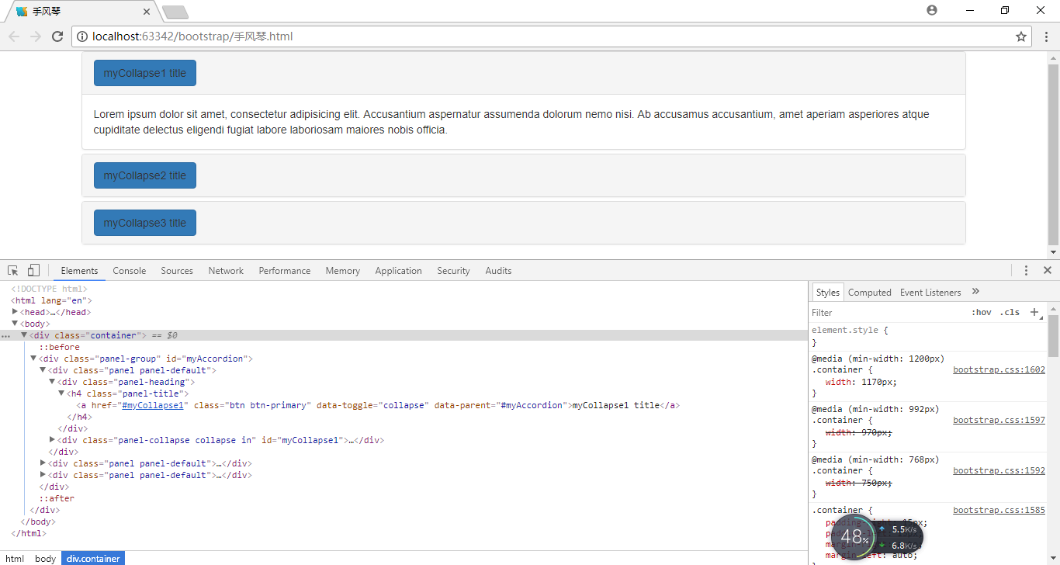

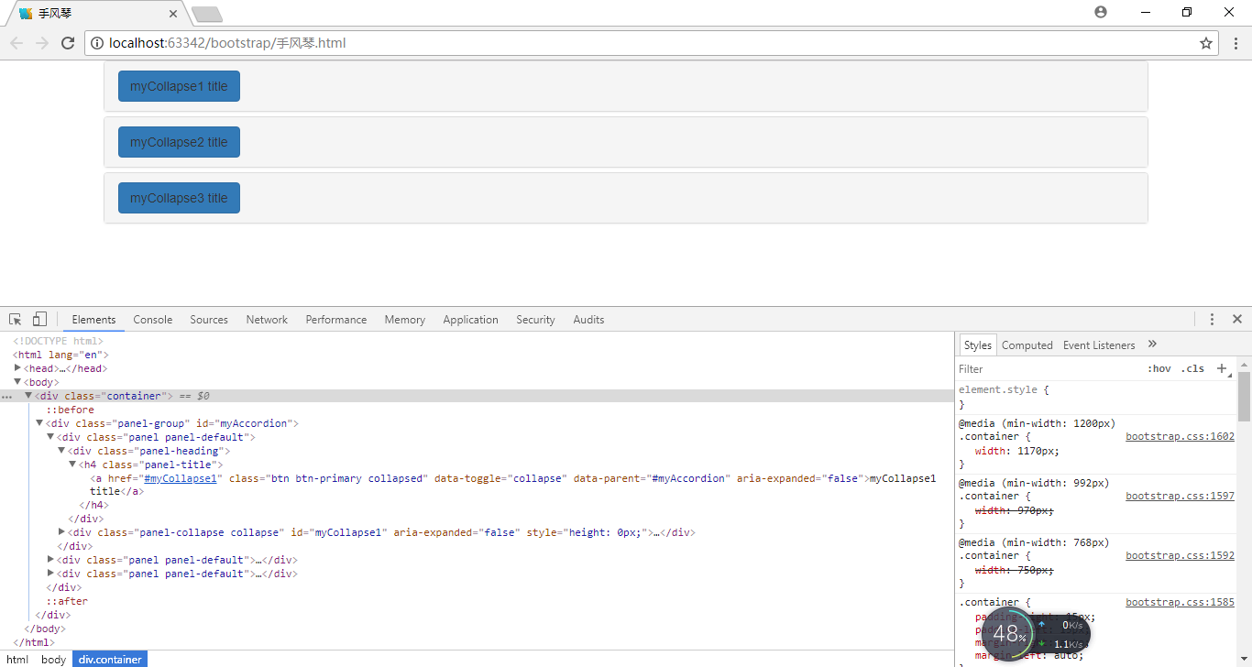

默认表单

<!DOCTYPE html>  
<html lang="en">  
<head>  
 <meta charset="UTF-8">  
 <title>默认表单</title>  
 <link rel="stylesheet" href="css/bootstrap.css"/>  
 <script src="js/jquery-1.11.3.js"></script>  
 <script src="js/bootstrap.js"></script>  
</head>  
<body>  
 <div class="container">  
 <form action="">  
 <div class="form-group">  
 <label for="uname">用户名：</label>  
 <input type="text" class="form-control" id="uname" name="uname"/>  
 </div>  
 <div class="form-group">  
 <label for="upwd">密码：</label>  
 <input type="password" class="form-control" id="upwd" name="upwd"/>  
 </div>  
 <div class="checkbox">  
 <label>  
 <input type="checkbox"/> 下次自动登录  
 </label>  
 </div>  
 <button type="submit" class="btn btn-primary">登录</button>  
 </form>  
 </div>  
</body>  
</html>

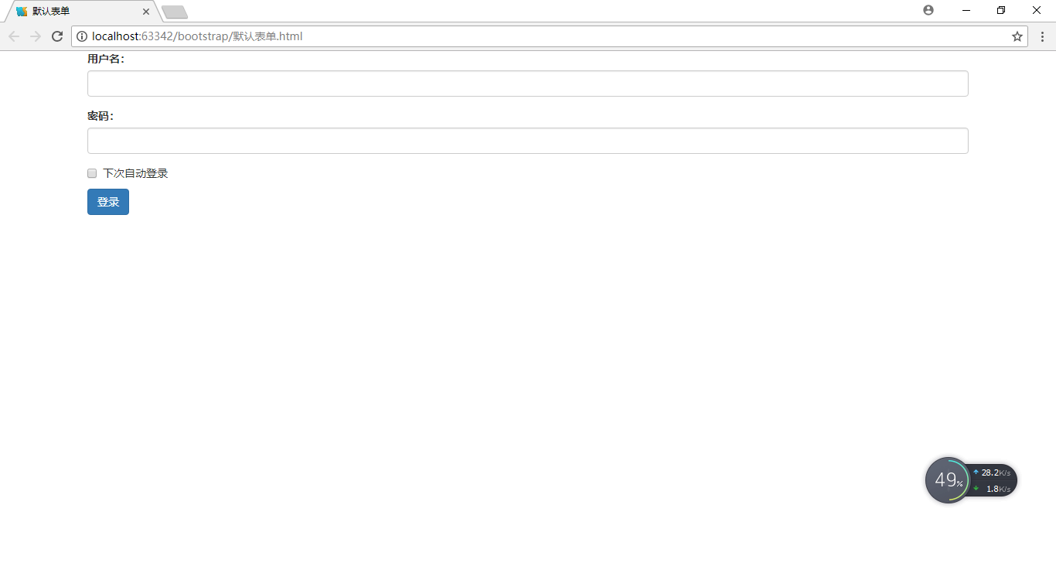

行内表单

当屏幕的宽度小于768px时，行内表单会自动变为默认表单。

<!DOCTYPE html>  
<html lang="en">  
<head>  
 <meta charset="UTF-8">  
 <title>行内表单</title>  
 <link rel="stylesheet" href="css/bootstrap.css"/>  
 <script src="js/jquery-1.11.3.js"></script>  
 <script src="js/bootstrap.js"></script>  
</head>  
<body>  
 <div class="container">  
 <form action="" class="form-inline">  
 <div class="form-group">  
 <label for="uname">用户名：</label>  
 <input type="text" class="form-control" id="uname" name="uname"/>  
 </div>  
 <div class="form-group">  
 <label for="upwd">密码：</label>  
 <input type="password" class="form-control" id="upwd" name="upwd"/>  
 </div>  
 <div class="checkbox">  
 <label>  
 <input type="checkbox"/> 下次自动登录  
 </label>  
 </div>  
 <button type="submit" class="btn btn-default">登录</button>  
 </form>  
 </div>  
</body>  
</html>

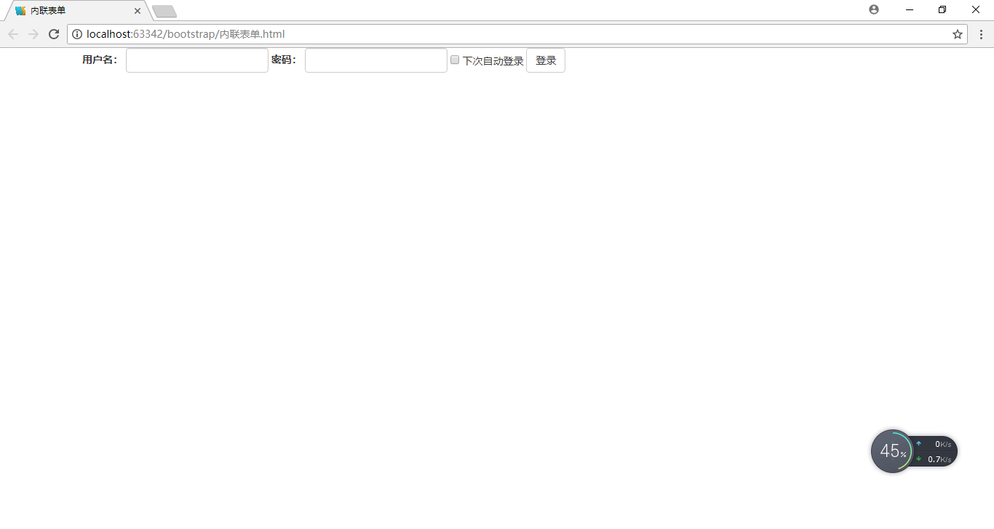

行内表单

<!DOCTYPE html>  
<html lang="en">  
<head>  
 <meta charset="UTF-8">  
 <title>水平表单</title>  
 <link rel="stylesheet" href="css/bootstrap.css"/>  
 <script src="js/jquery-1.11.3.js"></script>  
 <script src="js/bootstrap.js"></script>  
</head>  
<body>  
 <div class="container">  
 <form action="" class="form-horizontal">  
 <div class="form-group">  
 <div class="col-xs-3 control-label">  
 <label for="uname">用户名：</label>  
 </div>  
 <div class="col-xs-6">  
 <input type="text" class="form-control" id="uname" name="uname"/>  
 </div>  
 <div class="col-xs-3">  
 <span class="help-block">用户名由3到15个字符组成</span>  
 </div>  
 </div>  
 <div class="form-group">  
 <div class="col-xs-3 control-label">  
 <label for="upwd">密码：</label>  
 </div>  
 <div class="col-xs-6">  
 <input type="password" class="form-control" id="upwd" name="upwd"/>  
 </div>  
 <div class="col-xs-3">  
 <span class="help-block">请填写密码, 最小长度为6个字符</span>  
 </div>  
 </div>  
 <div class="form-group">  
 <div class="col-xs-6 col-xs-offset-3 col-sm-offset-3 col-md-offset-3 col-lg-offset-3">  
 <div class="checkbox">  
 <label>  
 <input type="checkbox"/> 下次自动登录  
 </label>  
 </div>  
 </div>  
 </div>  
 <div class="form-group">  
 <div class="col-xs-6 col-xs-offset-3 col-sm-offset-3 col-md-offset-3 col-lg-offset-3">  
 <button type="submit" class="btn btn-primary">登录</button>  
 </div>  
 </div>  
 </form>  
 </div>  
</body>  
</html>

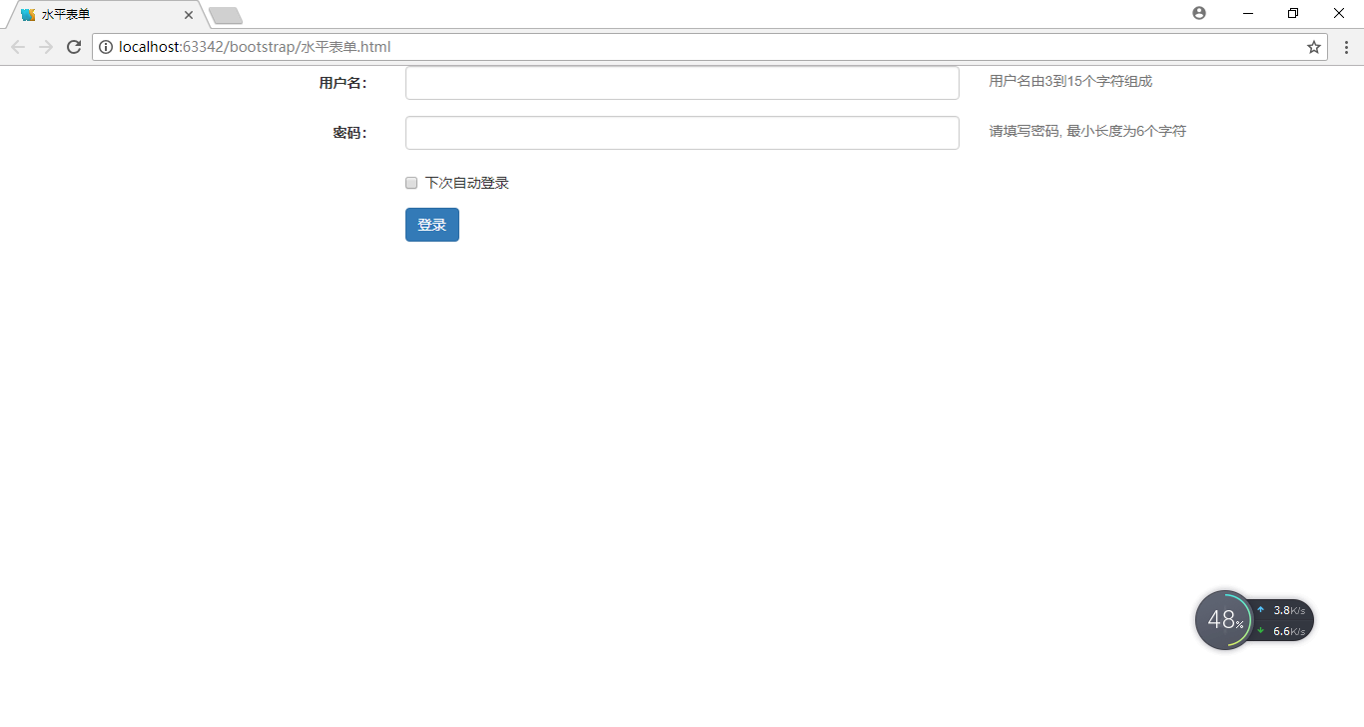

下拉菜单

<!DOCTYPE html>  
<html lang="en">  
<head>  
 <meta charset="UTF-8">  
 <title>下拉菜单</title>  
 <link rel="stylesheet" href="css/bootstrap.css"/>  
 <script src="js/jquery-1.11.3.js"></script>  
 <script src="js/bootstrap.js"></script>  
</head>  
<body>  
 <div class="container">  
 <div class="dropdown">  
 <a href="#" class="dropdown-toggle" data-toggle="dropdown">  
 Dropdown  
 <span class="caret"></span>  
 </a>  
 <ul class="dropdown-menu">  
 <li><a href="#">Action</a></li>  
 <li><a href="#">Another action</a></li>  
 </ul>  
 </div>  
 </div>  
</body>  
</html>

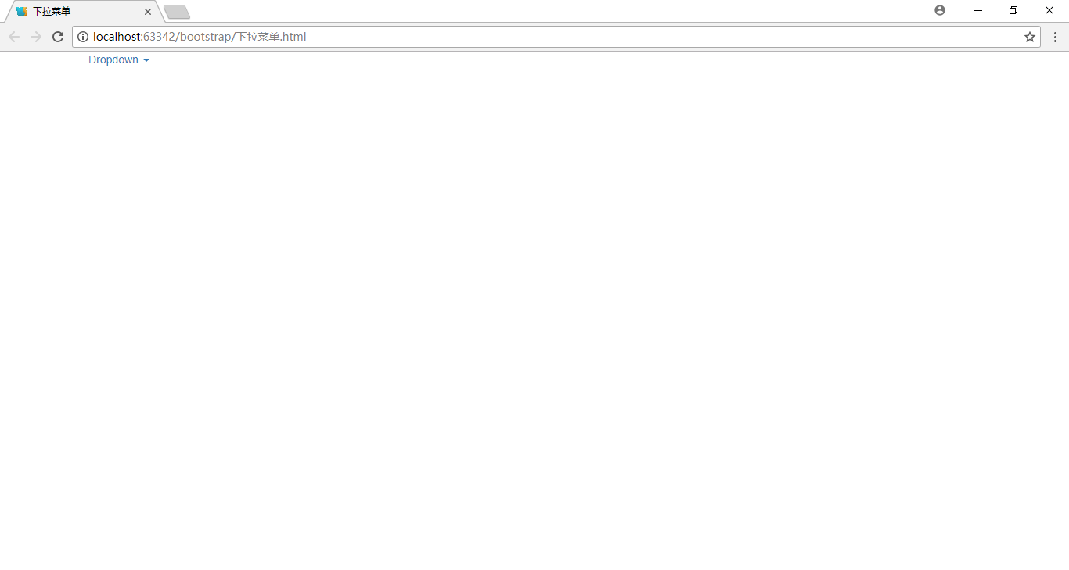

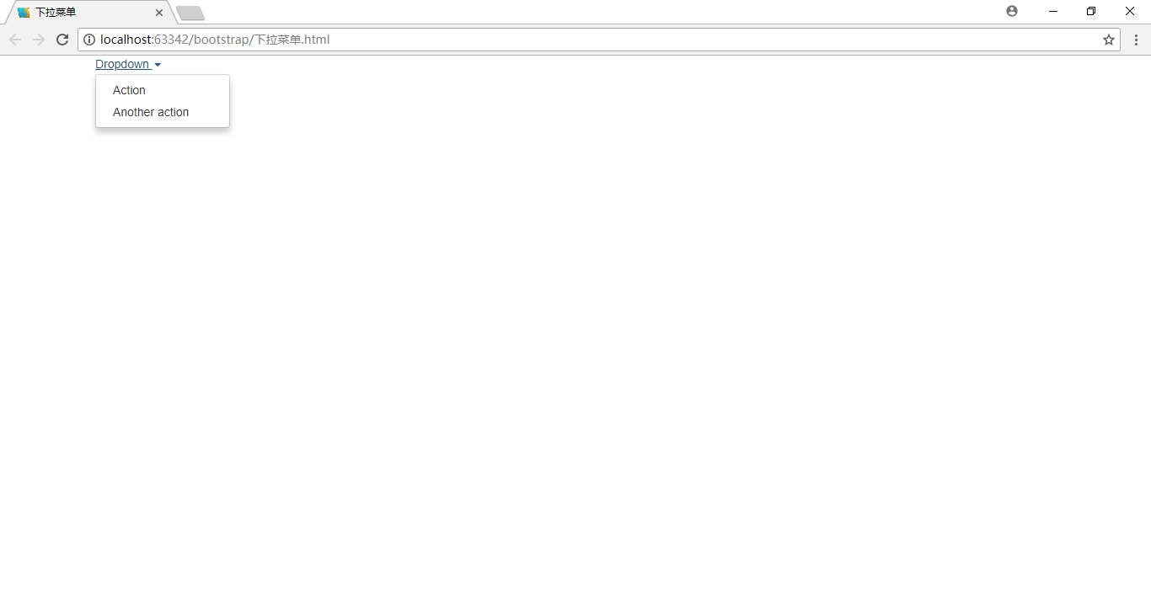

<!DOCTYPE html>  
<html lang="en">  
<head>  
 <meta charset="UTF-8">  
 <title>下拉菜单</title>  
 <link rel="stylesheet" href="css/bootstrap.css"/>  
 <script src="js/jquery-1.11.3.js"></script>  
 <script src="js/bootstrap.js"></script>  
</head>  
<body>  
 <div class="container">  
 <div class="dropdown">  
 <button type="button" class="dropdown-toggle" data-toggle="dropdown">  
 Dropdown  
 <span class="caret"></span>  
 </button>  
 <ul class="dropdown-menu">  
 <li><a href="#">Action</a></li>  
 <li><a href="#">Another action</a></li>  
 </ul>  
 </div>  
 </div>  
</body>  
</html>

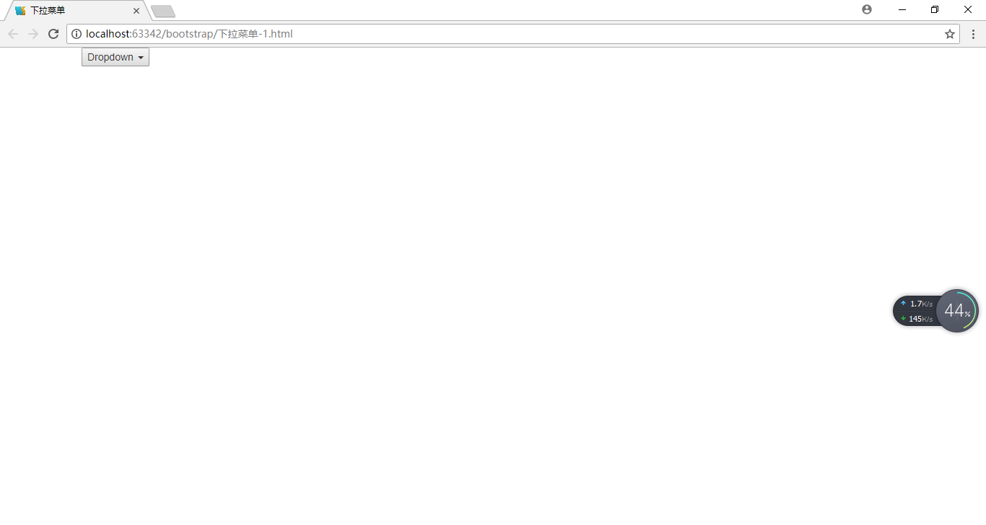

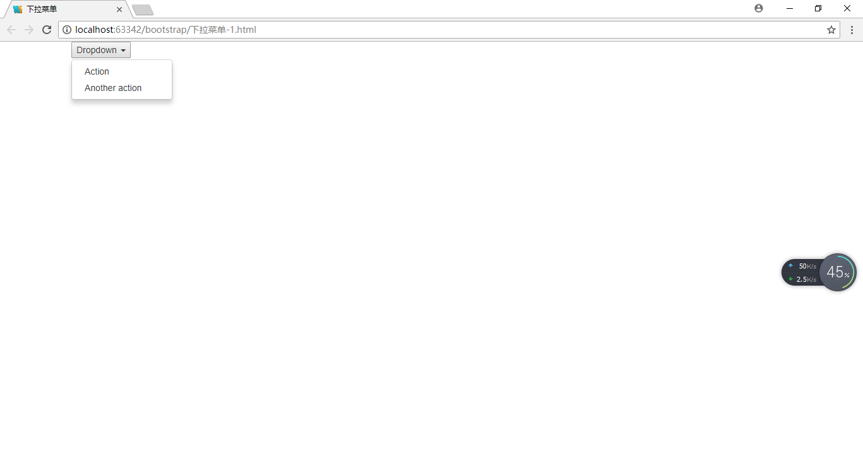

导航菜单

1. 带下拉菜单导航条里的导航菜单
2. <!DOCTYPE html>  
   <html lang="en">  
   <head>  
    <meta charset="UTF-8">  
    <title>带下拉菜单导航条里的导航菜单</title>  
    <link rel="stylesheet" href="css/bootstrap.css"/>  
    <script src="js/jquery-1.11.3.js"></script>  
    <script src="js/bootstrap.js"></script>  
   </head>  
   <body>  
    <div class="container">  
    <ul class="nav navbar-nav">  
    <li><a href="#">Link</a></li>  
    <li><a href="#">Another link</a></li>  
    <li class="dropdown">  
    <a href="#" class="dropdown-toggle" data-toggle="dropdown">  
    Dropdown  
    <span class="caret"></span>  
    </a>  
    <ul class="dropdown-menu">  
    <li><a href="#">Action</a></li>  
    <li><a href="#">Another action</a></li>  
    </ul>  
    </li>  
    </ul>  
    </div>  
   </body>  
   </html>

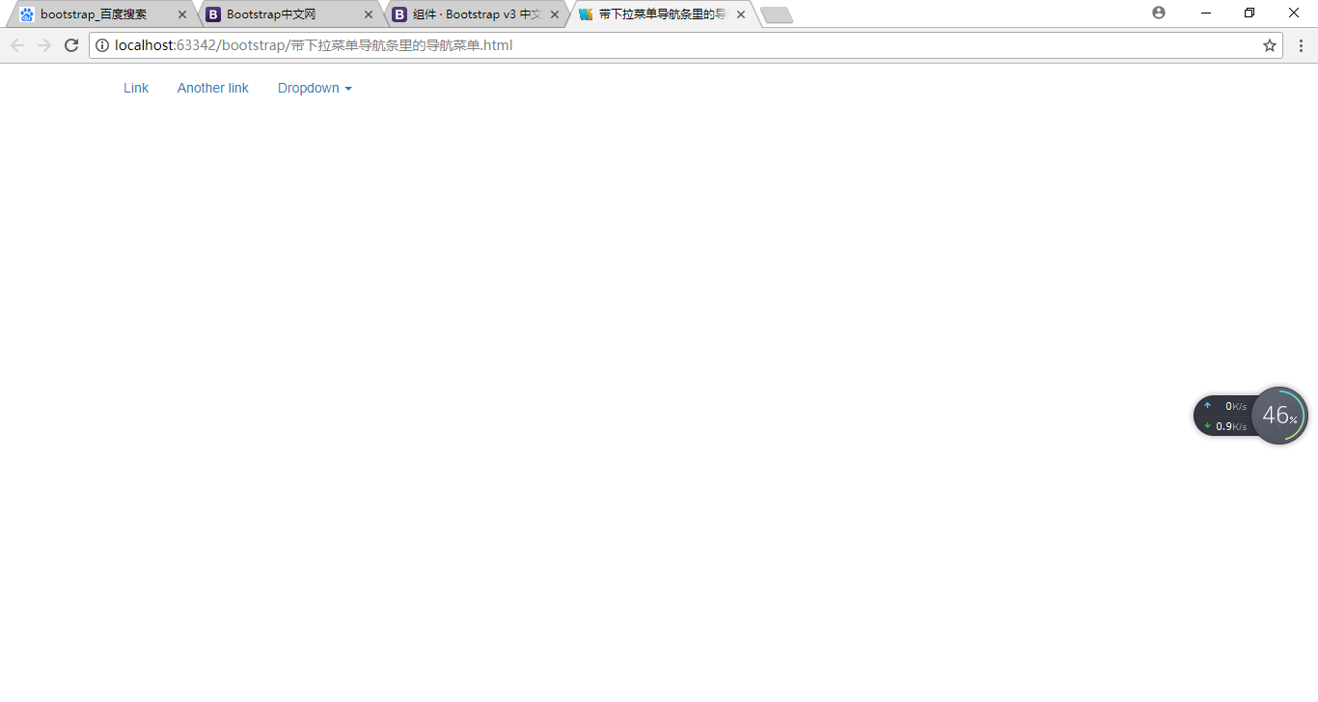

1. 带下拉菜单标签页式导航菜单
2. <!DOCTYPE html>  
   <html lang="en">  
   <head>  
    <meta charset="UTF-8">  
    <title>带下拉菜单标签页式导航菜单</title>  
    <link rel="stylesheet" href="css/bootstrap.css"/>  
    <script src="js/jquery-1.11.3.js"></script>  
    <script src="js/bootstrap.js"></script>  
   </head>  
   <body>  
    <div class="container">  
    <ul class="nav nav-tabs nav-justified">  
    <li class="active"><a href="#">Link</a></li>  
    <li><a href="#">Another link</a></li>  
    <li class="dropdown">  
    <a href="#" class="dropdown-toggle" data-toggle="dropdown">  
    Dropdown  
    <span class="caret"></span>  
    </a>  
    <ul class="dropdown-menu">  
    <li><a href="#">Action</a></li>  
    <li><a href="#">Another action</a></li>  
    </ul>  
    </li>  
    </ul>  
    </div>  
   </body>  
   </html>

有.nav-justified

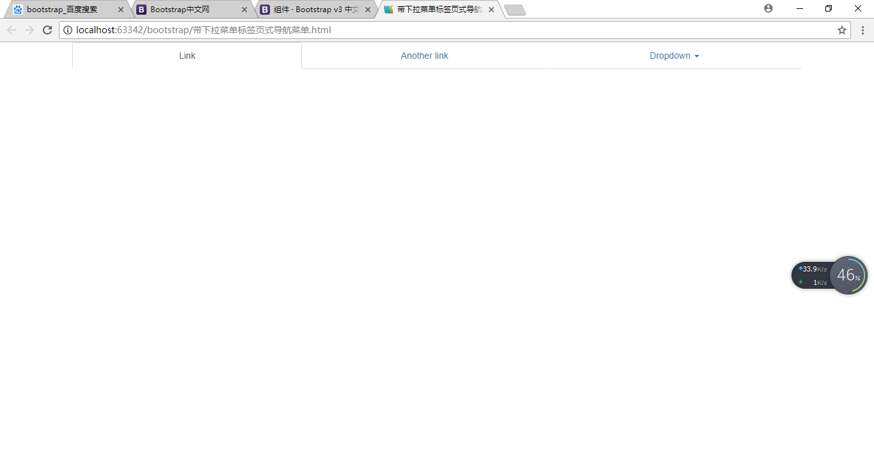

无.nav-justified

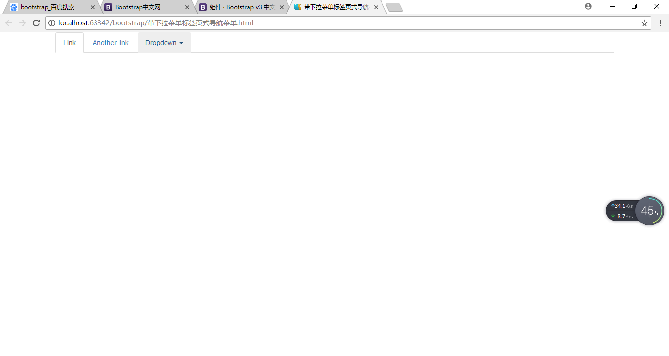

1. 带下拉菜单胶囊式导航菜单
2. <!DOCTYPE html>  
   <html lang="en">  
   <head>  
    <meta charset="UTF-8">  
    <title>带下拉菜单胶囊式导航菜单</title>  
    <link rel="stylesheet" href="css/bootstrap.css"/>  
    <script src="js/jquery-1.11.3.js"></script>  
    <script src="js/bootstrap.js"></script>  
   </head>  
   <body>  
    <div class="container">  
    <ul class="nav nav-pills nav-justified">  
    <li class="active"><a href="#">Link</a></li>  
    <li><a href="#">Another link</a></li>  
    <li class="dropdown">  
    <a href="#" class="dropdown-toggle" data-toggle="dropdown">  
    Dropdown  
    <span class="caret"></span>  
    </a>  
    <ul class="dropdown-menu">  
    <li><a href="#">Action</a></li>  
    <li><a href="#">Another action</a></li>  
    </ul>  
    </li>  
    </ul>  
    </div>  
   </body>  
   </html>

有.nav-justified

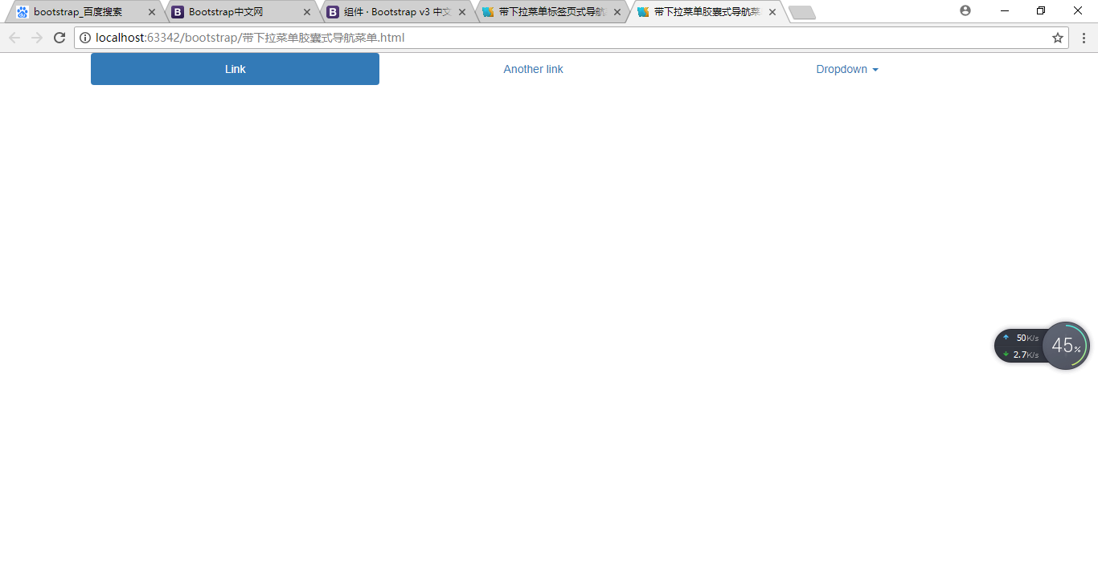

无.nav-justified

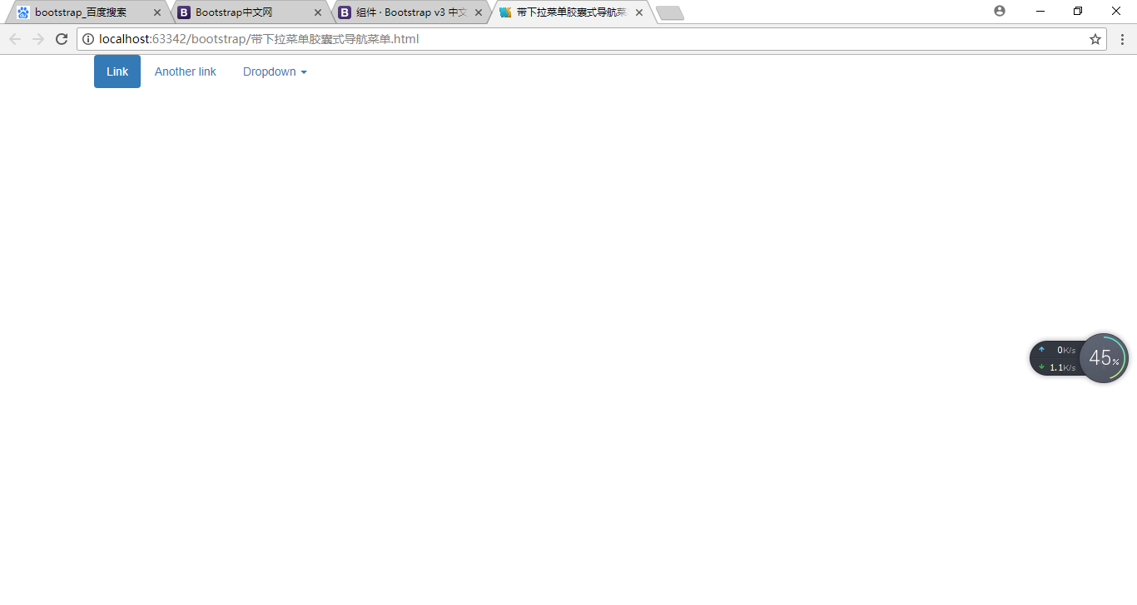

分页

<!DOCTYPE html>  
<html lang="en">  
<head>  
 <meta charset="UTF-8">  
 <title>分页</title>  
 <link rel="stylesheet" href="css/bootstrap.css"/>  
 <script src="js/jquery-1.11.3.js"></script>  
 <script src="js/bootstrap.js"></script>  
</head>  
<body>  
 <div class="container">  
 <nav>  
 <ul class="pagination pagination-lg">  
 <li class="disabled">  
 <a href="#">  
 <span>**&laquo;**</span><!--&laquo; ==> <<-->  
 </a>  
 </li>  
 <li class="active"><a href="#">1</a></li>  
 <li><a href="#">2</a></li>  
 <li><a href="#">3</a></li>  
 <li><a href="#">4</a></li>  
 <li><a href="#">5</a></li>  
 <li>  
 <a href="#">  
 <span>**&raquo;**</span><!--&raquo; ==> >>-->  
 </a>  
 </li>  
 </ul>  
 </nav>  
 <nav>  
 <ul class="pagination">  
 <li class="disabled">  
 <a href="#">  
 <span>**&laquo;**</span><!--&laquo; ==> <<-->  
 </a>  
 </li>  
 <li class="active"><a href="#">1</a></li>  
 <li><a href="#">2</a></li>  
 <li><a href="#">3</a></li>  
 <li><a href="#">4</a></li>  
 <li><a href="#">5</a></li>  
 <li>  
 <a href="#">  
 <span>**&raquo;**</span><!--&raquo; ==> >>-->  
 </a>  
 </li>  
 </ul>  
 </nav>  
 <nav>  
 <ul class="pagination pagination-small">  
 <li class="disabled">  
 <a href="#">  
 <span>**&laquo;**</span><!--&laquo; ==> <<-->  
 </a>  
 </li>  
 <li class="active"><a href="#">1</a></li>  
 <li><a href="#">2</a></li>  
 <li><a href="#">3</a></li>  
 <li><a href="#">4</a></li>  
 <li><a href="#">5</a></li>  
 <li>  
 <a href="#">  
 <span>**&raquo;**</span><!--&raquo; ==> >>-->  
 </a>  
 </li>  
 </ul>  
 </nav>  
 </div>  
</body>  
</html>

.pagination {  
 display: inline-block;  
 padding-left: 0;  
 margin: 20px 0;  
 border-radius: 4px;  
}  
.pagination > li {  
 display: inline;  
}  
.pagination > li > a,  
.pagination > li > span {  
 position: relative;  
 float: left;  
 padding: 6px 12px;  
 margin-left: -1px;  
 line-height: 1.42857143;  
 color: #337ab7;  
 text-decoration: none;  
 background-color: #fff;  
 border: 1px solid #ddd;  
}

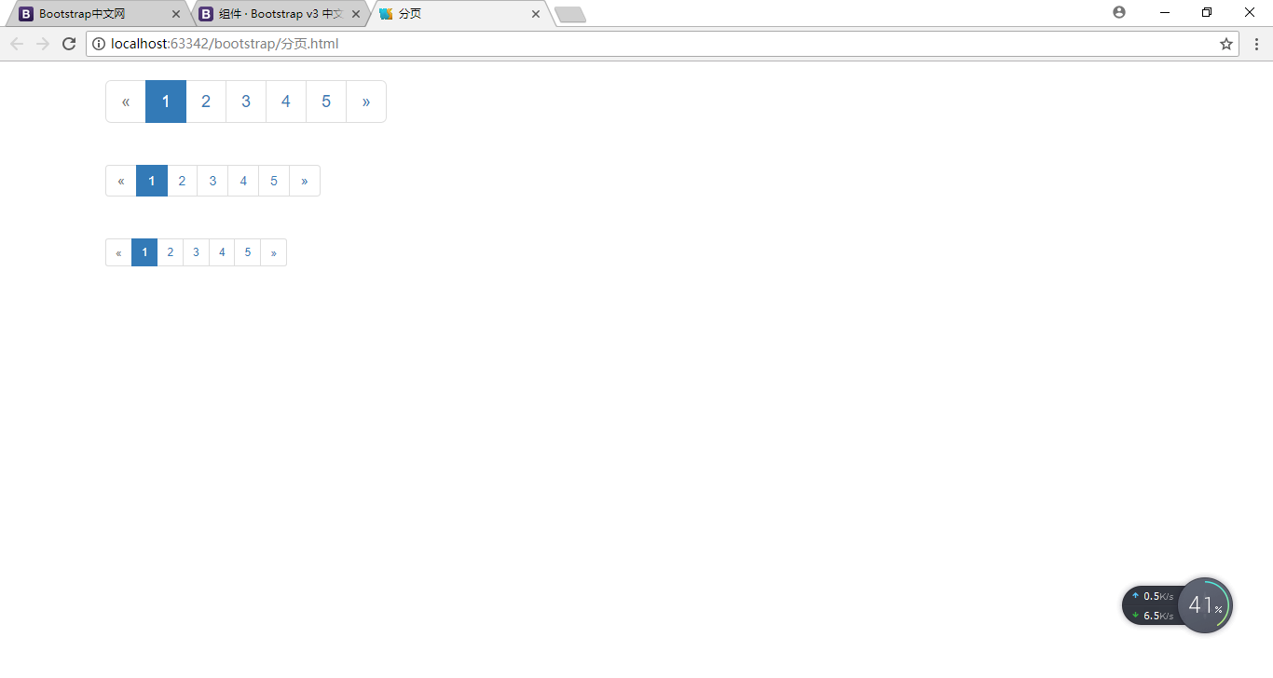

翻页（分页的简化版，主要用于博客等简单的站点）

<!DOCTYPE html>  
<html lang="en">  
<head>  
 <meta charset="UTF-8">  
 <title>翻页</title>  
 <link rel="stylesheet" href="css/bootstrap.css"/>  
 <script src="js/jquery-1.11.3.js"></script>  
 <script src="js/bootstrap.js"></script>  
</head>  
<body>  
 <div class="container">  
 <nav>  
 <ul class="pager">  
 <li class="disabled"><a href="#">Previous</a></li>  
 <li><a href="#">Next</a></li>  
 </ul>  
 </nav>  
 </div>  
</body>  
</html>

.pager {  
 padding-left: 0;  
 margin: 20px 0;  
 text-align: center;  
 list-style: none;  
}  
.pager li {  
 display: inline;  
}  
.pager li > a {  
 display: inline-block;  
 padding: 5px 14px;  
 background-color: #fff;  
 border: 1px solid #ddd;  
 border-radius: 15px;  
}

.pager:before,  
.pager:after {  
 display: table;  
 content: " ";  
}

.pager:after {  
 clear: both;  
}

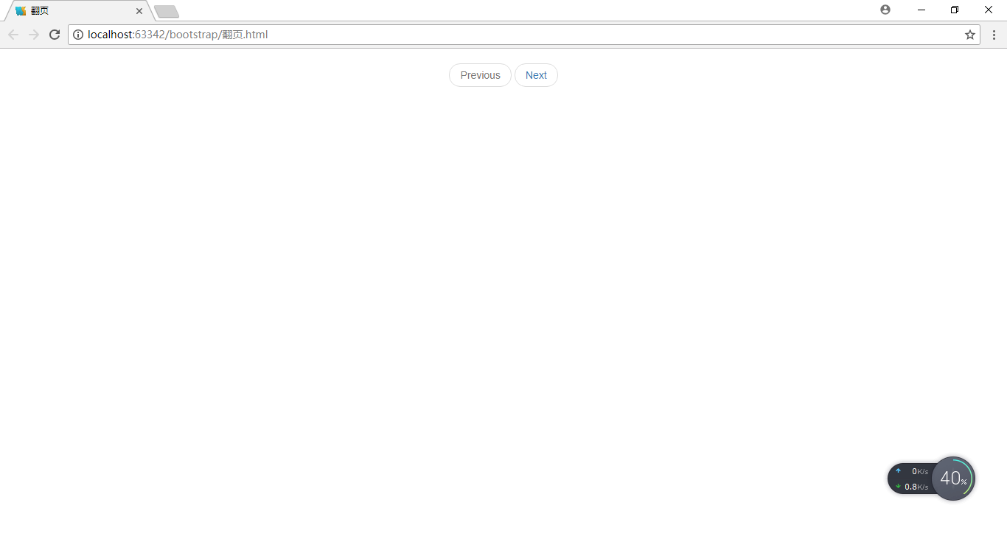

默认表格

<!DOCTYPE html>  
<html lang="en">  
<head>  
 <meta charset="UTF-8">  
 <title>默认表格</title>  
 <link rel="stylesheet" href="css/bootstrap.css"/>  
 <script src="js/jquery-1.11.3.js"></script>  
 <script src="js/bootstrap.js"></script>  
</head>  
<body>  
 <div class="container">  
 <table class="table">  
 <thead>  
 <tr>  
 <th>#</th>  
 <th>Firstname</th>  
 <th>Lastname</th>  
 <th>Username</th>  
 </tr>  
 </thead>  
 <tbody>  
 <tr>  
 <th>1</th>  
 <td>Mark</td>  
 <td>Otto</td>  
 <td>@mdo</td>  
 </tr>  
 <tr>  
 <th>2</th>  
 <td>Jacob</td>  
 <td>Thornton</td>  
 <td>@fat</td>  
 </tr>  
 <tr>  
 <th>3</th>  
 <td>Larry</td>  
 <td>Thebird</td>  
 <td>@twitter</td>  
 </tr>  
 </tbody>  
 </table>  
 </div>  
</body>  
</html>

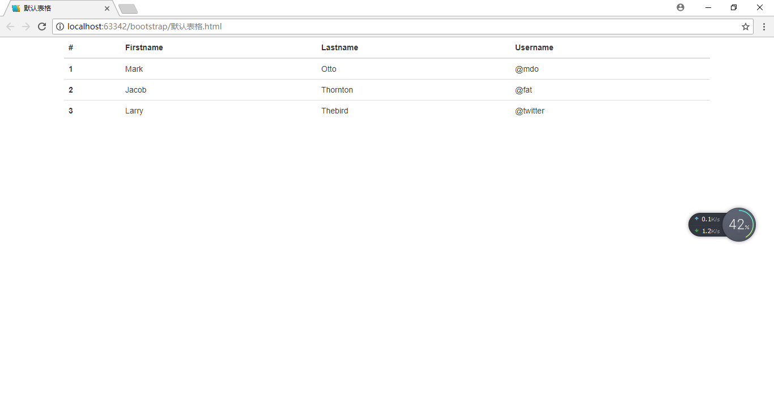

隔行变色的表格

<!DOCTYPE html>  
<html lang="en">  
<head>  
 <meta charset="UTF-8">  
 <title>各行变色的表格</title>  
 <link rel="stylesheet" href="css/bootstrap.css"/>  
 <script src="js/jquery-1.11.3.js"></script>  
 <script src="js/bootstrap.js"></script>  
</head>  
<body>  
 <div class="container">  
 <table class="table table-striped">  
 <thead>  
 <tr>  
 <th>#</th>  
 <th>Firstname</th>  
 <th>Lastname</th>  
 <th>Username</th>  
 </tr>  
 </thead>  
 <tbody>  
 <tr>  
 <th>1</th>  
 <td>Mark</td>  
 <td>Otto</td>  
 <td>@mdo</td>  
 </tr>  
 <tr>  
 <th>2</th>  
 <td>Jacob</td>  
 <td>Thornton</td>  
 <td>@fat</td>  
 </tr>  
 <tr>  
 <th>3</th>  
 <td>Larry</td>  
 <td>Thebird</td>  
 <td>@twitter</td>  
 </tr>  
 </tbody>  
 </table>  
 </div>  
</body>  
</html>

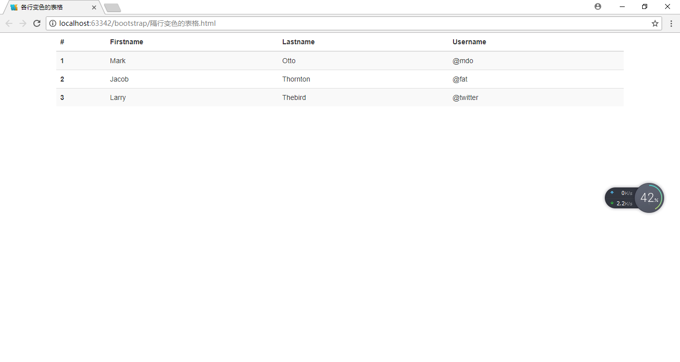

带边框的表格

<!DOCTYPE html>  
<html lang="en">  
<head>  
 <meta charset="UTF-8">  
 <title>带边框的表格</title>  
 <link rel="stylesheet" href="css/bootstrap.css"/>  
 <script src="js/jquery-1.11.3.js"></script>  
 <script src="js/bootstrap.js"></script>  
</head>  
<body>  
 <div class="container">  
 <table class="table table-bordered">  
 <thead>  
 <tr>  
 <th>#</th>  
 <th>Firstname</th>  
 <th>Lastname</th>  
 <th>Username</th>  
 </tr>  
 </thead>  
 <tbody>  
 <tr>  
 <th>1</th>  
 <td>Mark</td>  
 <td>Otto</td>  
 <td>@mdo</td>  
 </tr>  
 <tr>  
 <th>2</th>  
 <td>Jacob</td>  
 <td>Thornton</td>  
 <td>@fat</td>  
 </tr>  
 <tr>  
 <th>3</th>  
 <td>Larry</td>  
 <td>Thebird</td>  
 <td>@twitter</td>  
 </tr>  
 </tbody>  
 </table>  
 </div>  
</body>  
</html>

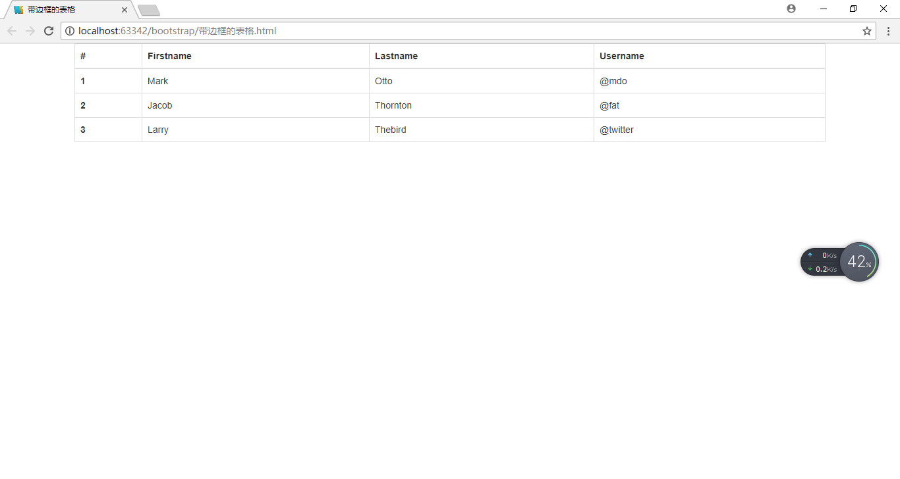

有鼠标悬停效果的表格

<!DOCTYPE html>  
<html lang="en">  
<head>  
 <meta charset="UTF-8">  
 <title>有鼠标悬停效果的表格</title>  
 <link rel="stylesheet" href="css/bootstrap.css"/>  
 <script src="js/jquery-1.11.3.js"></script>  
 <script src="js/bootstrap.js"></script>  
</head>  
<body>  
 <div class="container">  
 <table class="table table-hover">  
 <thead>  
 <tr>  
 <th>#</th>  
 <th>Firstname</th>  
 <th>Lastname</th>  
 <th>Username</th>  
 </tr>  
 </thead>  
 <tbody>  
 <tr>  
 <th>1</th>  
 <td>Mark</td>  
 <td>Otto</td>  
 <td>@mdo</td>  
 </tr>  
 <tr>  
 <th>2</th>  
 <td>Jacob</td>  
 <td>Thornton</td>  
 <td>@fat</td>  
 </tr>  
 <tr>  
 <th>3</th>  
 <td>Larry</td>  
 <td>Thebird</td>  
 <td>@twitter</td>  
 </tr>  
 </tbody>  
 </table>  
 </div>  
</body>  
</html>

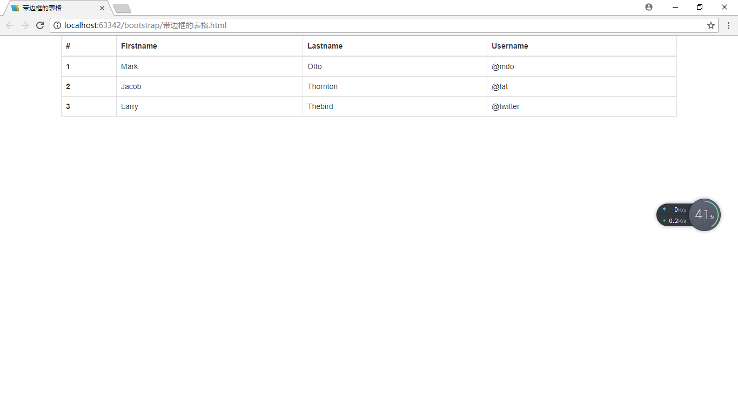

紧缩的表格（表格会变得紧凑，单元格中的padding会减半）

<!DOCTYPE html>  
<html lang="en">  
<head>  
 <meta charset="UTF-8">  
 <title>紧缩的表格</title>  
 <link rel="stylesheet" href="css/bootstrap.css"/>  
 <script src="js/jquery-1.11.3.js"></script>  
 <script src="js/bootstrap.js"></script>  
</head>  
<body>  
 <div class="container">  
 <table class="table table-condensed">  
 <thead>  
 <tr>  
 <th>#</th>  
 <th>Firstname</th>  
 <th>Lastname</th>  
 <th>Username</th>  
 </tr>  
 </thead>  
 <tbody>  
 <tr>  
 <th>1</th>  
 <td>Mark</td>  
 <td>Otto</td>  
 <td>@mdo</td>  
 </tr>  
 <tr>  
 <th>2</th>  
 <td>Jacob</td>  
 <td>Thornton</td>  
 <td>@fat</td>  
 </tr>  
 <tr>  
 <th>3</th>  
 <td>Larry</td>  
 <td>Thebird</td>  
 <td>@twitter</td>  
 </tr>  
 </tbody>  
 </table>  
 </div>  
</body>  
</html>

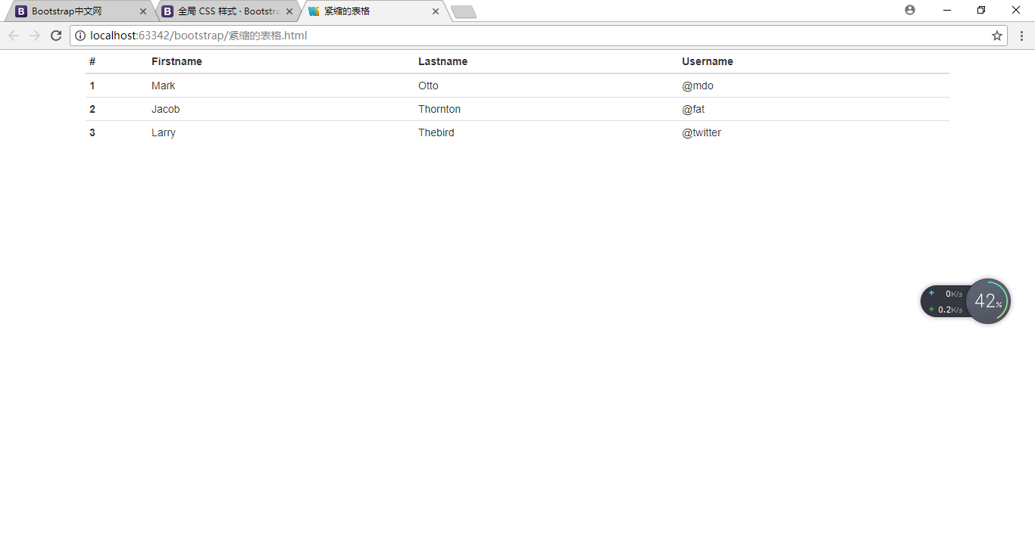

响应式表格（用一个带有.table-responsive的div把table包裹起来。当屏幕宽度小于768px时，会出现水平滚动条，表格可以水平滚动。当屏幕宽度大于 768px 宽度时，水平滚动条自动消失。）

<!DOCTYPE html>  
<html lang="en">  
<head>  
 <meta charset="UTF-8">  
 <title>响应式表格</title>  
 <link rel="stylesheet" href="css/bootstrap.css"/>  
 <script src="js/jquery-1.11.3.js"></script>  
 <script src="js/bootstrap.js"></script>  
</head>  
<body>  
 <div class="container">  
 <div class="table-responsive">  
 <table class="table">  
 <thead>  
 <tr>  
 <th>#</th>  
 <th>Table heading</th>  
 <th>Table heading</th>  
 <th>Table heading</th>  
 <th>Table heading</th>  
 <th>Table heading</th>  
 <th>Table heading</th>  
 </tr>  
 </thead>  
 <tbody>  
 <tr>  
 <td>1</td>  
 <td>Table cell</td>  
 <td>Table cell</td>  
 <td>Table cell</td>  
 <td>Table cell</td>  
 <td>Table cell</td>  
 <td>Table cell</td>  
 </tr>  
 <tr>  
 <td>2</td>  
 <td>Table cell</td>  
 <td>Table cell</td>  
 <td>Table cell</td>  
 <td>Table cell</td>  
 <td>Table cell</td>  
 <td>Table cell</td>  
 </tr>  
 <tr>  
 <td>3</td>  
 <td>Table cell</td>  
 <td>Table cell</td>  
 <td>Table cell</td>  
 <td>Table cell</td>  
 <td>Table cell</td>  
 <td>Table cell</td>  
 </tr>  
 </tbody>  
 </table>  
 </div>  
 </div>  
</body>  
</html>

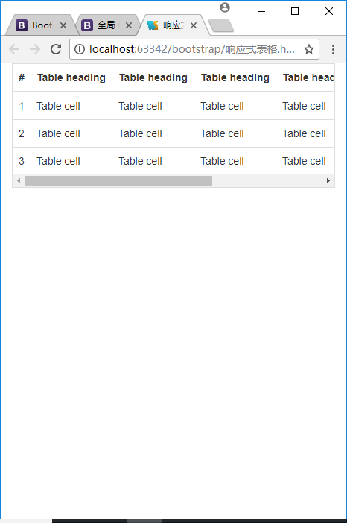

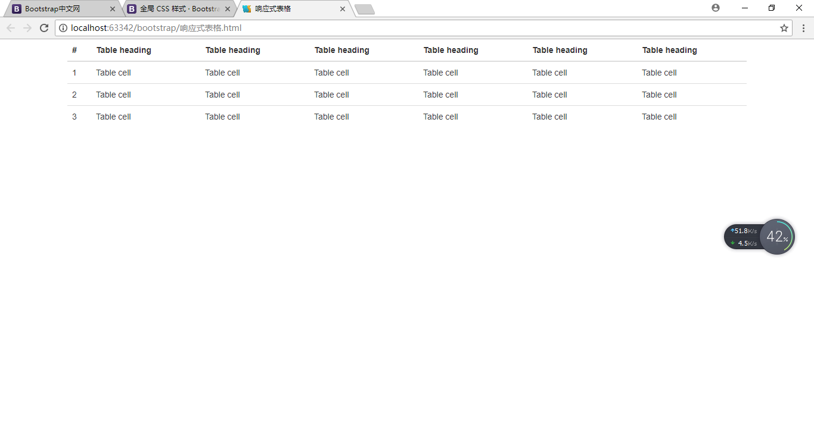

Object.setPrototypeOf(CNStudent.prototype,CNPeople.prototype);实现的继承

function CNPeople(*name*,*age*){  
 this.name=*name*;  
 this.age=*age*;  
}  
CNPeople.prototype.hairColor="black";  
CNPeople.prototype.talk=function(){  
 *console*.log("talk Chinese");  
};  
function CNStudent(*name*,*age*,*sumGrade*){  
 CNPeople.call(this,*name*,*age*);  
 this.sumGrade=*sumGrade*;  
}  
CNStudent.prototype.test=function(){  
 *console*.log("成绩为："+this.sumGrade);  
};  
Object.setPrototypeOf(CNStudent.prototype,CNPeople.prototype);  
  
var *s1*=new CNStudent("zsq",25,100);  
*console*.log(*s1*);  
*console*.log(*s1*.hairColor);  
*s1*.talk();  
*s1*.test();

*util*.inherits(CNStudent,CNPeople);实现的继承，若表达式1、2交换位置，则表达式3报错（s1.test is not a function）。

var *util*=require("util");  
function CNPeople(*name*,*age*){  
 this.name=*name*;  
 this.age=*age*;  
}  
CNPeople.prototype.hairColor="black";  
CNPeople.prototype.talk=function(){  
 *console*.log("talk Chinese");  
};  
function CNStudent(*name*,*age*,*sumGrade*){  
 CNPeople.call(this,*name*,*age*);  
 this.sumGrade=*sumGrade*;  
}  
*util*.inherits(CNStudent,CNPeople);//表达式1  
CNStudent.prototype.test=function(){  
 *console*.log("成绩为："+this.sumGrade);  
};//表达式2  
var *s1*=new CNStudent("zsq",25,100);  
*console*.log(*s1*);  
*console*.log(*s1*.hairColor);  
*s1*.talk();  
*s1*.test();//表达式3

*util*.inherits()方法实现的只是构造函数的原型对象的继承，并且与Object.setPrototypeOf()方法相比，有缺陷。

var *util*=require("util");  
function Base() {  
 this.name = 'base';  
 this.year = 1991;  
 this.sayHello = function() {  
 *console*.log('Hello ' + this.name);  
 };  
}  
Base.prototype.showName = function() {  
 *console*.log(this.name);  
};  
function Sub() {  
 this.name = 'sub';  
}  
*util*.inherits(Sub, Base);  
var *objSub* = new Sub();  
*console*.log(*objSub*);  
*console*.log(*objSub*.name);//sub  
*console*.log(*objSub*.year);//undefine  
*objSub*.showName();//sub

*objSub*.sayHello();//报错（sayHello is not a function）

向某个构造函数的原型对象中添加方法时不能用箭头函数

CNStudent.prototype.test=function(){  
 *console*.log("成绩为："+this.sumGrade);  
};

.clearfix:before,.clearfix:after {  
 display: table;  
 content: " ";  
}

.clearfix:after {  
 clear: both;  
}

margin实现div居中

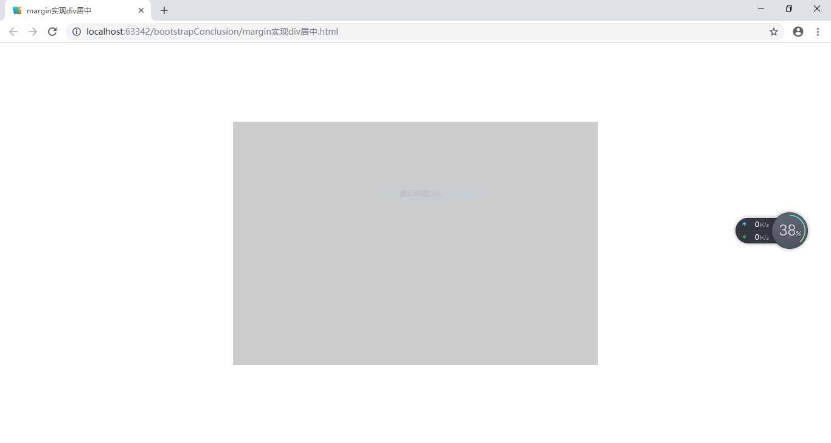

<!DOCTYPE html>  
<html lang="en">  
<head>  
 <meta charset="UTF-8">  
 <title>margin实现div居中</title>  
 <style>  
 html {  
 height: 100%;  
 }  
 body {  
 margin: 0;  
 height: 100%;  
 position: relative;  
 }  
 div {  
 width: 600px;  
 height: 400px;  
 background-color: #ccc;  
 position: absolute;  
 left: 50%;  
 top: 50%;  
 margin-left: -300px;  
 margin-top: -200px;  
 }  
 </style>  
</head>  
<body>  
 <div></div>  
</body>  
</html>

css3 transform实现div居中

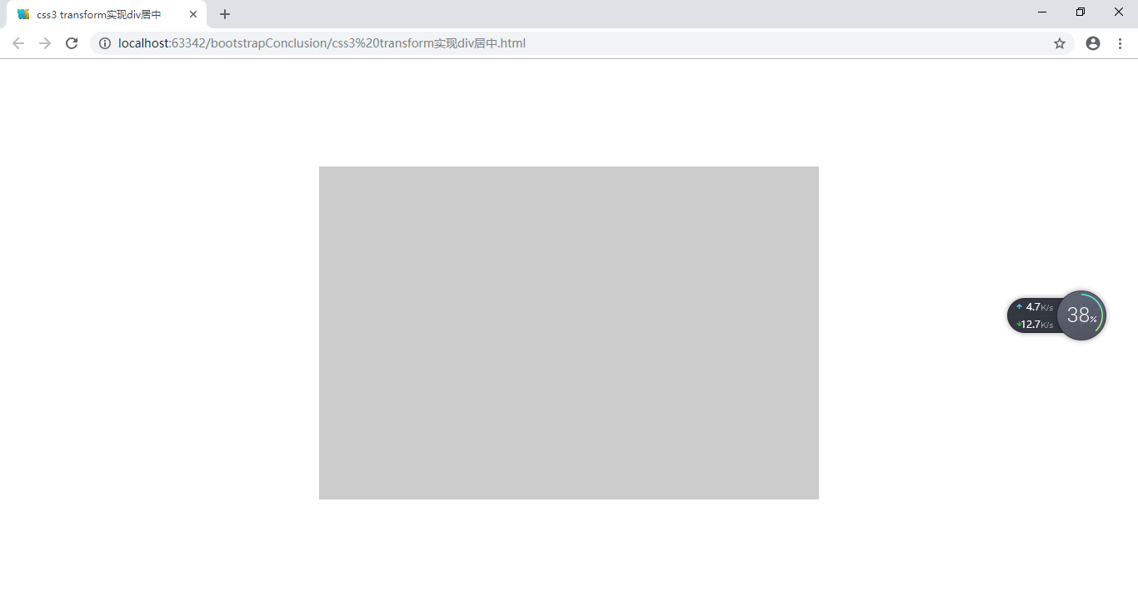

第三种方法实现div居中

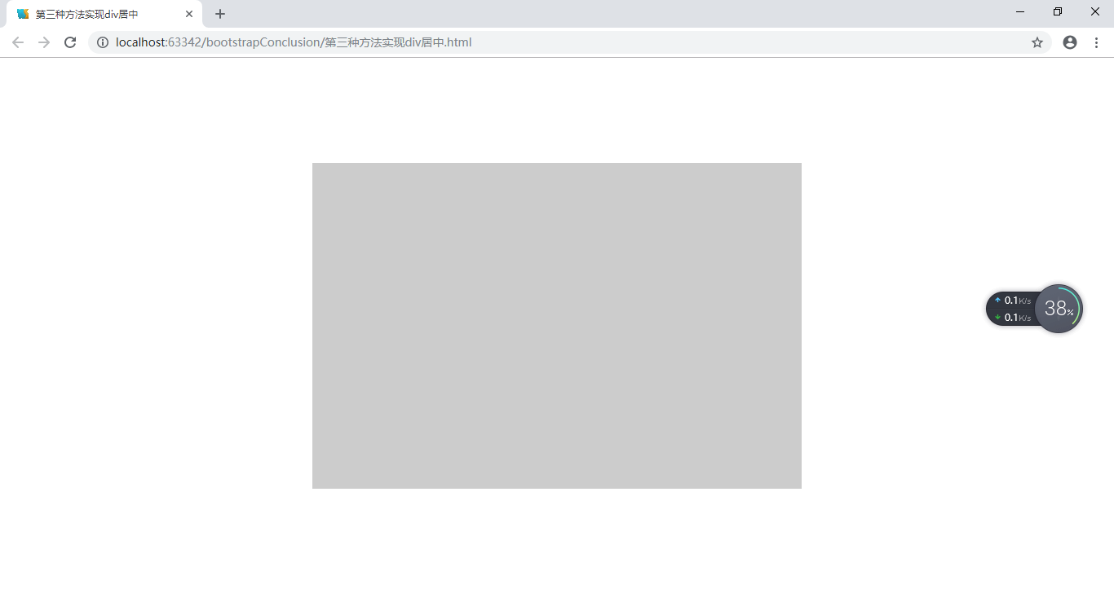

<!DOCTYPE html>  
<html lang="en">  
<head>  
 <meta charset="UTF-8">  
 <title>第三种方法实现div居中</title>  
 <style>  
 html {  
 height: 100%;  
 }  
 body {  
 margin: 0;  
 height: 100%;  
 position: relative;  
 }  
 div {  
 width: 600px;  
 height: 400px;  
 background-color: #ccc;  
 position: absolute;  
 margin: auto;  
 left: 0;  
 top: 0;  
 right: 0;  
 bottom: 0;  
 }  
 </style>  
</head>  
<body>  
 <div></div>  
</body>  
</html>

css属性-display-visibility-opacity区别

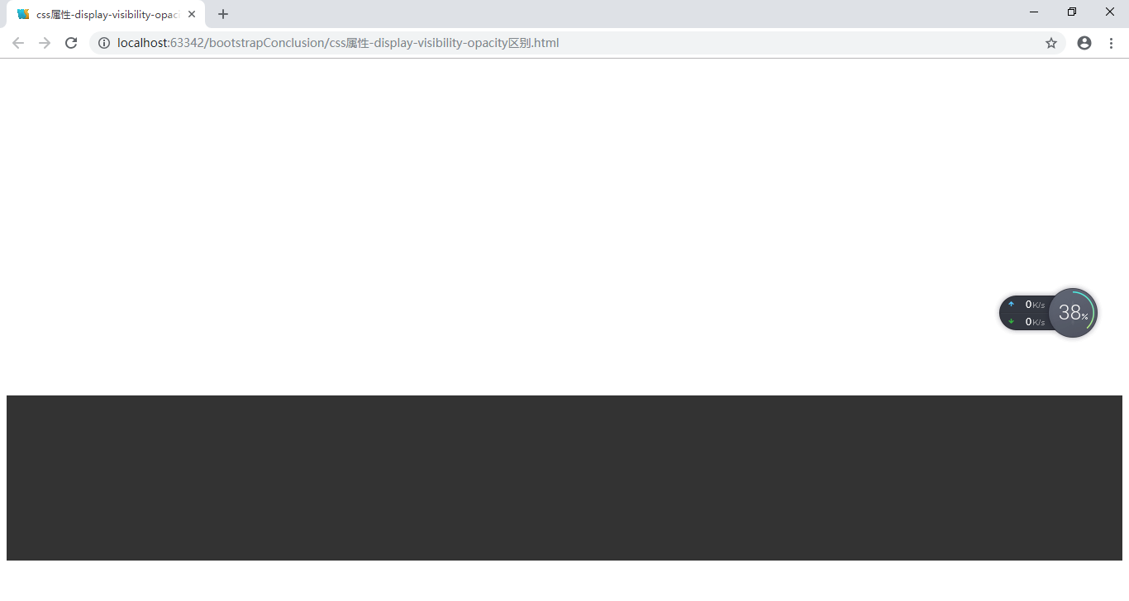

popup自写

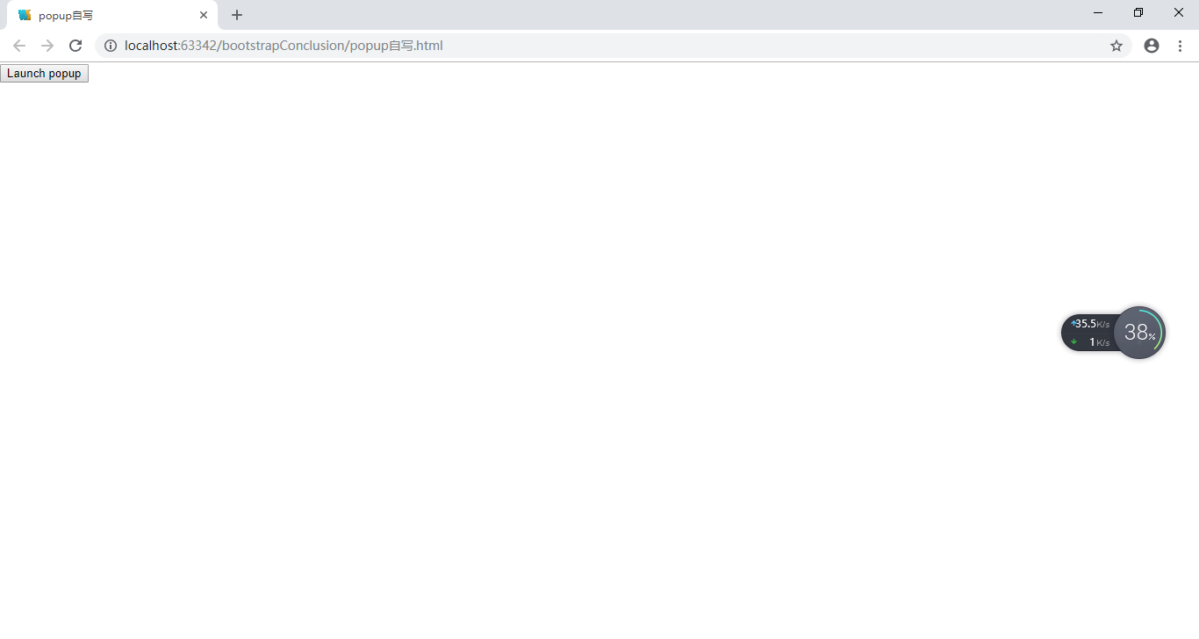

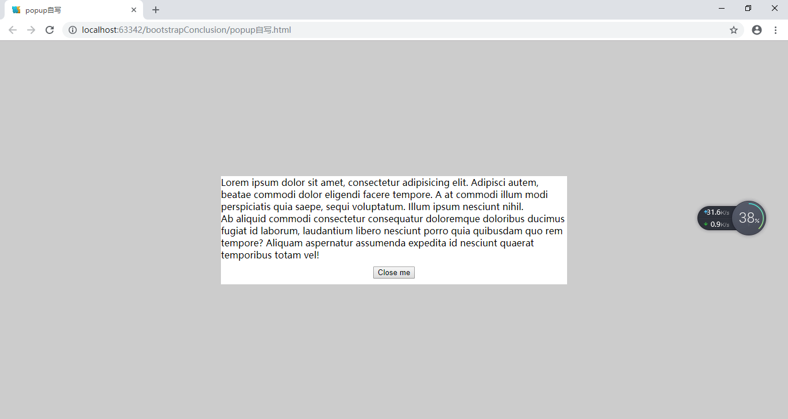

<!DOCTYPE html>  
<html lang="en">  
<head>  
 <meta charset="UTF-8">  
 <title>popup自写</title>  
 <script src="js/jquery-1.11.3.js"></script>  
 <style>  
 html {  
 height: 100%;  
 }  
 body {  
 margin: 0;  
 height: 100%;  
 }  
 #popup {  
 width: 100%;  
 height: 100%;  
 position: fixed;  
 left: 0;  
 top: 0;  
 display: none;  
 }  
 #popup-bg {  
 width: 100%;  
 height: 100%;  
 background-color: #ccc;  
 position: absolute;  
 left: 0;  
 top: 0;  
 }  
 #popup-content {  
 width: 600px;  
 background-color: #fff;  
 position: absolute;  
 left: 50%;  
 top: 50%;  
 transform: translate(-50%, -50%);  
 -ms-transform: translate(-50%, -50%);  
 -moz-transform: translate(-50%, -50%);  
 -webkit-transform: translate(-50%, -50%);  
 -o-transform: translate(-50%, -50%);  
 }  
 #close {  
 display: block;  
 margin: 10px auto;  
 }  
 #popup.show {  
 display: block;  
 }  
 </style>  
</head>  
<body>  
 <button type="button" id="launch">Launch popup</button>  
 <div id="popup">  
 <div id="popup-bg"></div>  
 <div id="popup-content">  
 <div>Lorem ipsum dolor sit amet, consectetur adipisicing elit. Adipisci autem, beatae commodi dolor eligendi  
 facere tempore. A at commodi illum modi perspiciatis quia saepe, sequi voluptatum. Illum ipsum nesciunt  
 nihil.  
 </div>  
 <div>Ab aliquid commodi consectetur consequatur doloremque doloribus ducimus fugiat id laborum, laudantium  
 libero nesciunt porro quia quibusdam quo rem tempore? Aliquam aspernatur assumenda expedita id nesciunt  
 quaerat temporibus totam vel!  
 </div>  
 <button type="button" id="close">Close me</button>  
 </div>  
 </div>  
 <script>  
 **$**("#launch,#popup-bg,#close").click(function(){  
 **$**("#popup").toggleClass("show");  
 });  
 </script>  
</body>  
</html>