1. From a transaction, obtain   
   \* KSN: F876543210040B800003  
   \* EncryptedPIN: C575540D19A26479
2. Using IdTech Encryption/Decryption tool obtain:  
   \* IPEK key: D513212CE472B04160495A01F5AE539C  
   \* Decrypted PIN: 0443FCFFFFFF8FE6  
   note: BDK = 0123456789ABCDEFFEDCBA9876543210  
     
   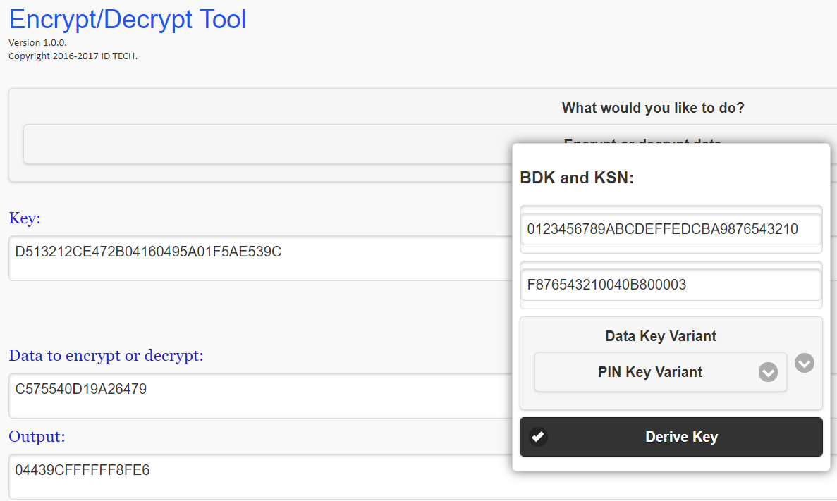  
     
   USING DUPKT IN BP-TOOLS  
   \* obtain Derived PEK: D513212CE472B0BE60495A01F5AE5363  
   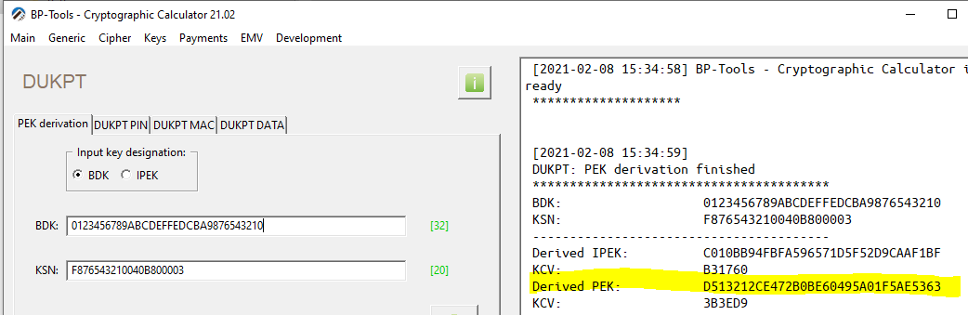  
     
   \* decode output using DUKPT PIN method:  
   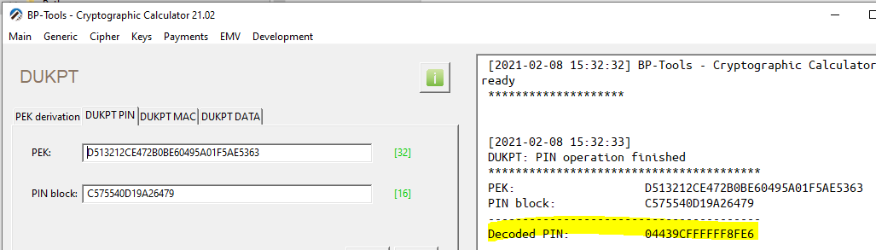
3. In the BP-Tools, decode the PIN using:  
   \*DecryptedPIN: 0443FCFFFFFF8FE6  
   \*PAN: 6799998900000070199  
     
   