Two Wheels Local Courier System
Design Document

Tiffany Bonneau
Bernard Simmons
Norris Walker
Vianco Hall

October 23, 2003
Version Final 1.0

Reviewed by Customer:
Reviewed by Project Manager:

Table of Contents
1.0 Introduction 2
1.1 Purpose 2
1.2 Scope 2
1.3 Definitions, acronyms, and abbreviations 2
1.4 References 2
1.5 Overview of Document 3
2.0 System Architecture Description 4
2.1 Overview of Modules/Components 4
2.2 Structure and Relationships 5
2.2.1 Operators 5
2.2.1.1 Clerks 5
2.2.1.2 Administrators 6
2.2.2 Components of System 7
2.2.2.1 Database 7
2.2.2.2 Package Tracking Logic 9
2.2.2.3 Account Creation Logic 9
2.2.2.4 Reports 9
3.0 User Interface Design 10
3.1 Description of the User Interfaces 10
3.1.1 Login Screen 10
3.1.2 Clerk Interfaces 11
3.1.2.1 Option 1: Viewing Existing Customer Information 11
3.1.2.2 Option 2: Input New Customer Information 13
3.1.2.3 Option 3: Track Packages 14
3.1.2.4 Option 4: View Reports 15
3.1.2.4.1 Customer Account 15
3.1.2.4.2 Outstanding Deliveries 16
3.1.2.5 Option 5: Logout 17
3.1.3 Administrator Main Interface 17
3.1.3.1 Option 1: Add New Users 18
3.1.3.2 Option 2: Delete Users 18
3.1.3.3 Option 3: View All Users 18
3.1.3.4 Option 4: View Reports 18
3.1.3.5 Option 5: Logout 18
4.0 Restrictions, Limitations, and Constraints 18
4.1 Time 18
4.2 Limited Project Scope 18

Introduction

Purpose
The purpose of this document is intended to describe the design for the Two Wheels Courier Company System for Susan VandeVen, instructor for SWE 4624.

Scope
This document was developed by Tiffany Bonneau, Norris Walker, Vianco Hall, and Bernard Simmons as required by our instructor, Susan VandeVen, for SWE 4624.

Requirements in this document were developed from our instructor’s system description found in the Two Wheels Local Courier System Data Sheet, Version 1.0. We are constrained to use resources available to us as students at Southern Polytechnic State University and there is no budget for this project since we are not being monetarily reimbursed for this project.

This system is designed to provide a package tracking system for the Two Wheels Courier Company. This system must be able to schedule package pickup and deliveries, cancel customer requests if needed, track each package, record customer information, and provide price quotes for package service. Managers will be able to access the report section of this system for reports on package status, billing/money received, and daily activity summary reports.

Definitions, acronyms, and abbreviations

Term | Meaning
Data | Information typed into the system
Database | The collection of SQL tables that contain the information for the system
GUI | Graphical User Interface
Server | A computer on which the program database is stored
SRS | Software Requirements Specification

References
Almstrum, Vicki. " S2S Documentation Standards: SDS Information Documentation standards for CS373, UT Austin", 9 June 1996. Online. Internet [22 October 2003]. Available WWW: http://www.cs.utexas.edu/users/almstrum/cs373/current/doc-stds/SDS-info.html

Bonneau, Tiffany.; Hall, Vianco.; Simmons, Bernard.; Walker, Norris. “Two Wheels Local Courier System Specification Document” Final Version 1.0, 25 September 2003.

Overview of Document
Section 2 of this document describes the system architecture of our design of this system and the main components associated with this system. Section 3 of this document describes the user interfaces associated with this system. Section 4 describes all the restriction, limitation, and constraints associated with this project.

System Architecture Description

Overview of Modules/Components
This system is based on a single system architecture and can be divided into five (5) major components:

- Database: collection of the required data from the students and teachers.
- User Interface: enables the user to enter data into the database and display the stored or resulting calculations (obtained from the stored data.)
- Program Server: stores the actual program software and application file and houses the database containing all customer records (accounts.)
- Account Creation Logic: algorithm that takes the input entered into the new customer interface and creates a new record consisting of the entered customer information.
- Package Tracking Logic: algorithm that takes an input package id and traverses the database to obtain the delivery and pick-up information of the specified package.

These components will interact with each other as needed as users select options in the interfaces. For an overview of these user actions and how they relate to the system, see Figure 1: Overview of System Design

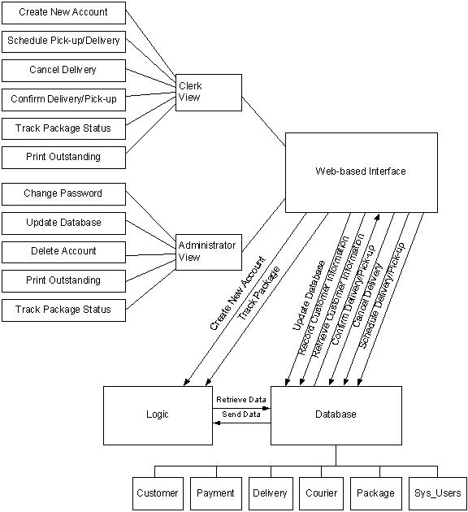
Figure 1: Overview of System Design

Structure and Relationships

Operators
This system will have the following types of users:

Clerks
Clerks will be able to:
- Create new customer accounts
- Confirm package deliveries and pick-ups
- Cancel deliveries
- Schedule package deliveries or pick-up
- View outstanding deliveries
- View customer accounts
- Track package status

Administrators
Administrators will be able to do everything that a clerk level user can do, but will have the following additional functionality:
- change passwords
- create new user accounts
- delete user accounts

Components of System

Database
Identification | Two Wheels Database
Type | Data files
Purpose | Repository for customer, payment, delivery, package, courier and user data.
Function | The database stores all information captured in Two Wheels courier daily operations. Information retrieved from the database is used to calculate charges for delivering packages and to create customer accounts.
Subordinates |  | The database consists of six tables, namely Customer, Payment,  Delivery, Courier, Package and User.
Dependencies |  | User Interface to interact with Database.
Interfaces |  | The user interfaces communicate with the database to store and retrieve operating data.
Resources |  | The database will be hosted on a WinTel platform. The data files will reside on the local hard drive.
Processing |  | Constraints will be placed on table columns to check for invalid entries.
Data |  | All tables except the user table will be empty on delivery of the system. These tables will be populated as the system is operated on a daily basis. The developers will create an initial administrative account and password, to be changed by customer upon delivery. The users with administrative privileges will then add users to the system as needed. The data tables to be created are: Customer, Payment, Delivery, Package, and Courier. The data tables will be linked together as shown in Figure 2: Entity - Relationship (ER) Diagram for System.
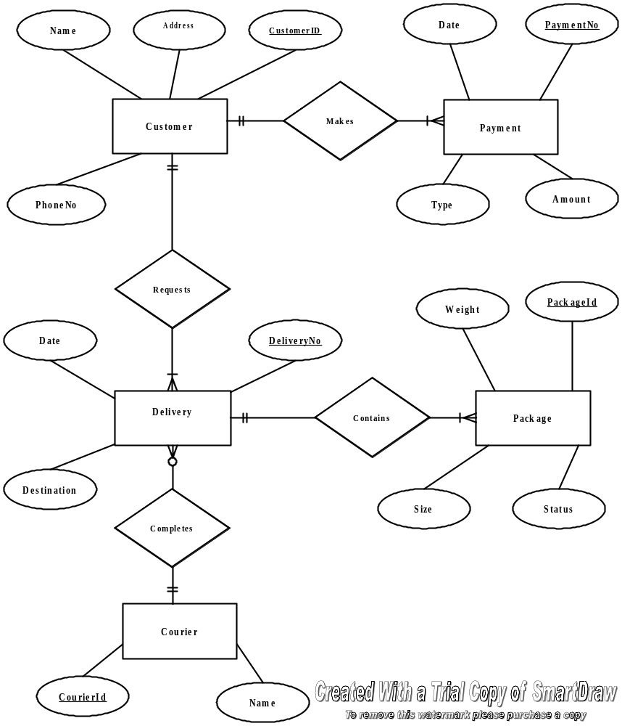
Figure 2: Entity - Relationship (ER) Diagram for System

Package Tracking Logic
Identification – Tracking.java
Type – Java Applet
Purpose – Tracks the status—delivered/picked-up—of a given package based upon its package id.
Function – Go through the database (package table) until a package id is found, and then, display package status information.
Subordinates – This level of detail is not available at this time
Dependencies – The package id input is a valid, existing package.
Interfaces – The module is to have an interface to retrieve data to update data in the database.
Resources – A computer with a Pentium class processor and 16 MB RAM.
Processing – Database must traverse package table to find matching package id from input.
Data – The external data is provided by the database and the internal data will be the corresponding data resulting from the external data (input package id.)

Account Creation Logic
Identification – NewAcct.java
Type – Java Applet
Purpose – Creates a new customer record in the database assigning it a unique id—customer telephone number.
Function – Go to next empty record in the database and append a new customer’s record, which will receive data (customer information) from the main interface
Subordinates – This level of detail is not available at this time
Dependencies – The input customer information is complete such that all fields in the new record can be filled.
Interfaces – The module is going to have an interface to the main web interface to receive data to update the database.
Resources – A computer with a Pentium class processor and 16 MB RAM.
Processing – Database must create a new record in the customer table.
Data – The external data is provided by the web interfaces and the internal data will be a copy of the external data to be stored in the database.

Reports
In this project, users will be able to print two types of reports—Customer Account and Outstanding Deliveries. For a more detailed description of the reports, see Section 4. The Customer Account and Outstanding Deliveries reports will be seen by both clerks and administrators.

User Interface Design
There will be about 14 interfaces in the design. Due to the iterative nature of the development process, this figure may change as development progresses and the different phases of the project are reviewed.

Description of the User Interfaces
Below are some of the forms and reports in the product. The application starts at the login screen. If the user enters a valid user name and password, they will be taken to an appropriate main screen depending on their classification (clerk or administrator).

Login Screen
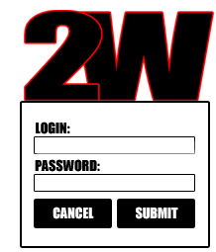
Figure 3: Login Screen
Access to our system is by a login screen. This screen is the same for all users. Currently it is expected that there will be three regular users of the application, two clerks and one administrator. The Office Manager will assume routine system administration duties, and she will contact the developers for non-routine problems. Because of the small number of users and to enhance security, a blind login name system will be adopted. The system design makes allowance for future growth in the number of users as the company grows.

This screen has the following elements:

Login Field
Users log into using Login ID can be 6 to 20 alphanumeric characters, as per industry standard. No special characters or space are allowed.

Password Field
Password can be 6 to 20 alphanumeric characters, as per industry standard. No special characters or space are allowed.

Submit Button
If the user enters a valid user name password pair, clicking “SUBMIT” will immediately take them to the appropriate main interface screen. Clerks will be taken to the “Main Clerk Interface (see Figure 3) and the Administrators will be taken to the “Administrator Main Interface” (see Figure 9).

Cancel Button
The user may click the “CANCEL” button to exit the application.

Clerk Interfaces
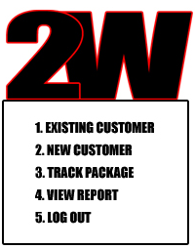
Figure 4: Login Options Screen
Once logged into the system, a login options screen will appear (see Figure 4) with options the clerk can select to interface with the system. Clerks will be able to: view existing customer information (option 1), input new customer information (option 2), track packages (option 3), view reports (option 4), or logout (option 5). These options will be selected by rolling over the menu option and clicking on the option. The functionality of each of these options is described in the following sections.

Option 1: Viewing Existing Customer Information
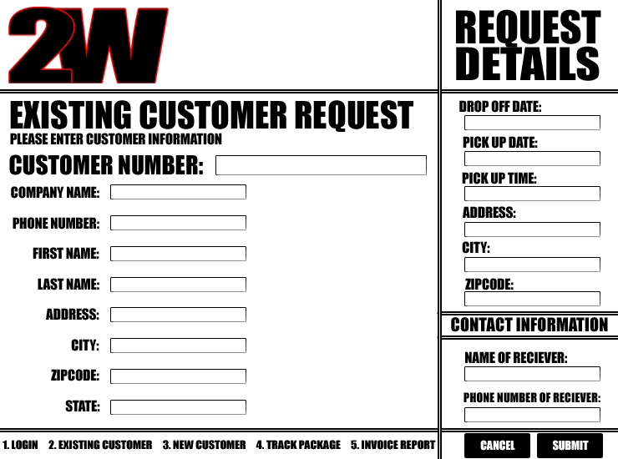
Figure 5: Existing Customer Service Request Screen
If the existing customer menu item is selected when dealing with existing customer data, the screen shown in Figure 5 will appear. From this screen you will have the ability to update existing customer data and schedule package pick up. You will enter the data needed on this screen in the fields provided and then hit submit to accept the scheduled pick up. If you select cancel, you will clear all the fields on the screen.
This screen has the following elements:

In the Main Existing Customer Request Box:
Customer Number Field
In this field you will be able to enter the customer’s number into the field. If you hit tab to go to the next field, the system should then look up the customer number from the database and put the customer’s information in the remaining fields for verification. If there are any changes to the customer’s information, the user will able to type the changes in the fields in this section and they will update when the user hits the submit button.

Company Name Field
Text field that allows up to 80 characters for the company’s name.

Phone Number Field
Number field that allows you to only type in a 10 digit phone number.

First Name Field
Text field that allows up to 40 characters for the customer’s first name.

Last Name Field
Text field that allows up to 40 characters for the customer’s last name.

Address Field
Text field that allows up to 120 characters for the customer’s address.

City Field
Text field that allows up to 25 characters for the customer’s city.

Zip Code Field
Number field that allows up to 9 characters for the customer’s zip code.

State Field
Drop down menu containing all 50 states 2 letter abbreviations for the customer’s city.

In the Request Details Box of this Screen:

Drop Off Date Field
Date field for date of drop off, if the customer is going to be dropping off the package at the Two Wheels Local Courier company headquarters. This field can be empty if the user is not going to be dropping off their package at Two Wheels.

Pick Up Date Field
Date field for date of pick up of package. This field cannot allow invalid dates to be selected.

Pick Up Time Field
Drop down menu with available time ranges for package pick up.

Address Field
Text field that allows up to 120 characters for the pick up address address.

City Field
Text field that allows up to 25 characters for the pick up city.

Zip Code Field
Number field that allows up to 9 characters for the pick up zip code. The information in the zip code will be used to determine if the package is within the delivery range. The state is not needed because Two Wheels does not make deliveries across state lines.

In the Contact Information Box of this Screen:

Name of Receiver Field
Text field that allows up to 80 characters for the customer’s full name.

Phone Number of Receiver Field
Number field that allows you to only type in a 10 digit phone number for recipient’s phone number.

Option 2: Input New Customer Information
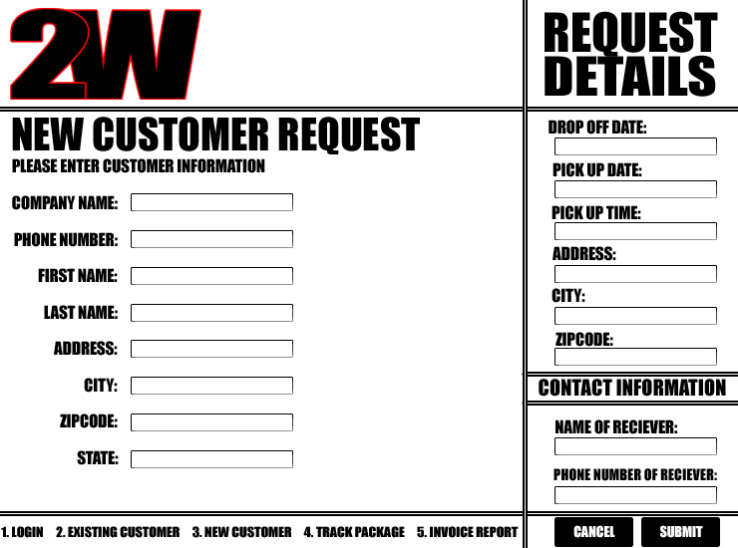
Figure 6: New Customer Information Input Screen

If the new customer menu item is selected when dealing with a new customer, the screen in Figure 6 will appear. From this screen you will have the ability to create a new customer account and schedule package pick up. The customer number will provided once their first package is scheduled after you hit submit. You will enter the data needed on this screen in the fields provided and then hit submit to accept the scheduled pick up. If you select cancel, you will clear all the fields on the screen.

This screen has the following elements:

In the Main Existing Customer Request Box:
Company Name Field
Text field that allows up to 80 characters for the company’s name.

Phone Number Field
Number field that allows you to only type in a 10 digit phone number.

First Name Field
Text field that allows up to 40 characters for the customer’s first name.

Last Name Field
Text field that allows up to 40 characters for the customer’s last name.

Address Field
Text field that allows up to 120 characters for the customer’s address.

City Field
Text field that allows up to 25 characters for the customer’s city.

Zip Code Field
Number field that allows up to 9 characters for the customer’s zip code.

State Field
Drop down menu containing all 50 states 2 letter abbreviations for the customer’s city.

In the Request Details Box of this Screen:

Drop Off Date Field
Date field for date of drop off, if the customer is going to be dropping off the package at the Two Wheels Local Courier company headquarters. This field can be empty if the user is not going to be dropping off their package at Two Wheels.

Pick Up Date Field
Date field for date of pick up of package. This field cannot allow invalid dates to be selected.

Pick Up Time Field
Drop down menu with available time ranges for package pick up.

Address Field
Text field that allows up to 120 characters for the pick up address address.

City Field
Text field that allows up to 25 characters for the pick up city.

Zip Code Field
Number field that allows up to 9 characters for the pick up zip code. The information in the zip code will be used to determine if the package is within the delivery range. The state is not needed because Two Wheels does not make deliveries across state lines.

In the Contact Information Box of this Screen:

Name of Receiver Field
Text field that allows up to 80 characters for the customer’s full name.

Phone Number of Receiver Field
Number field that allows you to only type in a 10 digit phone number for recipient’s phone number.

Option 3: Track Packages

The track package menu item is selected, a screen with a field for entering the package id, a submit button, and a cancel button will appear. In the field you will enter the tracking number. You will then either hit submit or cancel buttons. If you hit submit, a status window with all of the package information (customer number, address of pick up, address of delivery, and name of receiver) and the status of the package will be displayed. If you select cancel, you will go back to the Main Interface Screen with the menu options (see Figure 4).

This screen has the following elements:

Package ID Field
Text field for entering the package id number.

Submit Button
If the user enters a valid package id, clicking “SUBMIT” will produce a report to the screen of the package information and status, if the package is in the system. “Package Not Found” message will be displayed if the package id is not found in the database

Cancel Button
The user may click the “CANCEL” button to return their appropriate user main menu.

Option 4: View Reports
A listing of available reports will be available for selection, similar to the menu selection choices in Figure 4. Currently, the available reports are “View Customer Account” and “View Outstanding Deliveries”. These reports will be able to be selected by rolling over the items with the mouse and clicking on the desired report.

Customer Account
The customer account report will contain the following information:
- Customer name—first, last, MI
- Customer address—street, city, state, and zip
- Customer telephone number
- Current date/time
- Customer history (pick-ups/deliveries)
- payments/type
- dates/times
- recipient’s name
- destination address
- package id

The report will be formatted as shown in Figure 7.

Customer Report

Bernard Simmons
1555 Jason Rd.
Marietta, GA 33333
(770) 555-1948

Customer History

Delivery date: 10/19/2003
Delivery time: 15:32
Package id: BJS-33333-1948-001
Recipient: Mariana Razola
Address: 1332 Latin Ln.
Marietta, GA 30067

Charge: $5.31
Payment type: Check (#600341)

Delivery date: 10/20/2003
Delivery time: 18:32
Package id: BJS-33333-1948-001
Recipient: Mariana Razola
Address: 1332 Latin Ln.
Marietta, GA 30067

Charge: $10.63
Payment type: AMEX #4122-7023-1234-0027
exp. 11/2004

__________

-- End of Report –

Two Wheel Courier Systems
10/20/2003 21:02
Copyright © 2003-04 – SWE, Inc.
Figure 7: Customer Account Information Report

Outstanding Deliveries
The customer account report will contain the following information:
- Current date/time
- Outstanding deliveries
  - sender’s name
  - source address
  - package id
  - recipient’s name
  - destination address
The report will be formatted as shown in Figure 8.

Outstanding Deliveries

-- Pending deliveries as of Oct. 20, 2003 –

Package id: BJS-33333-1948-002
Sender: Bernard Simmons
Source address: 1555 Jason Rd.
Marietta, GA 33333
Recipient: Mariana Razola
Destination address: 1332 Latin Ln.
Marietta, GA 30067

Package id: MJC-30061-1981-003
Sender: María José Castellanos
Source address: 1575 Mexico Way
Marietta, GA 30061
Recipient: Mike Gutiérrez
Destination address: 1979 Spain St.
Marietta, GA 30054

_______

-- End of Report –

Two Wheel Courier Systems
10/20/2003 21:27
Copyright © 2003-04 – SWE, Inc.
Figure 8: Outstanding Deliveries Report

Option 5: Logout
If this option is selected, the user will be returned to the initial login screen as shown in Figure 1.

Administrator Main Interface
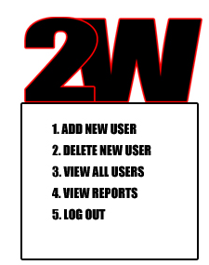
Figure 9: Administrator Main Interface
Once logged into the system, a login options screen will appear (see Figure 9) with options the administrator can select to interface with the system. Administrators will be able to: add new users (option 1), delete users (option 2), view all users (option 3), view reports (option 4), or logout (option 5). These options will be selected by rolling over the menu option and clicking on the option. The functionality of each of these options is described in the following sections.

Option 1: Add New Users
If this menu item is selected, the logged in user will be able to create new users as needed. This screen will have the following fields: userid (alphanumeric), passworld (alphanumeric), user’s name (text). It will also have a submit and cancel button.

Option 2: Delete Users
If this menu item is selected, the logged in user will be able to view a listing of users with access to the system. From the list provided, the user can select a user in the list to delete. A pop up window will then ask the logged in user if they really want to delete the user selected and provide yes and no buttons. The system will then take the appropriate action based on the button selected: yes – remove user or no-go back to the list of users.

Option 3: View All Users
If this menu item is selected, the logged in user will be able to view a listing of users with access to the system and their real names.

Option 4: View Reports
Same as clerk, see section 3.1.2.4.

Option 5: Logout
Same as clerk, see section 3.1.2.5

Restrictions, Limitations, and Constraints

Time
Given that we only have about one month and a half to finish the entire project, time has caused us to omit several software details from the overall design. For example, we could have added more options—such as additional reports or a help menu—to the software; nonetheless, we must keep the design simple in order to complete each development phase by the set deadline, and thus, finish the end prototype on time.

Limited Project Scope
Another constraint on this project is the fact that the project is limited in scope. For that reason, it is not necessary to design a full-blown software application; therefore, omitting some of the printable reports generation and the software usage tutorial (help menu) keeps the scope within the intended limits set by Professor VandeVen.

