23 OCT 2014

Matlab Simulink VRtool Bouncing Box Example

Ben Cheng and Don Brutzman

Naval Postgraduate School, Monterey California USA

Remodel the Bouncing Ball example in Matlab VRtool tutorial

<http://www.mathworks.com/help/sl3d/examples/bouncing-ball.html>

project online, available as Bouncing Box Simulink at

<http://x3dgraphics.com/examples/X3dForAdvancedModeling/Matlab>

1. Description: this project bounces a flexible Box up and down by adapting an example from Matlab using Simulink for animation. Matlab users can select the Simulink project link to run this demo, which uses the VRML .wrl version of the scene. Mathworks Inc. produces [MATLAB](http://www.mathworks.com/products/matlab/?s_tid=hp_fp_ml), a programming language for technical computing, and [Simulink](http://www.mathworks.com/products/simulink/?s_tid=hp_fp_sl), a visual diagramming tool for simulation and Model-Based Design.
2. Simulink diagrams: This project modifies the Bouncing Ball example in Matlab.

We set the gravity force= 9.8(m/s) in “Constant” block, initial velocity=0 in “Velocity” block, initial position (Z-axle) = 20(m) in “Position” block. MATLAB Function block “fcn” calculates the force “f”, the X,Y-axis scaling “a”, and Z- axis translation “b” variables during simulation by the input variables position “Z” and velocity “v”.

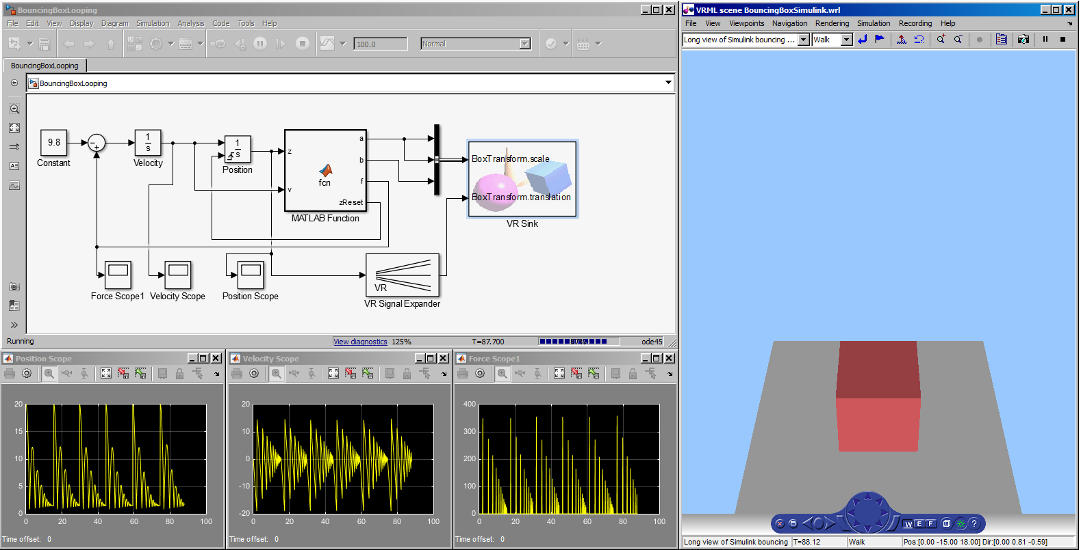

Double clicking one of the VR Sink *.slx files causes the simulation scene to appear.

**Parameters: VR Sink**

1. In Simulation/Block parameters, you can choose the 3D model in *.wrl format.
2. In VRML Tree, you can check the transformation variables you wish to render during the simulation. In this example, we chose “scale” and “translation”.

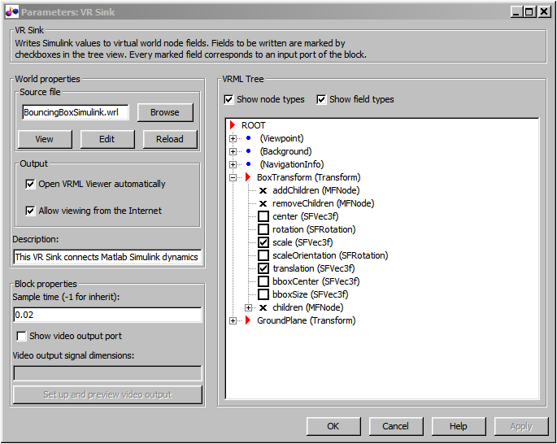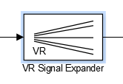

2.

1.

**Function Block Parameters**

1. Output width = 3 indicates there are three output parameters (X, Y, Z in this case).
2. The “Position” variable only goes to Z-axis by setting “Output signal indices = [3]”

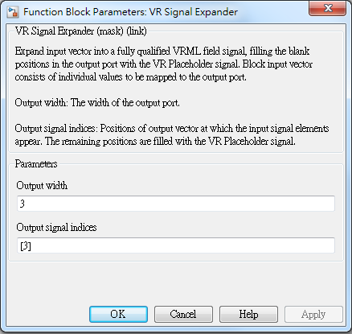

2.

1.

**Position Scope:**

It shows the position change ( Z-axis) of box. Since there is the damping function embedded in control block “fcn”, there is the attenuation of Z-axle movement.

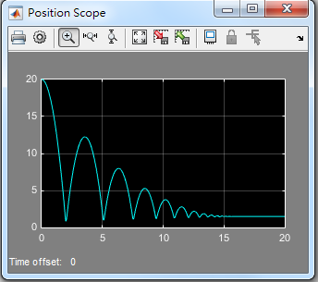

**Velocity Scope:**

It shows the velocity change (Z-axis) of box. Likewise, we can observe the attenuation in velocity over time.

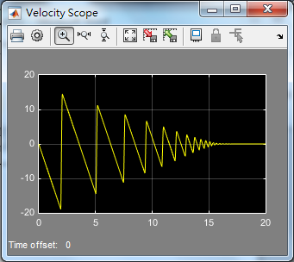

You can also view the animation in your PC web browser <http://localhost:8123> and change the view points by “Page-up” and “Page-down”

During free fall animation, box has acceleration = 9.8 m/s along the vertical Z-axis.

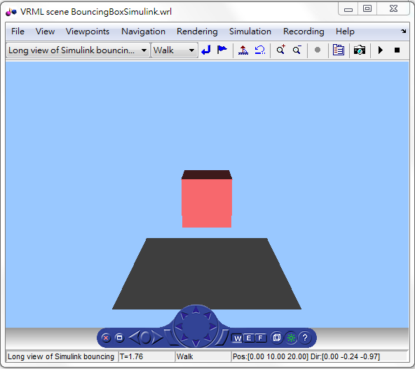

When collision occurs between the box and the ground, a “squishing” animation modifies the X, Y-axis scale of the box larger and Z-axis scales down smaller.

