2015

Deepalakshmi Subramanian

Vision College

5/4/2015

TREND Website Planning



Contents

Client details 3

Project description 4

Domain names 4

Research and analysis 5

Competitors 5

Visual elements 6

Colour scheme 6

Shapes 6

Important visual elements 6

Pages and content 7

Site map 10

System description 11

Login process 11

Registration process 11

Registered users system 11

Wish list 12

Shopping cart 12

User account 13

Admin process 13

Add/edit - category 13

Add/edit - subcategory 14

Add/edit products 14

Delete products 15

Enquiry process 15

Product search system 16

Full text search process 16

Security system 16

Wireframes 17

Home page 17

subcategory page 18

Product page 19

Contact page 20

Product description page 21

Login page 22

Sign up page 23

Wish list page 24

Shopping cart page 25

Shipping details page 26

Invoice page 27

My account page 28

Admin home page 29

Admin subcategory page 30

Admin product page 31

Task list 32

Draft design - desktop 35

Draft design - mobile 36

# Client details

Client name : Dave Williams

Company name : TREND

Brand name : TREND

Domain name : www.trend.co.nz

Email : [dave@trend.co.nz](mailto:dave@trend.co.nz)

Mobile : 0274048712

Designation of the person providing information : Business Owner

Responsibility of proofing, editing and copywriting : Dave Williams

The core business of the company is selling trendy men’s clothes. They are fairly new to the market and want to promote their brand name as well as sell their products online.

# Project description

A fully functional, user friendly, responsive and dynamic ecommerce website will be developed for the company TREND to sell their products online. As they sell fashion clothes for men, their target audience are men with good online experience and age range 25 - 40. Hence the style and appearance of the website must be modern resembling bold and sturdy characteristics. Further, after the launch of the website the client expect to achieve a 10% increase in the sales within the first month.

Goal : 10% increase in the sales within the first month after the launch of the website

Target audience : Urban/men customers with age range 25 – 40 and have high speed broadband connection

Client’s colour preference : bright and manly colours

Logo redesign : Must be readable and contrast

Images uploads : Administrator must be allowed to upload images

Content for the website : The content for the website will be provided by the client

Payment method : PayPal

Browser compatibility : Firefox 31+, Chrome 28+, Safari 5+, Opera 15+, IE 10+

Hosting and databases : Linux server technology, MySQL database

# Domain names

Suggested client to buy some domain names that are appropriate for the business.

**Domain name** **Cost**

[www.trend.com](http://www.trend.com) $28.95/year

[www.trend.org](http://www.trend.org) $19.99/year

# Research and analysis

Analysed the ecommerce websites of some of the online retail businesses like EziBuy, Farmers and GrabOne. The client liked the usage of tiles in Farmers website and wants to use the same in their website. The flow process of each ecommerce website has been studied and analysed to create a user friendly system for the client.

## Competitors

The client consider MECCANO as their current competitor and doesn’t quite like their website.

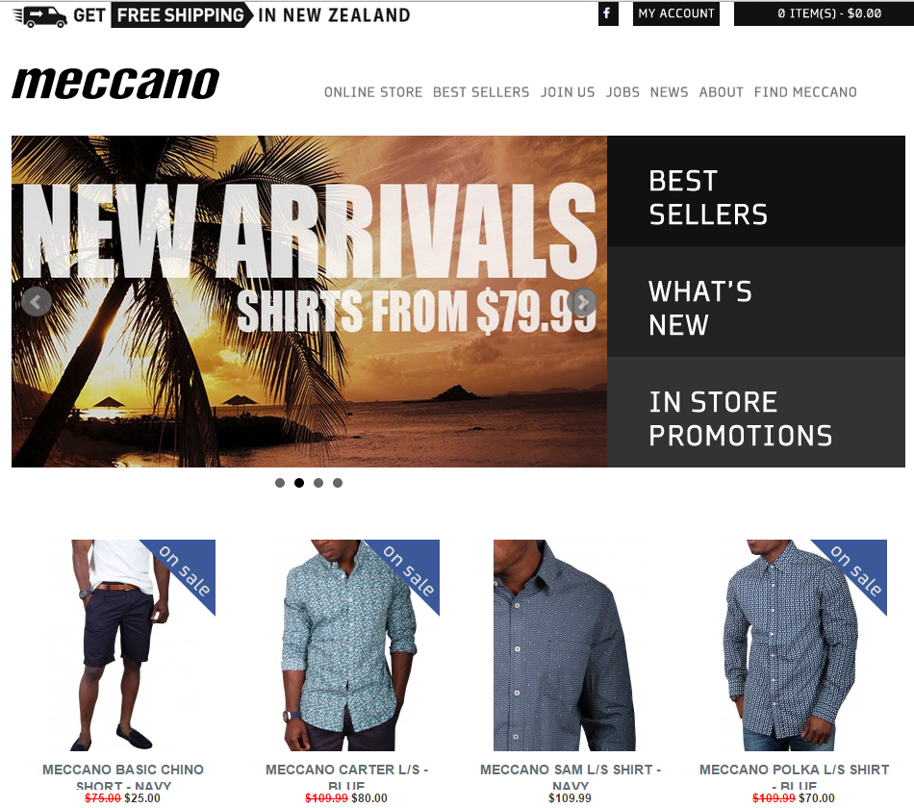

# Visual elements

## Colour scheme

Light background colour is selected for the main content area to showcase the products prominently. Grey shades and white are used for the menu to closely connect with the logo. Grey shades are used for displaying the products to give a consistent feel to the website. Overall a bright yet subtle and pleasant look is acquired.

## Shapes

Sharp squares and block shapes are used to give customers bold and sturdy feel. Further, overlapping squares and transparent labels give a modern look to the website. Logo is redesigned to be more readable.

## Important visual elements

All the main product categories and the header are the most important visual elements.

# Pages and content

|  |  |  |  |
| --- | --- | --- | --- |
| **No** | **Pages** | **Functionality** | **Content** |
| 1 | Home/main category page | To display the main product categories | Header, full text search, main category links, footer |
| 2 | Formal subcategory page | To display the formal product subcategories | Header, full text search, formal subcategory links, footer |
| 3 | Casual subcategory page | To display the casual product subcategories | Header, full text search, casual subcategory links, footer |
| 4 | Winter wear subcategory page | To display the winter wear product subcategories | Header, full text search, winter wear subcategory links, footer |
| 5 | Sleepwear subcategory page | To display the sleepwear product subcategories | Header, full text search, sleepwear subcategory links, footer |
| 6 | Shirt products page | To browse all the formal shirts | Header, full text search, Shirt products links, footer |
| 7 | Pant products page | To browse all the formal pants | Header, full text search, products links, footer |
| 8 | Jean products page | To browse all the jeans | Header, full text search, products links, footer |
| 9 | T-shirt products page | To browse all the T-shirts | Header, full text search, products links, footer |
| 10 | Jacket products page | To browse all the jackets | Header, full text search, products links, footer |
| 11 | Thermal products page | To browse all the thermals | Header, full text search, products links, footer |
| 12 | Pyjama products page | To browse all the pyjama sets | Header, full text search, products links, footer |
| 13 | Robes products page | To browse all the robes | Header, full text search, products links, footer |
| 14 | Product description page | To display information about single product | Header, full text search, product description, quantity – required field, ‘add to wish list’ link, ‘add to cart’ link , footer |
| 15 | Search page | To display search result | Header, full text search, search result links, footer |
| 16 | Login page | To allow user to login | Header, full text search, login form with link to register page, footer |
| 17 | Register page | To allow new users to sign up | Header, full text search, register form, footer |
| 18 | Logged in user pages | To allow logged in users to create wish list and to add items to the shopping cart | Header with acknowledgement, log out, full text search, ‘add to wish list’ link for every product in all the product displaying pages(shirt, pant, jean, T-shirt, jacket, thermal, pyjama, robes), footer |
| 19 | Wish list page | To allow the logged in users to view items in their wish list | Header with acknowledgement, log out, full text search, links to the product description page for each item in the wish list, quantity need not to be displayed, ‘add to cart’ link, ‘remove from wish list’ link, footer  *Redirect public users to login page |
| 20 | Shopping cart page | To allow the logged in users to view items in their shopping cart | Header with acknowledgement, log out, full text search, links to the product description page for each item in the cart, product image, product name, description, size, quantity, unit price, subtotal price, total price, ‘move to wish list’ link, ‘remove from cart’ link, footer  *Redirect public users to login page |
| 21 | Shipping detail page | To get billing and shipping details from customers | Header, full text search, footer, delivery type , billing address, shipping address |
| 22 | Invoice page | To display all possible information about the purchase | Header with acknowledgement, log out, full text search, summary of the purchase with order number and order details, footer |
| 23 | User account page | To display and edit the account details of the logged in users | Header, full text search, display user information with edit button. Then display the edited information to get confirmation from user. Finally, provide acknowledgement to user about the changes made, footer |
| 24 | Admin pages – add/edit/delete items, add/edit categories | Adding more controls to all other pages to enable adding, editing and deleting options to the admin person | Header with acknowledgement, log out, full text search, link to customer enquiry page , adding controls(add/edit/delete) to products display pages and the category pages, ability to upload images, footer |
| 25 | Contact page | To allow customers to contact TREND | Header, full text search, Contact form, email, physical address, phone number, footer |
| 26 | Terms and condition page | To display the purchase conditions | Header, full text search, Terms and condition , footer |
| 27 | Privacy policy  page | To display the privacy policy | Header, full text search, Privacy policy , footer |

# Site map

Invoice

Payment

Shipping details

Shopping cart

Contact

Sleepwear

Winter wear

Casual

Formal

Search

Wish list

Home

Yes

Log out

Register

Login

Logged in

Product description

Pyjama set

Jacket

Robes

Knitwear

T-shirt

Jean

Pant

Shirt

My account

No

Terms and condition

# System description

## Login process

User

Home

Login

Success?

No

Home

Log out

Home

Yes

## Registration process

Yes

User

Home

Register

Home

Log out

Home

Success?

No

## Registered users system

User

Home

Login

Success?

No

Yes

Wish list

Shopping cart

Only registered users will have access to wish list and shopping cart page. Every other user will be redirected to either login or sign up page.

## Wish list

Wish list

Yes

No

Login

User

Home

Logged in

No

Success?

Yes

Shopping cart

Payment

Success?

Get billing and shipping address

invoice

Yes

Reduce number of products in website and clear the cart

Homeome

Home

Log out

No

## Shopping cart

Homeome

Home

Log out

Yes

Success?

Yes

No

Shopping cart

Payment

Yes

No

User

Home

Logged in

Login

No

Success?

Reduce number of products in website and clear the cart

Get billing and shipping address

Invoice

## User account

Homeome

Home

Log out

Yes

Edited detail

confirmation

No

Yes

No

Success?

User

Home

Login

Home

My account

## Admin process

### Add/edit - category

Homeome

Log out

Updated

Version

Upload

Image

&

Provide

Title,

Description

Home

Add /edit categories

User

Home

Login

Admin?

Normal login process

Yes

No

### Add/edit - subcategory

Updated

Version

Homeome

Log out

Upload

Image

&

Provide

Title,

Description,

Which main category it belongs

Add /edit subcategories

Home

Normal login process

User

Home

Login

Admin?

No

Yes

### Add/edit products

Normal login process

Admin?

User

Home

Login

Home

Add /edit

Products

Upload image

&

Provide Title, Description, price,

Available sizes, main category,

Subcategory

Updated

Version

Homeome

Log out

No

Yes

### Delete products

Normal login process

Admin?

User

Home

Login

Home

Delete product

Delete product from the product table and delete all records from wish list for the corresponding product

Updated

Version

Homeome

Log out

No

Yes

## Enquiry process

Admin email

User

Home

Contact

## Product search system

User

Main category

Subcategory

Product list

## Full text search process

All the necessary columns of the appropriate tables in the database are indexed to perform full text search. This makes the search process easier and faster. Indexing is allowed for those columns (fields) with data types – char, varchar and text.

User

Home

Search

Database full text search

Result list

## Security system

Usage of HTML entities while displaying the content from the database and while inserting content to the database.

Prevention of SQL injection by binding values to parameters.

Hashing the passwords using md5 function to secure the login information.

Only authenticated admin person is authorized to add/edit/update product status.

Validation of all user input.

# Wireframes

## Home page

Formal Casual Winter wear Sleepwear

Contact Login Sign up

Logo

(200x57)

Wish list

Cart

Search box

Main category

Formal

(300x282)

Casual

(300x282)

Winter wear

(300x282)

Sleepwear

(300x282)

© Copyright TREND Ltd 2015 | Terms and condition | Privacy Policy

## subcategory page

Formal Casual Winter wear Sleepwear

Contact Login Sign up

Logo

(200x57)

Wish list

Cart

Search box

Subcategory

(300x282)

(300x282)

(300x282)

(300x282)

© Copyright TREND Ltd 2015 | Terms and condition | Privacy Policy

## Product page

Formal Casual Winter wear Sleepwear

Contact Login Sign up

Logo

(200x57)

Wish list

Cart

Search box

Products

Name and price

(300x282)

Name and price

(300x282)

Name and price

(300x282)

Name and price

(300x282)

© Copyright TREND Ltd 2015 | Terms and condition | Privacy Policy

## Contact page

Contact

Email

Phone number

Physical address

Send

Comment

Name

Email

Phone number

Formal Casual Winter wear Sleepwear

Contact Login Sign up

Logo

(200x57)

Wish list

Cart

Search box

© Copyright TREND Ltd 2015 | Terms and condition | Privacy Policy

## Product description page

Product description

With price

Product image

(300x282)

Add to

Wish list

Add to cart

Size

Product name

Formal Casual Winter wear Sleepwear

Contact Login Sign up

Logo

(200x57)

Wish list

Cart

Search box

Quantity

© Copyright TREND Ltd 2015 | Terms and condition | Privacy Policy

## Login page

Formal Casual Winter wear Sleepwear

Contact Login Sign up

Logo

(200x57)

Wish list

Cart

Search box

Login

Email

Password

Submit

© Copyright TREND Ltd 2015 | Terms and condition | Privacy Policy

## Sign up page

Formal Casual Winter wear Sleepwear

Contact Login Sign up

Logo

(200x57)

Wish list

Cart

Search box

Email

Password

Submit

First name

Last name

About you

© Copyright TREND Ltd 2015 | Terms and condition | Privacy Policy

## Wish list page

Formal Casual Winter wear Sleepwear

Wish list Cart Contact My account Log out

Logo

(200x57)

Search box

Wish list

Product name

Product image

(300x282)

Product unit price

Add to cart remove from wish list

Product name

Product image

(300x282)

Product unit price

Add to cart remove from wish list

© Copyright TREND Ltd 2015 | Terms and condition | Privacy Policy

## Shopping cart page

Product name

Product image

(300x282)

Product unit price

Product size

Product quantity

Subtotal amount

Product name

Product image

(300x282)

Product unit price

Product size

Product quantity

Subtotal amount

My shopping Bag

Formal Casual Winter wear Sleepwear

Wish list Cart Contact My account Log out

Logo

(200x57)

Search box

Move to wish list remove from cart

Move to wish list remove from cart

Total amount

Proceed to checkout

© Copyright TREND Ltd 2015 | Terms and condition | Privacy Policy

## Shipping details page

Formal Casual Winter wear Sleepwear

Wish list Cart Contact My account Log out

Logo

(200x57)

Search box

Shipping Information

Standard (drop down menu)

Delivery type

Address

Billing address

Address

Shipping address

Phone number

Continue

© Copyright TREND Ltd 2015 | Terms and condition | Privacy Policy

## Invoice page

Formal Casual Winter wear Sleepwear

Wish list Cart Contact My account Log out

Logo

(200x57)

Search box

First name Last name

Billing address

Shipping address

Order number

Order date

Amount

Product quantity

Product size

Product unit price

Product name

1

1

1

1

1

2

2

2

2

2

Total amount

Proceed to payment

© Copyright TREND Ltd 2015 | Terms and condition | Privacy Policy

## My account page

Formal Casual Winter wear Sleepwear

Wish list Cart Contact My account Log out

Logo

(200x57)

Search box

User email

Email

Edit

User last name

User first name

First name

Last name

Account information

Phone number

User phone number

Change password

My account Log out

© Copyright TREND Ltd 2015 | Terms and condition | Privacy Policy

## Admin home page

Add category

Edit

Edit

Edit

Winter wear

(300x282)

Sleepwear

(300x282)

Edit

Formal

(300x282)

Casual

(300x282)

Formal Casual Winter wear Sleepwear

Wish list Cart Contact My account Log out

Logo

(200x57)

Search box

© Copyright TREND Ltd 2015 | Terms and condition | Privacy Policy

## Admin subcategory page

Add subcategory

Edit

Edit

Main category name

Subcategory name

(300x282)

Subcategory name

(300x282)

Formal Casual Winter wear Sleepwear

Wish list Cart Contact My account Log out

Logo

(200x57)

Search box

© Copyright TREND Ltd 2015 | Terms and condition | Privacy Policy

## Admin product page

Add product

Edit

Edit

Products

(300x282)

Products

(300x282)

Sub category name

Formal Casual Winter wear Sleepwear

Wish list Cart Contact My account Log out

Logo

(200x57)

Search box

delete

delete

© Copyright TREND Ltd 2015 | Terms and condition | Privacy Policy

# Task list

|  |  |
| --- | --- |
| **Task list** | **Timeframe(min)** |
| Planning | 2400 |
| Client meeting (initial-sign off) | 400 |
| Design | 600 |
| Photoshop design | 300 |
| Database design | 460 |
| Database building | 180 |
| Database Populating | 300 |
| **Coding and styling** (php, html, css) | |
| Home page | 500 |
| Subcategory pages(4) | 800 |
| Products page(8) | 1600 |
| Product description page | 200 |
| Wish list page | 200 |
| Shopping cart page | 450 |
| Shipping details page | 120 |
| Invoice page | 240 |
| Login page | 120 |
| Sign up page | 120 |
| User account page | 100 |
| Contact page | 200 |
| Enquiry page | 200 |
| Terms and condition page | 20 |
| Search page | 200 |
| Log out page | 40 |
| Common pages(header & footer) | 200 |
| JavaScript – coding | 240 |
| SEO | 180 |
| Web hosting | 580 |
| Deployment | 600 |
| Testing | 1960 |
| Subtotal | 13510 |
| Time for unforeseen issues | 20%~2702 |
| **Total time estimated** | **16212** |

# Draft design - desktop

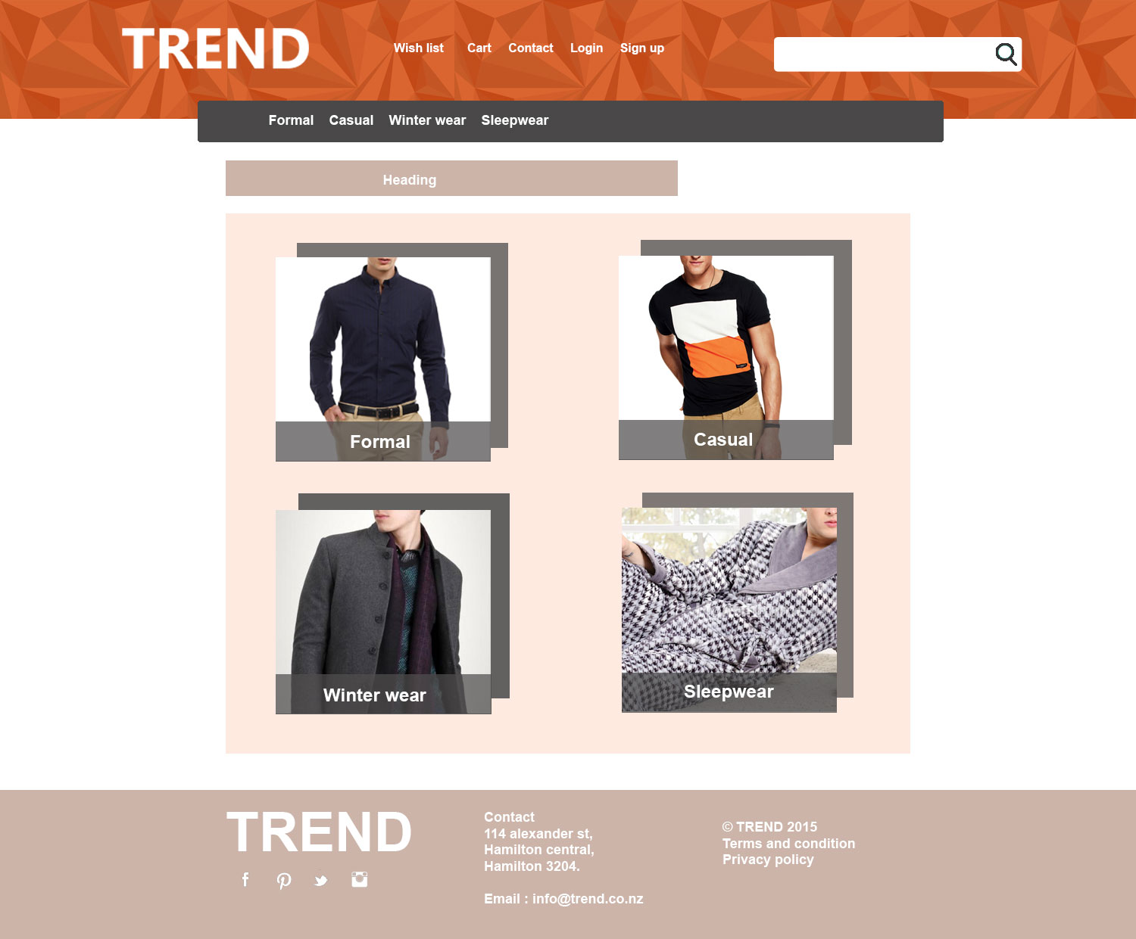

# Draft design - mobile

