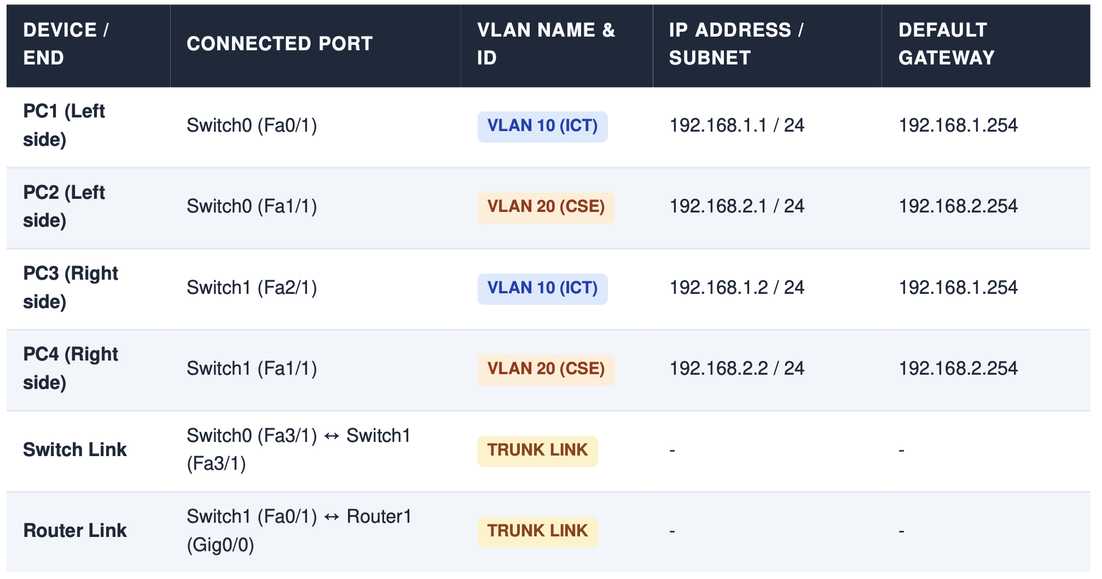

Switch 0:

en
config t
vlan 10
name ICT
exit
vlan 20
name CSE
exit
interface FastEthernet 3/1
switchport mode trunk
exit
interface FastEthernet 0/1
switchport mode access
switchport access vlan 10
exit
interface FastEthernet 1/1
switchport mode access
switchport access vlan 20
exit

Switch 1:

en
config t
vlan 10
name ICT
exit
vlan 20
name CSE
exit
interface FastEthernet 3/1
switchport mode trunk
exit
interface FastEthernet 2/1
switchport mode access
switchport access vlan 10
exit
interface FastEthernet 1/1
switchport access vlan 20
exit

Switch 1 to Router

interface FastEthernet 0/1
switchport mode trunk
exit

Router (Router 1):

en
config t
interface GigabitEthernet 0/0
no shutdown
exit
interface GigabitEthernet 0/0.10
encapsulation dot1Q 10
ip address 192.168.1.254 255.255.255.0
no shutdown
exit
interface GigabitEthernet 0/0.20
encapsulation dot1Q 20
ip address 192.168.2.254 255.255.255.0
no shutdown
exit

