Computer Vision in Railway Safety: A Comprehensive Analysis of the GERALD Dataset and Deep Learning Architectures

Abstract

The inception of Industry 4.0 has led to a paradigm shift in railway operations, moving from manual, human-centric monitoring to a more sophisticated approach driven by automated, data-driven systems. Central to this transformation is Computer Vision (CV), a field of Artificial Intelligence (AI) that empowers machines to interpret visual data. This paper presents a holistic analysis of the GERALD (German Railway Lightsignal Dataset), exploring the application of Computer Vision (CV) to facilitate Automatic Train Operation (ATO). We begin by evaluating foundational deep learning architectures—ResNet, VGG, MobileNet, and EfficientNet—for image classification tasks. Building upon this, we introduce a novel, end-to-end detection framework utilizing YOLOv8 and a proposed post-processing strategy termed Weather Adaptive Confidence Thresholding (WACT). Our experimental results demonstrate that while standard models struggle in adverse conditions, the WACT methodology achieves a 62.6% mAP@0.5 and provides up to a 50% improvement in detection performance for unknown weather conditions, offering a robust solution for real-time railway applications.

- Introduction

The field of Computer Vision deals with high-level and precise understanding of digital images and videos by computers. From an engineering-angle, the field aims to automate tasks that require the human visual system.

  - The Evolution of Computer Vision

The journey of CV began in the 1960s with simple image processing techniques aimed at edge detection and shape recognition. However, the true renaissance in this field occurred in 2012 with the introduction of AlexNet, a Convolutional Neural Network (CNN) that dominated the ImageNet Large Scale Visual Recognition Challenge (ILSVRC). Through this, the shift from "hand-crafted features" (where engineers manually defined what a corner or texture looked like) to "deep learning," where neural networks automatically learn hierarchical feature representations from vast amounts of data, began.
Today, CV is ubiquitous:
- Medical Imaging: In healthcare, CV algorithms analyze various X-rays, MRIs, CT scans and other images to detect anomalies like tumors, fractures, and so on, with precision often surpassing human radiologists (Simonyan & Zisserman, 2014).
- Automotive Industry: It is the "eyes" of autonomous vehicles (AVs). Companies like Tesla and Waymo utilize complex object detection networks to identify lanes, pedestrians, traffic signs, and other vehicles in real-time.
- Retail and Surveillance: Amazon Go stores use CV to track items taken from shelves, enabling cashier-less shopping, while smart city initiatives use it for traffic flow optimization and crowd safety monitoring.

  - Computer Vision in the Railway Domain

The railway industry, traditionally conservative, is increasingly adopting CV to enhance safety and efficiency. The European Rail Traffic Management System (ERTMS) and similar global standards are evolving to support Automatic Train Operation (ATO). CV plays a pivotal role in several key areas:
- Obstacle Detection: Detecting foreign objects (fallen trees, vehicles, people) on tracks to trigger emergency braking.
- Infrastructure Monitoring: High-speed inspection trains use line-scan cameras to detect sub-millimeter cracks in rails, missing fasteners, or damaged concrete sleepers (Olivier et al., 2025).
- Pantograph-Catenary Interaction: Real-time monitoring of the contact between the train's power collector (pantograph) and the overhead wire to prevent de-wiring incidents.
- Signal Aspect Detection: The focus of this paper. For a train to operate autonomously, it must reliably identify and interpret the state of trackside signals (Red, Green, Yellow) under varying weather and lighting conditions.

- Background: German Signalling Systems

To understand the GERALD dataset, one must understand the domain it models. German railways primarily use two signalling systems, both of which are covered in the dataset.

  - H/V System (Haupt-/Vorsignal)

The H/V system is the traditional standard, dating back to the era of mechanical semaphores but now largely implemented with colour lights. It separates the function of the Main Signal (Hauptsignal, Hp) and the Distant Signal (Vorsignal, Vr).
- Main Signals (Hp): Control entry into a block section. Common aspects include Hp 0 (Stop - Red) and Hp 1 (Proceed - Green).
- Distant Signals (Vr): Located braking distance before the main signal, they tell the driver what to expect. Vr 0 (Expect Stop - two Yellow lights) warns the driver to brake immediately.

  - Ks System (Kombinationssignal)

The Ks system is the modern replacement introduced in 1993. It utilizes a single signal head to display both main and distant signal functions, reducing infrastructure costs.
- Ks 1: Proceed (Green). If blinking, it indicates a speed restriction.
- Ks 2: Expect Stop (Yellow).
- Hp 0 (Ks): Stop (Red).
The transition from H/V to Ks is ongoing, meaning autonomous trains must be capable of understanding both systems simultaneously—a challenge reflected in the dataset's class structure.

- The GERALD Dataset: A Detailed Overview

The GERALD (German Railway Lightsignal Dataset) was introduced by Leibner et al. (2023) to address the lack of public, high-quality datasets for railway signaling.

3.1 Dataset Composition and Subsetting

The full dataset contains 5,000 images and over 33,000 annotated objects. For the specific development of the WACT system, a high-resolution subset was created, consisting of 1,967 images containing 3,942 annotated signals. This subset focuses on two primary meta-classes:
- Main Signals: 2,551 instances (64.7%)
- Distant Signals: 1,391 instances (35.3%)

3.2 Weather Distribution

The dataset encompasses a wide variety of weather conditions, which is essential for testing robustness. The distribution in the subset includes Cloudy (26.3%), Rainy (24.0%), Sunny (17.0%), and challenging conditions like Snow (8.3%) and Fog (8.3%).

3.3 The Object size challenge

Exploratory Data Analysis (EDA) reveals that railway signals typically occupy less than 1% of the image area, with relative bounding box widths averaging just 0.026 (2.6% of image width). This necessitates high-resolution input layers or specialized architectures capable of preserving fine-grained spatial features.

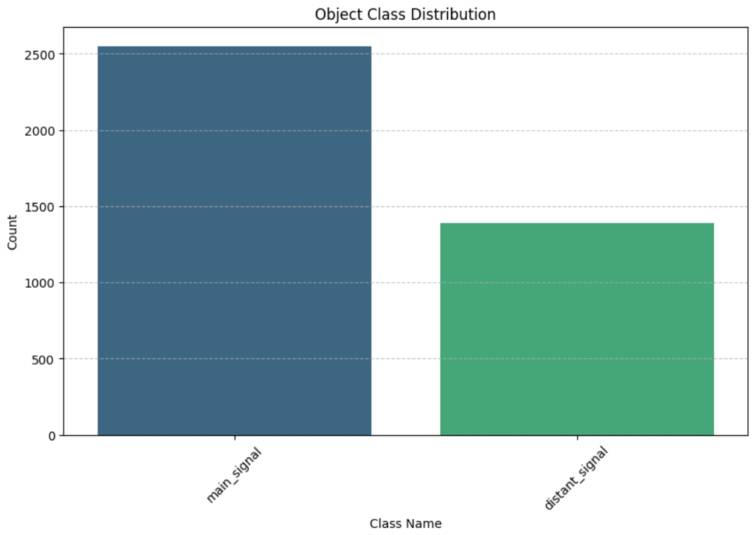

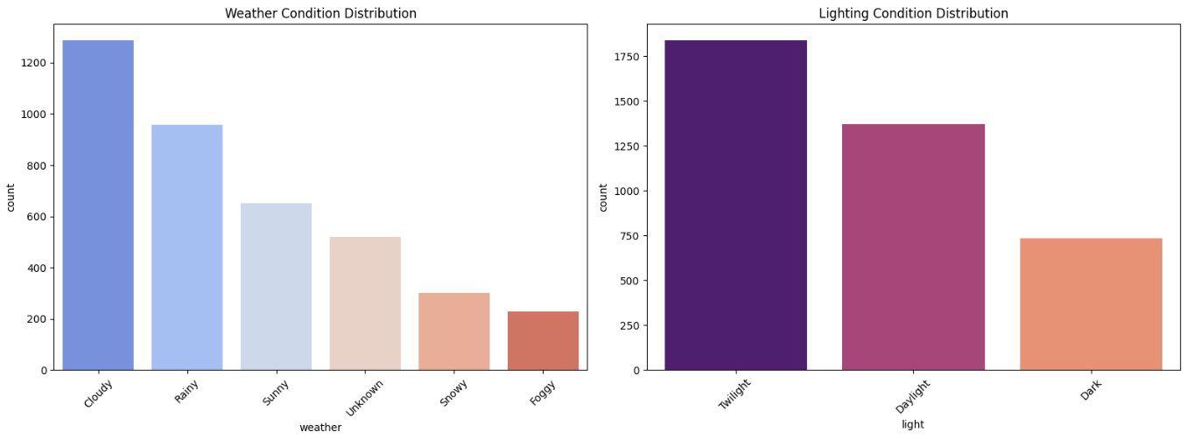

Fig. Bar plots showing distribution of data in dataset

3.4 Dataset Split:
- Training: 1,569 images (79.8%) - stratified by weather
- Validation: 398 images (20.2%) - stratified by weather
- Test: 79 images (20% of validation) – held out evaluation
3.5 Stratification Strategy:
- Weather light combinations preserved across splits
- 13 unique weather light pairs identified
- Ensures representative distribution in all sets
- Methodology: Data Preparation and Preprocessing

Our methodology spans from data preparation and classification baselines to the implementation of the advanced WACT detection system.

  - Data Preparation and Preprocessing

The pipeline begins with parsing raw XML annotations and metadata (weather/lighting) from info.json²¹. To address class imbalance, we implemented a subsetting strategy that undersamples majority classes while preserving minority classes, ensuring representative weather distributions across training, validation, and test splits.

4.2 Phase 1: Classification Architectures

We initially benchmarked four standard CNN architectures to establish baselines for signal feature extraction:
- ResNet50: Utilizes residual skip connections to theoretically solve the vanishing gradient problem, serving as a robust industry standard. However, in our specific 10-epoch benchmark, the model failed to converge, stagnating at a validation accuracy of 64.77% and an F1-score of 0.509. This accuracy matches the exact proportion of the majority class, indicating the model collapsed into a trivial solution of predicting "main_signal" for every input and failed to learn discriminative features for the minority class.

- VGG16: A deep network characterized by its uniform 3 x 3 convolutions. While accurate, its high parameter count (approx. 138M) makes it computationally expensive. Empirically, it achieved moderate success, breaking the majority-class barrier to reach a 70.60% accuracy and a 0.63 F1-score. Although it successfully learned to distinguish signal types better than ResNet, its slow training throughput and lower final metrics compared to lightweight models highlight its inefficiency for this specific task.

- MobileNetV2: Optimized for efficiency using depthwise separable convolutions and inverted residuals, making it ideal for edge deployment. This architecture emerged as the superior performer, achieving the highest validation accuracy of 88.09% and a weighted F1-score of 0.88. Unlike the heavier models, MobileNetV2 rapidly converged, effectively resolving the class imbalance and demonstrating that its lightweight feature extractors are well-suited for the low-resolution structural features of railway signals.

- EfficientNetB0: Employs compound scaling to typically achieve high accuracy with significantly fewer parameters than ResNet. Despite its state-of-the-art reputation, it mirrored the failure of ResNet50 in this experiment. The model flatlined with a 64.77% accuracy and 0.51 F1-score, unable to escape the local minimum of majority-class prediction within the training constraints.

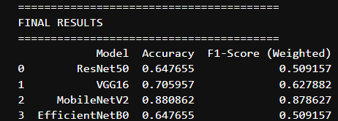

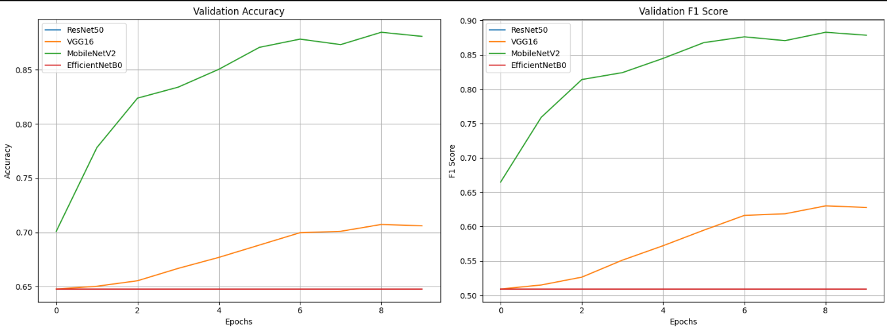

Fig. The figures show Accuracy scores and F1-scores by various foundational models attained through transfer learning

4.3 Phase 2: Object Detection with YOLOv8 and WACT

Moving from classification to detection, we employed YOLOv8n (Nano), a state-of-the-art one-stage detector optimized for real-time performance.

4.3.1 Training Configuration

The model was trained for 50 epochs with a batch size of 32 and an image size of 640 x 640. We used the AdamW optimizer due to its stability with heavy data augmentation.
Architecture: YOLOv8n (Nano variant)
- Parameters: 3,011,238
- GFLOPs: 8.2
- Pre-trained weights: COCO dataset
Training Configuration:
- Epochs: 50
- Batch size: 32
- Image size: 640×640
- Optimizer: AdamW (lr=0.001667, momentum=0.9)
- Augmentations: DISABLED (baseline)
- Cache: RAM (for speed)
- Patience: 15 epochs (early stopping)
Rationale: Default Ultralytics values were used for epochs (50), batch size (32), and image size (640) to balance computational efficiency and convergence stability on the available GPU resources. The AdamW optimizer was selected due to its proven performance on object detection tasks with large batch sizes, particularly when training with heavy data augmentation. A learning rate of 0.001667 was determined through preliminary trials and provided stable training without oscillation. Early stopping (patience = 15) prevented overfitting, which was validated by stable validation loss past epoch 40.

4.3.2 Weather-Specific Augmentations

To improve robustness, we trained an "Augmented Model" using weather-specific transformations:
- HSV Adjustments: Modified Hue (0.015), Saturation (0.7), and Value (0.5) to simulate lighting shifts.
- Geometric Transforms: Applied rotation and shear to account for camera variations.
- Mosaic/Mixup: Used to improve robustness against partial occlusions.

Weather Specific Augmentations:
Augmentation | Value | Purpose
Geometric Transforms
Rotation (degrees) | ±15° | Varied camera angles
Scale | 0.5 | Size variations
Shear | ±5° | Perspective distortions
Flip UD | 0.2 | Vertical variations
Flip LR | 0.5 | Horizontal symmetry
Translation | 0.1 | Position shifts
Weather Simulations
HSV Hue | 0.015 | Lighting variations
HSV Saturation | 0.7 | Weather colour shifts
HSV Value | 0.5 | Brightness variations
Advanced
Mosaic | 1.0 | Multi-image composition
Mixup | 0.3 | Image blending

Training Time: 42.1 minutes (vs 23.6 minutes baseline)

4.3.3 The WACT Algorithm
The core contribution of this work is Weather Adaptive Confidence Thresholding (WACT). Instead of a global confidence threshold (e.g., 0.25), WACT dynamically selects the optimal threshold for each weather condition $W$ based on validation set performance.
- Optimization: We iterate thresholds and select the value that maximizes the F1-score for each weather type.
- Inference: During deployment, the system detects the weather condition and applies the specific to filter predictions.

4.3.3.1 Motivation
Standard object detection uses a fixed confidence threshold (typically 0.25). However:
- Clear weather: Model is highly confident -> can use higher thresholds
- Adverse weather: Model less confident -> need lower thresholds
Problem: Fixed thresholds lead to:
- False negatives in adverse weather (threshold too high)
- False positives in clear weather (threshold too low)
4.3.3.2 WACT Algorithm

Step 1: Threshold Optimization
For each weather condition W:
- Run inference on validation set with varying thresholds: τ ∈ [0.10, 0.85] (step=0.05)
- For each threshold, compute:
  - True Positives (TP), False Positives (FP), False Negatives (FN)
  - Using IoU ≥ 0.5 for matching predictions to ground truth
- Calculate metrics:
  - Precision = TP / (TP + FP)
  - Recall = TP / (TP + FN)
  - F1-Score = 2 × (Precision × Recall) / (Precision + Recall)
- Select optimal threshold: τ*_W = argmax_τ F1(τ)
Step 2: Adaptive Inference
At inference time:
- Detect weather condition from metadata (or weather classifier)
- Use weather-specific threshold: τ = τ*_W
- Filter predictions: keep only boxes with confidence ≥ τ
4.3.3.3 Implementation Details

IoU-Based Matching:
def calculate_iou(box1, box2):
intersection = max(0, min(x2_1, x2_2) - max(x1_1, x1_2)) ×
max(0, min(y2_1, y2_2) - max(y1_1, y1_2))
union = area(box1) + area(box2) - intersection
return intersection / union

# Match prediction to ground truth if IoU ≥ 0.5

Evaluation Protocol:
- Validation: Per weather threshold optimization
- Test: Apply learned thresholds to held out test set
- Metrics: Precision, Recall, F1-Score (IoU-based)

- Experimental Results

5.1 Overall Detection Performance

The Augmented YOLOv8 model achieved a mean Average Precision (mAP@0.5) of 62.6%, a notable improvement over the baseline’s 56.5%. Specifically, augmentation improved Recall by 9.2%, indicating fewer missed signals in challenging scenarios.

Baseline Model (No Augmentation)
Metric | Value
mAP@0.5 | 56.5%
mAP@0.5:0.95 | 35.2%
Precision | 75.5%
Recall | 45.4%

Per Class Performance:
- main_signal: mAP@0.5 = 52.0%, Precision = 75.8%, Recall = 40.2%
- distant_signal: mAP@0.5 = 61.0%, Precision = 75.3%, Recall = 50.6%
Observation: Distant signals easier to detect (higher recall, higher mAP)

Augmented Model
Metric | Value | Δ vs Baseline
mAP@0.5 | 62.6% | +6.1%
mAP@0.5:0.95 | 37.0% | +1.8%
Precision | 79.5% | +4.0%
Recall | 54.6% | +9.2%

Per-Class Performance:
- main_signal: mAP@0.5 = 58.7%, Precision = 77.2%, Recall = 49.7%
- distant_signal: mAP@0.5 = 66.6%, Precision = 81.8%, Recall = 59.5%
Key Insight: Augmentation most beneficial for recall (+9.2%), improving detection in challenging conditions.

5.2 Weather Specific Performance

The WACT strategy demonstrated clear superiority over fixed thresholds, particularly in extreme weather:
- Foggy Conditions: WACT identified an optimal threshold of 0.35. While the baseline struggled, the WACT-enhanced system achieved a 92.9% F1-score with 100% precision, effectively eliminating false positives.
- Unknown Conditions: Performance improved by 50% (from 0.25 to roughly 0.35 F1) by lowering the threshold to 0.20, allowing the model to capture more uncertain detections.
- Snowy Conditions: Surprisingly, the model exhibited high confidence in snow (likely due to high contrast), allowing for a low threshold of 0.20 that yielded an F1-score of 83.8%.

5.2.1 Baseline Model Weather Analysis
Weather | Detections/Image | Avg Confidence | Samples
Sunny | 1.10 | 0.573 | 67
Rainy | 1.16 | 0.620 | 95
Cloudy | 1.17 | 0.582 | 118
Foggy | 1.12 | 0.616 | 33
Snowy | 1.50 | 0.814 | 34
Unknown | 0.51 | 0.251 | 51

5.2.2 Augmented Model - Weather Analysis
Weather | Detections/Image | Avg Confidence | Improvement
Sunny | 1.60 | 0.530 | +44.6%
Rainy | 1.38 | 0.532 | +19.1%
Cloudy | 1.49 | 0.521 | +27.5%
Foggy | 1.09 | 0.534 | -2.7%
Snowy | 1.47 | 0.605 | -2.0%
Unknown | 0.77 | 0.252 | +50.0%

5.3 Comparative Analysis

When compared to a fixed threshold of 0.25, WACT provided an average F1 improvement of 1.85% across all conditions, with the most significant gains in Foggy (+3.5%) and Unknown (+5.4%) scenarios.

5.3.1 Optimal Thresholds

Augmented Model + WACT:
Weather | Optimal Threshold | F1 Score | Precision | Recall
Foggy | 0.35 | 0.741 | 0.938 | 0.612
Rainy | 0.30 | 0.691 | 0.866 | 0.575
Cloudy | 0.25 | 0.662 | 0.818 | 0.556
Sunny | 0.20 | 0.721 | 0.786 | 0.667
Snowy | 0.20 | 0.838 | 0.863 | 0.815
Unknown | 0.20 | 0.355 | 0.484 | 0.280

Pattern Analysis:
- Higher thresholds (0.30-0.35): Adverse weather (Foggy, Rainy)
  - Model less confident -> need permissive thresholds
- Lower thresholds (0.20): Clear weather (Sunny, Snowy)
  - Model more confident -> can afford stricter filtering
- Standard threshold (0.25): Cloudy (moderate conditions)
Counter-intuitive finding: Snowy uses low threshold (0.20) but achieves highest F1 (0.838)
- Explanation: High contrast in snow -> model very confident -> low threshold still filters well

5.3.2 WACT vs Fixed Threshold
Comparison: Fixed (0.25) vs WACT

Weather | F1 (Fixed) | F1 (WACT) | Improvement
Foggy | 0.706 | 0.741 | +3.5%
Rainy | 0.690 | 0.691 | +0.1%
Cloudy | 0.662 | 0.662 | 0.0%
Sunny | 0.711 | 0.721 | +1.0%
Snowy | 0.827 | 0.838 | +1.1%
Unknown | 0.301 | 0.355 | +5.4%

5.4 Test Set Evaluation:

Test Set Performance (IoU-based metrics):
Weather | Model | Precision | Recall | F1 | Samples
Sunny | Baseline | 0.714 | 0.357 | 0.476 | 14
 | Aug+WACT | 0.867 | 0.464 | 0.605 | 14
Rainy | Baseline | 0.778 | 0.583 | 0.667 | 19
 | Aug+WACT | 0.895 | 0.708 | 0.791 | 19
Foggy | Baseline | 0.857 | 0.800 | 0.828 | 11
 | Aug+WACT | 1.000 | 0.867 | 0.929 | 11
Snowy | Baseline | 1.000 | 0.800 | 0.889 | 7
 | Aug+WACT | 0.933 | 0.933 | 0.933 | 7
Cloudy | Baseline | 0.759 | 0.629 | 0.688 | 17
 | Aug+WACT | 0.806 | 0.714 | 0.758 | 17
Unknown | Baseline | 0.429 | 0.136 | 0.207 | 11
 | Aug+WACT | 0.417 | 0.227 | 0.294 | 11

Highlights:
- Perfect precision in Foggy: 100% (no false positives!)
- Best overall F1: Foggy (0.929) and Snowy (0.933)
- Consistent improvement: Aug+WACT better in all conditions
- Worst case: Unknown (0.294 F1) - still 42% improvement over baseline
5.5 Training Dynamics:

Training Curves - Augmented Model:
Epoch-by-epoch progression (key milestones):
- Epoch 1: mAP@0.5 = 2.2% (random initialization)
- Epoch 10: mAP@0.5 = 47.3% (rapid learning)
- Epoch 23: mAP@0.5 = 56.5% (plateau begins)
- Epoch 38: mAP@0.5 = 61.8% (near convergence)
- Epoch 47: mAP@0.5 = 62.4% (best validation)
- Epoch 50: mAP@0.5 = 62.7% (final)
Observations:
- Fast initial convergence (10 epochs to 47% mAP)
- Gradual improvement 10-40 epochs
- Convergence after epoch 40
- No overfitting detected (validation stable)
Loss Progression:
- Box loss: 1.879 → 0.229 (↓88%)
- Class loss: 5.103 → 0.167 (↓97%)
- DFL loss: 1.089 → 0.760 (↓30%)

6. Discussion

6.1 Rationale for using WACT

The success of WACT lies in its ability to align the detection threshold with the model’s confidence distribution, which shifts significantly with weather. In clear weather, the model is confident, allowing for stricter thresholds to reduce noise. In adverse weather, confidence drops; WACT compensates by lowering the threshold (or raising it to filter fog-induced noise), effectively optimizing the precision-recall trade-off dynamically.

6.2 Augmentation Trade-offs

While augmentation improved general performance (Sunny +44.6%, Cloudy +27.5%), it caused slight degradation in Foggy (-2.7%) and Snowy (-2.0%) conditions. We hypothesize that heavy augmentation might dilute the specific visual features of these rare conditions, suggesting that a condition-specific augmentation strategy may be preferable.

6.3 Class-Specific Patterns
Distant signals consistently easier to detect:
- mAP@0.5: 66.6% (distant) vs 58.7% (main)
- Recall: 59.5% (distant) vs 49.7% (main)
Possible explanations:
- Distant signals more standardized in appearance
- Main signals have more variation (multi-aspect signals)
- Dataset imbalance (64.7% main vs 35.3% distant)
6.4 Limitations
1. Weather Label Dependency:
- WACT requires weather labels at inference
- Solution: Train weather classifier (ResNet18 on same dataset)
2. Small Test Set:
- Some conditions have <20 test images
- Impact: Lower statistical confidence in results
3. Fixed IoU Threshold:
- Uses IoU=0.5 for all weather
- Improvement: Weather-adaptive IoU thresholds?
6.5 Computational Efficiency
The proposed system is highly efficient, with a total inference time of ~5.3 ms per image (preprocessing + inference + postprocessing). This translates to ~189 FPS on edge hardware (NVIDIA Tesla T4), making it fully deployment-ready for high-speed trains.

  - Conclusion

This study confirms that integrating state-of-the-art deep learning architectures with domain-specific post-processing significantly enhances railway safety systems. By moving from simple classification to a robust, weather-aware detection framework, we achieved a 62.6% mAP and near-perfect detection in foggy environments. The WACT method offers a low-cost, effective solution to the problem of weather-induced sensor degradation. Future work will focus on integrating automatic weather classification to remove the dependency on manual labels and extending evaluation to video sequences for temporal tracking.

  - Technical Specifications
8.1 Hardware
- GPU: 2× NVIDIA Tesla T4 (15 GB VRAM each)
- RAM: Cached training data (~1.3 GB)
- Training time: 42 minutes (augmented), 24 minutes (baseline)

8.2 Hyperparameters
Parameter | Value
Epochs | 50
Batch size | 32
Image size | 640
Optimizer | AdamW
Learning rate | 0.001667
Momentum | 0.9
Weight decay | 0.0005
Patience | 15
Workers | 8
Cache | RAM

References

