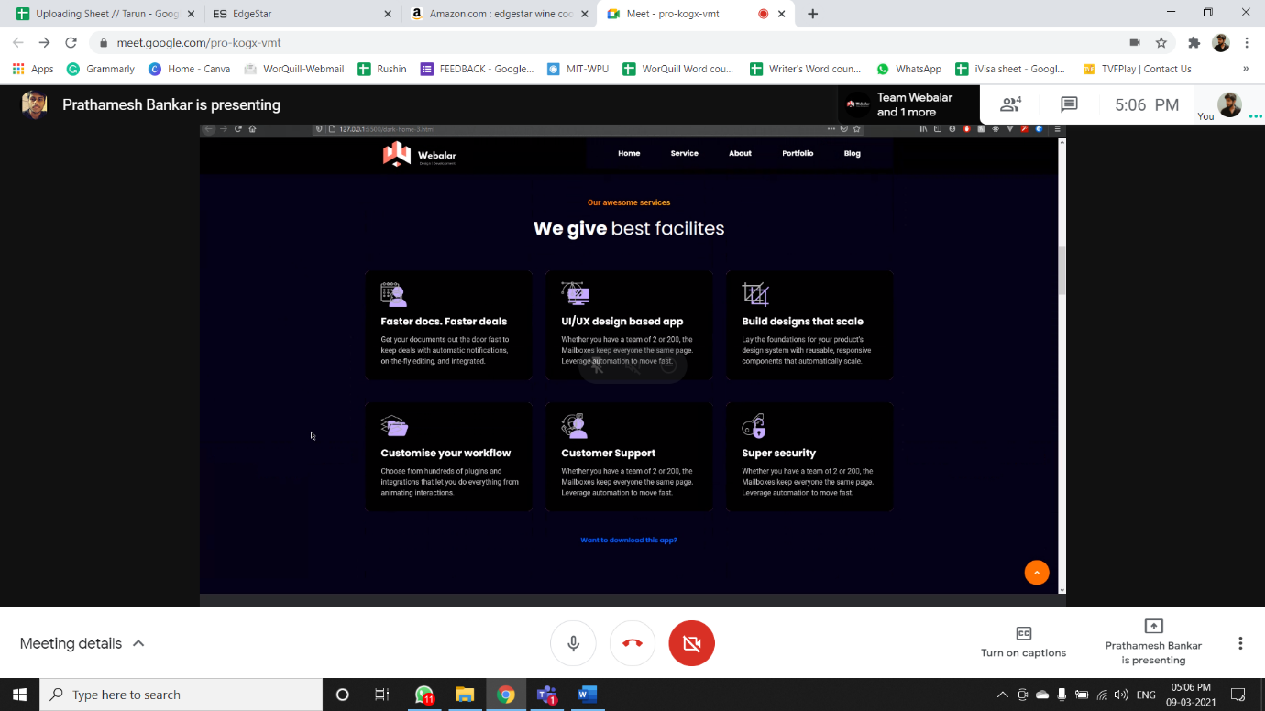

**UI/UX design** **–**

Aggrandize your work with unique and unmatched UI/UX designs developed exclusively for You!

**Build designs that scale –**

We provide quality designs that may fetch you impeccable returns. Let your impressive web design go online with flying colors.

**Yearly Maintenance –**

Sit back and relax! We have got you covered with active website maintenance and care services.

**Customised Admin Panel –**

Your convenience on your fingertips! With customised admin panel, control and run your online establishment at your own pace.

**Customer Support –**

Being available for your assistance and service in minimum time is our speciality. You can surely count on us for doubts, queries, assistance, etc.

**Solution for every website –**

We are functional into various design and development projects. Let us help you with any issue regarding your website.

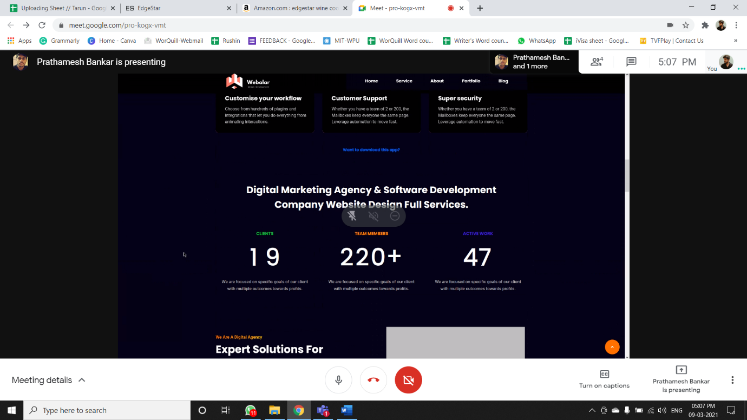

**With our services boosting your digital presence, we are the website designers and developers you can rely upon!**

**Clients –**

With focus and dedication to serve you better, our family is growing each and every day.

**Team Members –**

Active team members at your service. With us, wait less and grow more.

**Active Work –**

Happily sufficing the requirements of our clients with our excellence.