Date : 04/08/2021

Task: HTML Basics

Given Task: To Learn about Some Basic HTML Tags

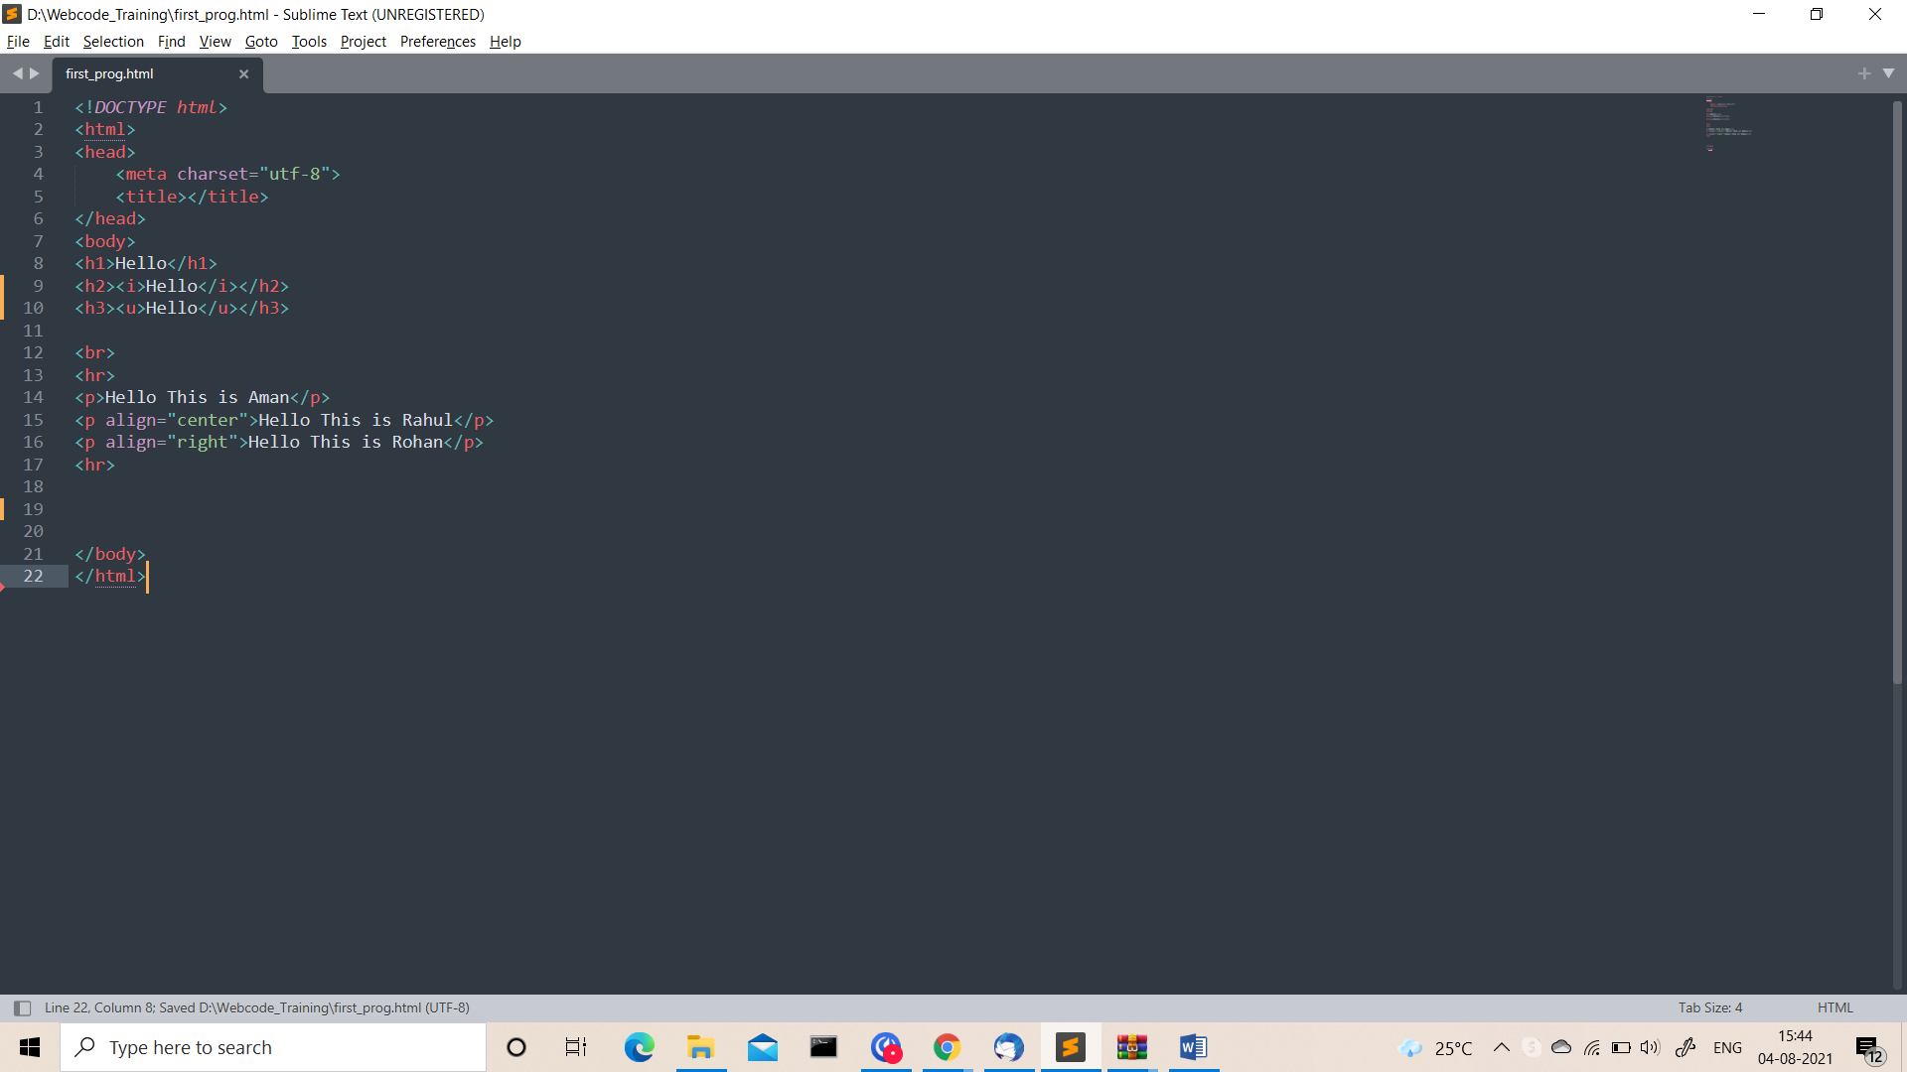

Output:-

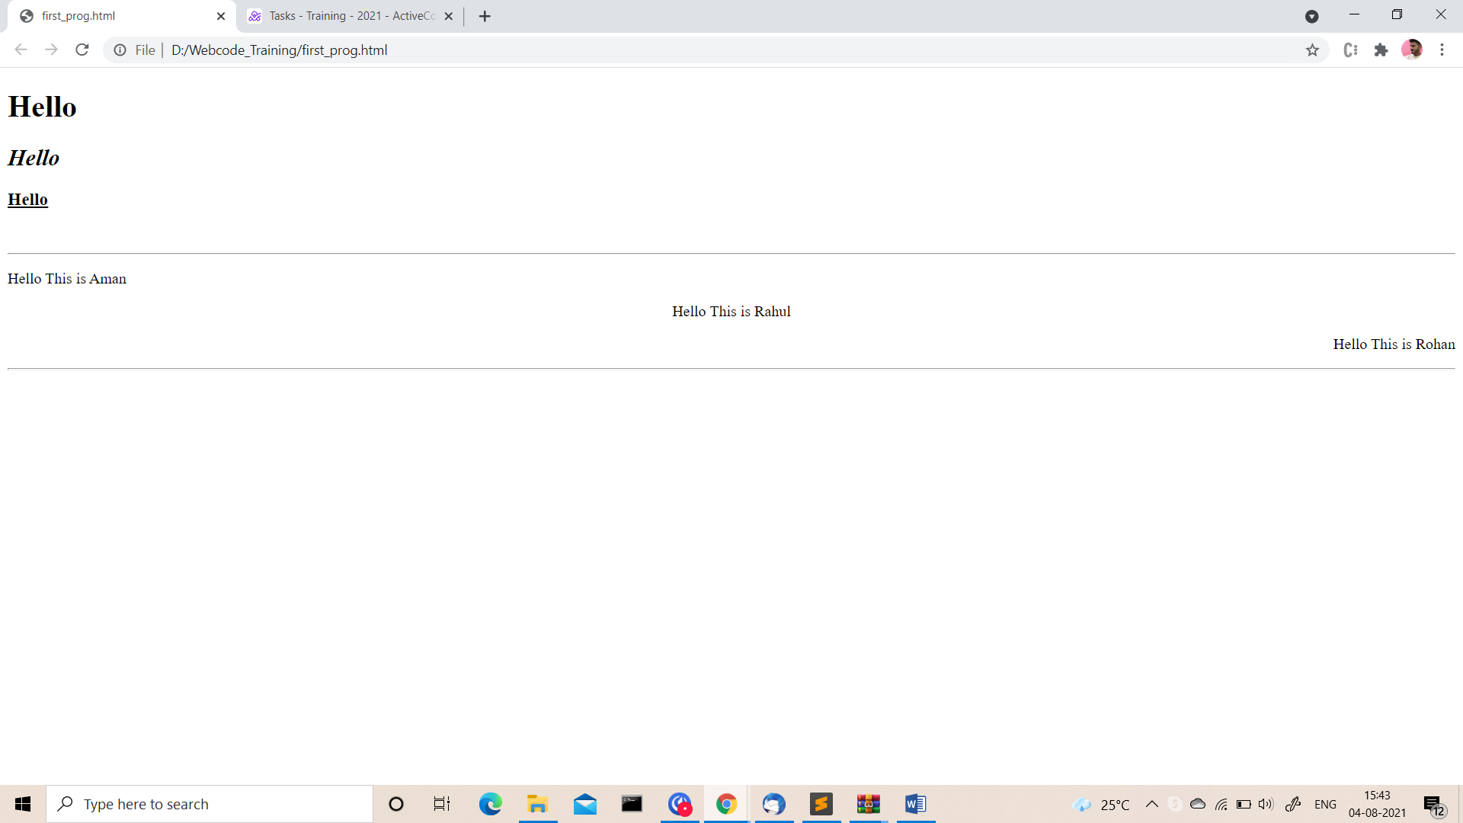

Task: HTML Controls

Given Task: To Designing the Layout of Simple HTML Form

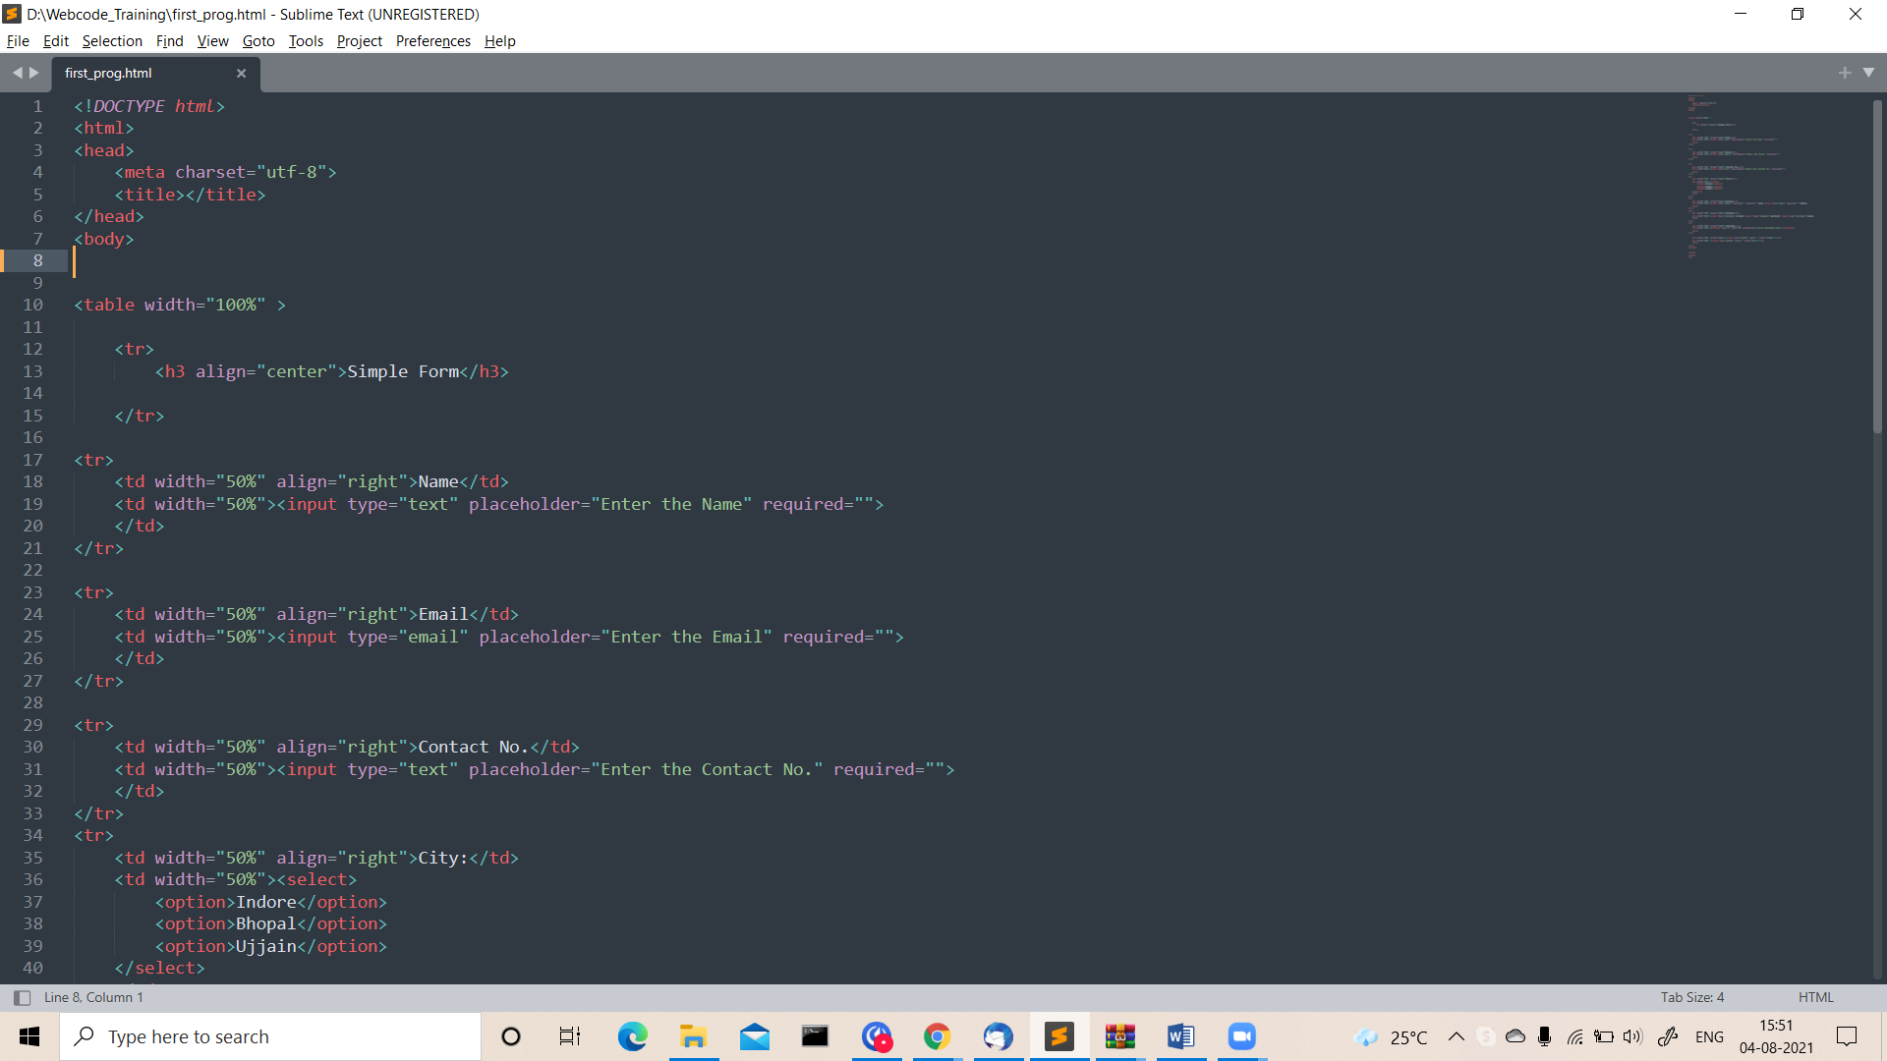

Output:-

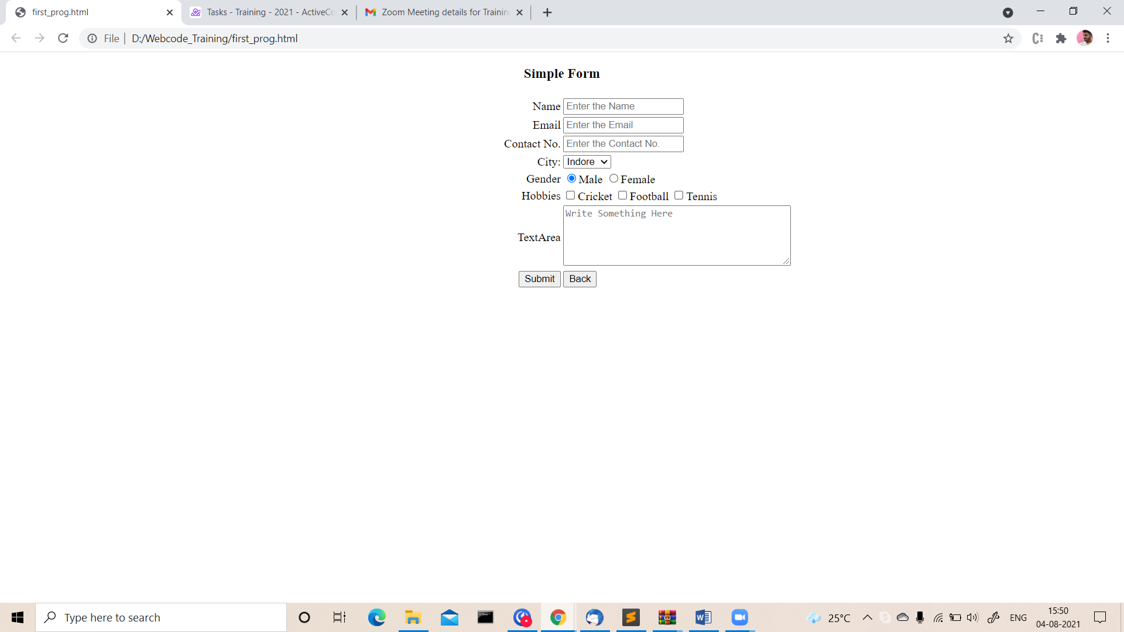

Task: HTML Bullets and Numbering

Given Task:- To Learn Bullets and numbering in HTML

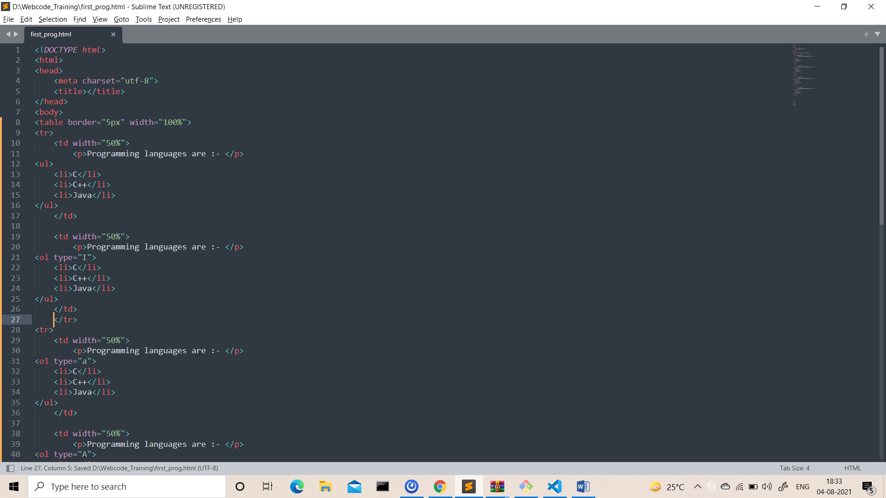

Output:-

