Date- 05/Aug/2021

Task:- HTML Format ,Tags, Element & Attributes etc.

Given Task:- To Design Three pages using HTML Elements etc.

Homepage

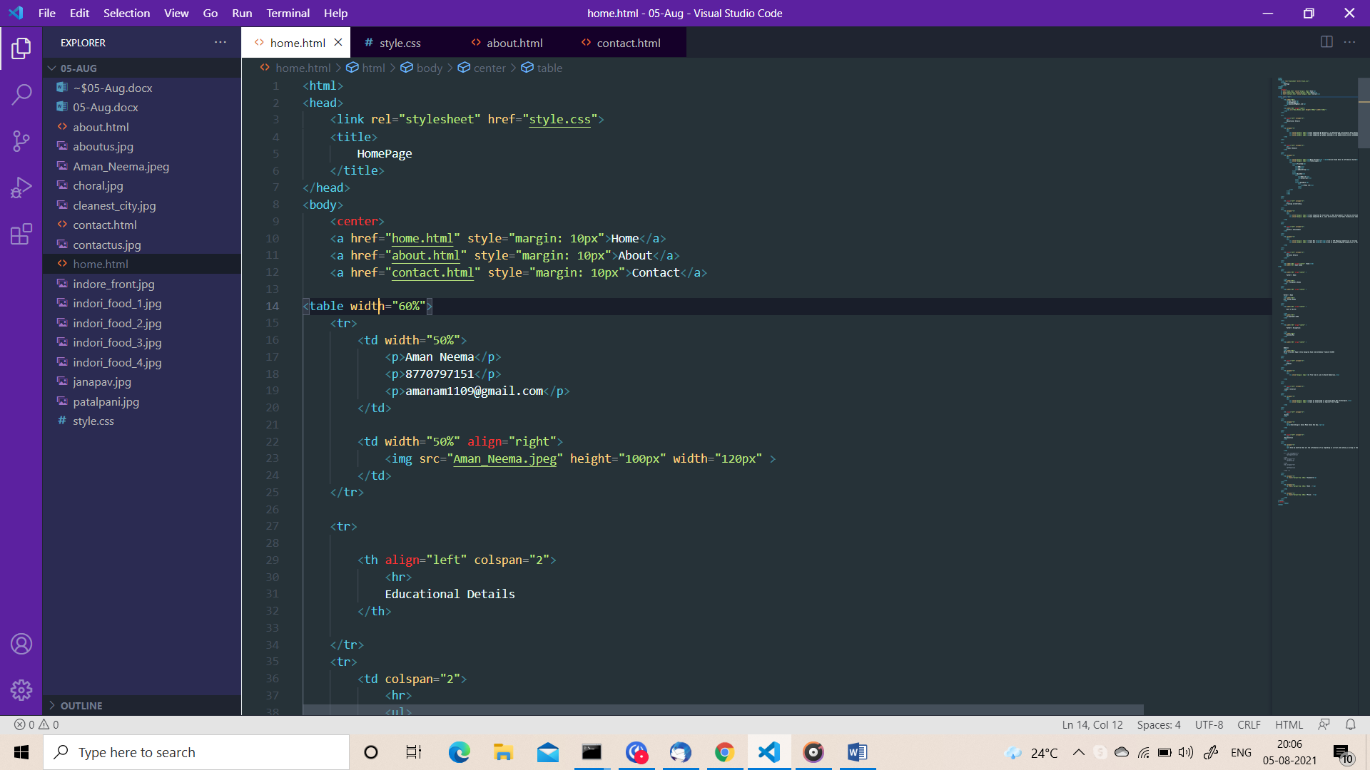

Output:-

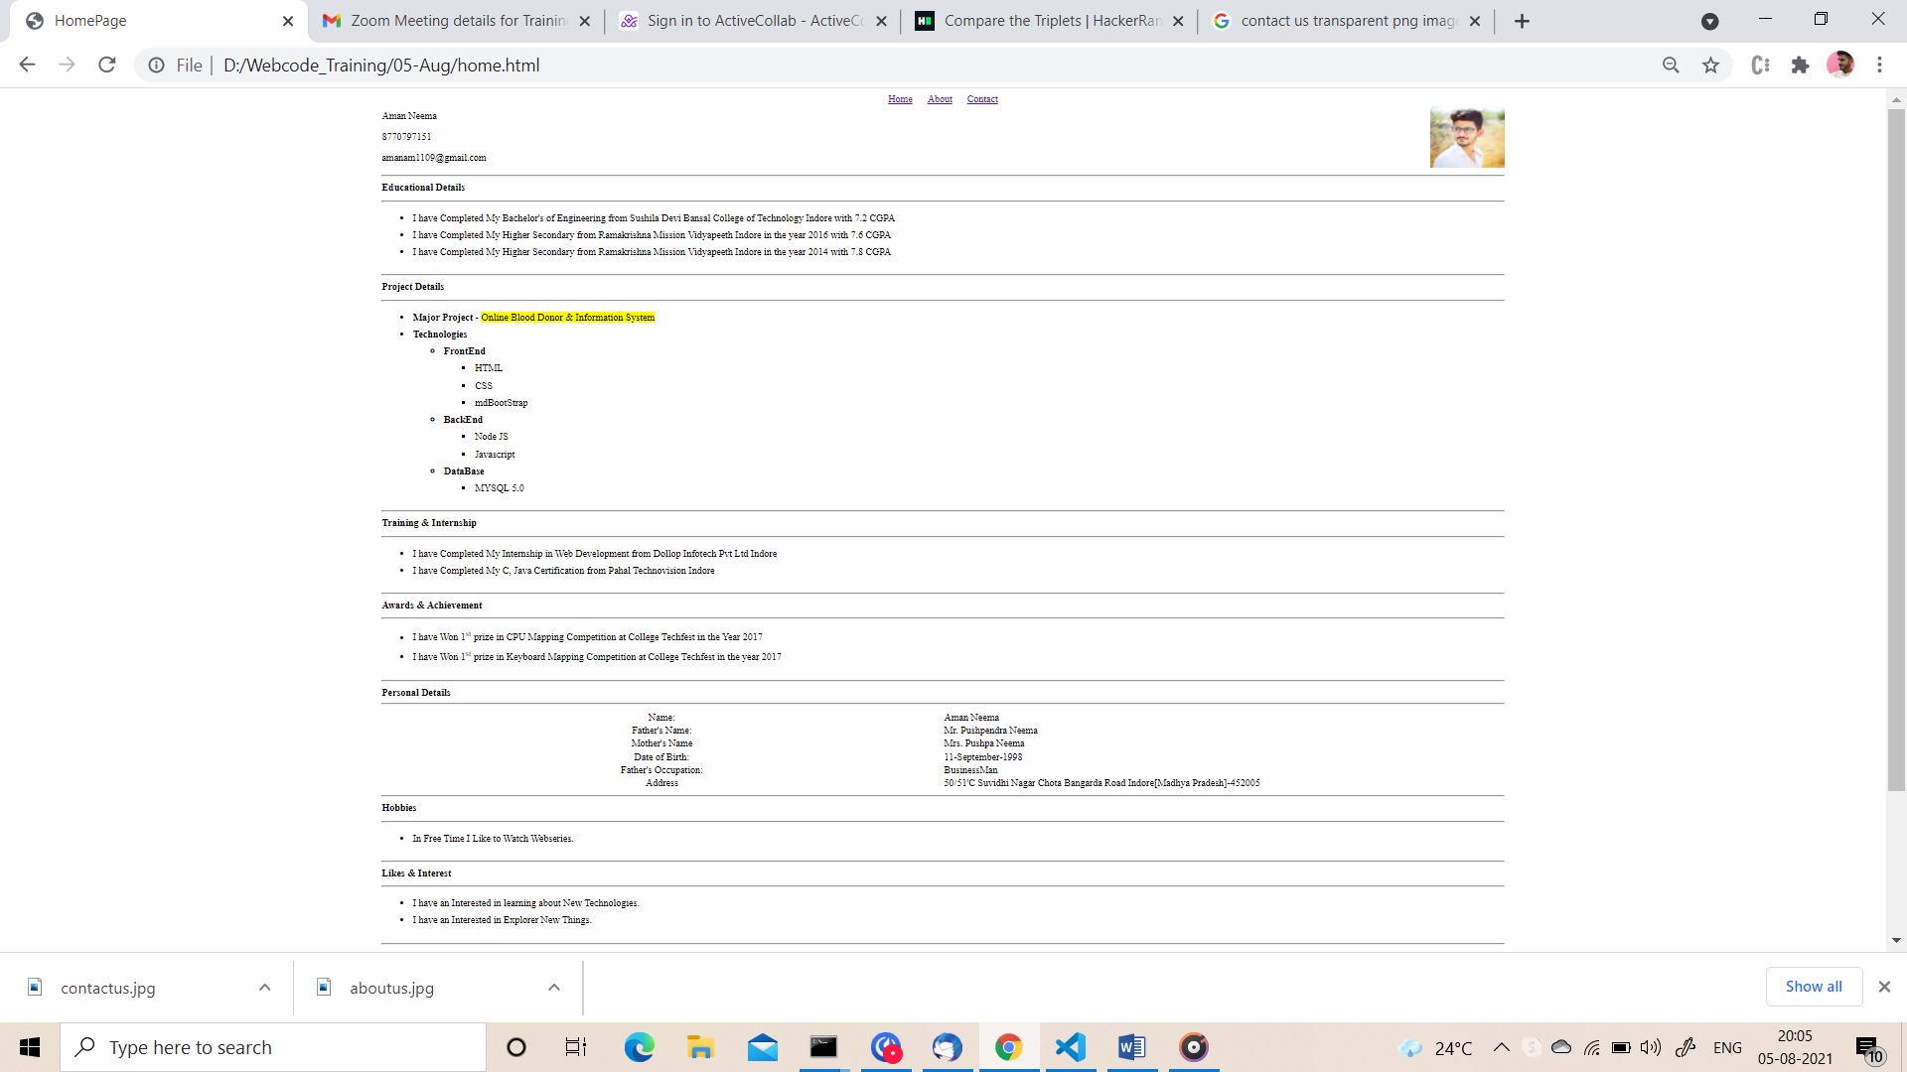

Page 2

About Page

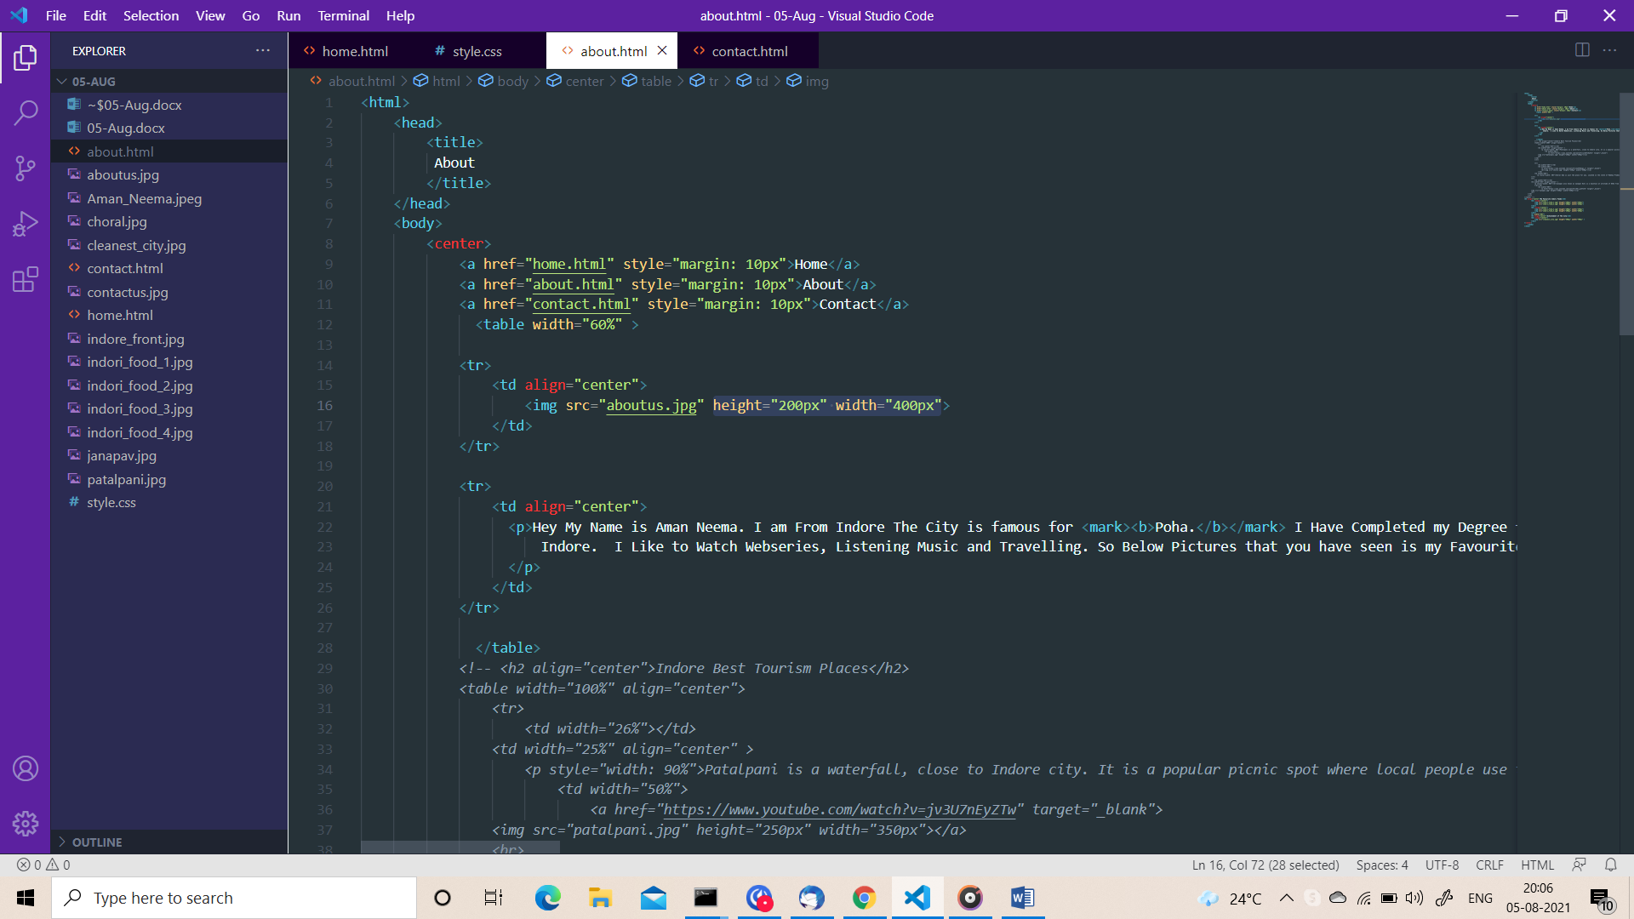

Output:-

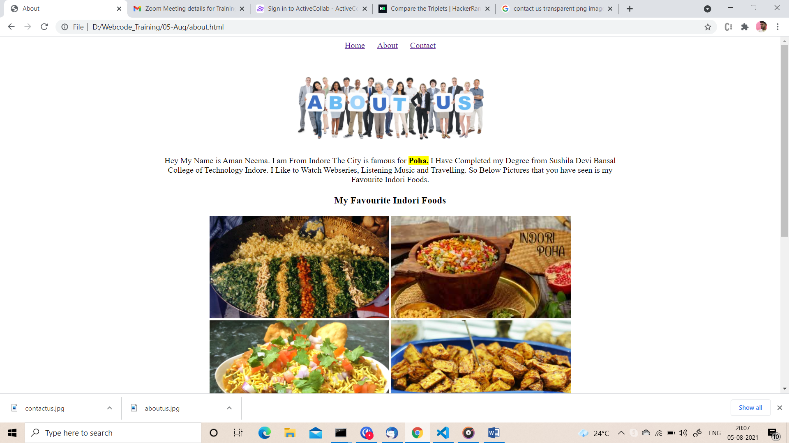

Page 3

Contact Page

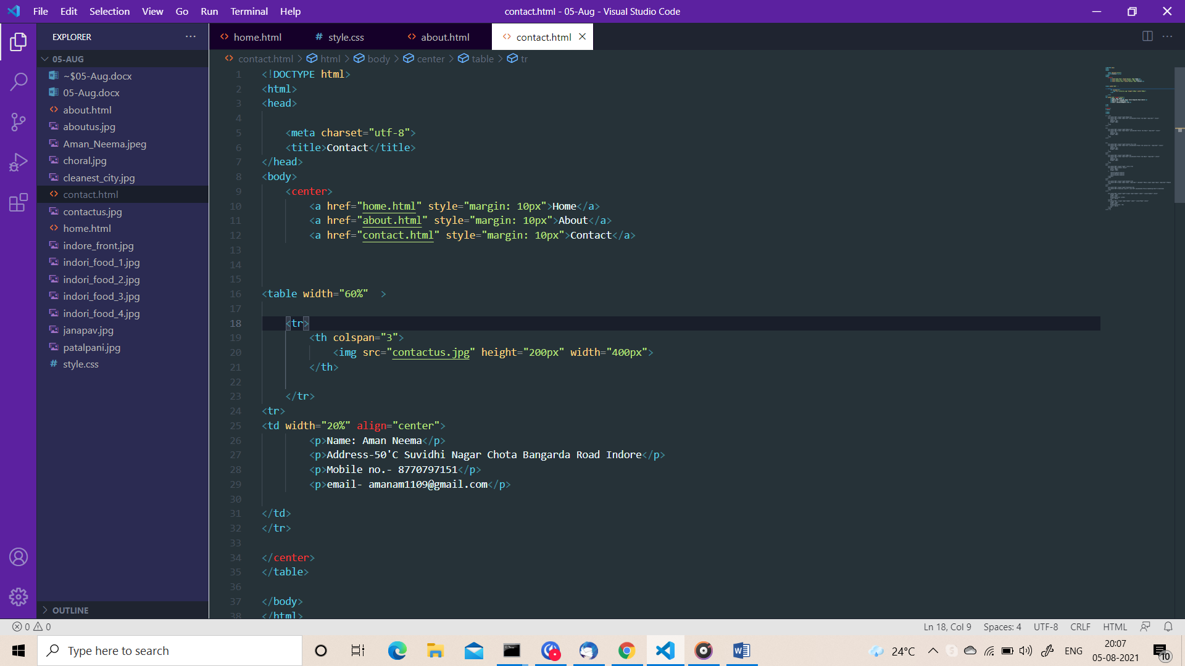

Output:-

