Date: 06/Aug/2021

Task: To Design The HTML Registration Page

Given Task:- Design The HTML Registration Page using Formats, Tags, Attribute etc.

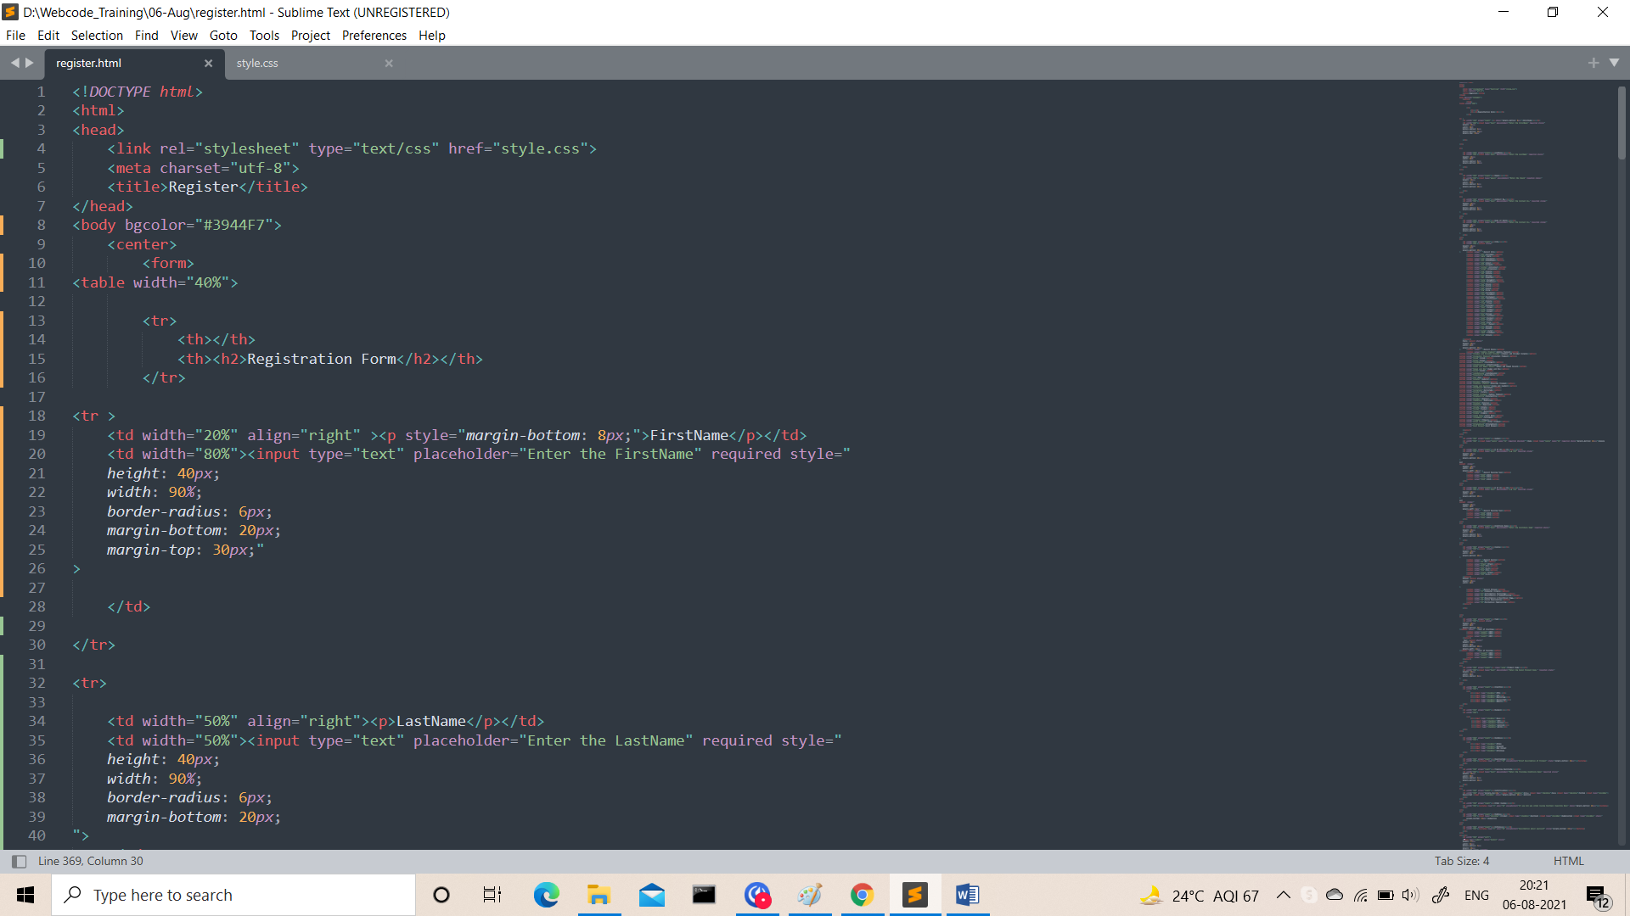

Output:-

