**Project Report: Travel Agency Website**

**Student Name: Anchal**

**Student ID: S20242666**

**Table Of Content**

**1. Introduction** **1**

**2. Project Purpose and Objectives** **2**

Key Objectives 2

**3. Technologies Used** **3**

**4. Code Structure and Design** **4**

4.1. HTML Layout and Content 4

4.2. CSS Styling 5

4.3. Image Gallery Styling and Hover Effects 5

4.4. JavaScript for Interactivity 6

**5. Trip Cost Calculator with Validation** **7**

**6. Contact Form** **7**

**7. Responsive Design** **8**

**8. Conclusion** **8**

## 1. Introduction

Following report documents the development process and programming techniques used to create a dynamic and responsive website for a travel agency. The primary objective of this project is to design a fully functional, appealing single- page website that provides a high-quality user experience for perspective travelers. It’s standout features include a trip cost calculator, a photo gallery with hovering effects, scrolling animations and a contact form for inquiries.

Web technologies used in the project are HTML, CSS and JavaScript, demonstrating expertise in its application and ability to integrate design and functionality seamlessly. These features contribute to a user-friendly interface, where users can get estimate on their travel expenses or reach out to the agency with customized inquiries

In addition to the visual appeal of the website, it was essential to focus on working and responsiveness of the design, making sure, website adapts well across various devices and screen sizes. The following sections details each stage of development, setting up HTML, using CSS for designing and using JavaScript for making it responsive. All of these elements and animations are explained, from code to decision making process and techniques that were applied.

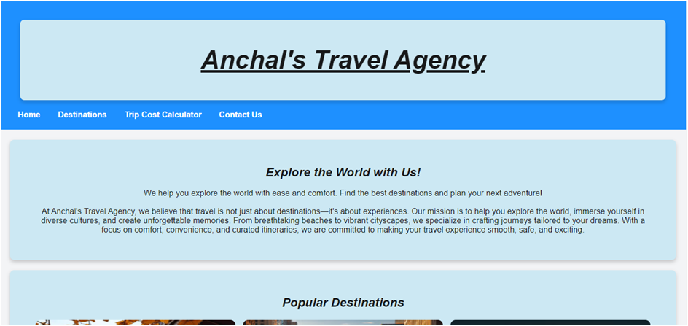

## 2. Project Purpose and Objectives

The travel agency’s website aims to capture the attention of potential clients with the help of a functional design that will allow exploring destinations and prices, as well as asking the agency questions. Every single aspect of design and functionality was well chosen to meet users’ requirements, improve their aesthetic perception, and provide valuable services to those who visit the site.

The website was designed to be both informative and also appealing visually to the prospects, whole purpose of this project is to create a scenario virtually for the prospect to explore travel options and interact with the website to get the information like travel cost based on their preference without the need to talking with different travel agencies.

### Key Objectives

1. **Responsiveness** – The importance of this function calling for user-friendly design is that the site has to look good on every device. This goal could only be achieved if the layout, pictures, phone type and style, and interactive components were adjusted for the rescaled device enabling the site to look good for a mobile, tablet, or desktop. CSS Flex box and media queries were used to configure the responsive nature of the site so that different components would adjust to fit appropriately different devices enhancing the site's usability.
2. **User** **Interaction**: A cost calculator, scroll-triggered videos, and image hover effects were introduced to elicit interest and enhance user growth. Besides directing them to certain focal points, hover effects also zoom pictures as if luring users into a target. Another good case of scrolling animations is as users move through the content, those animations become visible, thus capturing more and more of the users’ focus. With all these types of interactions, it is easier to accomplish interactive conditions needed in users to avoid monotony, promoting a dynamic feel to the website.
3. **Functionality**: A core functionality was a trip cost calculator where the expected expenses of a given traveler were fully determined by their select destination, duration, and group size. This is an added advantage of these tools as they help users easily make decisions regarding their travel plans. Further, the contact form facilitates communication between the prospective traveler and the agency. Inquiries can be made easily and there is no need to call or email the agency directly to get the information.
4. **Accessibility**: The website was usable for people with different needs, and accessibility design was also considered. Semantic HTML tags combined with simple text labels, and decent color choices to enhance the overall readability and text alternatives for screen readers, make sure that the goals of this website are met enabling everyone to make use of the sites’ capabilities.

These goals were the North Star in deciding every aspect of this project, from planning to implementations, making sure it meets users’ expectations while providing an engaging and visually appealing experience.

## 3. Technologies Used

The technologies chosen for this project were HTML, CSS and JavaScript. Each language serves a unique purpose, and collectively they provide the functionality and effects making the website accessible and functional.

1. **HTML (Hypertext Markup Language)**: HTML supplies a framework around the content of the web pages that makes it possible for the audience to identify different parts of the content. The website which includes header, navigational elements, main content areas, and footers was built using <section>, <header>, <nav>, and other semantic markup tags. This method not only enhances the readability of the code but also enhances the usefulness of the code since the tags assist screen readers in interpreting the structure of pages in the right manner.
2. **CSS (Cascading Style Sheets):** A large amount of CSS was used to define the look of the HTML structure regarding layout, style, and other visually enhancing features. CSS Flexbox was important for the positioning of the elements whereas CSS Grid was useful in creating the structure for the image gallery and destination divisions. Furthermore, CSS images were animated to create hover effects and transitions that attract users while navigating the gallery.
3. **JavaScript:** JavaScript contributed three major features that enabled the users to interact with the system more dynamically, these are the scroll interactions, the trip cost calculator, and the form validation. Each web JavaScript functionality contributes to the total Web site usability test since user inputs are responded to in real-time for example the trip cost is presented based on user selections. On top of that, the dynamic effects of fading in the images include JavaScript-powered scroll animations that were added to avail the sections as users scroll down the pages which eventually increase the visual flow and keep the users entertained. These technologies work together to create a professional and user-friendly website that is functional and visually engaging, this structured approach allowed for neat and organized code, which makes maintenance and updates easier.

## 4. Code Structure and Design

The code for the whole website is organized into a single HTML file, a CSS file for design and JavaScript file for functionality. All the files are separated as is the common practice in web development, keeping it organized, easier to read and debug.

### 4.1. HTML Layout and Content

The HTML file is organized into several sections, each serving a different purpose. The layout includes the following sections:

* **Header and Navigation Bar**: Provides branding and navigation links that help users scroll smoothly between sections.
* **Home Section**: Introduces the travel agency with a brief description and welcoming message.
* **Destinations Section**: Features an image gallery that displays popular travel destinations.
* **Trip Cost Calculator**: Allows users to input details about their trip and calculate an estimated cost.
* **Contact Form**: Includes a form for custom inquiries, allowing users to reach out with specific questions about their travel plans.

This simple, organized structure makes it easy for users to find information and interact with the site.

**Code Example:**

<header>

<h1>Explore the World with Us</h1>

<nav>

<a href="#home">Home</a>

<a href="#destinations">Destinations</a>

<a href="#calculator">Trip Cost Calculator</a>

<a href="#contact">Contact Us</a>

</nav>

</header>

In this code, each navigation link points to an anchor in the HTML file. When clicked, the link scrolls the page to the respective section, providing smooth navigation throughout the single-page website.

### 4.2. CSS Styling

The CSS file is used to style the HTML elements, adding the visual appeal of the website with colors, fonts, animations, and layout adjustments. The styling focuses on providing a professional look, with adequate spacing, color contrast, and a modern design that suits a travel agency.

**General Styling**

The body style establishes a clean background color and a neutral text color, setting the tone for the rest of the website’s design.

body {

font-family: Arial, sans-serif;

background-color: #f3f4f6;

color: #333;

}

**Header and Navigation Bar**

The navigation bar is styled to stand out, with bold white text on a blue background. It appears at the top of the page, allowing users to access different sections with ease.

header {

background-color: #1e90ff;

color: white;

padding: 20px;

text-align: center;

}

This color scheme makes the navigation bar visually appealing and aligns with the overall design theme of the website.

### 4.3. Image Gallery Styling and Hover Effects

The **Destinations** section includes an image gallery that displays popular travel destinations. CSS is used to add hover effects on images, creating an interactive experience. When a user hovers over an image, it scales up slightly and gains a shadow effect.

**CSS Code for Hover Effect:**

.image-galleryimg:hover {

transform: scale(1.05);

box-shadow: 04px10pxrgba(0, 0, 0, 0.3);

transition: transform 0.3s ease, box-shadow 0.3s ease;

}

The transform: scale(1.05); property enlarges the image by 5%, while the shadow effect makes the images stand out, attracting user attention to each destination.

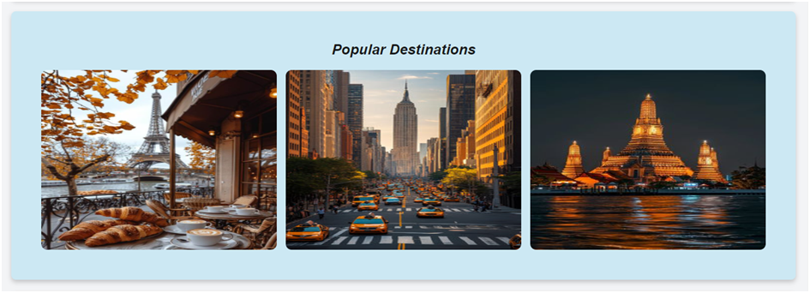

### 4.4. JavaScript for Interactivity

JavaScript plays a critical role in adding dynamic elements to the website, such as scroll-triggered animations, cost calculations, and form validation.

**Scroll Animation for Images**

The scrolling animation is implemented to make images in the Destinations section fade in as users scroll. This effect is triggered when the images enter the viewport.

document.addEventListener("DOMContentLoaded", function() {

constfadeElements = document.querySelectorAll('.fade-in');

functionrevealElements() {

fadeElements.forEach(el => {

const position = el.getBoundingClientRect().top;

if (position <window.innerHeight - 100) {

el.classList.add('visible');

}

});

}

window.addEventListener('scroll', revealElements);

revealElements();

});

This code enhances the user experience by adding a fade-in effect, which engages users as they scroll through the site.

## 5. Trip Cost Calculator with Validation

The trip cost calculator is a crucial feature of the website. It allows users to select a destination, input the number of nights and the number of people, and then calculates the estimated cost of the trip. Validation is added to ensure users input values that are greater than or equal to 1.

functioncalculateTripCost() {

constdestinationCost = parseFloat(document.getElementById('destination').value);

const nights = parseInt(document.getElementById('nights').value);

const people = parseInt(document.getElementById('people').value);

if (nights <1 || people <1) {

document.getElementById('tripCostDisplay').textContent = "Please enter at least 1 night and 1 person.";

document.getElementById('tripCostDisplay').style.color = "red";

return;

}

consttotalCost = destinationCost * nights * people;

document.getElementById('tripCostDisplay').textContent = `Total Trip Cost: $${totalCost.toFixed(2)}`;

document.getElementById('tripCostDisplay').style.color = "black";

}

This validation enhances usability by guiding users to input appropriate values, providing clear instructions when the input is invalid. The calculator improves user engagement, allowing prospective travelers to gauge the cost of a trip conveniently.

## 6. Contact Form

This section is important, where a single form is used, allowing users to submit contact information for inquiries. Clear labels and placeholders guide users on how to fill out each field. This form can be made more interactive with JavaScript validation, ensuring different data types like string for email, int for phone number is used, making sure it is stored correctly.

## 7. Responsive Design

The importance of ensuring the website is completely responsive cannot be overstated when discussing user experience. Given the importance of the mobile web, there is a practical necessity to enable users to use all the features of a smartphone or tablet as easily as a desktop PC. This responsiveness was made possible through CSS Flexbox and media queries. Flexbox provided an automated reorder of elements to capture the variability of screen dimensions such as changing navigation bars and image galleries. Media queries were adopted in this context for resizing text and images to smaller dimensions and reconfiguring layout patterns to make the small screen more user-friendly for reading the text and using the images.

As a way to heighten performance while still focusing on the mobile experience, we conducted a test on touch interactions to check the accessibility of buttons and form inputs without the need for zooming. Furthermore, subdivisions involving optimizing image resolutions for mobile devices were implemented to enhance performance while cutting down on expenses during networks with mobile coverage. By overlapping content and layout appropriately within the frame, the site assures users a seamless experience regardless of the device used. Designs that originated mobile themes so that when the design is enlarged it starts to shift the dimensions and provides refined speed and reliability without compromising the design regardless of the platform being viewed on the website.

## 8. Conclusion

To conclude, the travel agency web page has a great structure because its’ design and website interface appear intuitive. The combination of HTML, CSS, and JavaScript contributed to making the project responsive, engaging, and most importantly, very easy to work with. Every single feature, the hovers or the cost calculator for instance, enhances the user interface of the site making averagely wise user to be able to use the site effortlessly to get the information they need in the shortest time possible.

Future development may include accessibility evaluation so improvements such as checking color contrast, enabling keyboard accessibility, and providing better error messages on forms can be implemented. These would further improve the usability of the website and make it more accessible to people of different backgrounds. Overall, this project demonstrates the effective use of web technologies to create a professional, user-centered website that fulfills both business and user goals.

Codes of website

Index.html

<!DOCTYPE html>

<html lang="en">

<head>

    <meta charset="UTF-8">

    <meta name="viewport" content="width=device-width, initial-scale=1.0">

    <title>Travel Agency</title>

    <link rel="stylesheet" href="style.css">

    <script defer src="script.js"></script>

</head>

<body>

    <!-- Navigation Bar -->

    <header>

        <section>

        <h1><u><i>Anchal's Travel Agency</i></u></h1>

    </section>

        <nav>

            <a href="#home">Home</a>

            <a href="#destinations">Destinations</a>

            <a href="#calculator">Trip Cost Calculator</a>

            <a href="#contact">Contact Us</a>

        </nav>

    </header>

    <!-- Home Section -->

    <section id="home">

        <h2><i>Explore the World with Us!</i></h2><br>

        <p>We help you explore the world with ease and comfort. Find the best destinations and plan your

            next adventure!

            <br>

            <br>

            At Anchal's Travel Agency, we believe that travel is not just about destinations—it's

            about experiences. Our mission is to help you explore the world, immerse yourself in diverse

            cultures, and create unforgettable memories. From breathtaking beaches to vibrant cityscapes,

            we specialize in crafting journeys tailored to your dreams. With a focus on comfort, convenience,

            and curated itineraries, we are committed to making your travel experience smooth, safe,

            and exciting.

        </p>

    </section>

    <!-- Destinations Section -->

    <section id="destinations">

        <h2><i>Popular Destinations</i></h2>

        <div class="image-gallery">

            <img src="paris.jpg" alt="Destination 1" class="fade-in">

            <img src="nyc.jpg" alt="Destination 2" class="fade-in">

            <img src="bangkok.jpg" alt="Destination 3" class="fade-in">

        </div>

    </section>

    <!-- Trip Cost Calculator Section -->

    <section id="calculator">

        <h2><i>Trip Cost Calculator</i></h2><br>

        <form id="costCalculator">

            <label for="destination">Select Destination:</label>

            <select id="destination">

                <option value="1000">Paris</option>

                <option value="1200">New York</option>

                <option value="800">Bangkok</option>

            </select>

            <label for="nights">Number of Nights:</label>

            <input type="number" id="nights" placeholder="Enter nights">

            <label for="people">Number of People:</label>

            <input type="number" id="people" placeholder="Enter number of people">

            <button type="button" onclick="calculateTripCost()">Calculate Cost</button>

        </form>

        <p id="tripCostDisplay"></p>

    </section>

    <!-- Contact Us Section -->

    <section id="contact">

        <h2><i>Contact Us</i></h2>

        <br>

        <form id="contactForm">

            <label for="name">Name:</label>

            <input type="text" id="name" name="name" required>

            <label for="email">Email:</label>

            <input type="email" id="email" name="email" required>

            <label for="message">Message:</label>

            <textarea id="message" name="message" rows="4" placeholder="Your custom travel inquiry..."></textarea>

            <button type="submit">Submit</button>

        </form>

    </section>

<!-- Footer Section -->

<footer>

    <div class="footer-content">

        <p>&copy; 2024 Anchal's Travel Agency | All rights reserved</p>

        <p>Contact us: <a href="mailto:info@travelagency.com">info@travelagency.com</a> | Phone: +1 (555) 123-4567</p>

    </div>

</footer>

</body>

</html>

Style.css

/* Basic Reset and Styling */

* {

    margin: 0;

    padding: 0;

    box-sizing: border-box;

}

body {

    font-family: Arial, sans-serif;

    background-color: #f3f4f6;

    color: #333;

}

h1{

    font-size: 50px;

}

/* Header and Navigation Styling */

header {

    background-color: #1e90ff;

    color: white;

    padding: 20px;

    text-align: left;

}

nav a {

    color: white;

    margin: 0 15px;

    text-decoration: none;

    font-weight: bold;

}

nav a:hover {

    text-decoration: underline;

}

/* Section Styling */

section {

    padding: 50px;

    text-align: center;

    margin: 20px;

    background-color: #cce8f3;

    color: #18191a;

    border-radius: 8px;

    box-shadow: 0 4px 8px rgba(0, 0, 0, 0.2);

}

/* Image Gallery for Destinations */

.image-gallery {

    display: flex;

    justify-content: center;

    gap: 15px;

    margin-top: 20px;

}

.image-gallery img {

    width: 1500px;

    height: 300px;

    border-radius: 10px;

    opacity: 0;

    transform: translateY(20px);

    transition: opacity 0.8s ease-out, transform 0.8s ease-out, transform 0.3s ease-in-out;

}

/* Hover Effect */

.image-gallery img:hover {

    transform: scale(1.05); /* Slightly increase size on hover */

    box-shadow: 0 4px 10px rgba(0, 0, 0, 0.3); /* Add shadow on hover */

    transition: transform 0.3s ease, box-shadow 0.3s ease; /* Smooth transition */

}

.fade-in.visible {

    opacity: 1;

    transform: translateY(0);

}

/* Trip Cost Calculator and Contact Form Styling */

form label, form input, form select, form textarea, button {

    display: block;

    width: 100%;

    margin-bottom: 10px;

}

button {

    padding: 10px;

    background-color: #1e90ff;

    color: white;

    border: none;

    border-radius: 5px;

    cursor: pointer;

}

/* Footer Styling */

footer {

    background-color: #1e90ff;

    color: white;

    padding: 20px;

    text-align: center;

}

.footer-content {

    max-width: 1000px;

    margin: auto;

}

.footer-content p {

    margin: 5px 0;

}

.footer-content a {

    color: white;

    text-decoration: none;

}

.footer-content a:hover {

    text-decoration: underline;

}

.social-icons {

    margin-top: 10px;

}

.social-icons a {

    margin: 0 10px;

}

.social-icons img {

    width: 24px;

    height: 24px;

    transition: transform 0.3s ease;

}

.social-icons a:hover img {

    transform: scale(1.1);

}

Script.js

// Scroll Animation for Images

document.addEventListener("DOMContentLoaded", function() {

    const fadeElements = document.querySelectorAll('.fade-in');

    function revealElements() {

        fadeElements.forEach(el => {

            const position = el.getBoundingClientRect().top;

            if (position < window.innerHeight - 100) {

                el.classList.add('visible');

            }

        });

    }

    window.addEventListener('scroll', revealElements);

    revealElements(); // Initial check

});

// Trip Cost Calculator Function

function calculateTripCost() {

    const destinationCost = parseFloat(document.getElementById('destination').value);

    const nights = parseInt(document.getElementById('nights').value) || 1;

    const people = parseInt(document.getElementById('people').value) || 1;

    const totalCost = destinationCost * nights * people;

    document.getElementById('tripCostDisplay').textContent = `Total Trip Cost: $${totalCost.toFixed(2)}`;

}