**WEB BASED GAMES**

### A Project Work

*Submitted in the partial fulfillment for the award of the degree of*

# BACHELOR OF ENGINEERING

### IN

### CSE-IOT

### Submitted by:

**ABHISHEK SINGH**

### 19BCS4508

### Under the Supervision of:

### Dr. MONICA LUTHRA

# DEPARTMENT OF COMPUTER SCIENCE AND ENGINEERING APEX INSTITUE OF TECHNOLOGY

### CHANDIGARH UNIVERSITY, GHARUAN, MOHALI - 140413,

**PUNJAB**

**APRIL, 2021**

**DECLARATION**

I, **Abhishek Singh**, student of **Bachelor of Engineering in CSE-IOT**, **session: 2019/2023**, Department of Computer Science and Engineering, Apex Institute of Technology, Chandigarh University, Punjab, hereby declare that the work presented in this Project Work entitled **Web Based Games** is the outcome of our own bona fide work and is correct to the best of our knowledge and this work has been undertaken taking care of Engineering Ethics. It contains no material previously published or written by another person nor material which has been accepted for the award of any other degree or diploma of the university or other institute of higher learning, except where due acknowledgment has been made in the text.

#### 

**ABHISHEK SINGH**

**UID: 19BCS4508**

#### Date: 26/04/2021

**Place: CHANDIGARH UNIVERSITY**

**ACKNOWLEGDEMENT**

I take this opportunity to express my profound gratitude and deep regards to my teacher **Dr. MONICA LUTHRA** for their exemplary guidance, monitoring and constant encouragement throughout the course of this project. The blessing, help and guidance given by them time to time shall carry me a long way in the journey of life on which I am about to embark.

# ABSTRACT

The purpose of the project is to provide a free and open-source cross platform game collection that runs on any platform through a web browser. We chose this project because we saw a lot of people who are not able to play any game on their computers due to a number of small issues that pile up and pose a great problem. We are going to provide a well refined system that does what it says and meets expectations.

**TABLE OF CONTENTS**

|  |  |  |
| --- | --- | --- |
|  | Title Page  Declaration of the Student  Abstract Acknowledgement  List of Figures | 1 |
| 2 |
| 3, 4 |
| 6 |
|  |
|
|
| **1.** | **INTRODUCTION\*** | **7** |
|  | * 1. Problem Definition   2. Project Overview/Specifications   3. Hardware Specification   4. Software Specification 1.3.1   1.3.2  … | 7  8  9  9  9 |
| 1. **LITERATURE SURVEY**    1. Existing System    2. Proposed System 2. **PROBLEM FORMULATION** | | **10** |
| 10  11 |
| 12  15  16  17  23 |
| 1. **OBJECTIVES** 2. **METHODOLOGY** 3. **CONCLUSIONS AND DISCUSSION** 4. **REFERENCES** | |

**LIST OF FIGURES**

1. Cross platform unavailability screenshot 13
2. Home page 18
3. About Us page 18
4. Tic Tac Toe 19
5. Bizarre Adventure 20
6. Tetris 20
7. Snake Xenzia 21

# INTRODUCTION

## **Problem Definition**

Games are a great way to relax and let loose after a long and hard day. Everyone knows the different ways playing a game can put your mind at ease and be helpful after a hard day.

The problem arises when people try to play them. There are a lot of ways a person can enjoy digital games and most of them require dedicated hardware that can sometimes be expensive or difficult to obtain. An instance of this can be a person who has a non-windows computer, where they have no way of enjoying a little to relax and play games other than on their smartphone which can also bring up a lot of other problems like having an underpowered hardware. The same problem can also arise in case of a computer because traditional computer or phone games require good hardware to even run properly.

In some cases, the operating system that a person is using can pose a lot of problems in case they want to enjoy some games. There are not a lot of free and light weight games available for MacOS and Linux in the market and there are very few companies or people who try to counter this problem.

## **Project Overview and Specifications**

The problem that we are trying to counter is quite a unique one indeed. What we are trying to achieve is an idea of a free game collection consisting of classic games that can run on any computer regardless of computing abilities given that it supports a graphical web browser and can run simple JavaScript code.

We thought of providing a cross platform solution to this simple yet significant problem and we ended up studying a lot about how different OSs differ from each other in the way that creates problems or hinders the cross-platform development in the first place. We ended up allocating a lot of time to the prior information collection regarding the problem before we started with the development phase of the project.

As a result of all this, we ended up creating a Website that hosts a collection of three classic games including Tic Tac Toe, Snake Xenzia, Tetris, and also a game that has been exclusively developed by us after taking some inspiration from a popular anime series called **Death Note**[1] directed by Tetsurō Araki in the year 2006. This game has been named by us as **Bizarre Adventures.** We took inspiration for the format of this game from a youtuber called **Web Dev Simplified**[2]

### Hardware Specifications:

1. A computer
2. A keyboard
3. A mouse

### Software Specifications:

1. A graphical OS.
2. A modern web browser.

**LITERATURE REVIEW**

## **Existing System**

There exist some services like Roblox, Google Stadia, GeForce Now, etc. that cater to the same problem but there are some issues. The way that they are trying to provide gaming experience without having a powerful hardware finally breaks down to having a good quality internet connection to be able to enjoy them properly. To add to that, they are providing even competitive level games that can be played which are very much affected by the factor of latency in between.

There are quite a lot of individual games that run on web browsers like:

* + - Powerline.io
    - Pokémon showdown
    - Nepotes

There are also some online game collections available in the market with **Roblox** being the most popular one. The problem with this is that it works only on modern versions of windows and macOS X. There is no support for older windows or mac and neither for Linux based systems.

## **Proposed system**

Our motive through this web-based games website is to combine a few games and make it as cross platform as possible. This is the main thing that have aimed for during the development of the whole project from the beginning to the last line of code.

The website we have developed has come out as we expected by consisting of four simple games that can run on any traditional computer regardless of the Operating System in question given that it supports web browsing capabilities.

This is the entire idea that we have moving forward with the problem and the solution that we have been able to come up with.

# PROBLEM FORMULATION

## **THE PROBLEM**

Computer games have become a large part of the entire industry and people play a lot of games in the present world. Some people use an Xbox, some use a Sony PlayStation, some build a fast and powerful gaming PC running on Windows to achieve the same goal.

Let us take a moment and evaluate the above statement. What we can make out of it is:

* + - Games are a big part of today’s lifestyle.
    - People use different types of dedicated hardware and software to play games.

The traditional approach follows the following steps:

1. Identify which games you like to play.
2. Look for a medium that can run them properly.
3. Buy dedicated hardware and software to play them properly.

There are quite a few problems with this approach. To put it in perspective, let us look at them one by one:

* + - Researching for what games to play and what hardware to buy can be

tiresome and sometimes useless for a normal person who just wants to play a game to relax for a bit.

* + - Hardware and software required to play games might be expensive in some cases:
      * An Xbox or a PlayStation costs around USD 500.
      * A gaming PC can cost anywhere from 1000 to 5000 USD.

The above-mentioned problems are the reason that a lot of people are not able to play games on their computers. Although there have been many advancements like cloud gaming, there are still many people all over the globe who don’t have a good enough Internet connection just because they are unable to afford it and to have to buy dedicated hardware to play games throws them off even more. As a result, they are not able to play games on their computers.

Another problem is Cross platform compatibility, which is one of the biggest issues in existence. Even big corporations do not pay much attention to this issue.

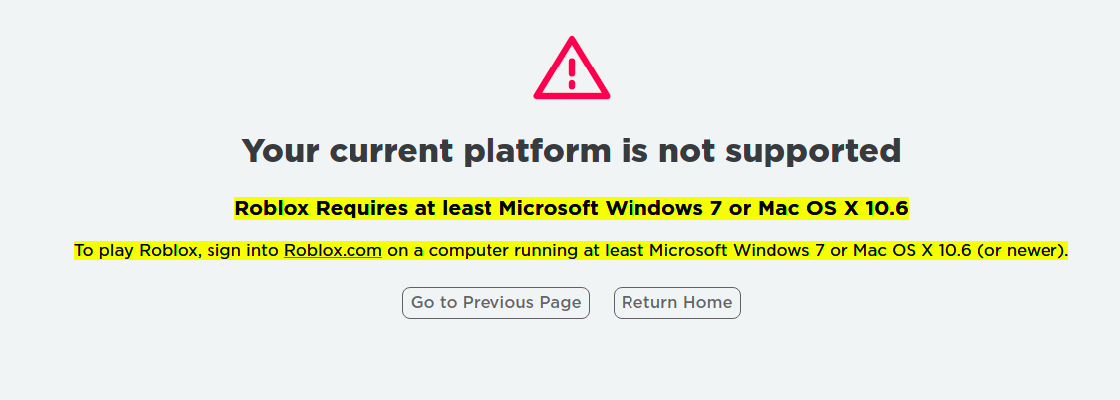Here is a screenshot of the Roblox’s downloads page opened in a web browser in a Linux based operating system.

This issue is very important and there is not much work being done about it by many people.

## **THE SOLUTION**

We took a deep look into the stated problem and asked some people about if and why or how are they able to play games and if they would like to change the situation at hand.

After talking to some people, we came to the realization that the above stated problem contains some valid reasons as to why people are not able to play games on their computers.

Now, to solve the problem at hand, we propose the development of a Web based games system that eliminates the problem of requiring dedicated hardware to play games as it requires just a web browser to work properly and be available for use to the user. The minimum requirements have been stated previously and most of the people satisfy the requirements without the need to buy new hardware or software.

Another issue that it solves is the cross-platform compatibility. As we have shown that even the biggest web games are not platform independent and how it can be an issue for some people. With our project, we are completely eradicating the need for a dedicated system to play games.

There is another issue that it is solving and that is the nature of games being free and light hearted.

Following list illustrates the benefits of our project:

* + - Cross Platform
    - Free and Open Source
    - Light on resources

We can conclude by saying that we all know the importance of being able to have some time to play games without having to spend a fortune on it. That is what we are aiming to achieve through our project.

**OBJECTIVES**

The proposed research is aimed to carry out work leading to the development of an approach for an application of **WEB BASED GAMES**. The main purpose of this application is to develop cross platform ability to play some classic games and the proposed aim will be achieved by dividing the work into following objectives:

* To understand and explore various types of operating software like LINUX, WINDOWS AND MAC.
* To study and analyze various game making techniques that are suitable for different types of operating software.
* To design and develop the technique for web-based games.
* To verify and validate the proposed system.

# METHODOLOGY

The following methodology will be followed to achieve the objectives defined for proposed research work:

* Detailed study of operating software, their types and impact of application’s code on different operating software will be done.
* Installation of web development tools like, VS CODE and hand on experience on existing approaches of HTML, CSS AND JAVASCRIPT applicable for web development will be done. Relative pros and cons will be identified.
* HTML framework will be created, which will provide us with the structure of an application. Then designing of the application will be done by using CSS, it is done to make website more attractive and at last with the help of JAVA SCRIPT we will provide various instructions to the application that how it will work and how can a user can access the games.
* Different UI techniques will be analyzed to make the application more and more user friendly and easy to access.
* An approach will be developed for web-based games.
* Various parameters will be identified to evaluate the proposed system.
* Comparison of new implemented approach with exiting approaches will be done.

**RESULTS AND DISCUSSION**

As we went on with the actual design and implementation of the project, we faced numerous difficulties including but not limited to:

* Responsiveness of the system with respect to different screen sizes.
* The question of where to host the site left us with a large number of free and paid hosting services and was quite difficult to come to a concrete conclusion.
* We included three classic games but to truly innovate, we had to create a game of our own. This step took the highest toll on the entire team as we had to take extra time to decide the type and content of the actual game in such a way that it does not feel boring to the end user.
* The actual selection of the color pallet used in the website was also a matter of serious discussion and took a lot of time to come to a conclusion.

To counter each of these problems, we ended up following the following strategies:

* To counter the problem of responsiveness, we used the CSS built-in flexbox and grid layouts wherever possible.
* After thorough discussion while taking into consideration the use case we had and the size of the site, we settled with GitHub pages as our hosting service.
* The process of developing our own new game certainly was a complex problem to tackle having no prior experience with what can engage a user. We ended up taking some inspiration from an anime series and a youtuber who inspired us to develop a text option-based game. After 1 month worth of work, we ended up with the final game in our repertoire.
* The color pallet took a long time to decide and it ended up being the combination of Purple, Yellow, Black, White, Green, Red, and Grey.

After all the work and considering we had to create a cross platform system, we ended up with the final result of the project as shown under:

The website has been hosted at <https://www.webbasedgames.github.io/index.html>.

The following screenshots are from the website and the games that we have included.

**HOME PAGE:**

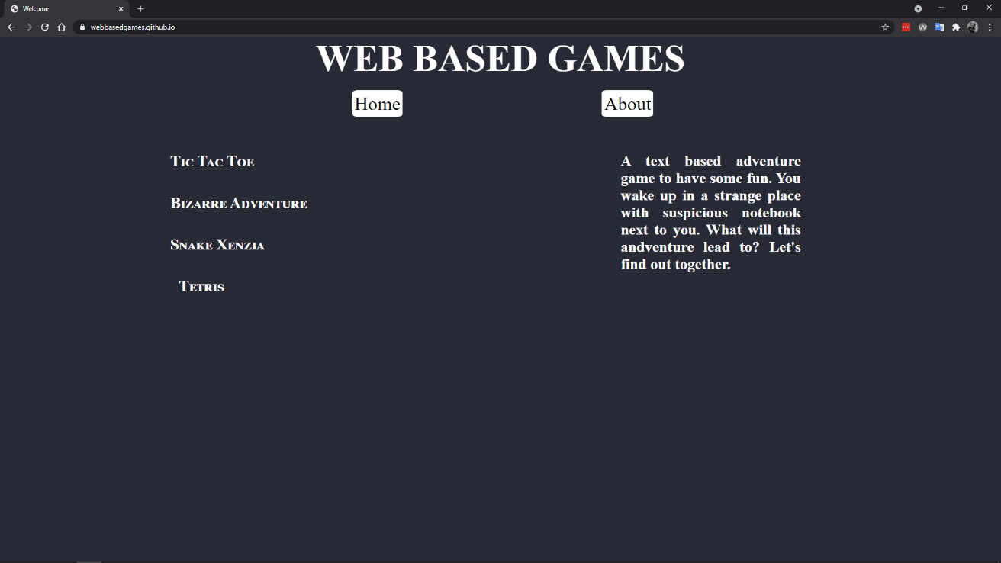

**ABOUT US PAGE:**

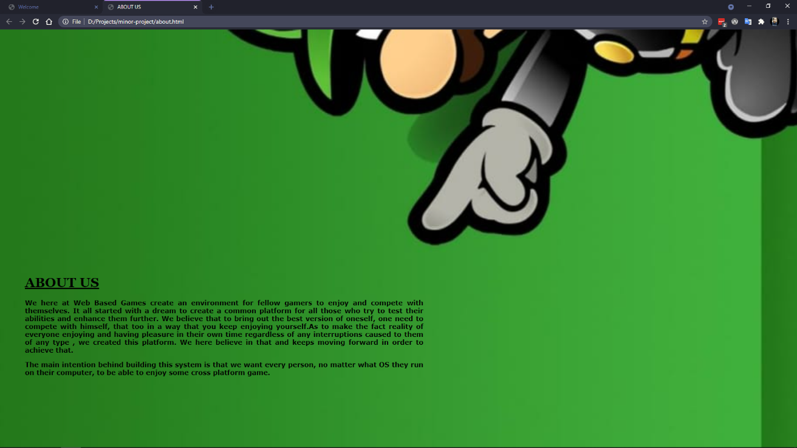

**TIC TAC TOE:**

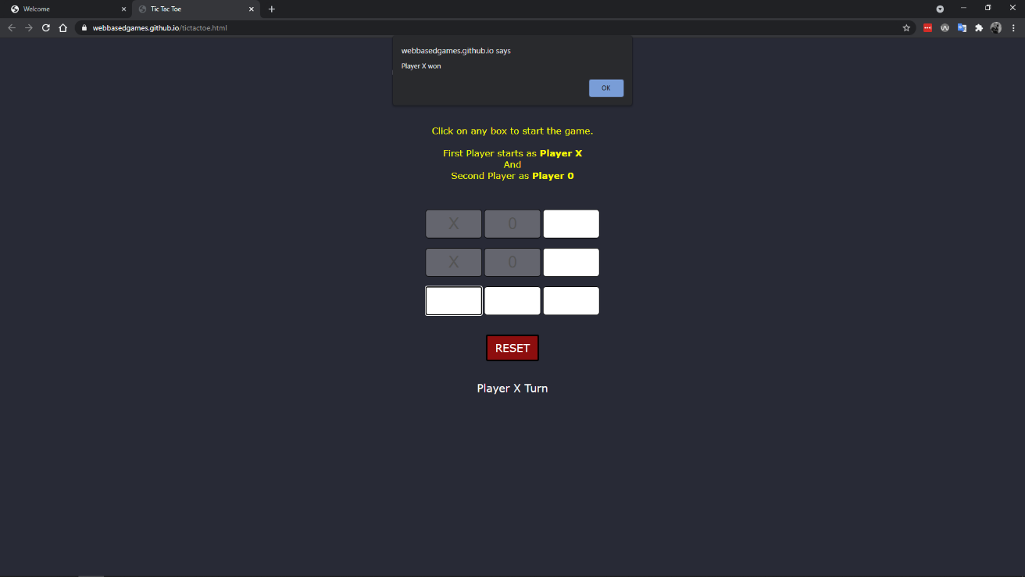

**BIZARRE ADVENTURE:**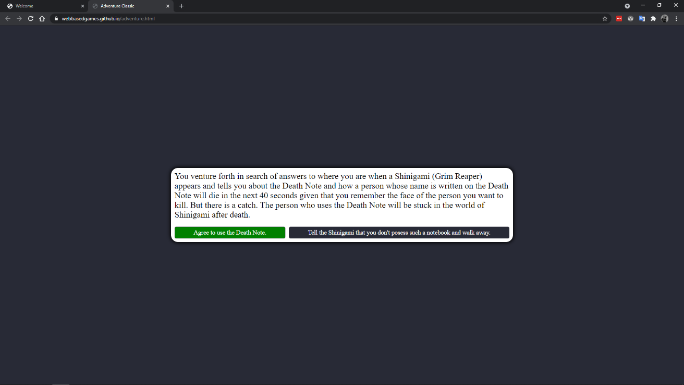

**TETRIS:**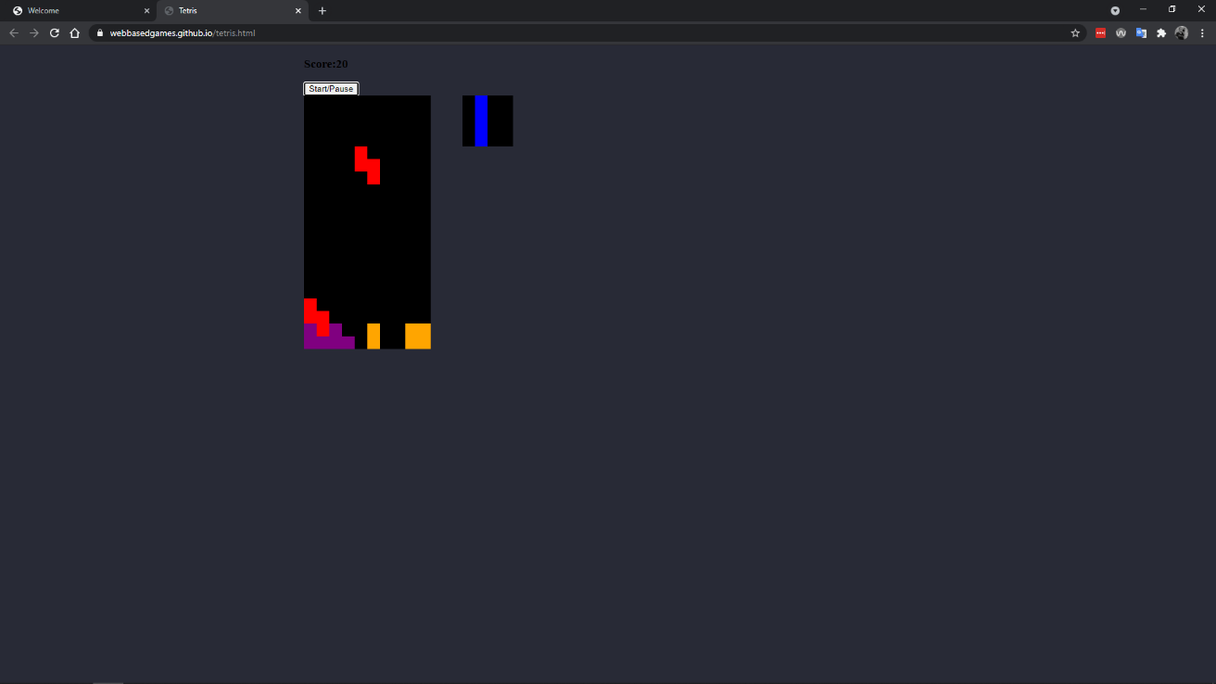

**SNAKE XENZIA:**

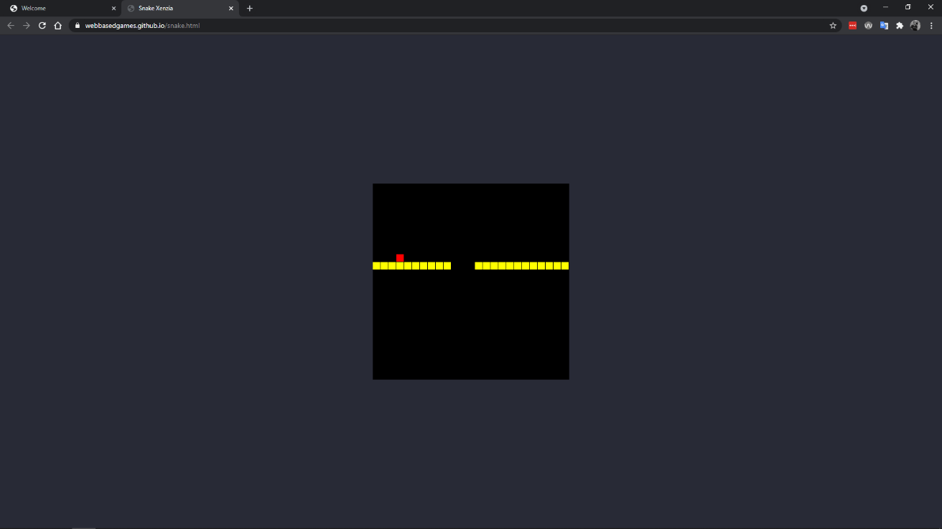

The above given screenshots give the proper representation of what has been developed in the given timeframe of three months and represents the final stage of the project as per the date of submission of the document. The future of the project depends on how well it performs in this phase and if it is worth continuing will be determined by us after observing the analytics of the website in the long run.

Thus, the discussion about the project **Web Based Games** is concluded here.

**REFERENCES**

1. Death note anime, Directed by Tetsurō Araki in the year 2006.
2. Web Dev Simplified, YouTube channel, https://www.youtube.com/channel/ UCFbNIlppjAuEX4znoulh0Cw