|  |  |  |  |  |  |  |
| --- | --- | --- | --- | --- | --- | --- |
|  | | agefx | | | | |
| epochs |  | 50s | 60s | 70s | 80s | 90s |
| 1948-1976 | 16/37398=  0.0004 | 24/27148=  0.0009 | 36/10002=  0.0036 | 14/1042=  0.0134 | 0/0 |
| 1977-1985 | 1/695=  0.0014 | 20/9596=  0.0021 | 39/7439=  0.0052 | 68/2983=  0.0228 | 10/156=  0.0641 |
| 1986-1991 | 0/0 | 0/999=  0 | 22/5406=  0.0041 | 42/2037=  0.0206 | 14/341=  0.0411 |
| 1992-2003 | 0/0 | 0/1=  0 | 25/2769=  0.009 | 91/4905=  0.0186 | 31/784=  0.0395 |
| 2004-2010 | 0/0 | 0/0 | 0/0 | 18/558=  0.0323 | 16/525=  0.0305 |

**Framingham**

|  |  |  |  |  |  |  |
| --- | --- | --- | --- | --- | --- | --- |
| male | | agefx | | | | |
| epochs |  | 50s | 60s | 70s | 80s | 90s |
| 1948-1976 | 8/16570=  0.0005 | 3/11493=  0.0003 | 7/3920=  0.0018 | 2/292=  0.0068 | 0/0 |
| 1977-1985 | 0/301=  0 | 4/4090=  0.001 | 10/2842=  0.0035 | 12/979=0.0123 | 0/31=  0 |
| 1986-1991 | 0/0 | 0/404=  0 | 5/2079=  0.0024 | 8/668=  0.012 | 4/88=  0.0455 |
| 1992-2003 | 0/0 | 0/0 | 4/1019=  0.0039 | 17/1602=0.0106 | 7/186=  0.0376 |
| 2004-2010 | 0/0 | 0/0 | 0/0 | 3/187=  0.016 | 6/140=  0.0429 |

|  |  |  |  |  |  |  |
| --- | --- | --- | --- | --- | --- | --- |
| female | | agefx | | | | |
| epochs |  | 50s | 60s | 70s | 80s | 90s |
| 1948-1976 | 8/20828=  0.0004 | 21/15655=  0.0013 | 29/6102=  0.0048 | 12/750=  0.016 | 0/0 |
| 1977-1985 | 1/394=  0.0025 | 16/5506=  0.0029 | 29/4597=  0.0063 | 56/2004=  0.0279 | 10/125=0.08 |
| 1986-1991 | 0/0 | 0/595=  0 | 17/3327=  0.0051 | 34/1369=  0.0248 | 10/253=0.0395 |
| 1992-2003 | 0/0 | 0/1=  0 | 21/1750=  0.012 | 74/3303=  0.0224 | 24/598=0.0401 |
| 2004-2010 | 0/0 | 0/0 | 0/0 | 15/371=  0.0404 | 10/385=0.026 |

**Fram**

| **Decade** | **50-59** | **60-69** | **70-79** | **80-89** | **90-99** |
| --- | --- | --- | --- | --- | --- |
| 1950-1959 | 0.00022 | 0.00111 |  |  |  |
| 1960-1969 | 0.00051 | 0.00075 | 0.00321 | 0.07692 |  |
| 1970-1979 | 0.00076 | 0.00132 | 0.00437 | 0.01911 |  |
| 1980-1989 |  | 0.00167 | 0.00456 | 0.02246 | 0.05962 |
| 1990-1999 |  |  | 0.00741 | 0.01839 | 0.03839 |
| 2000-2009 |  |  |  | 0.02111 | 0.03086 |

|  |  |  |  |  |  |  |
| --- | --- | --- | --- | --- | --- | --- |
| offspring | | agefx | | | | |
| decade |  | 50s | 60s | 70s | 80s | 90s |
| 1948-1959 | 0/0 | 0/0 | 0/0 | 0/0 | 0/0 |
| 1960-1969 | 0/0 | 0/0 | 0/0 | 0/0 | 0/0 |
| 1970-1979 | 2/5095=  4e-04 | 0/452=  0 | 0/11=  0 | 0/0 | 0/0 |
| 1980-1989 | 5/12297=  4e-04 | 4/5373=  7e-04 | 0/409=  0 | 0/3=  0 | 0/0 |
| 1990-1999 | 2/14137=  1e-04 | 10/10816=  9e-04 | 14/4180=  0.0033 | 5/223=  0.0224 | 0/0 |
| 2000-2010 | 7/9566=  7e-04 | 10/13248=  8e-04 | 18/8423=  0.0021 | 17/2209=0.0077 | 0/46=  0 |

|  |  |  |  |  |  |  |
| --- | --- | --- | --- | --- | --- | --- |
| Fram+offspring | | agefx | | | | |
| decade |  | 50s | 60s | 70s | 80s | 90s |
| 1948-1959 | 3/14510=  2e-04 | 7/6302=  0.0011 | 0/29=  0 | 0/0 | 0/0 |
| 1960-1969 | 8/15658=  5e-04 | 9/12009=  7e-04 | 14/4367=  0.0032 | 1/13=  0.0769 | 0/0 |
| 1970-1979 | 8/13010=  6e-04 | 17/13309=  0.0013 | 35/8024=  0.0044 | 38/1989=0.0191 | 0/2=0 |
| 1980-1989 | 5/12307=  4e-04 | 15/11941=  0.0013 | 40/9181=  0.0044 | 75/3342=0.0224 | 22/369=0.0596 |
| 1990-1999 | 2/14137=  1e-04 | 10/10824=  9e-04 | 47/8632=  0.0054 | 83/4465=0.0186 | 21/551=0.0381 |
| 2000-2010 | 7/9566=  7e-04 | 10/13248=  8e-04 | 18/8426=  0.0021 | 58/4151=0.014 | 28/930=0.0301 |

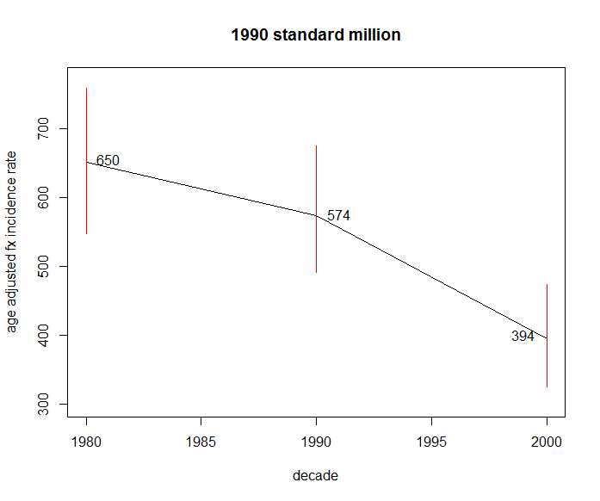

Fram+offspring

|  |  |  |  |  |  |  |
| --- | --- | --- | --- | --- | --- | --- |
| Male=1 | | agefx | | | | |
| decade |  | 50’s | 60’s | 70’s | 80’s | 90’s |
| 1948-1959 | 1/6424=  0.0002 | 1/2693=  0.0004 | 0/11=  0 | 0/0 | 0/0 |
| 1960-1969 | 3/6869=  0.0004 | 2/5093=  0.0004 | 2/1690=  0.0012 | 0/2=  0 | 0/0 |
| 1970-1979 | 6/6176=  0.001 | 0/5666=  0 | 8/3153=  0.0025 | 5/593=  0.0084 | 0/0 |
| 1980-1989 | 1/5963=  0.0002 | 5/5527=  0.0009 | 11/3571=  0.0031 | 14/1125=  0.0124 | 4/90=  0.0444 |
| 1990-1999 | 0/6576=  0 | 4/5145=  0.0008 | 8/3589=  0.0022 | 18/1477=  0.0122 | 16/422=  0.0379 |
| 2000-2010 | 3/4118=  0.0007 | 1/6010=  0.0002 | 6/3721=  0.0016 | 13/1576=  0.0082 | 20/696=  0.0287 |

|  |  |  |  |  |  |  |
| --- | --- | --- | --- | --- | --- | --- |
| Female=2 | | agefx | | | | |
| decade |  | 50’s | 60’s | 70’s | 80’s | 90’s |
| 1948-1959 | 2/8086=  0.0002 | 6/3609=  0.0017 | 0/18=  0 | 0/0 | 0/0 |
| 1960-1969 | 5/8789=  0.0006 | 7/6916=  0.001 | 12/2677=  0.0045 | 1/11=  0.0909 | 0/0 |
| 1970-1979 | 2/6834=  0.0003 | 17/7643=  0.0022 | 27/4871=  0.0055 | 33/1396=  0.0236 | 0/2=0 |
| 1980-1989 | 4/6344=  0.0006 | 10/6414=  0.0016 | 29/5610=  0.0052 | 61/2217=  0.0275 | 18/279=  0.0645 |
| 1990-1999 | 2/7561=  0.0003 | 6/5679=  0.0011 | 39/5043=  0.0077 | 65/2988=  0.0218 | 16/422=  0.0379 |
| 2000-2010 | 4/5448=  0.0007 | 9/7238=  0.0012 | 12/4705=  0.0026 | 45/2575=  0.0175 | 20/696=  0.0287 |

#1990 census by age sex

male 60-69 70-79 85above

1970-1979 0.0000 0.0025 0.0084

1980-1989 0.0009 0.0031 0.0124

1990-1999 0.0008 0.0022 0.0122

2000-2010 0.0002 0.0016 0.0082

female 60-69 70-79 85above

1970-1979 0.0022 0.0055 0.0236

1980-1989 0.0016 0.0052 0.0275

1990-1999 0.0011 0.0077 0.0218

2000-2010 0.0012 0.0026 0.0175