Results of Statistical Analysis

Abhijit

May 31, 2019

Table of Contents

## RESULTS

In 2011, there were 239,950 TKA among 28,808,011 beneficiaries in the study, while in 2015, there were 262,013 TKA among 30,177,710 beneficiaries. When the expected rate of TKA was based on adjustment for age, sex, and race/ethnicity, the OER varied widely among HRRs (Supplemental figure 1-map). The highest OER of 1.72 was in Idaho Falls, ID, while the lowest OER of 0.52 was in Bronx, NY. HRRs with the highest OER were predominantly white, while HRRs with the lowest OERs had large proportions of ethnic minorities (Supplemental table 1). Despite adjustment of the expected rates for race/ethnicity, significant correlations remained between the OER and the racial composition of the HRR, indicating residual confounding (Supplemental figure 2). Therefore, subsequent analyses used race-specific models to generate the expected number of TKA. Because whites comprised 84.64% of the sample, our analyses focused on associations among whites.

Among whites, the clinical characteristics of beneficiaries varied widely among HRR, with for example, the percent of poor beneficiaries ranging from 0.83% to 3.33%, and those with dementia ranging from 0.63% to 2.63%. (Supplemental table 2). Adjustment for indicators of knee osteoarthritis, comorbidities, and socioeconomic status resulted in OERs that were somewhat less divergent, with 10th and 90th percentiles of X and X, compared to X and X for OERs based on age and sex-adjustment (Supplemental figure 3 and Supplemental table 3). However, substantial regional variation in OERs remained after adjustment for patient characteristics, with high OER in several HRR in the upper Midwest and mountain west, and low OER in the New York City region and south Florida (Figure 1 and Supplemental table 4).

HRRs that included more rural residents had generally higher OER than those that were less rural (Figure 2). HRRs whose residents had fewer outpatient visits for knee complaints also had higher OER than those whose residents had more such visits. There was no association between the OER and the proportion of Medicare Advantage beneficiaries in an HRR. In contrast, HRRs with more TKA surgeons per capita had higher OERs than those with fewer surgeons per capita.

HRRs with high OERs tended to have high OERs among patients with very low estimated probabilities of TKA as well as those with higher estimated probabilities of TKA, while HRRs with low OERs tended to have low OERs across quartiles of estimated probability of TKA (Figure 3). This pattern suggests that HRRs with high OERs were less discriminating in performing TKA across a spectrum of beneficiaries with varying likelihood of TKA, and that HRRs with low OERs were universally more discriminating. Consistent with this interpretation, rates of TKA among beneficiaries with dementia, peripheral vascular disease, and leg ulcers were higher in HRRs with high OERs, as were rates among healthy 65 to 69 year-olds (Figure 4).

The number of TKA surgeons per HRR ranged from 48 to 1047. The annual number of TKA performed varied widely, but the number and range of TKAs per surgeon was similar in high OER regions as in other regions (Supplemental figure 4).

Analyses in blacks, Hispanics, and Asians was limited by low representation  
across HRRs. Only six HRR included at least 15,000 Hispanic beneficiaries,  
which corresponded to the lowest white HRR population in our study. Forty-two  
HRRs included at least 15,000 black beneficiaries. OERs among blacks in these  
HRRs ranged from 0.70 to 1.2 (Supplemental table 5). OERs in blacks and whites  
in these regions were positively correlated, and generally higher among blacks  
(Figure 5).

We limited the analysis of blacks and Hispanics to those HRRs that had at least 15,000 black or Hispanic Medicare beneficiaries to provide stable OER estimates. This number corresponded to the lowest HRR population in the analysis of whites. Among blacks, there was comparatively little variation in OERs among the 42 HRRs studied, with a range from 0.59 to 1.38 (Supplemental table 5).

## Hawaii

The Hawaii HRR information

| **HRR** | **City** | **State** | **OER (Model 1)** | **OER (Model 3)** |
| --- | --- | --- | --- | --- |
| 150 | Honolulu | HI | 0.703 | 0.865 |

## Figures

*This plot is available as a separate file, since it takes long to render*

**Figure 1.** Observed-to-expected ratios for rates of total knee arthroplasties among white Medicare beneficiaries age 65 to 89 in 2011-2015, by Health Referral Region. Ratios greater than 1.0 indicate higher than expected rates of total knee arthroplasty, while ratios less than 1.0 indicate lower than expected rates.

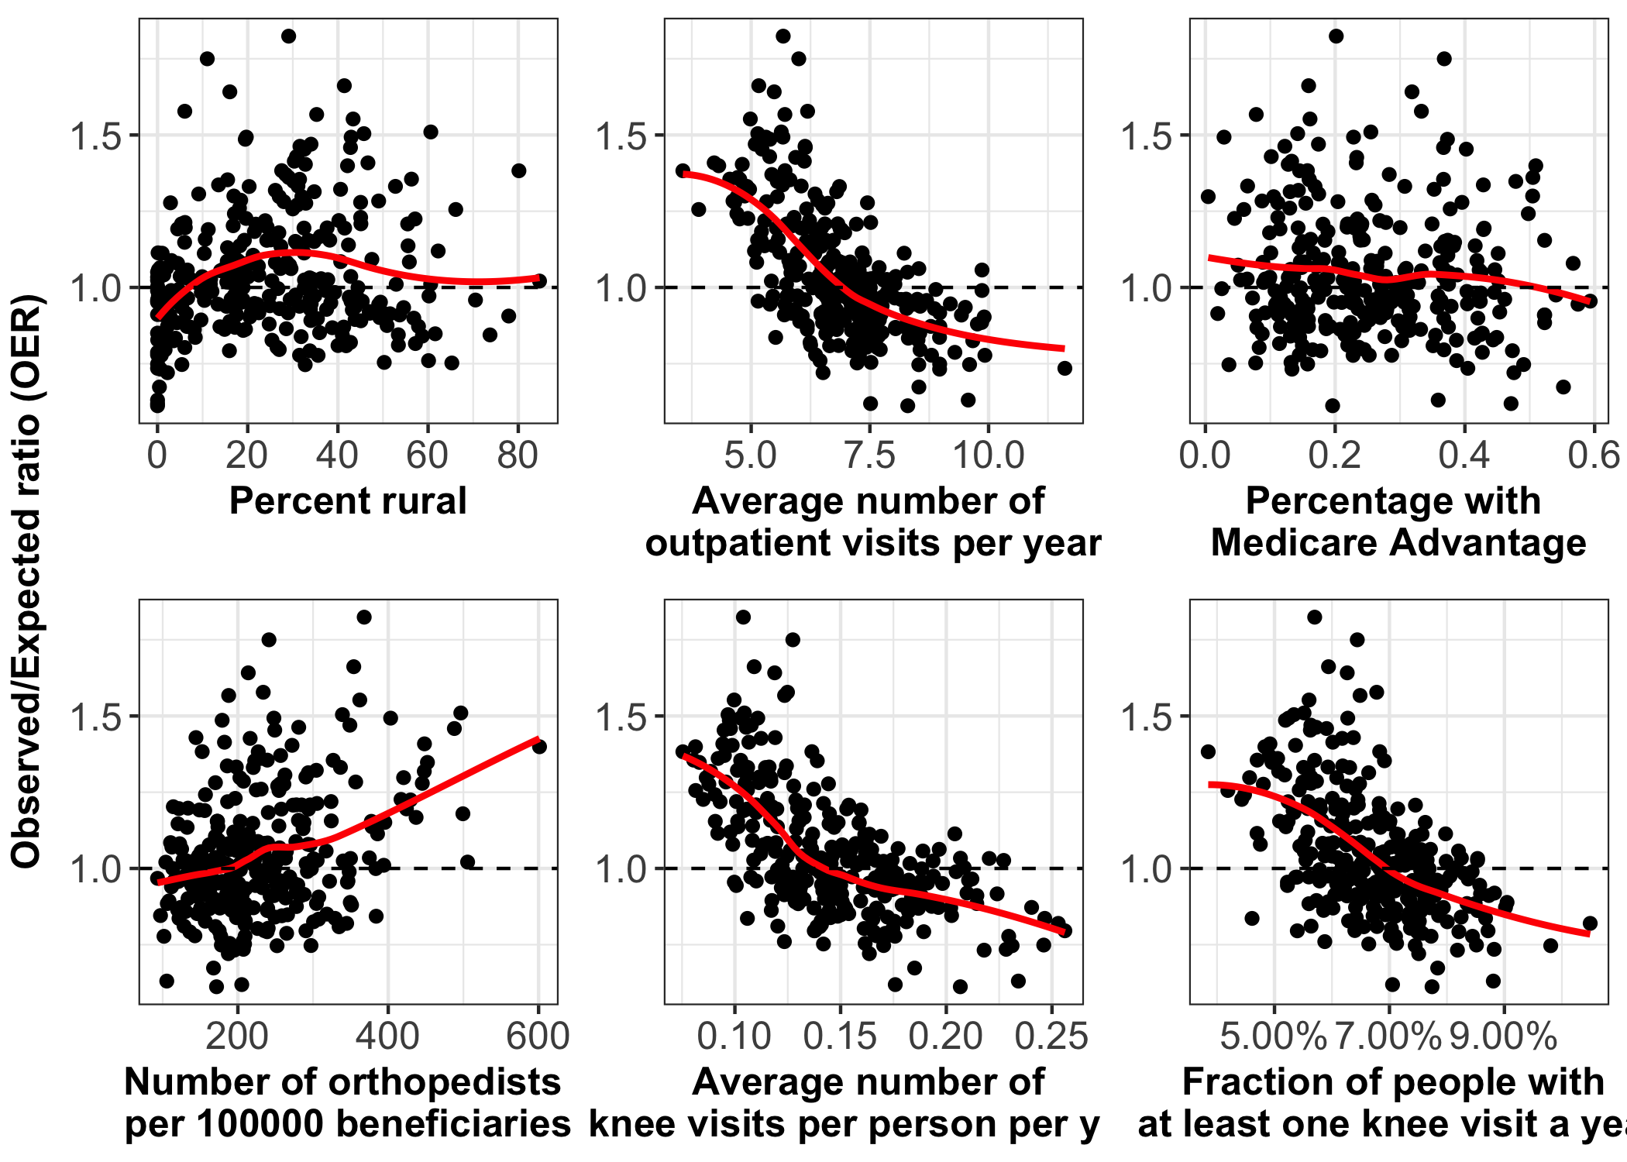

**Figure 2.** Associations between the percent of beneficiaries living in rural areas, the number of outpatient visits for knee complaints, the percent of beneficiaries in Medicare Advantage plans, and the number of surgeons performing total knee arthroplasties per 10,000 beneficiaries in the and the observed-to-expected ratio for rates of total knee arthroplasty among white Medicare beneficiaries in each Health Referral Region.

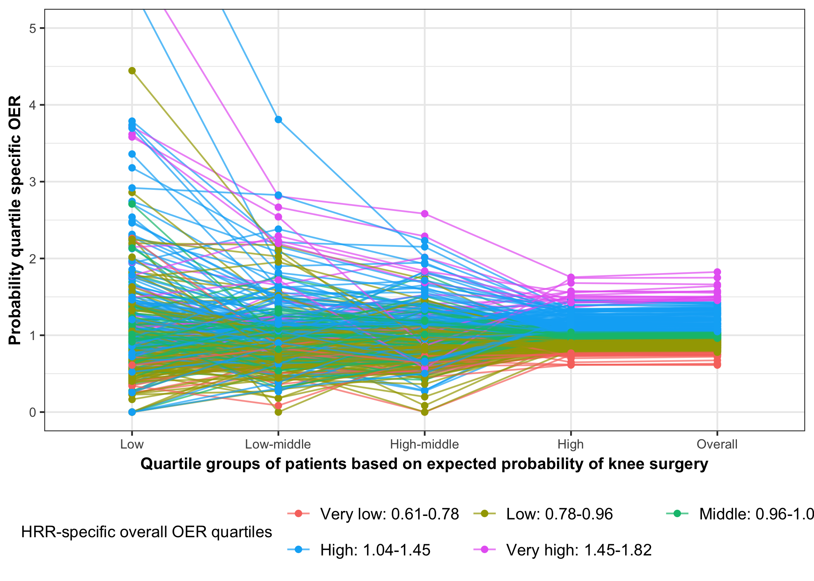

**Figure 3.** Observed-to-expected ratios for rates of total knee arthroplasty in each Health Referral Region among white Medicare beneficiaries, stratified by beneficiary’s expected probability of total knee arthroplasty. Expected probabilities were stratified into quartiles from very low (on the left) to highest (on the right), and quartile-specific observed-to-expected ratios were computed for each region.

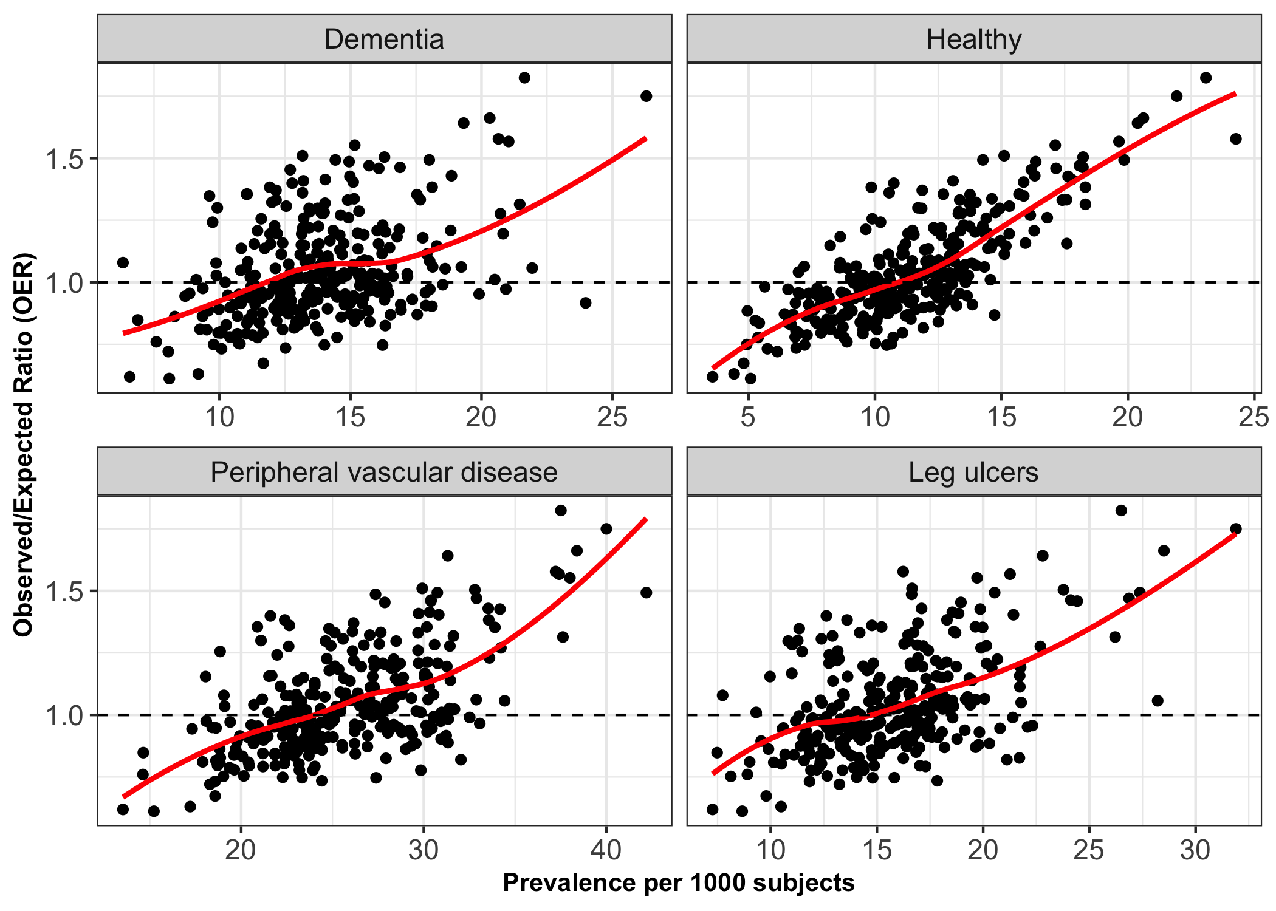

**Figure 4.** Associations between rates of total knee arthroplasty among white Medicare beneficiaries with either dementia, peripheral vascular disease, leg ulcers, or who were age 65 to 69 with no comorbidities and the observed-to-expected ratio for rates of total knee arthroplasty by Health Referral Region.

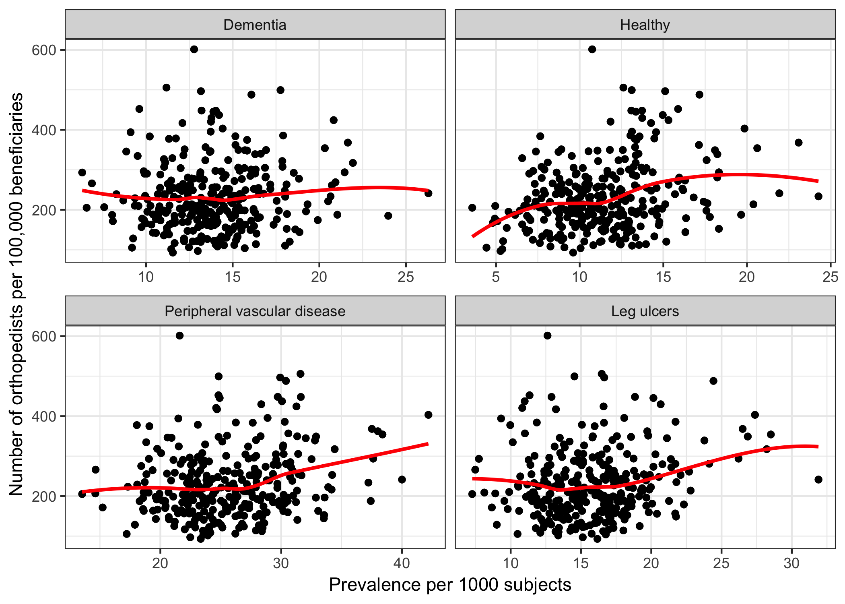

**Figure 4a.** Association between density of orthopedists and prevalence of demential pvd, leg ulcers or healthy individuals among white Medicare beneficiaries by HRR

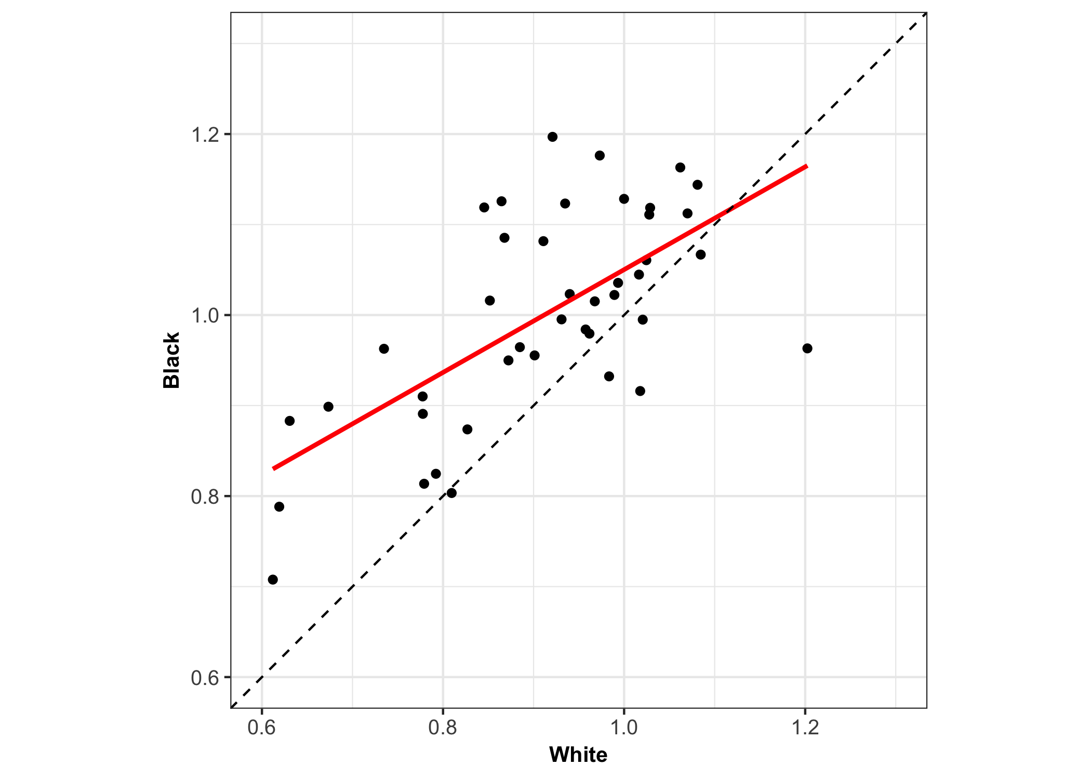

**Figure 5.** Association between the observed-to-expected ratios for rates of total knee arthroplasty between white and black Medicare beneficiaries. Associations between the observed-to-expected ratios for rates of total knee arthroplasty in white and black Medicare beneficiaries and the number of surgeons performing total knee arthroplasties per 10,000 beneficiaries in the Health Referral Region. HRRs for blacks are restricted to those with at least 15,000 black beneficiaries.

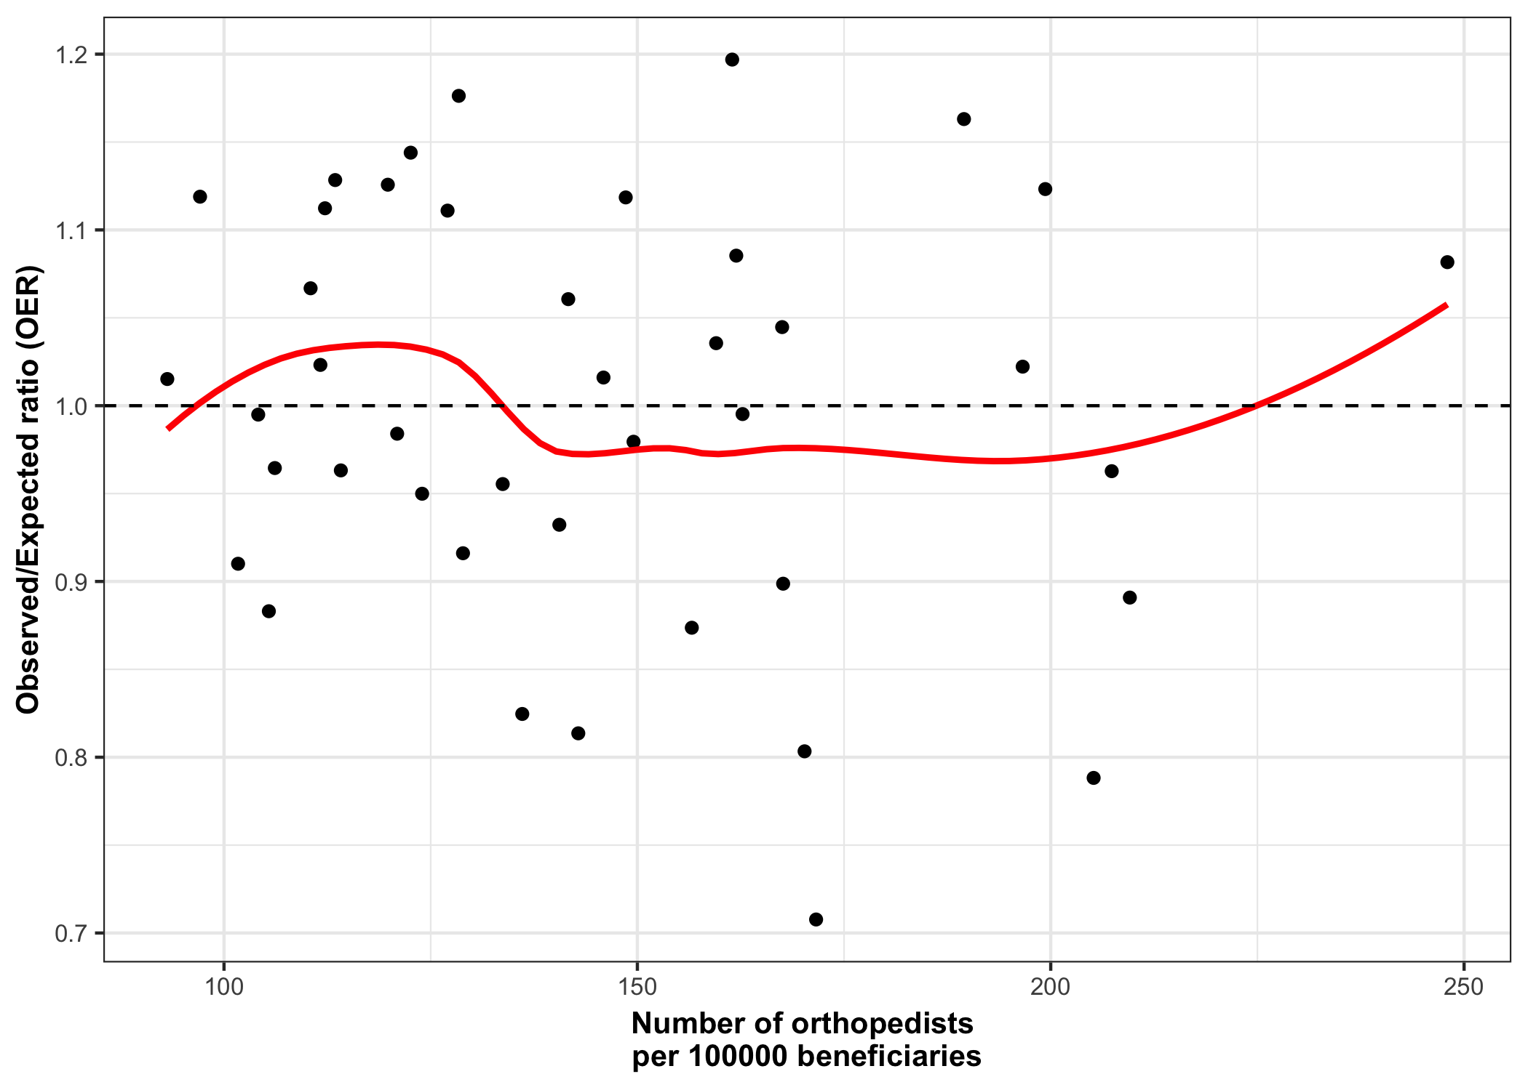

**Figure 6.** Association of the OER among blacks with the number of orthopedists per 100000 beneficiaries in a HRR.

# Supplemental materials

## Tables

| **HRR** | **OER** | **City** | **State** | **White** | **Black** | **Hispanic** | **Asian** | **Other** |
| --- | --- | --- | --- | --- | --- | --- | --- | --- |
| Lowest 10 |  |  |  |  |  |  |  |  |
| 297 | 0.521 | Bronx | NY | 47.00% | 33.11% | 11.75% | 2.73% | 5.41% |
| 289 | 0.539 | Newark | NJ | 62.71% | 23.97% | 4.70% | 3.72% | 4.90% |
| 303 | 0.544 | New York | NY | 66.85% | 16.64% | 4.15% | 5.83% | 6.54% |
| 127 | 0.659 | Miami | FL | 62.67% | 9.94% | 22.97% | 0.87% | 3.56% |
| 284 | 0.677 | Hackensack | NJ | 79.01% | 5.30% | 5.45% | 4.83% | 5.40% |
| 288 | 0.682 | New Brunswick | NJ | 78.86% | 6.49% | 2.02% | 6.62% | 6.02% |
| 79 | 0.694 | San Bernardino | CA | 70.31% | 8.17% | 9.63% | 6.17% | 5.72% |
| 150 | 0.703 | Honolulu | HI | 33.38% | 0.89% | 0.38% | 25.92% | 39.43% |
| 301 | 0.705 | East Long Island | NY | 77.85% | 9.35% | 2.38% | 4.89% | 5.53% |
| 156 | 0.707 | Chicago | IL | 51.65% | 35.20% | 5.11% | 4.10% | 3.93% |
| Highest 10 |  |  |  |  |  |  |  |  |
| 195 | 1.417 | Mason City | IA | 98.55% | 0.18% | 0.13% | 0.12% | 1.03% |
| 201 | 1.424 | Wichita | KS | 93.99% | 2.24% | 1.12% | 0.80% | 1.85% |
| 321 | 1.439 | Bismarck | ND | 95.54% | 0.09% | 0.04% | 0.11% | 4.22% |
| 371 | 1.455 | Sioux Falls | SD | 96.54% | 0.20% | 0.14% | 0.22% | 2.90% |
| 423 | 1.484 | Salt Lake City | UT | 93.73% | 0.38% | 1.44% | 1.12% | 3.33% |
| 196 | 1.547 | Sioux City | IA | 95.26% | 0.31% | 1.02% | 0.78% | 2.63% |
| 277 | 1.574 | Lincoln | NE | 96.96% | 0.51% | 0.44% | 0.63% | 1.46% |
| 421 | 1.603 | Ogden | UT | 94.31% | 0.90% | 1.60% | 0.91% | 2.28% |
| 422 | 1.643 | Provo | UT | 95.54% | 0.14% | 2.02% | 0.55% | 1.75% |
| 152 | 1.720 | Idaho Falls | ID | 95.40% | 0.14% | 1.57% | 0.32% | 2.58% |

**Supplemental Table 1:** Racial composition in the HRRs with the highest and lowest OER when adjusted for age, race and sex

| **Variable** | **Min** | **10%** | **Median** | **90%** | **Max** |
| --- | --- | --- | --- | --- | --- |
| Age | 72.27 | 73.39 | 73.96 | 74.56 | 75.06 |
| Percent white | 33.30% | 74.04% | 90.09% | 96.64% | 98.55% |
| Gender: Male | 42.69% | 44.33% | 45.74% | 48.02% | 52.18% |
| Acute MI | 0.30% | 0.55% | 0.75% | 0.96% | 1.53% |
| Atrial fibrilation | 4.97% | 6.78% | 8.28% | 9.46% | 10.63% |
| Breast Cancer | 2.93% | 3.80% | 4.29% | 4.85% | 5.91% |
| Chronic heart failure | 11.98% | 15.70% | 20.26% | 25.44% | 34.13% |
| Chronic kidney disease | 6.26% | 10.66% | 13.19% | 15.79% | 22.11% |
| Colorectal cancer | 1.42% | 1.75% | 2.21% | 2.57% | 3.08% |
| COPD | 10.97% | 16.02% | 21.88% | 27.84% | 35.17% |
| Dementia | 5.98% | 8.12% | 10.41% | 12.46% | 18.60% |
| Depression | 6.87% | 9.89% | 11.94% | 13.68% | 16.29% |
| Diabetes mellitus | 11.21% | 16.65% | 21.63% | 25.51% | 34.23% |
| Endometrial cancer | 0.35% | 0.49% | 0.68% | 0.88% | 1.18% |
| Heme malignancy | 1.17% | 1.51% | 1.70% | 1.98% | 2.73% |
| HIV | 0.02% | 0.04% | 0.06% | 0.11% | 1.02% |
| Ischemic heart disease | 24.05% | 29.85% | 39.11% | 49.29% | 59.63% |
| Any knee OA visit | 3.85% | 5.40% | 6.76% | 8.00% | 10.49% |
| Liver disease | 3.16% | 4.47% | 5.75% | 7.68% | 17.55% |
| Lung cancer | 0.35% | 0.84% | 1.09% | 1.39% | 1.80% |
| Prostate cancer | 3.22% | 3.89% | 4.55% | 5.51% | 7.18% |
| Peripheral vasuclar disease | 6.67% | 11.04% | 16.28% | 22.05% | 30.63% |
| Stroke | 7.05% | 8.90% | 11.86% | 14.22% | 17.00% |
| Leg ulcers | 1.73% | 2.66% | 3.36% | 4.37% | 5.88% |
| Knee symptoms | 3.27% | 4.88% | 5.92% | 7.46% | 9.62% |
| Knee patient | 5.88% | 8.36% | 9.75% | 11.24% | 12.65% |
| Outpatient visits | 3.56 | 5.30 | 6.81 | 8.52 | 11.61 |
| Percent Obese | 23.49% | 30.94% | 36.51% | 40.38% | 47.30% |
| Percent with physical occupation | 8.28% | 12.02% | 14.80% | 18.32% | 26.76% |
| Percent smokers | 9.05% | 17.08% | 22.28% | 26.38% | 29.79% |
| Percent with Medicare Advantage | 0.43% | 10.94% | 23.58% | 42.60% | 59.32% |
|  |  |  |  |  |  |
| Poor | 2.08% | 4.83% | 8.00% | 13.39% | 35.66% |
| SES score | -6.77 | -2.19 | 0.90 | 6.09 | 12.96 |
| Rural residence | 0.00% | 1.24% | 24.05% | 50.33% | 84.71% |

**Supplemental Table 2:** Distribution of demographic and clinical characteristics across HRRs

| **HRR** | **City** | **State** | **OER** |
| --- | --- | --- | --- |
| Lowest 10 |  |  |  |
| 289 | Newark | NJ | 0.61 |
| 297 | Bronx | NY | 0.62 |
| 303 | New York | NY | 0.63 |
| 127 | Miami | FL | 0.67 |
| 218 | New Orleans | LA | 0.72 |
| 288 | New Brunswick | NJ | 0.73 |
| 118 | Fort Lauderdale | FL | 0.73 |
| 225 | Salisbury | MD | 0.75 |
| 122 | Hudson | FL | 0.75 |
| 284 | Hackensack | NJ | 0.75 |
| Highest 10 |  |  |  |
| 106 | Greeley | CO | 1.49 |
| 321 | Bismarck | ND | 1.50 |
| 249 | Traverse City | MI | 1.51 |
| 371 | Sioux Falls | SD | 1.55 |
| 277 | Lincoln | NE | 1.57 |
| 421 | Ogden | UT | 1.58 |
| 423 | Salt Lake City | UT | 1.64 |
| 196 | Sioux City | IA | 1.66 |
| 422 | Provo | UT | 1.75 |
| 152 | Idaho Falls | ID | 1.82 |

**Supplemental Table 4:** Top and bottom 10 HRRs based on white-only analyses (Model 3)

| **HRR** | **City** | **State** | **OER** |
| --- | --- | --- | --- |
| 289 | Newark | NJ | 0.708 |
| 297 | Bronx | NY | 0.788 |
| 219 | Shreveport | LA | 0.803 |
| 156 | Chicago | IL | 0.814 |
| 379 | Memphis | TN | 0.825 |
| 210 | Baton Rouge | LA | 0.874 |
| 303 | New York | NY | 0.883 |
| 147 | Macon | GA | 0.891 |
| 127 | Miami | FL | 0.899 |
| 301 | East Long Island | NY | 0.910 |
| 397 | Houston | TX | 0.916 |
| 234 | Detroit | MI | 0.932 |
| 283 | Camden | NJ | 0.950 |
| 1 | Birmingham | AL | 0.955 |
| 118 | Fort Lauderdale | FL | 0.963 |
| 268 | Kansas City | MO | 0.963 |
| 356 | Philadelphia | PA | 0.965 |
| 430 | Norfolk | VA | 0.979 |
| 328 | Cleveland | OH | 0.984 |
| 391 | Dallas | TX | 0.995 |
| 365 | Charleston | SC | 0.995 |
| 227 | Boston | MA | 1.015 |
| 312 | Durham | NC | 1.016 |
| 155 | Blue Island | IL | 1.022 |
| 144 | Atlanta | GA | 1.023 |
| 123 | Jacksonville | FL | 1.036 |
| 113 | Washington | DC | 1.045 |
| 431 | Richmond | VA | 1.061 |
| 19 | Little Rock | AR | 1.067 |
| 226 | Takoma Park | MD | 1.082 |
| 314 | Greenville | NC | 1.085 |
| 223 | Baltimore | MD | 1.111 |
| 273 | St Louis | MO | 1.112 |
| 366 | Columbia | SC | 1.118 |
| 56 | Los Angeles | CA | 1.119 |
| 130 | Orlando | FL | 1.123 |
| 318 | Raleigh | NC | 1.126 |
| 311 | Charlotte | NC | 1.128 |
| 183 | Indianapolis | IN | 1.144 |
| 145 | Augusta | GA | 1.163 |
| 380 | Nashville | TN | 1.176 |
| 259 | Jackson | MS | 1.197 |

**Supplemental Table 5:** OERs based only on Blacks in the 42 HRRs with at least 15,000 Black beneficiaries

## Figures

*This plot is available separately due to long rendering times*

**Supplemental Figure 1:** Map of OER across HRRs based on age, sex and race adjustment

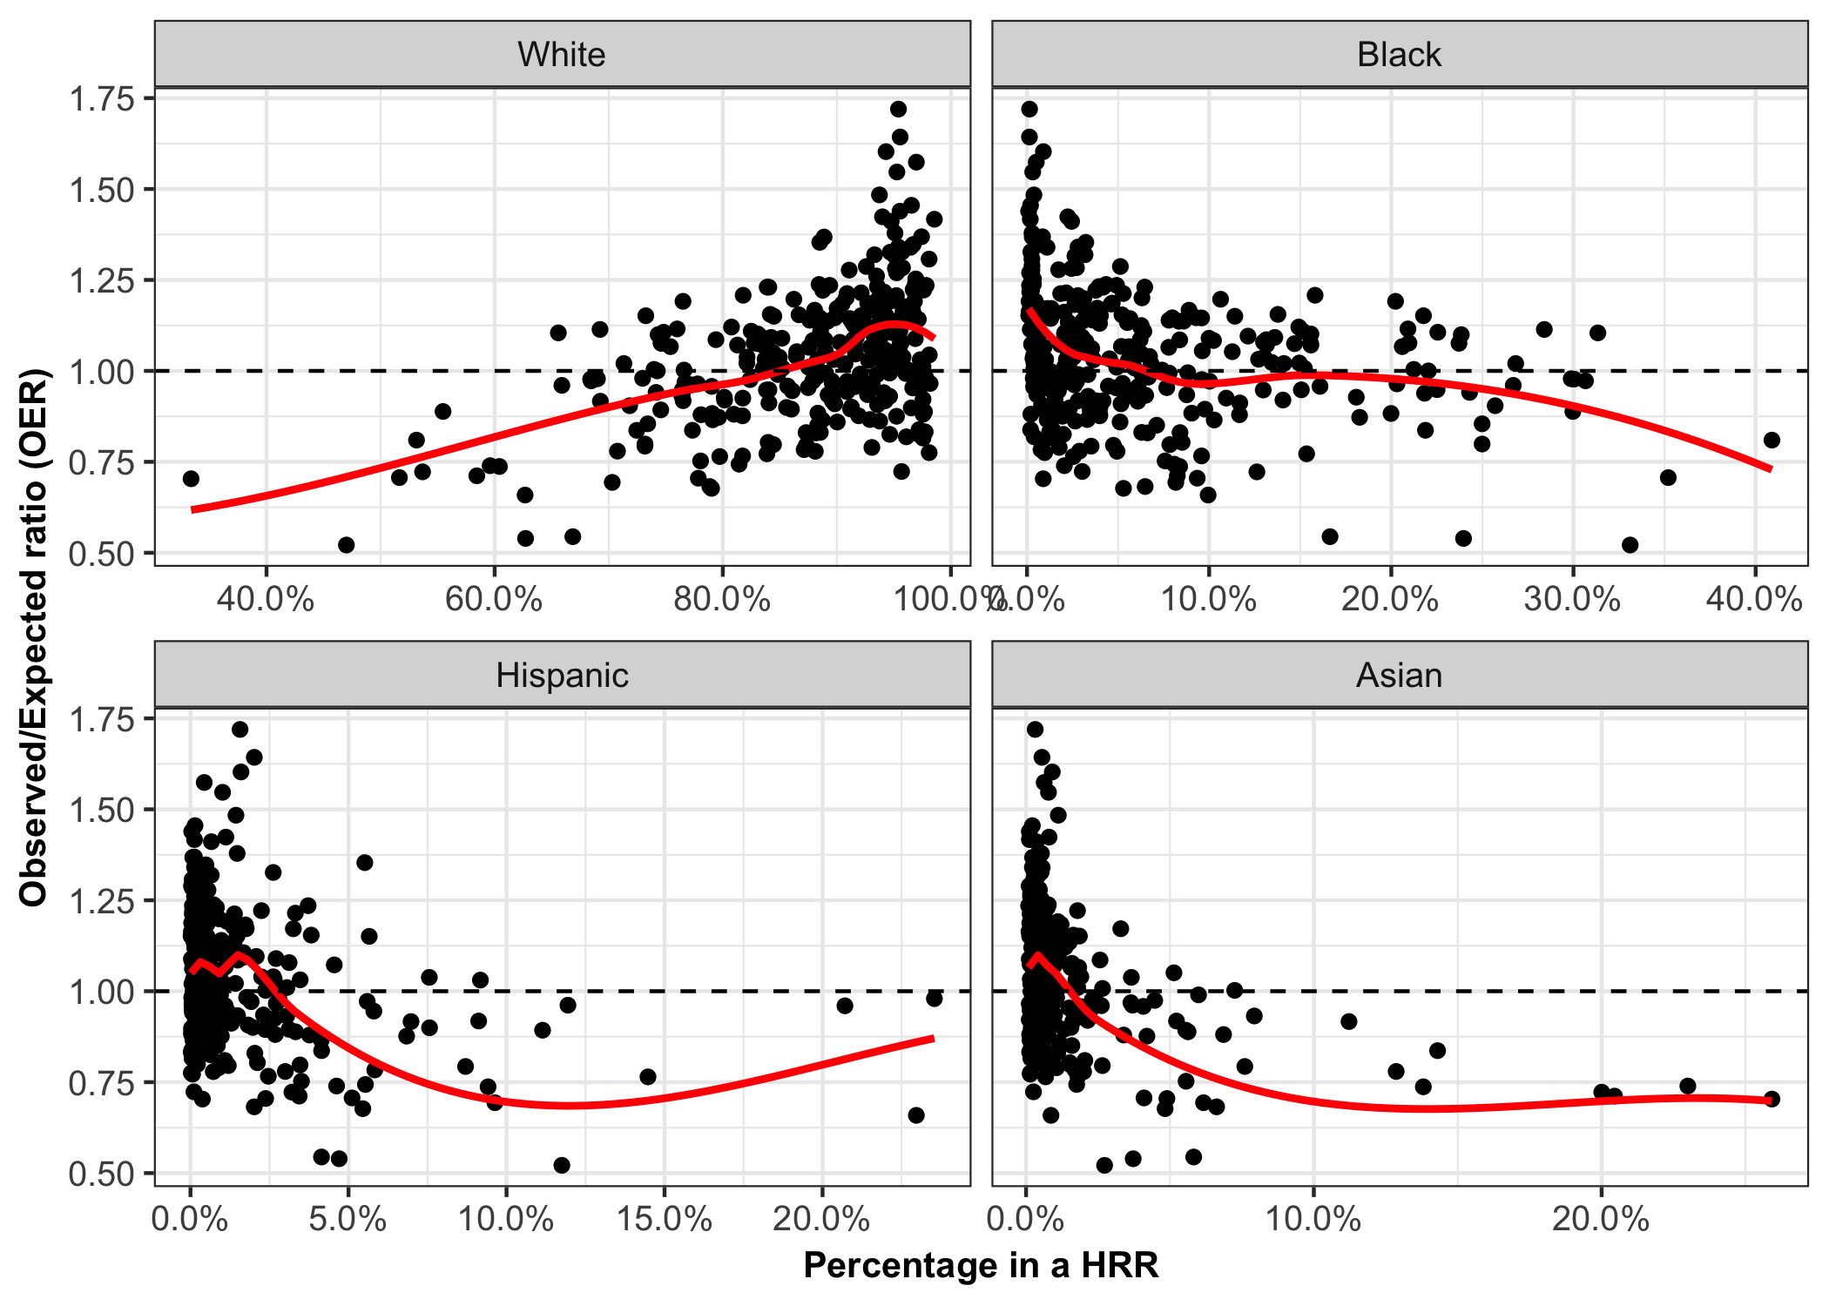

**Supplemental Figure 2:** Association of OER based on age, race and sex adjustment with racial composition in the HRR

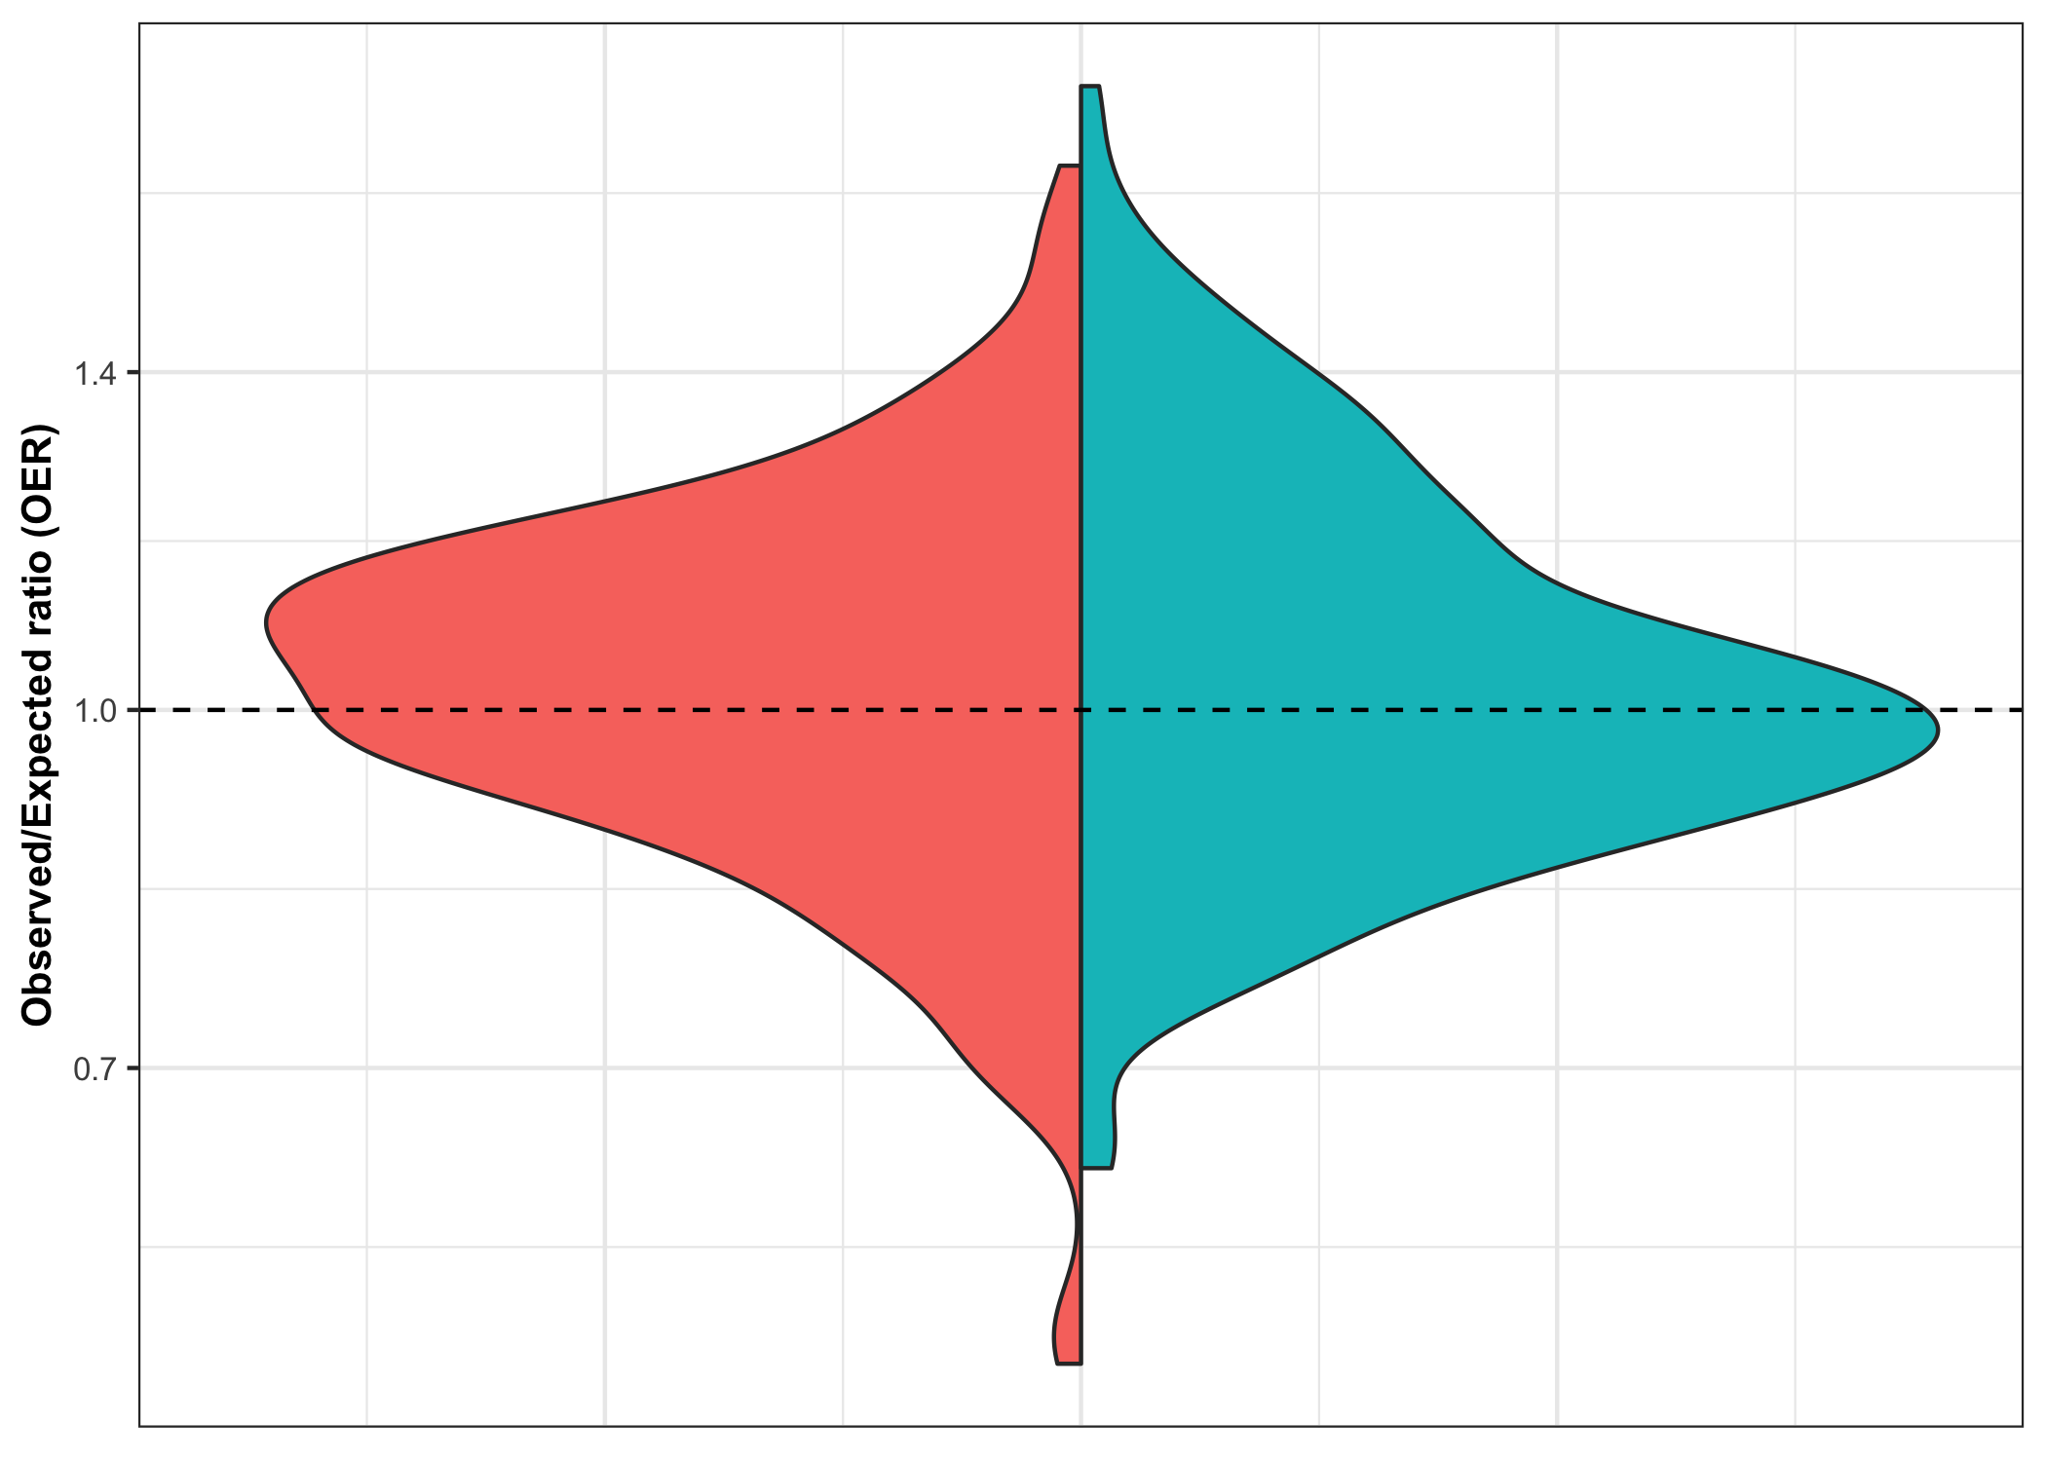

**Supplemental Figure 3:** Contrasting distributions of OERs based on Model 1 (left/red) and Model 3 (right/blue).

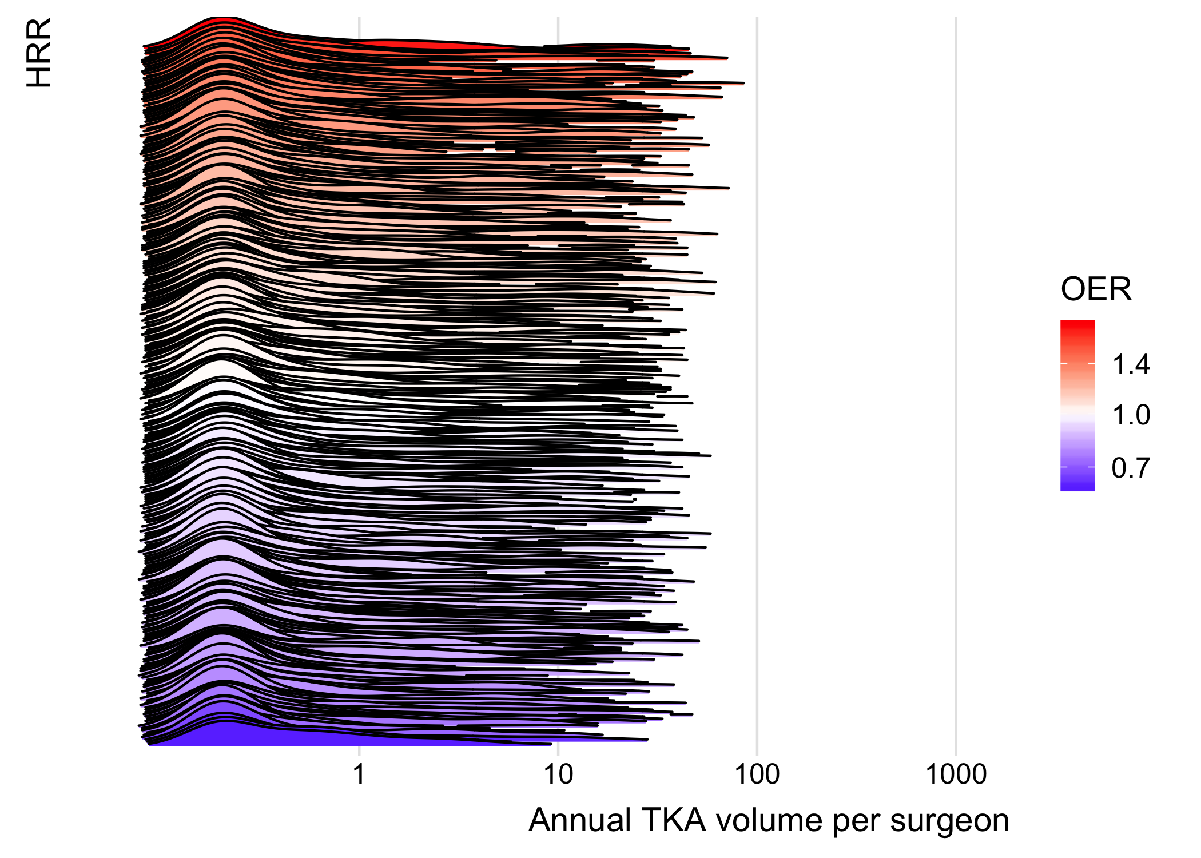

**Supplemental Figure 4:** A ridgeline plot of the distributions of surgeon TKA volume per year in 2011-2015 by Hospital Referral Region (HRR)