Results

## Table 1

|  |  |  |  |  |
| --- | --- | --- | --- | --- |
|  | non-sle alive | sle alive | non-sle dead | sle dead |
| Age | 49.23 | 44.60 | 52.71 | 47.92 |
| Female | 49.43 % | 88.82 % | 46.42 % | 85.62 % |
| Elix score | 8.18 | 7.42 | 13.69 | 11.64 |
| On ventilator | 14.07 % | 10.93 % | 66.35 % | 70.15 % |
| On medicare | 29.42 % | 38.93 % | 30.08 % | 42.7 % |
| On medicaid | 21.71 % | 22.53 % | 24.16 % | 19.39 % |
| On private insurance | 36.14 % | 31.73 % | 32.56 % | 27.67 % |
| On other insurance | 12.7 % | 6.78 % | 13.12 % | 10.24 % |

## Figure 1

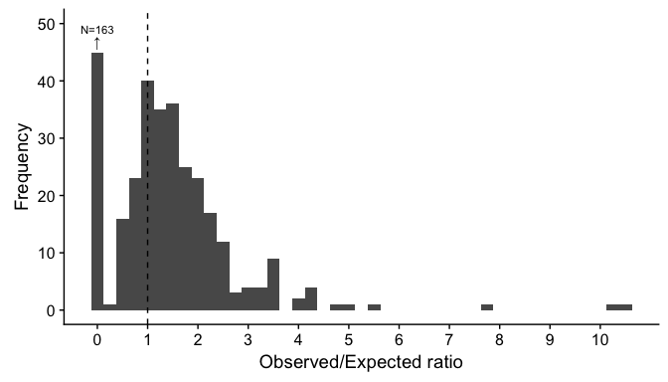

## Figure 2

