# An example

First we will find out which software packages/systems we use.

|  |  |  |  |  |
| --- | --- | --- | --- | --- |
| var1 | var2 | var3 | var4 | ID |
| Python | Java | Javascript |  | 1 |
| SAS | SPSS | Excel | R | 2 |

### So which software is the most popular?

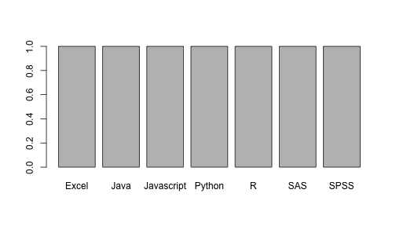

Frequency of software use

This report was generated with [R](http://www.r-project.org/) (3.0.1) and [pander](https://github.com/rapporter/pander) (0.3.7) on x86_64-apple-darwin10.8.0 platform.