1. Collect 20-year land SAT data (Oct – Dec period) of say, Nainital Lake.
2. Prepare data cube.
3. Apply an algorithm to calculate NDVI for each pixel
4. Clicking on a pixel draws a graph of the trend (NDVI value vs time).
5. Tech stack used – Frontend – Leaflet.js, Backend – python.

**DETAILS OF CURRENT PROJECT SITUATION**

* Bootstrap used for CSS part
* Base map is imported via script
* There were many layers available for base map (Road view, Satellite view and all), picked National Geographic one.
* Load server button, loads all the layers and you can select what all layers to display.
* Extent is coordinates of tiles
* QGIS3 – software used for stacking the bands I download (Satellite data comes in bands).
* AWIFS bands, False Colour Composites (FCCs)
* Properties > Symbologies > Select bands
* Layers – Raster (pixels me hai data) vs Vector (Points ko join karke)
* Clicking load button calls myFunction()
* myFunction() checks get capabilities file (which is an XML file), takes Layers tag data, Put it in an array.
* Auto play just displays those layers in an animated manner.
* Remove layer – removes all layers from frontend, empties the array , Make slider range to 0.
* NDVI – Normalised Differential Vegetation Index.
* It’s a ratio b/w -1 to 1. Can’t b 0
* >0 => more vegetation and vice versa
* GEO585 John A Dutton
* NDVI = (NIR-R)/(NIR+R).

**DATA COLLECTION SITES**

1. nrsc.gov.in
2. usgs.gov
3. vertex.daac
4. scihub.copernicus
5. glovis
6. NASA Earth Observer
7. NASA Earth Explorer
8. ESA’s sentinel data
9. Vito vision
10. Lance
11. Ippmus class
12. NOAA digital cast

**DATA CUBES**

Basically, imagine a 3D or higher grid. In each little box, you store a piece of data. To get the data out, you need its coordinates. I could store a number at (0,3,27), which is at row 0, column 3, and depth 27.

Data cubes are often used for images over time. You could store a movie this way, with the row and columns being the image pixels and the depth being the time.

Theoretically, it could be any number of dimensions. You can't draw it, but you could store something in a 4D, 5D, 6D, etc. array. They'd take up a huge amount of memory, but you could.

A data cube refers is a three-dimensional (3D) (or higher) range of values that are generally used to explain the time sequence of an image's data. It is a data abstraction to evaluate aggregated data from a variety of viewpoints. It is also useful for imaging spectroscopy as a spectrally-resolved image is depicted as a 3-D volume.  
  
A data cube can also be described as the multidimensional extensions of two-dimensional tables. It can be viewed as a collection of identical 2-D tables stacked upon one another. Data cubes are used to represent data that is too complex to be described by a table of columns and rows. As such, data cubes can go far beyond 3-D to include many more dimensions.

----------------------------------------------------------------------------------------------------------------------

<http://ceur-ws.org/Vol-2083/paper-02.pdf>

Landsat 8 is taking images of the Earth at 30 m spatial resolution in 8 spectral bands every 16 days.

Multi-spectral sensors like Landsat record the sun’s energy reflected by a surface in a few distinct spectral wavelengths (bands), e.g. blue, green, red in the visible spectrum (400 nm to 700 nm), near infrared (700 to 1100 nm), and short-wave infrared (1100 to 3000 nm). Since land surfaces with different chemical and structural properties often absorb and reflect sunlight differently and wavelength-dependent, information on land cover can be derived from these spectral bands. For example, water absorbs much of the near-infrared radiation, so these wavelengths are useful for discerning land-water boundaries that are not obvious in visible light. Similarly, green vegetation absorbs much of the incoming radiation in the red spectrum while reflecting about 50% of the radiation in the near-infrared spectrum

Much of the past research on classification algorithms has focused on exploiting the spectral and spatial properties of land covers, including artificial neural networks [1], decision trees [11], support vector machines [15], and spatial segmentation algorithms [10]. Each algorithm has its strength and weakness with respect to: the distributional assumptions made about the data, training requirements, computational complexity, and robustness to overfitting, data noise, and errors in training data. Also common to all algorithms is that the work is supervised, i.e., they need an independent reference data set (i.e., land cover information collected in the field or from air-photos) for training a model.

To this end, satellite images typically first undergo a series of pre-processing steps, including the correction of atmospheric effects, geometric alignment and cloud and cloud-shadow masking. Once these steps are finished, spectral values of pixels can be traced over time to identify and detect land surface changes such as deforestation, or urbanization

Time-series-based classifiers can broadly be categorized into two classes: Similarity-based methods use a similarity measure over sequences, such as Dynamic Time Warping (DTW), to perform a point-wise comparison of two time series. In contrast, feature based TSC rely on comparing features extracted from the different time series, typically generated from their substructures.

Public dataset taken from the TiSeLaC (Time Series Land Cover Classification Challenge).

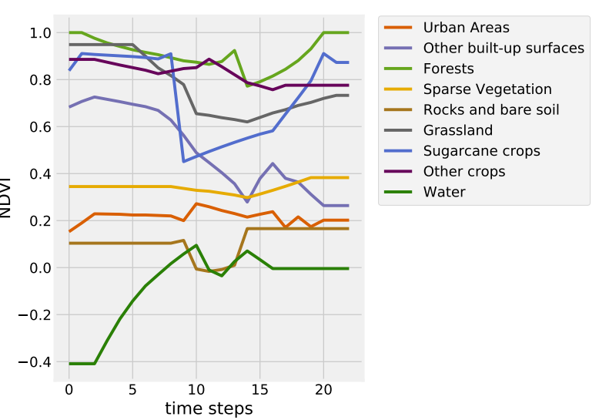

**Figure 1: Normalized Difference Vegetation Index (NDVI) of 9 different land cover classes**

atmospherically corrected, geometrically corrected, and cloud-masked with the Multi-sensor Atmospheric Correction and Cloud Screening (MACCS) level 2A processor developed at the French National Space Agency (CNES). Data pre-processing and temporal gap filling was performed using the iota21 Land Cover processor developed by CESBIO2 .

For each time step and pixel, ten spectral features were extracted, i.e., the seven reflectance bands and three vegetation indices: the Normalized Difference Vegetation Index (NDVI), the Normalized Difference Water Index (NDWI), and the Brightness Index (BI)

Reference land cover data were derived from two publicly available dataset: the 2012 CORINE Land Cover (CLC) map and the 2014 farmers’ graphical land parcel registration (Régistre Parcellaire Graphique - RPG).

<http://www.ccpo.odu.edu/SEES/veget/class/Chap_5/5_1.htm>

Remote sensing is a broad term used to describe acquiring information about an object by means of "remote" examination; that is, with no direct contact of the object. Viewing other planets, distant stars and galaxies with telescopes might immediately come to mind, but animal eyes and microscopes also gather information remotely. The discussion included here focuses on ground based, airborne, and spaceborne (satellite) remote sensing instruments that measure and record energy reflected or emitted by the earth's surface. This includes photographic cameras, and electronic imaging and non-imaging sensors.

**Spectral Domain Information**

Remote sensing instruments are designed to detect various wavelengths of the electromagnetic spectrum. Each discrete, distinctly recorded wavelength interval measured by a sensor is referred to as a "band" or "channel." Some instruments detect many discrete bands, each with relatively narrow wavelength widths, whereas others sense fewer, broader bands.

Most sensors are multispectral (detecting more than one band). Using multispectral data to create multispectral images (by building up image layers each representing a single spectral band's response of the same scene) provides the ability to differentiate objects that otherwise cannot be resolved by differences in texture or shape

Historically, visible and near-infrared wavelengths were the most commonly used spectral regions for vegetation study, but the use of microwave and thermal sensing systems to research various aspects of vegetation has become more widespread.

**Spatial Domain**

In digital images, a scene is created by displaying data (from a digital grid or array) as picture elements (pixels). Associated with each pixel are spatial and spectral attributes -- the spatial information includes the location (position) of each pixel in an image and the apparent size of the resolution cell (the area on the ground represented by each pixel), and the spectral information is the value assigned to each pixel, usually a numeric representation of the intensity of reflectance or emittance measured by a sensor for each resolution cell (pixel) in particular spectral bands.

----------------------------------------------------------------------------------------------------------------------