Port Houston Hydrogen Study

Proposed Modeling Methods: v1.4

Last updated: April 14, 2021

Contact Thomas Deetjen with feedback: [t.deetjen@cem.utexas.edu](mailto:t.deetjen@cem.utexas.edu)

The following document describes a proposed modeling method to perform analysis for the Port Houston hydrogen study, a component of the H2@Scale project. As we are early in the development process, any revisions, feedback, and questions will be valuable for improving future versions of the model.

Note that this model is designed to show trends and comparisons between different scenarios. The forecasted numbers about future hydrogen economies aren’t meant to provide accurate forecasts, but moreso to compare how changes in technology, policy, and economics will impact the potential for hydrogen economy growth.

**Background**

This model will be used to simulate the impacts of different technology advances, policies, fuel prices, and other factors on the growth of a Texas hydrogen economy. The model is not meant to predict the future hydrogen economy in Texas, but to describe trends and comparisons. The model will be used for the following objectives:

* Identify a pathway to 4 $/kg hydrogen. Determine how hydrogen production costs can be minimized by using multiple generation sources.
* Develop a 5-year plan for the expansion of the Port Houston hydrogen economy that considers existing production, distribution, and demand infrastructure assets.
  + Quantify the economic and environmental benefits.
  + Identify sectors with strong potential for switching fuels to hydrogen.
  + Identify key barriers.
  + Identify solutions—policy, technology, etc.—to those barriers.

To explore the potential pathways for expanding the Texas hydrogen economy, the study starts with the following hypotheses:

* Hydrogen is a commodity. It can be bought/sold in a market and delivered via a common infrastructure that connects multiple producers and consumers.
* Hydrogen can be diversified in two ways:
  + Purity: 99% hydrogen is “high purity” and used for fuel cells. 90% hydrogen is “low purity” and used for industrial processes, combustion, etc. These two purities require separate delivery infrastructures.
  + Carbon Intensity: the CO2 emissions associated with hydrogen production vary significantly based on the production technology and feedstock. Hydrogen with different CO2 intensities will be delivered via a common delivery infrastructure—i.e., customers desiring low-carbon hydrogen will not actually receive hydrogen molecules produced via low-carbon processes, but will procure the low-carbon credits through financial contracts.
* The successful scaling of a hydrogen economy requires that multiple sectors—including industry, transportation, heating, and/or electricity generation—shift from their current energy sources to using hydrogen.
* In many sectors, hydrogen demand will remain low without policy intervention—in particular, policy aimed at pollution and/or greenhouse gas emissions.
* The successful scaling of a hydrogen economy will require significant amounts of hydrogen demand and production to reach the large economies of scale and high utilization of infrastructure needed to reduce hydrogen prices.
* Technology improvements will drive reductions in hydrogen production costs.

To answer those research questions, we develop a model that builds production facilities and distribution infrastructure to supply hydrogen to potential consumers. The model has geographic resolution to represent the location of supply, demand, and distribution infrastructure. It tracks hydrogen prices, hydrogen consumption by sector, and CO2 emissions. The model can build and operate a variety of production technologies and distribution methods to construct a hydrogen network that can supply multiple, geographically-dispersed hydrogen consumers at competitive prices and accounting for particular policies. The following section describes the model in more detail.

**Objective**

The model maximizes the total surplus (consumer surplus + producer surplus). To achieve this objective, the model can build production facilities and distribution networks to create hydrogen and deliver it to consumers. The model can also choose which consumers it decides to sell hydrogen to. It makes these choices based on whether they increase the system’s total surplus.

For example, consider a choice where the model can a consumer. It must then build the production and distribution necessary to deliver hydrogen to that consumer. If this decision results in an increase in consumer utility that outweighs the increase in production cost, then the model will add that consumer/production/distribution to the network.

$$\max\left(U_{h}+U_{c}-P_{f}-P_{v}-P_{carbon}-{CCS}_{v}-D_{f}-D_{v}\right)$$

where: $$U_{h}=\sum_{t}^{T}{\sum_{j}^{C}{H_{c}(j,t)×{}_{c}\left(j\right)}}$$

*Uh* = consumer utility  
*C* = set of all potential hydrogen consumers  
*T* = set of time periods over which the model runs  
*Hc* = daily hydrogen consumption by a firm  
*θc* = breakeven hydrogen price for a firm

$$U_{c}=\sum_{t}^{T}{\sum_{j}^{C}{β_{c}(j,t)×E_{c}\left(j\right)×{}_{co2}}}$$

*Uc* = consumer utility  
*C* = set of all potential hydrogen consumers  
*T* = set of time periods over which the model runs  
*βc* = daily hydrogen black consumption by a consumer  
*Ec* = breakeven hydrogen rate of a consumer [tons-CO2/tons-H2]—i.e., the carbon-intensity of the consumed hydrogen needed to reduce the consumer’s CO2 emissions when compared to its current fuel use   
*θco2* = cost of CO2 emissions [$/ton-CO2]

*Pf* = production cost, fixed  
*P* = set of all producers that generate or may generate hydrogen  
*Ĥp* = hydrogen generation capacity of a producer   
*Kp,f* = fixed cost of hydrogen production capacity for a producer [$/ton], includes fixed O&M and amortized capital cost

$$P_{v}=\sum_{t}^{T}{\sum_{i}^{P}{H_{p}(i,t)×K_{p,v}\left(i\right)}}$$

*Pv* = production cost, variable  
*P* = set of all producers that generate or may generate hydrogen  
*T* = set of time periods over which the model runs  
*Hp* = daily hydrogen generation by a producer   
*Kp,v* = variable cost of hydrogen production for a producer [$/ton-day]

$$P_{carbon}=\left(\sum_{t}^{T}{\sum_{i}^{P}{\sum_{n}^{CCS}{β_{p}(i,t)×E_{p}\left(i\right)}}-β_{ccs}(n,i,t)×}\left(E_{p}\left(i\right)×\left(1-η_{co2}(n)\right)\right)\right)×{}_{co2}$$

*Pcarbon* = production cost associated with CO2 emissions  
*CCS =* set of allcarbon capture and sequestration technologies  
*P* = set of all producers that generate or may generate hydrogen  
*T* = set of time periods over which the model runs  
*βp* = daily generation of hydrogen-black by a producer   
*Ep* = carbon emissions rate of a producer [tonCO2/tonH2]  
*βccs* = daily generation of hydrogen-black by a producer’s CCS technology  
*ηco2* = efficiency of the CCS technology [% of producer’s CO2 captured]  
*θco2­* = price of CO2 emissions [$/tonCO2]

*CCSv* = carbon capture and sequestration cost, variable  
*CCS =* set of allcarbon capture and sequestration technologies  
*P* = set of all producers that generate or may generate hydrogen  
*T* = set of time periods over which the model runs $ε_{ccs}^{co2}$ 
 = daily amount of captured CO2 for a ccs technology at a producer [tons]  
*Kccs,v* = variable cost of captured CO2 for a ccs technology [$/tonCO2-day]

*Df* = distribution cost, fixed  
*D* = set of all distribution arcs  
*Ď* = distribution capacity units of a distributor (i.e., km of pipeline, number of trucks)  
*Kd,f* = fixed cost of distribution capacity for a distributor [$/unit], includes fixed O&M and amortized capital cost

$$D_{v}=\sum_{t}^{T}{\sum_{l}^{D}{H_{d}(l,t)×K_{d,v}\left(l\right)}}$$

*Df* = distribution cost, variable  
*D* = set of all distribution arcs  
*T* = set of time periods over which the model runs  
*Hd* = daily hydrogen flow across a distribution arc   
*Kd,v* = variable cost of hydrogen flow across a distribution arc [$/ton-day]

**Hydrogen Black and Carbon Capture and Sequestration (CCS)**

To capture the value of reducing CO2 emissions, the model is designed to enable a sort of carbon-credit transaction between producers and consumers. This transaction happens indirectly via a proxy-commodity which we call “hydrogen black.” Hydrogen black lets a producer sell hydrogen of a specific carbon intensity to a carbon-sensitive consumer without directly delivering hydrogen from that producer to that consumer. That is, this construct allows a hydrogen producer with relatively low carbon emissions to sell the low-carbon benefits of its produced hydrogen, and it allows a carbon-sensitive consumer to gain additional utility by purchasing those low-carbon benefits. If the model can build hydrogen production with lower carbon emissions, and the increased production cost of that producer is outweighed by the climate-related utility gained by the carbon-sensitive consumer, then the model will build that production and sell that hydrogen black.

Besides building low-carbon production technologies, such as electrolyzers, the model can also reduce carbon emissions by adding CCS to other production facilities. From a hydrogen black perspective, this means that when a producer builds a CCS facility, it can now sell hydrogen black at a lower carbon intensity than it could before. This reduction in carbon intensity makes the producer’s hydrogen black more valuable to the carbon-sensitive consumer who buys it—i.e., it increases their utility.

Hydrogen black and CCS are described using the following equations.

$$ε_{ccs}^{co2}\left(n,i,t\right)×B_{ccs}\left(n,i\right)≤{\hat{ε}}_{ccs}^{h2}\left(n,i\right)×E_{p}\left(i\right)×η_{co2}\left(n\right)∀n∝CCS,∀i∝P,∀t∝T$$

The daily amount of captured CO2 for a CCS technology at a producer $ε_{ccs}^{co2}$ is limited by: 1) whether the producer is allowed to build that CCS technology *Bccs*(binary, where “1” allows the producer to construct the CCS technology), and 2) the capacity of the CCS technology ${\hat{ε}}_{ccs}^{h2}\left(n,i\right)$ multiplied by the carbon emissions rate of the producer Ep multiplied by the efficiency of the CCS technology *ηco2*.

The sum of the CCS capacity ${\hat{ε}}_{ccs}^{h2}$ (in terms of tons-H2) at a production facilitycannot exceed the production facility’s hydrogen generation capacity *Ĥp*. That is, a CCS facility cannot be built to process more hydrogen than the production facility is able to produce.

$$β_{ccs}\left(n,i,t\right)≤{\hat{ε}}_{ccs}^{h2}\left(n,i\right) ∀n∝CCS,∀i∝P,∀t∝T$$

The hydrogen black produced by a CCS facility *βccs* cannot exceed the capacity of the CCS facility ${\hat{ε}}_{ccs}^{h2}$ (in terms of tons-H2).

The total amount of daily hydrogen black produced by a production facility—including the hydrogen black produced by its CCS—cannot exceed the production facility’s daily production of hydrogen *Hp*.

The total amount of daily hydrogen black consumed cannot exceed the total amount of daily hydrogen black produced.

**Production**

The model can build production facilities to create hydrogen. It then sells that hydrogen to consumers. The building and operation of these production facilities is constrained by the following equations.

$$H_{p}\left(i,t\right)≤{\hat{H}}_{p}\left(i\right) ∀i∝P,∀t∝T$$

Hydrogen production during time *t* cannot exceed hydrogen production capacity, for all producers, and for all time periods. Note that, for each producer, the model can choose to set *Ĥp* = 0, meaning that it does not build the producer: therefore, the hydrogen production from that producer must be zero, and the costs from that producer are also zero.

$$K_{p,f}=K_{p,CAP}×A+K_{p,FOM}$$

Fixed cost of production capacity (in units of [$/ton]) equals overnight capital costs (*Kp,CAP*) times the amortization factor (*A*) plus the fixed operation and maintenance cost (*Kp,FOM*).

Variable cost of production (in units of [$/ton-day] or [$/ton-hour]) equals the efficiency (*ηp­*) of converting the feedstock (e.g., natural gas, electricity, biomass) into hydrogen times the price of the feedstock (*θFUEL*).

**Steam Methane Reforming:**

Cost model

Efficiency model

How do the cost and efficiency coefficients changes over time (i.e., from 2020-2035 or -2050)?

**Electrolysis:**

Cost model

Efficiency model

How do the cost and efficiency coefficients changes over time (i.e., from 2020-2035 or -2050)?

**Distribution**

To connect hydrogen production facilities with hydrogen demand requires distribution infrastructure. We model this distribution infrastructure using a network model. In this framework, hydrogen consumers and production facilities are clustered into hubs or nodes. The model assumes that the distribution costs of distributing hydrogen within the same node are negligible. To distribute hydrogen form one node to another, the model builds an “arc” to represent a pipeline, truck route, or other distribution infrastructure. Arcs enables hydrogen to flow between nodes—i.e., from suppliers to consumers in separate nodes. That flow of hydrogen between nodes incurs some cost. See Fig 1 below for an example of how to represent hydrogen generation with a network modeling framework.

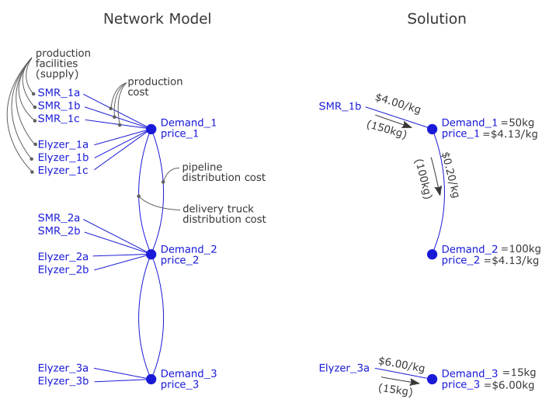

Figure 1: A hypothetical network model schematic for a hydrogen distribution system. The left side shows all of the potential ways to create hydrogen locally for each demand (SMR or electrolyzer) or move hydrogen from one place to another (pipeline or delivery truck) to also satisfy demand. Each node has existing and/or potential hydrogen demand, which depends on the hydrogen price. The model solves by building production facilities and distribution infrastructure and then using that infrastructure to satisfy demand at the lowest total cost. In the solution, the model builds SMR_1b at node 1, a pipeline between nodes 1-2, and an electrolyzer (Elyzer_3a) at node 3. The pipeline costs are spread across all consumers connected to the pipeline, so node 1 and node 2 have the same hydrogen price. Node 3 has a unique hydrogen price dependent on the production cost of the electrolyzer. In this solution, node 3 has too low of demand and is too far away from node 2 to justify the construction of a pipeline or the use of a delivery truck.

This general network modeling framework can be applied to Port Houston and/or Texas by designing the network to reflect the existing hydrogen infrastructure. Consider, for example, Fig 2. In this example, the hydrogen network of the greater Port Houston area may be described as a 15-node model with some existing SMR facilities and some existing distribution pipelines. By defining the cost and capacity of the SMR facilities and pipelines, we can solve for the lowest cost flow and infrastructure investment needed to satisfy the potential demand.

Some nodes, such as Hobby Airport, are not currently connected to the pipeline. At lower hydrogen prices, demand for hydrogen from truck fueling stations, building heating, and airplanes may increase. As demand increases, the potential hydrogen market at the Hobby Airport node becomes more attractive for model investment, and the model may build production facilities, distribution pipelines, or delivery truck routes to connect the Hobby Airport node to a hydrogen supply.



Figure 2: Hypothetical network model of the Port Houston existing hydrogen network. Lines between nodes show existing pipelines. To distribute hydrogen to unconnected nodes, the model can build new pipelines or use delivery trucks.

The model can build distribution infrastructure to connect nodes and deliver hydrogen. The building and operation of this distribution infrastructure is constrained by the following equations.

$$H_{d}\left(l,t\right)≤\hat{D}\left(l\right)×{\hat{H}}_{d}(l) ∀l∝D,∀t∝T$$

Hydrogen flow across a distribution arc *l* during time *t* cannot exceed the number of distribution units *Ď* times the daily hydrogen flow capacity of each distribution unit *Ĥd*, for all distribution arcs, and for all time periods. Note that, for each distributor, the model can choose to set *Ď* = 0, meaning that it does not build the distribution infrastructure between those nodes: therefore, the hydrogen flow across that arc must be zero, and the costs from that distribution infrastructure are also zero. Note that daily hydrogen flow capacity *Ĥd* varies for each distribution technology. Using data from Yang et al., we assume that 1 compressed air truck can make ~8.67 deliveries per day and deliver 2.6 tons of hydrogen per day; and that 1 liquefied hydrogen truck can make 2 deliveries per day and deliver 8.0 tons of hydrogen per day [reference Yang et al.]. We assume that pipelines can carry 5,000 tons per day [reference here].

$$K_{d,f}=\left(K_{d,CAP}×A+K_{d,FOM}\right)×L_{d},∀d∝pipeline arcs$$

The fixed cost of distribution capacity (in units of [$/pipeline segment]) equals overnight capital costs (*Kd,CAP*) times the amortization factor (*A*) plus the fixed operation and maintenance cost (*Kd,FOM*). This is then multiplied by the length of the distribution arc [km]. This constraint applies only to arcs where the model can build pipelines.

$$K_{d,f}=K_{d,CAP}×A+K_{d,FOM},∀d∝truck depot arcs$$

For trucks, the fixed cost of distribution capacity (in units of [$/truck]) equals overnight capital costs (*Kd,CAP*) times the amortization factor (*A*) plus the fixed operation and maintenance cost (*Kd,FOM*). This is then multiplied by the length of the distribution arc [km]. This constraint applies only to arcs where the model can build truck depots. Note that a truck depot is an arc that connects the main hydrogen hub (where producers sends hydrogen and consumers receive hydrogen) to the truck route network. The number of trucks built by the model at the depot *Ď* limits the amount of hydrogen that can be shipped across the truck route network.

$$K_{p,v}={}_{d}×L_{d}$$

Variable cost of distribution (in units of [$/ton-day] or [$/ton-hour]) equals the variable delivery cost (*θp­* in units [$/ton-km]) times the length of the distribution arc [km]. Note that the variable costs for trucks also include the cost of compression or liquefaction (a $/ton-day value that includes the amortized capital cost of the compression or liquefaction plant) and the cost of storage (a $/ton-day value that includes the amortized capital cost of the storage vessel).

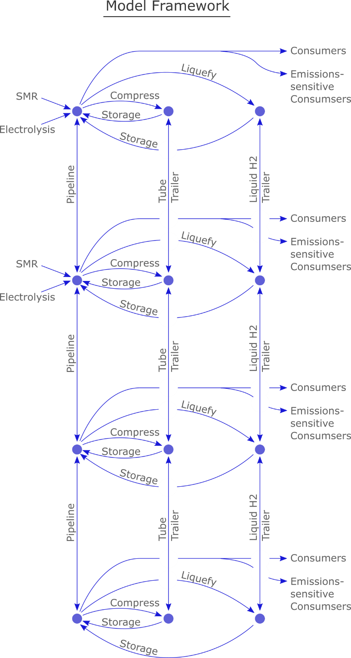

Figure 3: A schematic of the network modeling framework. The “compress” and “liquefy” arcs denote truck depot arcs, which limit the capacity of how much hydrogen can be trucked from that hydrogen pipeline hub, and which capture the cost of converting the pipeline hydrogen into compressed or liquefied hydrogen ready for trucking.

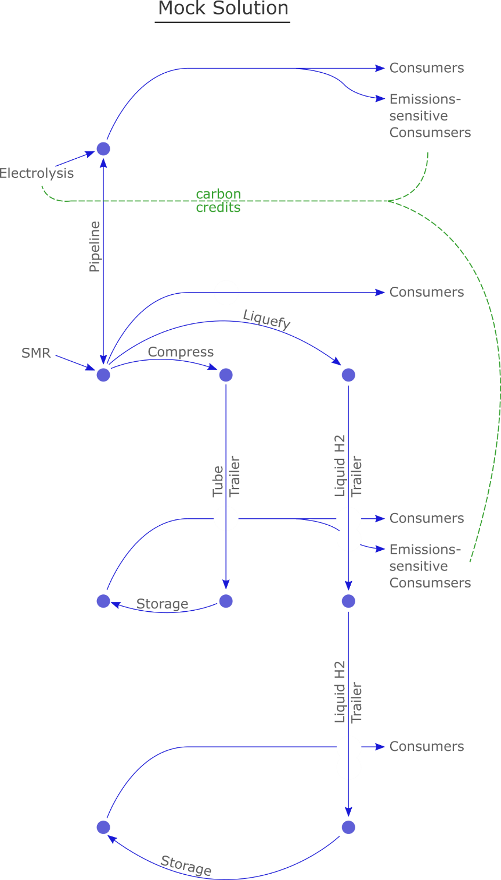

Figure 4: A hypothetical solution to the modeling framework shown in the previous figure. This solution takes advantage of all three distribution technologies.

**Pipelines versus Trucks**

For pipeline distribution, the model must build pipeline infrastructure across an arc prior to using that arc to distributing hydrogen between nodes. The cost of building new hydrogen pipelines is described using an annualized cost, which includes the amortized capital cost and fixed operation and maintenance cost in terms of $/km of pipeline.

For truck delivery, the model must build truck fleets at a particular hydrogen hub, and then convert the pipeline hydrogen into trucked hydrogen. This conversion from pipeline to truck is limited by the number of trucks the model builds *Ď* and the daily flow capacity of each truck *Ĥd* [ton-day/truck], but once the hydrogen has been converted from pipeline to truck, the model may send as much of the trucked hydrogen across truck routes (arcs that move trucked hydrogen from one hydrogen hub to another) as needed.

We assume that the annualized capital and fixed costs of a pipelines and trucks are distributed equally among the consumers served by that network. That is, we divide the pipeline’s total annualized cost by the annual hydrogen demand of the consumers in the pipeline network to calculate a $/kg fee. That fee is added to each consumer’s hydrogen price.

**Hydrogen Demand**

The model includes many potential consumers of hydrogen. A consumer will convert from its current fuel to hydrogen if the production cost of hydrogen falls below the consumer’s breakeven price. These consumers include a number of different sectors, and each sector includes a variety of different firms.

We assume that each sector’s potential hydrogen demand can be described using a Normal distribution. That is, we assume that

* each sector has a diversity of firms with unique costs,
* each firm has a break-even hydrogen price, at which the firm is indifferent to using its current fuel or switching to hydrogen,
* each industry has a median break-even hydrogen price at which half of the firms (i.e., half of the potential hydrogen demand) will switch from their current energy/feedstock to hydrogen, and
* the distribution of the break-even prices above and below the median break-even price can be described using a standard deviation.

We quantify the median and the standard deviation for each industry’s price-demand model by gathering data from industry reports, the academic literature, and stakeholder feedback. After we compile multiple data on the break-even prices or ranges of prices for an industry, we fit a Normal distribution curve to those data. In Fig 3 below, for example, we compile multiple data points and describe them statistically using a median price of $2.81/kg and a standard deviation of $0.62/kg.

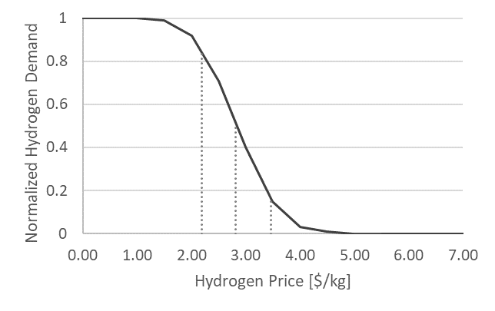

Figure 5: Hypothetical demand-price curve for an industry that may switch to using hydrogen. As the price of hydrogen decreases, more firms in this industry will switch from their current energy/feedstock to hydrogen. This price-demand model is a Normal distribution whose median and standard deviation are calculated statistically from a variety of data points from industry reports, academic literature, and stakeholder feedback.

We convert each industry to a variety of firms by dividing the demand-price curve into discrete segments. This enables the model to capture greater diversity within each sector. For example, later in the Methods we discuss how these segments can be used to model firms with a sensitivity to the carbon emissions of their purchased hydrogen or to model how larger firms may be able to buy hydrogen in bulk contracts at lower prices.

Fig 4 below, for example, shows how the Normal distribution describing a sector’s hydrogen demand (see Fig 3) can be approximated by multiple firms of different sizes and different break-even prices.

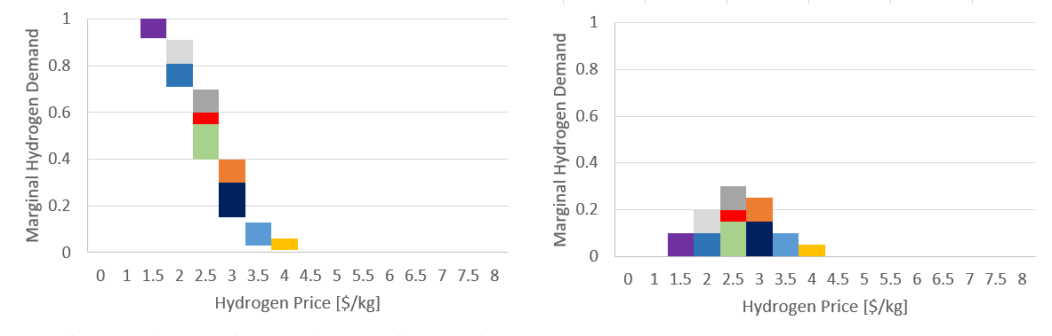

Figure 6: A discretized version of the demand-price curve. Left shows a cumulative function, right shows a probability function. In this example, there are 8 discrete firms within the sector. These firms have different sizes and different price points.

These sector-specific demand models can be scaled up and aggregated to represent the total potential hydrogen demand at each node. For example, an industrial hub, may have large potential demand for hydrogen from high-heat industry, district heating, and electricity generation, while a commercial hub may have small potential hydrogen demand from refueling stations for fuel-cell cars and a district heating system. For each node, we scale up each sector’s normalized price-demand curve to the level of potential demand in each specific node, and we divide those price-demand curves into firms. In this way, each node has multiple firms from multiple sectors to capture that nodes’ overall hydrogen demand potential.

$$H_{c}\left(i,t\right)≤{\hat{H}}_{c}\left(i\right) ∀i∝C,∀t∝T$$

Hydrogen consumption *Hc* during time *t* cannot exceed maximum hydrogen consumption *Ĥc*, for all consumers, and for all time periods. Note that, for each consumer, the model can choose to set *Ĥc* = 0, meaning that it does not deliver hydrogen to the consumer.

$$β_{c}\left(i,t\right)==H_{c}\left(i,t\right)×B_{co2} ∀i∝C,∀t∝T$$

Hydrogen black consumption *βc* during time *t* must equal the hydrogen consumption *Hc* for all consumers, and for all time periods. This only applies to carbon-sensitive consumers—i.e., consumers where the binary variable *Bco2* equals 1.

$${}_{c}\left(i\right)=f(cost(i)) ∀i∝C$$

For all consumers, the breakeven price *θc* for each firm is some function of the firm’s current costs and the cost of switching from its current fuel to hydrogen.

**Additional Model Features**

The previous section describes the method for building version 1 of a hydrogen economy model. The version 1 model balances supply, demand, distribution, and hydrogen price to develop an infrastructure of hydrogen production facilities, pipelines, and delivery routes. After model version 1 is built and calibrated, we will add the following features.

**CO2 Emissions and Carbon Credits (rewarding the model for low-emissions)**

The emissions benefits of hydrogen may be a significant driver in its wider adoption. To capture this in our model, we track CO2 emissions as a separate cost for consumers. CO2 is not resolved over the physical infrastructure—i.e., low-carbon hydrogen and high-carbon hydrogen molecules are not separated physically in the distribution. The CO2 market is resolved transactionally.

To capture this, we implement the following feature:

Zero-Carbon Hydrogen Credits

Each production facility produces some amount of zero-carbon hydrogen credits. The amount of credits it produces is less than or equal to the total amount of hydrogen it produces. For example, an average SMR plant may produce 0 credits for every 1 unit of hydrogen, an electrolyzer connected to the grid may produce 0.6 credits for every 1 unit of hydrogen, and an electrolyzer co-located with a wind farm may produce 1 credit for every 1 unit of hydrogen. The ratio of credits:hydrogen depends on the average emissions intensity of the hydrogen system and the emissions intensity of the particular production technology.

The zero-carbon credit construct allows the model to reward the construction of low-carbon production facilities, even if they produce hydrogen at a higher production cost. It also allows for diversity among the firms that are carbon-sensitive. For example, a heavy duty trucking fleet may not need very-low-carbon hydrogen to do better than its current diesel fuel, so it might only buy a small amount of zero-carbon hydrogen credits. A combined heat and power plant, however, may already have relatively low carbon emissions, and might need to buy a significant amount of zero-carbon hydrogen credits to make a good case for switching fuels.

We model each firms carbon sensitivity by expanding the demand formula as follows:

For each firm:

Break-even price = some fixed price depending on the baseline fuel and switching costs and on the carbon costs of the baseline fuel. The breakeven price gives us a baseline for calculating whether we can provide zero-carbon at a low enough overall price to make it profitable. ~~When we add carbon, the break-even price goes up. But the firm will only switch to hydrogen if it lowers its CO~~~~2~~ ~~emissions.~~

Revenue = Hydrogen Demand * Break-even price + delta(CO2) * CO2 Price

*i.e., if the firm switches to hydrogen, it will pay the break-even price and it will also pay extra money for any CO2 reductions we are able to provide it compared to its baseline*

Hydrogen Demand <= Energy Demand

*i.e. the firm will either choose hydrogen demand equal to energy demand or equal to zero*

delta(CO2) = (H2 Demand – Zero-Carbon-Credits) * H2 CO2 Intensity -- Baseline CO2

For each producer:

Production Cost = linear cost equation (Production)

Binary constraint for whether we actually built this facility or not.

Then another set of equations to describe how many zero-carbon-credits each producer creates

Zero-Carbon-Credits <= Production * Credit Ratio

Credit Ratio <= 1 – (H2 Co2 Intensity – Producer CO2 intensity)/H2 Co2 Intensity

Then, overall, the objective is to maximize revenue minus production cost, production cost is simply the sum of the production costs of each facility, and there is a constraint that supply >= demand

In this set of equations, a firm will switch to hydrogen if its total costs (energy + carbon) is lower than the total costs of its current fuel. The confusing part here is about how the objective function improves. The equation should resolve if the firm can procure enough carbon credits so that switching to hydrogen—although more expensive, provides a CO2 benefit that it is willing to pay for. In either case, the Energy Cost of this equation is going to be the same, right? Because if hydrogen prices are low, the firm will not need to buy as many carbon credits to justify the switch, right?

Maybe what we can say is that every firm has a willingness to pay, and that if the hydrogen price is lower than that, it will switch to hydrogen and pay the willingness to pay price (not less). So, in that sense, it improve the objective function to get a firm to switch to hydrogen if the overall change in profit is positive. That is, if the model can build an electrolyzer, and produce zero-carbon hydrogen credits at a cost low enough to get the firm to switch over to hydrogen and leave a bit of profit on the table, then it’s good.

Since we have discretized the firms, we are able to indicate how many of the firms are carbon-sensitive or not. If there are few carbon-sensitive firms, they can still provide enough low-carbon demand to incentivize the model to build some electrolyzers. This increases profit, because the electrolyzers can provide zero-carbon hydrogen at a cost that is competitive versus the carbon-sensitive consumers current fuel.

In this case, we don’t even end up with a market for carbon credits, although we can probably calculate that on the back end.

**CO­2 Capture and Sequestration**

One opportunity for reducing the CO2 emissions intensity of the hydrogen supply is to add CO2 Capture and Sequestration (CCS). When CCS is added to a SMR production facility, for example, it captures CO2 from the SMR process and sequesters it from the atmosphere. This reduces the CO2 intensity of the SMR facility but increases its operating costs.

We simulate CCS using a simple model that adds an additional component to the production cost. CCS has some fixed cost (in terms of $/ton) and some variable cost (in terms of $/ton-day). If the model adds CCS to a particular producer, then that producer’s fixed and variable costs increase, but it begins to produce more Zero-Carbon Hydrogen Credits.

[Gaffney Cline](https://www.gaffneycline.com/carbon-capture-use-and-storage-ccus-project-evaluations) : Please click on the following [link](https://confirmsubscription.com/h/r/B60F86410B7D81172540EF23F30FEDED) to request access to the Cost Assessment Tool from the US National Petroleum Council CCUS Study.

**Storage**

Some demand sectors experience daily and seasonal changes in hydrogen demand. For example, truck fueling stations may see greater hydrogen demand during the daytime, and seasonal electricity storage may see greater demand during the summer.

We assume these daily and seasonal variations in demand will be accommodated via hydrogen storage. In this case, hydrogen supply is decoupled from demand, which allows hydrogen supply to seek high utilization factors without ramping up and down with changes in demand.

Rather than model the hourly or seasonal use of storage facilities, we approximate the storage capacity needed to provide hydrogen to different demand sectors. For example, a truck fueling station may require storage facilities equal to two-days of total demand while seasonal electricity storage may require storage facilities equal to ninety-days of total demand. Using these heuristics, we require the model to build enough storage to accommodate the hydrogen demand. Like distribution costs, the cost of the storage is spread out among the consumers across the same pipeline network.

**Policy Scenarios**

We will model a variety of policy scenarios to assess their impact on hydrogen economy development. Such scenarios might include:

* *Hydrogen blending requirements in the natural gas infrastructure:* Mandates to inject some amount of hydrogen into the existing natural gas infrastructure will artificially increase the demand for hydrogen. Given the economies of scale captured by our model, this increased hydrogen demand should lead to reduced hydrogen prices that may further incentivize new hydrogen demand. We can model this blending requirement by creating a normalize demand curve that is price inelastic—i.e., where hydrogen demand is 100% regardless of price—and scaling that up as described in the “Node-specific Price-Demand Curves” section.
* *Carbon prices:* Prices on CO2 emissions create demand for low-carbon energy and feedstock. We capture this change in demand by assuming a CO2 intensity for hydrogen supply, calculating each demand sector’s net change in CO2 emissions intensity from switching to hydrogen, and adjusting the price-demand curve to reflect that change. Then, we solve the model as before, but iterate not only hydrogen price but also on CO2 intensity—i.e., given the model solution’s hydrogen price and CO2 intensity, we recalculate the demand curves, recalculate the hydrogen demand, and re-solve the model, iterating until it converges.
* *Emissions requirements:* In some cases, particular industries may see new regulations that require them to reduce their emissions. For example, regulations of marine vessel’s emissions when nearby a port may become stricter. These types of regulations may increase the demand for hydrogen, because hydrogen provides one solution to the problem. To capture how these regulations influence an industry’s price-demand curve for hydrogen, we would estimate the cost of the least expensive compliance option, and use that increased cost to update the break-even price for hydrogen for that industry.

**Capacity-expansion over time**

With the current model, we can forecast the hydrogen economy infrastructure for specific years—e.g., 2035 or 2050—by using forecasted technology costs, feedstock prices, price-demand curves, etc. that reflect that future year.

In some cases, it may be desirable to model future solutions that depend on the infrastructure built in previous years. For example, the model may build pipelines in 2030 that will influence its decisions in 2035 and beyond.

To capture the impact of existing infrastructure builds, we loop the model to solve multiple times for different years—e.g., [2025, 2030, 2035]. For each loop, the model updates:

* the existing production facilities and pipelines based on the solution of the previous model,
* the technology costs, feedstock prices, price-demand curves, etc. to reflect the next modeled year.

By comparing this solution to another model that only looks at the last year of interest, we can explore how earlier infrastructure investments may lead to path dependencies that deviate from a more optimal future solution.

**Hydrogen Export**

As global demand for low-carbon energy sources grows, international markets for hydrogen may develop. To capture that opportunity in the model, we create an export node. The export node has a price-demand curve that may depend on CO2 emissions, a demand scale that may increase in future years.

To send hydrogen flow to the export node, the model must build a hydrogen export facility. The model handles the export facility similar to how it handles a delivery truck route—it pays an annualized capital and fixed operation cost, which it passes on to the export node consumers, and adds its variable operation cost in $/kg to the delivery price of hydrogen to the export node. Thus, the annualized capital, fixed, and variable costs of the hydrogen export facility will be passed on to the export node and not to the consumers in the existing, local hydrogen pipeline network. The local network does, however, receive the economies of scale benefits of the increased hydrogen demand from export. As exports increase the demand for hydrogen, the model scales up its supply and delivery infrastructure, which achieves greater economies of scale, and reduces the price of hydrogen in the local network.

***Ammonia. See Literature “Port of the Future Conference notes_DNV_Shell_Air Liquide”

**Calculating Price, Consumer Surplus, and Producer Surplus**

How do we calculate the price at each node? Is there still a price at each node? Or do things like arc costs and delivery costs get captured implicitly in the model without actually tracking each node’s price?

Can we calculate the price of the zero-carbon credits? i.e., how much were firms willing to pay for these in the end?

Keep in mind that the DoE is specifically interested in 4 $/kg production costs, right? So, if we can subtract the zero-carbon value from the production costs, then that’s one way to reduce them…

**Additional Production Technologies**

Biomass Thermal Reforming. Especially given the nearby forestry and agricultural industries, this could be a promising supply of hydrogen.

Industrial byproducts from the chemical industry. For example, chlor-alkali and other chemical production processes create hydrogen as a byproduct. Many of these facilities simply vent hydrogen or use it to fuel their boilers. There is potential to harvest the hydrogen from these processes. Based on discussions with Nick Kovics, there is enough chlor-alkali in the Houston currently that capturing the hydrogen from those plants would add 5% to the existing hydrogen supply.

Turquoise hydrogen – a hydrogen production process that produces carbon black as the byproduct, so it’s much easier to sequester the carbon in a solid state. See [article](https://www.prnewswire.com/news-releases/monolith-materials-receives-investment-from-mitsubishi-heavy-industries-mhi-to-support-clean-hydrogen-production-301181333.html) sent by Ricky Masai (MHI), and [another article](https://www.greentechmedia.com/articles/read/c-zero-raises-11.5m-to-scale-up-turquoise-hydrogen-technology).

**Additional Distributors**

Liquefaction—i.e., trucks delivering liquid H2. We’ll also want to include liquefied trucks. At some distance, that becomes an important technology because compressed H2 trucks diesel costs become prohibitive, so doing fewer truck runs becomes more economical outweighing the compression costs. According to Jeff, LH2 trucks can carry 4,000 kg of H2, while compressed air trucks can only carry 400 kg. This is mainly because of the weight of the truck. A compressed air truck has lots of heavy metal tubing which comprise the majority of the truck’s weight. A LH2 truck requires less weight for the storage vessels, which leaves more weight for the actual hydrogen. In the end, both trailers have the same total weight and the same per-mile delivery costs. The cost of liquefying, or course, adds some cost over the compressed air version, so there is some breakeven point there.

Shipping—also probably uses liquefaction, but might also use ammonia.

**Additional Consumer Sectors**

Lots of options, but here are some suggested by our stakeholders.

Port Equipment, Drayage Trucking, Ships, and Exports—especially if this is called the “Port Houston” study, then there needs to be a strong component about the port itself, and a general sentiment that ports may be the best places to get hydrogen economies rolling.

Data Centers—this could be a big market for H2 in the future, as they are concerned about reliability and green electricity. It’s not immediately obvious how this would benefit the model, because they might not consume a lot of hydrogen. But we could include some sort of soft cost component around maintenance, where having more hydrogen technology ends up reducing soft costs/fixed maintenance costs for everyone. Powercell works with Microsoft, and their datacenter presence is growing like crazy, and they are very interested in zero-carbon energy as well as reliability. Their current plans include consideration of a system that has wind, solar, and hydrogen on-site along with 48-hours of 3 MW storage. This is a sizable volume, even when liquefied. But connecting to a larger natural gas network might be more sensible since they could conceivably rely on that centralized storage to some extent.

Ship-to-shore—

**Additional Firm Diversity**

How will you incorporate wholesale versus retail, i.e., that very large consumers can buy hydrogen bulk at a lower price? Maybe we can divide sectors into two or three sizes of firms, and say that the larger firms tend to make up the cheaper part of the demand curve?

**Disappearing Demand**

One of the major hydrogen consumers today is oil refining. If that demand dwindles in the future, what will we do with the excess hydrogen generation capacity?

**Electrolysis thoughts**

Based on some conversations with NREL, you might also want to consider the nuances of electricity cost structures. For example, I asked why refueling stations don’t just build electrolysis systems—it seems like it could be cheaper than getting compressed hydrogen delivered. Michel’s answer was that they have commercial electricity rate structures with big demand charges, so the economics just aren’t there.

This gets to a broader point though—electrolysis costs are very sensitive to electricity prices, so if there are ways to re-structure electricity rates in ways that reward the type of profile that electrolysis provides, then they might become more cost competitive.

This is likely to happen more larger, centralized electrolysis facilities (or with those that have their own wind/solar resources).

So, electrolysis costs might not only scale with utilization (assuming they can shift their demand toward lower electricity prices) but also with size (because larger electrolysis facilities can get electricity rates). You could probably find some centerpoint rate structures to go off of.

**Questions for Stakeholders**

Is it better to have lots of resolution around the marginal value, markets, prices, etc. Or is it better to have more resolution around the geography, infrastructure expansion, etc.

*What drives cost for producers.

Is it scale of size?

It is probably efficiency, because gas and electircit prices are driving factors for boht technolgogies. And it’s also likely that efficieny doesn’t really improve wit hscale. In that case, it might have more to do with vintage. We would assume that technology gets more efficient over time, and that older plants are less efficient.

*a major caveat here is that there will be a potentially significant cost curve for electrolysis because of the varying costs of electricity. You could simply assume that there is enough storage that any hydrogen produced via electrolysis during the year will be available for consumption. Then, the cost curve for electrolysis is directly tied to some sort of formulation about utilization and electricity prices. Let’s say it produces at 2,000 hours a year, then you assume that it pays the 2,000 lowest electricity prices, and that is its cost curve.

(you would need to implement this concept connected to some sort of representation of storage. I.e., as you build electrolysis, you might require some amount of storage via a constraint?)

Why don’t fuel stations just build electrolyzers? If it’s 10 $/kg to get delivered SMR hydrogen, then it seems an on-site electrolyzer would make a lot of sense, right?