Implementing RSA Accumulators for Asynchronous and Permissionless Reliable Broadcasting
Eric Webb  College of Computing, AI, and Cybersecurity  Nova Southeastern University  Ft. Lauderdale FL, USA  ew774@mynsu.nova.edu | Gregory Simco  College of Computing, AI, and Cybersecurity  Nova Southeastern University  Ft. Lauderdale FL, USA  greg@nova.edu | Francisco Mitropoulos  College of Computing, AI, and Cybersecurity  Nova Southeastern University Ft. Lauderdale FL, USA  mitrof@nova.edu
Sumitra Mukherjee  College of Computing, AI, and Cybersecurity  Nova Southeastern University  Ft. Lauderdale FL, USA  sumitra@nova.edu | Michael Lehrfeld  College of Business and Technology  East Tennessee State University Johnson City TN, USA  lehrfeld@mail.etsu.edu

ABSTRACT
Asynchronous consensus protocols are critical for decentralized and trustless environments such as decentralized finance, supply chains, and voting systems. These protocols avoid centralized authority and timing assumptions, improving resilience and security. As networks scale communication overhead becomes a major bottleneck limiting performance. The Aleph protocol is a notable example that offers both asynchronous and permissionless Byzantine Fault Tolerance. Unlike many prior designs, Aleph does not depend on a trusted dealer or fixed membership, making it well suited for open blockchain systems. Aleph’s design advances decentralization and security in the blockchain trilemma but at the cost of higher communication complexity and hindering scalability. The Aleph consensus relies on a Chain Reliable Broadcast protocol (ch-RBC) that suffers from quadratic communication overhead in large networks. This study enhances ch-RBC by replacing its Merkle tree-based transaction validation with Rivest–Shamir–Adleman (RSA) accumulators. RSA accumulators provide compact and constant sized proofs that can be batched and parallelized, thus reducing the protocol’s complexity from O(Tr + N² log N) to O(Tr + N²), where T and r denote the number of transactions and rounds respectively. This modification lowers bandwidth consumption and improves scalability while preserving security guarantees. In this study both Merkle and RSA based versions of ch-RBC were implemented in Rust and deployed on AWS EC2 instances using the AWS CDK. Experiments were scaled from 5 to 104 nodes with batch sizes up to 1024 transactions per round. Key metrics included throughput, latency, communication overhead, and resource utilization. Results demonstrated that RSA accumulators significantly improve scalability as the network increases, showing promise for future asynchronous and permissionless consensus..
CCS CONCEPTS
• Information systems → Blockchain • Computer systems organization → Dependable and fault tolerant systems and networks • Theory of computation → Distributed algorithms Networks → Network reliability • Software and its engineering → Distributed systems organizing principles
KEYWORDS
Blockchain; Asynchronous Consensus; Permissionless Systems; Reliable Broadcast (RBC); RSA Accumulators; Byzantine Fault Tolerance (BFT); Merkle Trees; Erasure coding (Reed–Solomon); AlephBFT (Aleph); HoneyBadgerBFT (HBFT); Directed Acyclic Graph (DAG); Decentralized finance (DeFi);

Eric Webb, Gregory Simco, Francisco Mitropoulos, Sumitra Mukherjee, and Michael Lehrfeld. 2025. Implementing RSA Accumulators for Asynchronous and Permissionless Reliable Broadcasting. In Proceedings of the 63rd ACM Mid-Southeast Conference (ACM MSE’25). ACM, Gatlinburg, TN, USA, 4 pages.https://doi.org/

1 INTRODUCTION
Reliable broadcast protocols are fundamental to distributed consensus in adversarial networks. Early approaches distinguished between synchronous and asynchronous designs with the former relying on timing assumptions while the latter tolerated arbitrary message delays [1]. Asynchronous Byzantine Fault Tolerant systems such as HoneyBadgerBFT [2], BEAT [3], and Dumbo [4] demonstrated practical scalability but often required permissioned membership. Aleph [5] was among the first to extend this model to permissionless environments to combine asynchrony and openness. However, Aleph's chain reliable broadcast (ch-RBC) protocol depended on Merkle tree proofs that scale poorly due to logarithmic proof sizes and limited opportunities for parallelization. Recent cryptographic literature highlights the potential of RSA accumulators [6,7], whose constant sized proofs, batching, and parallel validation make them well suited to permissionless asynchronous consensus.

2 Implementation
In this study both Merkle tree based and RSA accumulator based versions of Aleph’s ch-RBC protocol were implemented in Rust, deploying nodes on AWS EC2 T3.Medium and C5N.Xlarge instances using the AWS CDK framework [8]. Each node exposes REST APIs for proposing, prevoting, and committing transactions, while erasure coding is applied via Reed–Solomon to ensure reliability under network faults [9]. The experimental setup scales from five to 104 nodes with transaction batches up to 1024, measuring throughput, latency, communication overhead, and resource utilization, providing a comparative evaluation between Merkle proofs and RSA accumulators. The focus is on whether RSA’s batching and parallel proof verification can reduce the O(N²log N) overhead of Merkle based RBC to closer to O(N²), while maintaining security guarantees.
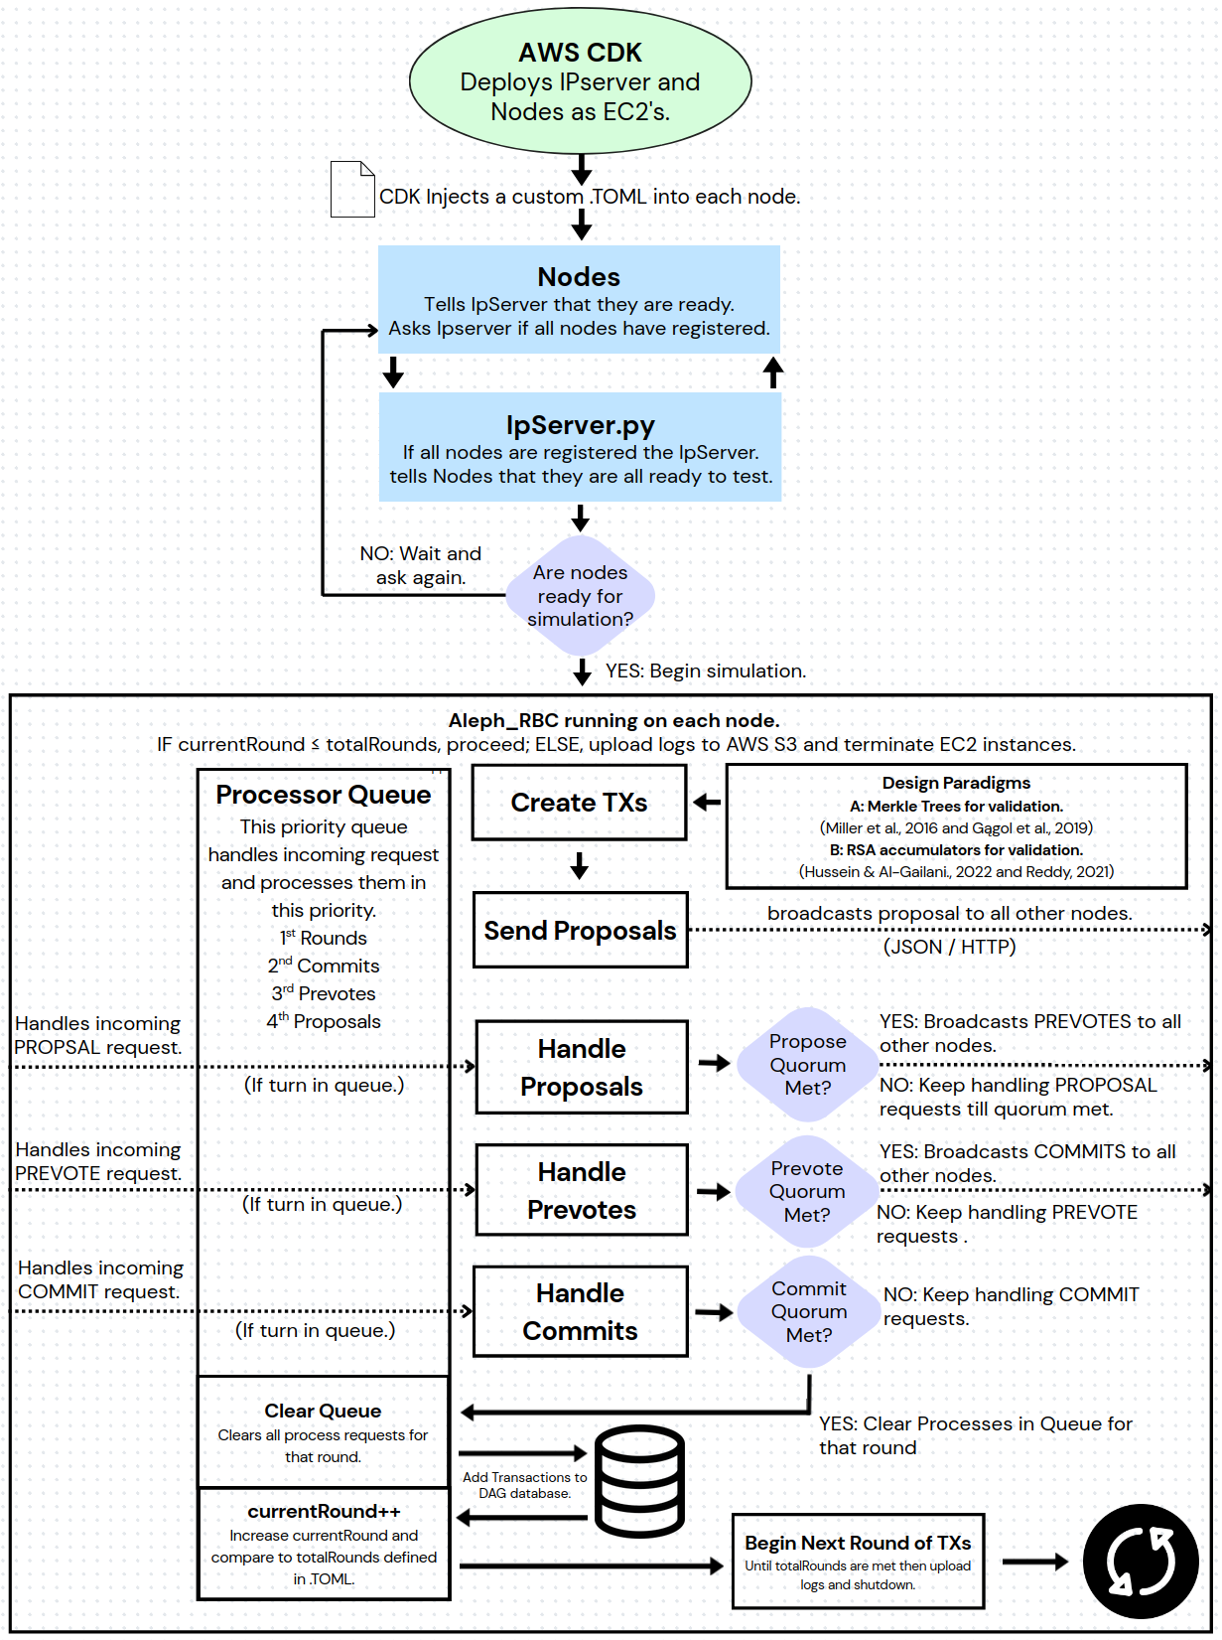
Fig. 1. Implementation Flow Chart
3 Lemmas
Model & notation. This study had N nodes running ch-RBC over r rounds. Each round disseminates T transactions in total (across all proposers) either by direct broadcast or using erasure coding. Messages used fixed headers plus a validation witness (Merkle proof or RSA accumulator proof); m denotes the number of elements per validation structure in a round (such as data shards or items per batch). Assuming m grows at most polynomially with N (typical when batch size scales with system size), thus
log m∈Θ(log N). Bytes communicated are counted in this study; local computation is discussed only when it changes how much data is sent. Ch-RBC’s control pattern follows echo/ready style broadcast ensuring that all honest nodes deliver the same message, or none do, even if the proposer is faulty.

Lemma 1 (RBC control traffic). In each round, ch-RBC induces Θ(N²) messages in the worst case due to all-to-all echo/ready exchanges and relay/forking defenses (constant number of phases; constant replication factors).

Proof sketch. Standard reliable broadcast analyses show each node sends O(N) control messages to distinct peers; across N nodes this is Θ(N²) (Cf. classic RBC and ABFT constructions [2,5].)

Lemma 2 (Witness size).
Merkle: An inclusion proof has size Θ(log m) hashes, hence Θ(logm) words∈Θ(log N) under the growth assumption.
RSA accumulator: A membership proof is constant size (one group element), Θ(1), and supports batching/parallel verification without changing proof size [6,7].

Proof sketch.
Depth of a balanced Merkle tree is log₂ m
RSA membership proofs are single exponents modulo N; batching alters verifier work, not byte length.

Theorem 1 (Per round communication). The per round communication is



Therefore with Merkle witnesses the per round bound is O(T + N² logN) with RSA accumulators it is Θ(T+N²). Over r rounds the totals are
Merkle   | RSA  
Proof sketch. By Lemma 1, the number of control/validation transmissions is Θ(N²). Each such transmission must carry a validation witness: Θ(log N) words for Merkle (Lemma 2a) and Θ(1) for RSA (Lemma 2b). Transaction/shard payloads contribute Θ(T) per round regardless of the witness scheme (erasure coding factors into the constant). Summing and multiplying by r yields the stated bounds.

Remark (computation vs. communication). Merkle verification incurs Θ(log N) hash checks per proof; RSA verification uses modular exponentiation but admits batch/parallel verification. These affect CPU, not the asymptotic bytes, hence do not change the communication bounds above.
4 Results
Both protocols were compared across T3.Medium and C5N.Xlarge instance types. In smaller deployments with light traffic Merkle trees initially performed more favorably up to a certain threshold. However, they failed to scale effectively beyond that point where RSA consistently was able to outscale. On the more performant C5N.Xlarge instances the performance delta widened further with RSA dominating and Merkle struggling to keep pace during threshold testing and often failing to complete consensus. The following scenarios are defined by the number of nodes and the number of transactions per batch.

4.1 T3.Medium Instance Results
Scaling transaction sizes on five nodes showed that Merkle initially delivered higher throughput than RSA at lower batch sizes. However as the transaction load increased RSA surpassed Merkle in throughput and continued scaling while Merkle collapsed. Indicating a critical threshold where its consensus process could no longer sustain execution.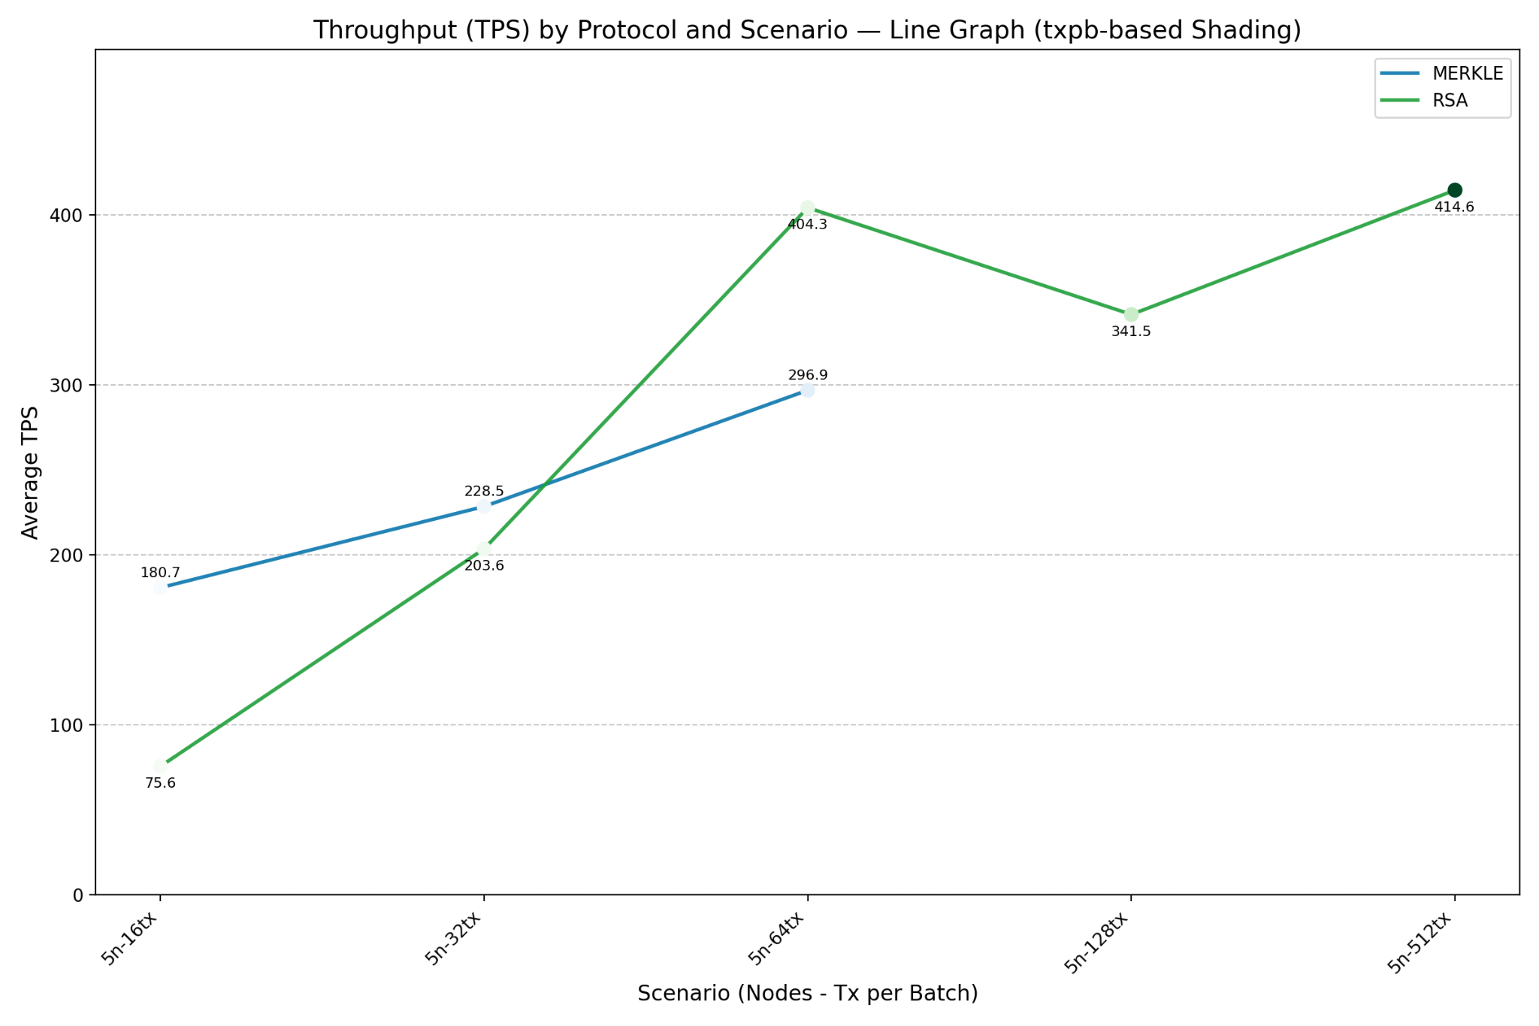
Fig. 2. T3.Medium: Scaling Transaction Sizes on 5 Nodes
T3.Medium small deployments showed that while Merkle initially achieved higher throughput than RSA in the smallest scenario its performance declined steadily as system complexity increased. In contrast RSA’s throughput improved indicating better adaptability and sustained processing under load.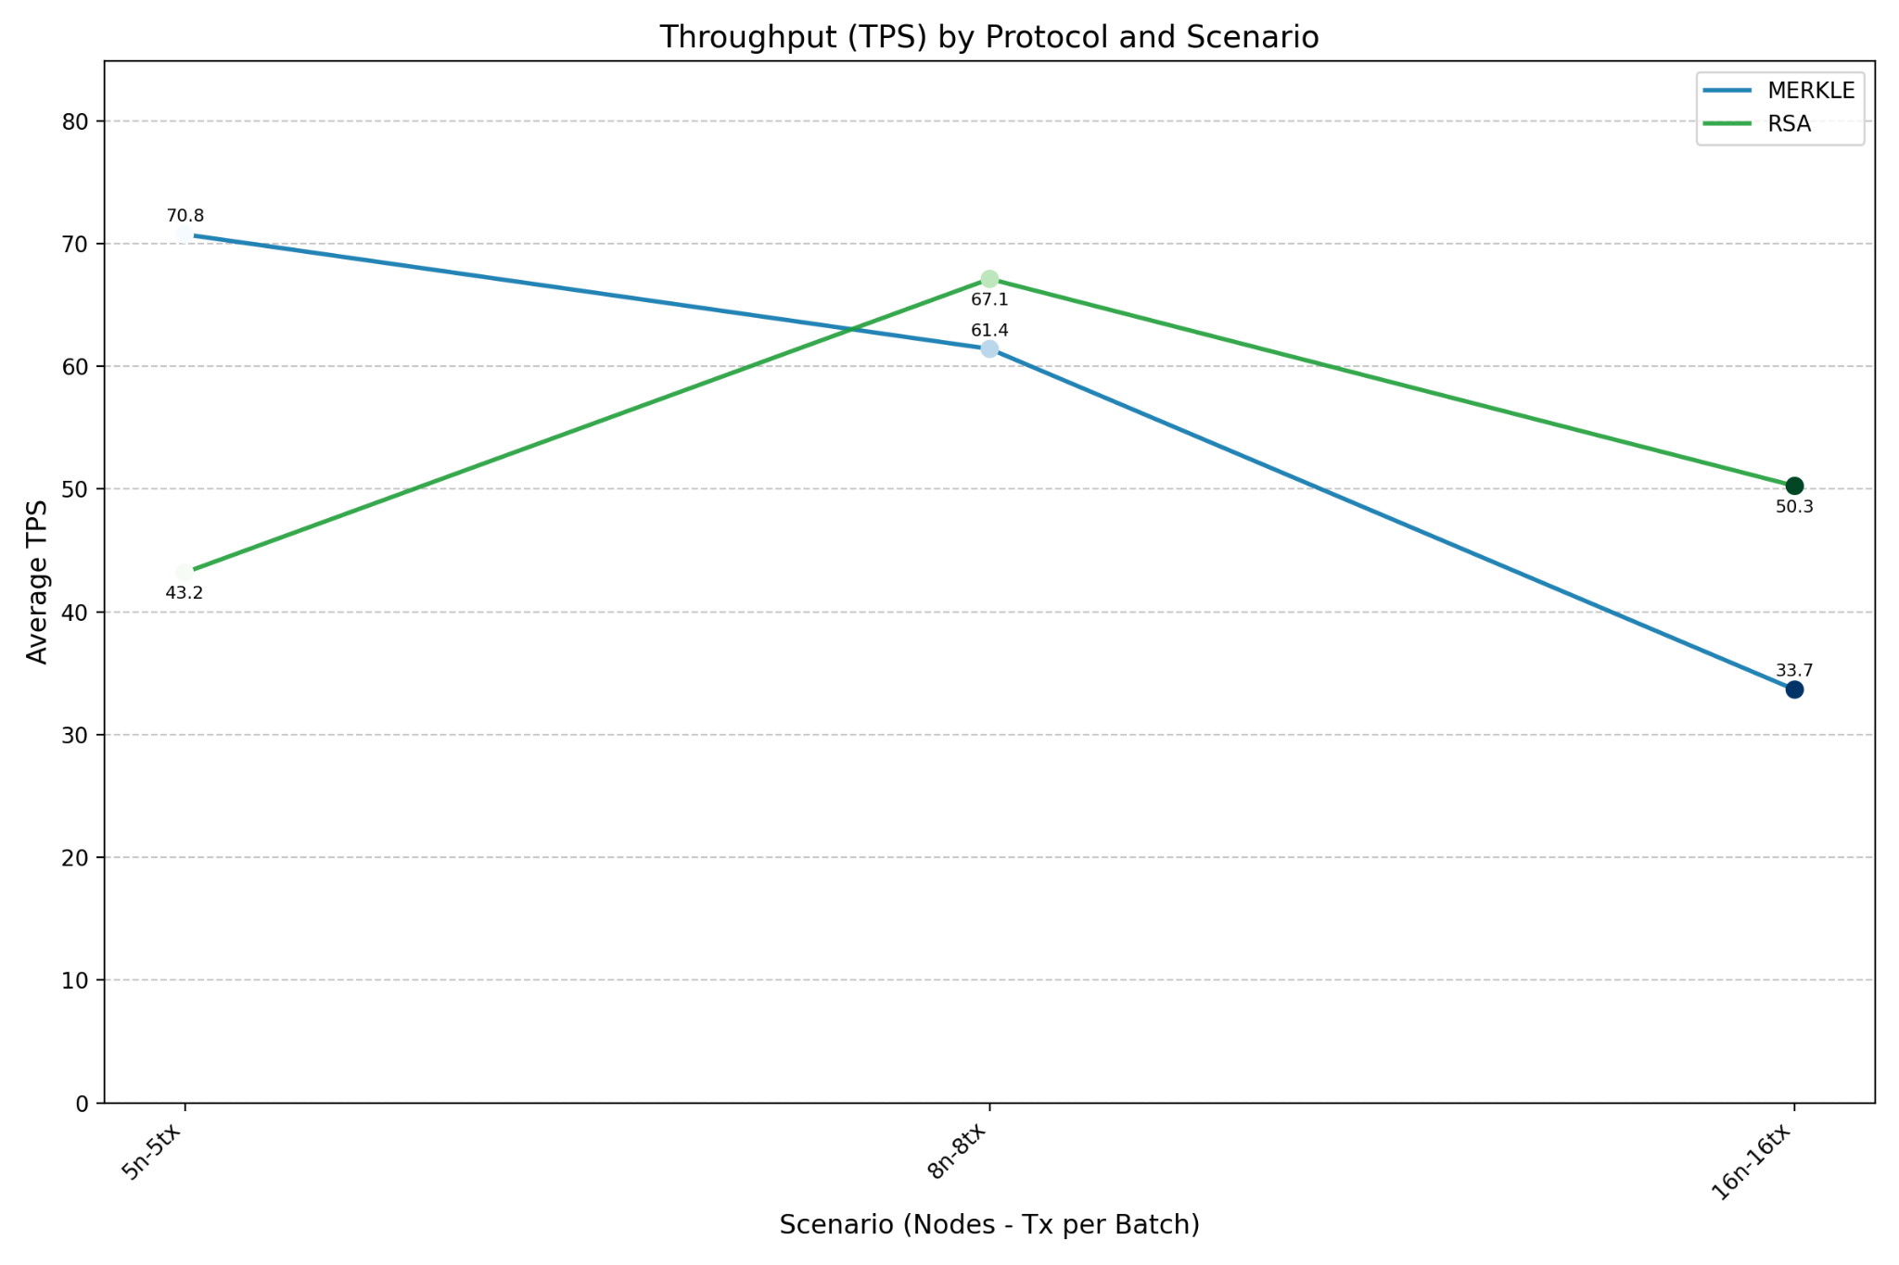
Fig. 3. T3.Medium: Small Throughput Deployments
4.2 C5N.Xlarge Results
Communication overhead remained relatively comparable between the protocols at smaller scales with Merkle occasionally demonstrating slightly lower overhead in the less complex configurations. However as deployments expanded in both node count and transaction volume RSA's communication load increased more sharply.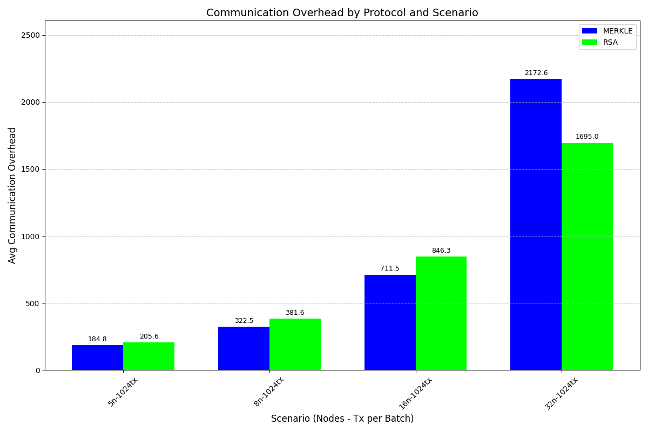
Fig. 4. C5N.Xlarge: Small Deployments Throughput
Comparing transactions in a batch with throughput in small deployments showed that RSA based configurations consistently achieved higher throughput than their Merkle based counterparts across all node counts and batch sizes. While both protocols exhibit improved throughput as batch sizes increase. Merkle's growth begins to taper off at higher values whereas RSA continues scaling more effectively. At no point does Merkle surpass RSA in throughput. Indicating RSA's superior batching efficiency and better suitability for high throughput deployments.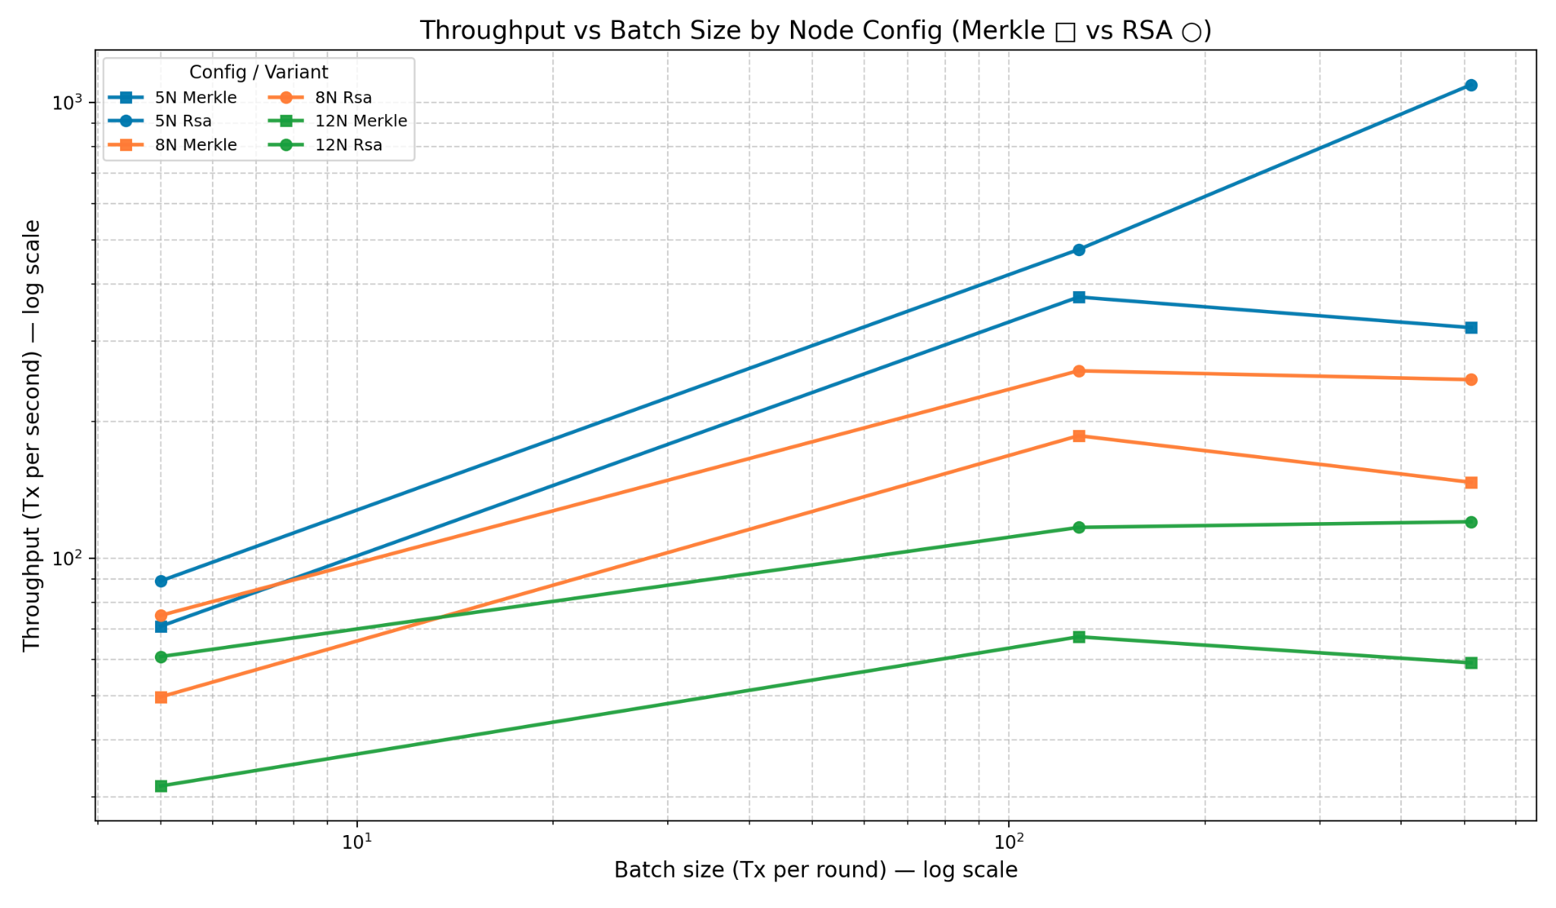
Fig. 5. C5N.Xlarge: Comparing Batch Size to Throughput

While the Merkle based implementation initially exhibited lower communication overhead in smaller network configurations, this advantage quickly diminished as the system scaled. At higher node counts Merkle's communication cost surpassed that of RSA.
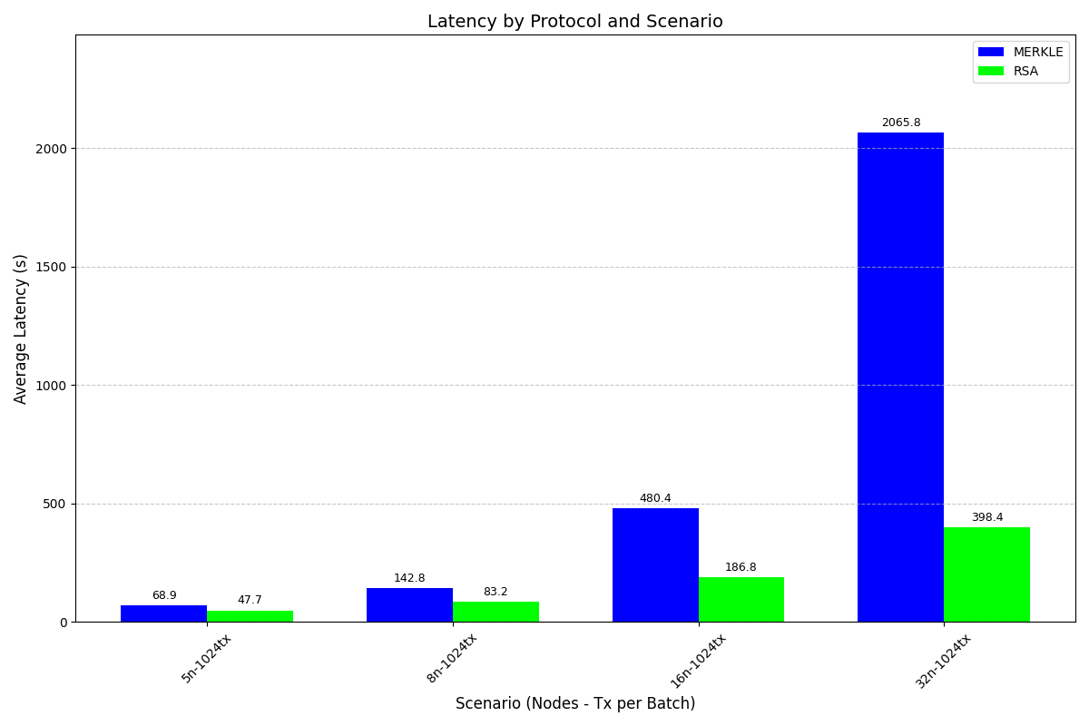Fig. 6. C5N.Xlarge: Batch Heavy Latency Deployments
Increasing nodes and transactions highlighted Merkle’s severe underperformance at scale. At 64 nodes with increasing transaction sizes, Merkle’s latency skyrockets. While RSA remains consistently low. Merkle ultimately fails to complete the largest configuration, further cementing RSA’s superior scalability and reliability.
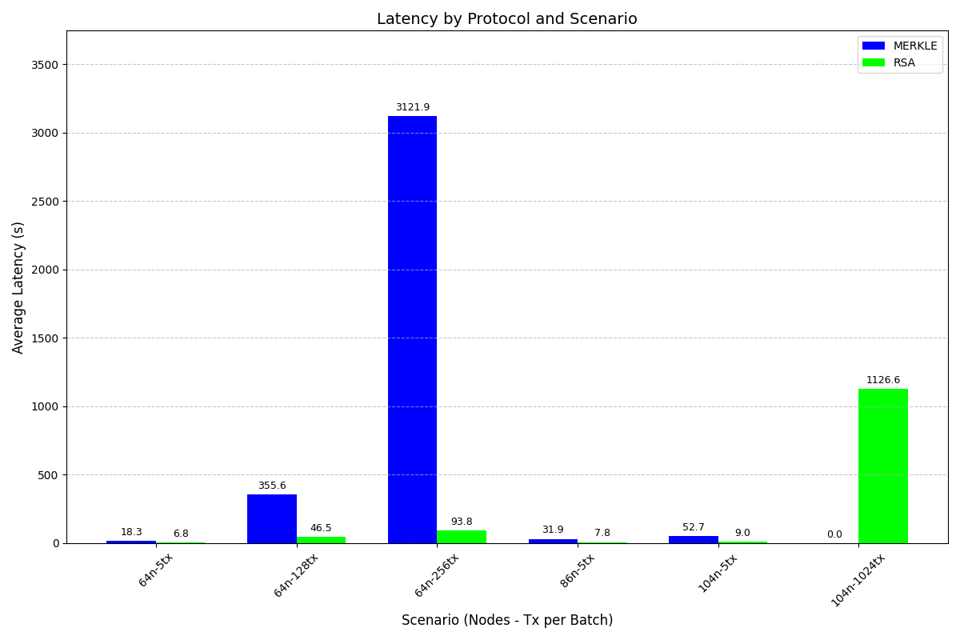Fig. 7. C5N.Xlarge: Threshold Deployments

5 Conclusion

This study demonstrated that replacing Merkle tree proofs with RSA accumulators in Aleph’s chain reliable broadcast can significantly reduce communication overhead while preserving security and fault tolerance in asynchronous and permissionless consensus. Rust implementations deployed on AWS EC2, RSA’s based on constant size proofs and batching capability allowed the protocol to scale beyond the thresholds where Merkle based validation collapsed. While Merkle trees performed competitively at small scales, their logarithmic proof growth and limited parallelism hindered performance under high load. Whereas RSA accumulators maintained consistent throughput and latency across larger deployments. These findings highlight the potential of RSA based validation as a practical path forward for scalable trustless consensus in blockchain and distributed applications.
6 Future Work
Future research should explore hybrid cryptographic validation techniques, combining RSA accumulators with succinct proofs such as SNARKs or vector commitments to achieve even tighter communication bounds. Another promising direction is the optimization of Merkle based batching through advanced data structures such as Merkle forests, segmented trees, or parallel subtree hashing [8]. These approaches may alleviate Merkle’s scalability bottlenecks by distributing proof generation and validation across multiple substructures. Finally, future deployments could take the examples above and apply them to a RPC based communication in place of REST, reducing serialization overhead and enabling streaming channels that further optimize throughput in large scale consensus environments.
REFERENCES

[1] A. Miller, Y. Xia, K. Croman, E. Shi, and D. Song. 2016. The Honey Badger of BFT Protocols. In Proceedings of the 2016 ACM SIGSAC Conference on Computer and Communications Security (CCS ’16), 31–42. https://doi.org/10.1145/2976749.2978399

[2] S. Duan, M. Reiter, and H. Zhang. 2018. BEAT: Asynchronous BFT Made Practical. In Proceedings of the 2018 ACM SIGSAC Conference on Computer and Communications Security (CCS ’18), 2028–2041. https://doi.org/10.1145/3243734.3243812

[3] B. Guo, Z. Lu, Q. Tang, J. Xu, and Z. Zhang. 2020. Dumbo: Faster Asynchronous BFT Protocols. In Proceedings of the 2020 ACM SIGSAC Conference on Computer and Communications Security (CCS ’20), 803–818. https://doi.org/10.1145/3372297.3417262

[4] A. Gągol, D. Leśniak, D. Straszak, and M. Świętek. 2019. Aleph: Efficient Atomic Broadcast in Asynchronous Networks with Byzantine Nodes. In Proceedings of the 1st ACM Conference on Advances in Financial Technologies (AFT ’19), 214–228. https://doi.org/10.1145/3318041.3355467

[5] K. M. Hussein and M. F. Al-Gailani. 2022. An Efficient Bandwidth Based on the Cryptographic Technique of the RSA Accumulator in Blockchain Networks. In 2022 Fifth College of Science International Conference of Recent Trends in Information Technology (CSCTIT), 164–168. https://doi.org/10.1109/CSCTIT56299.2022.10145614

[6] B. S. Reddy. 2021. securePrune: Secure Block Pruning in UTXO Based Blockchains Using Accumulators. In 2021 International Conference on COMmunication Systems & NETworkS (COMSNETS), 174–178. https://doi.org/10.1109/COMSNETS51098.2021.9352892

[7] I. S. Reed and G. Solomon. 1960. Polynomial codes over certain finite fields.
Journal of the Society for Industrial and Applied Mathematics 8, 2 (1960), 300– 304. https://doi.org/10.1137/0108018

[8] Morishima, Y., Kohler, M., & Feist, C. 2025. Towards Stateless Clients in
Ethereum: Benchmarking Verkle Trees and Binary Merkle Trees with SNARKs. arXiv:2504.14069 [cs.CR]. Retrieved from https://arxiv.org/abs/2504.14069

