**Technologies used.**

**GoLang** - v1.16.7 <https://golang.org/>

**PostGresSQL** - <https://www.postgresql.org/download/>

**PgAdmin** - <https://www.pgadmin.org/download/>

**Node Package Manager (NPM)** - https://nodejs.org/en/download/

**VueJs** - <https://vuejs.org/>

**Gorm** - <https://gorm.io/index.html>

**TO CLONE PROJECT**

“Git clone [**https://github.com/webberic92/Reimbursement_Vuetify_Go#:~:text=https%3A//github.com/webberic92/Reimbursement_Vuetify_Go.git**](https://github.com/webberic92/Reimbursement_Vuetify_Go#:~:text=https%3A//github.com/webberic92/Reimbursement_Vuetify_Go.git)**”**

**Verify GO Is installed properly… (By typing “go version”)**

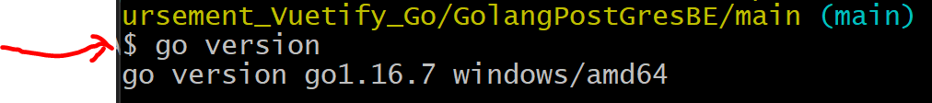

**Verify PostGresSql is running in your services.**

**Verify NPM is installed with “npm -v”**

**VERIFY YOUR PRIOR APPLICATIONS ARENT TAKING UP PORTS 8000 & 8081…**

**You can use netstat to check and if so kill those processes.**

netstat -ano | findStr 8000

netstat -ano | findStr 8081

taskkill /F /PID PID_To_kill_From_Netstat_command

**First Step is to set up Database!**

(This can be done in the **database.go** file. Notice I am using local host with a user/pwd of *postgres/root* and a *dbname of reimbursement_db*)

You will need to set up your *database.go* file with your own database information.

File path : *Vuetify_Go/GolangPostGresBE/database/database.go*

**Open up pgAdmin and create a user and password.**

You will need to set up postGres with some type of database administration tool of your choice. In this instance I chose pgAdmin.

I created the “**reimbursement_db**” database by right clicking and selecting “**create -> database**” in PgAdmin.

Gorm will automatically create the tables “**User**” and “**Reimbursement**” via lines 18 and 19 shown above.

**Once Database is created to match what is in database.go file, try and run the application with “run main.go” command from the “main” folder.**

**IF NOT SET UP CORRECTLY YOU WILL GET ERROR WHEN RUNNING “GO RUN MAIN.GO” from Main.**

**IF SET UP CORRECTLY WHEN RUNNING “GO RUN MAIN.GO”**

**Congratulations!**

**You now have The backend set up for this project.**

**Next we will set up the front end.**

**Open up a new CLI in the front-end portion of the project** “/reimbursementAPP/Reimbursement_Vuetify_Go/vuetify_go_jwt_app”

Run **“npm install”** and then **“npm run serve”**

**If successful, you should see app running on localhost:8081**

Web browse to localhost:8081 to verify front end is up and running.

**Now That Frontend and Backend are running lets verify they can communicate with eachother.**

**Try Registering as a new user.**

**If it fails read the console to debug issue.**

**(Your backend it probably running on wrong port or the DB is not set up correctly)**

If Successful it will show this message and route you to login page.

CONGRATULATIONS

You now have a running full stack application.

Head over to user guide to see the ins and outs of how this application works.