Verify PostGresSql is running

In a terminal, execute the command 'sudo ss –nlt | grep 5432'

You should see something. If not then the service isn't running

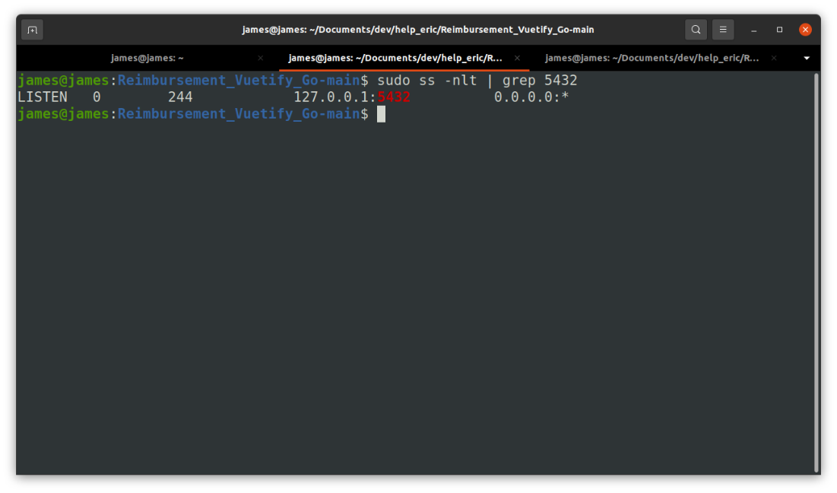

If not running, troubleshooting and instructions can be found here (<https://www.postgresql.org/docs/>)

reset password for postgres user

If you leave the default password of 'root' in the database.go file, then you will need to reset the postgres password using psql. Do so with the following commands:

sudo –u postgres psql

\password

root

root

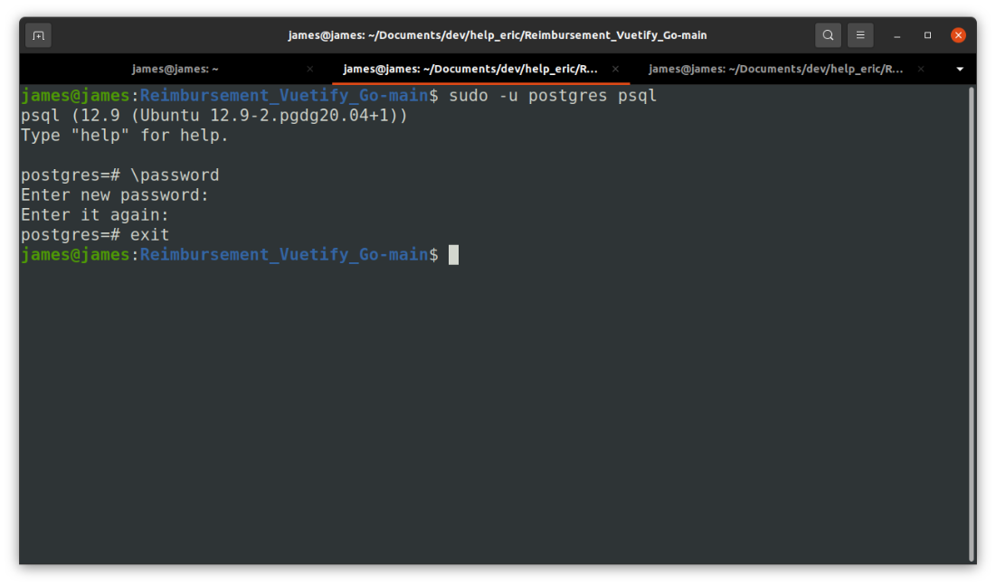

Set up the database server

open pgadmin3

fill out the following fields:

Name: reimbursement

Host: localhost

Password: root

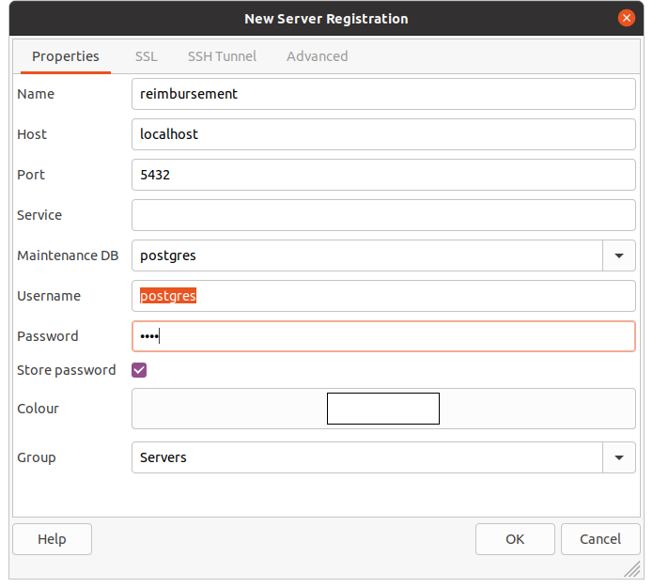

Click 'ok'

You should now have a new server

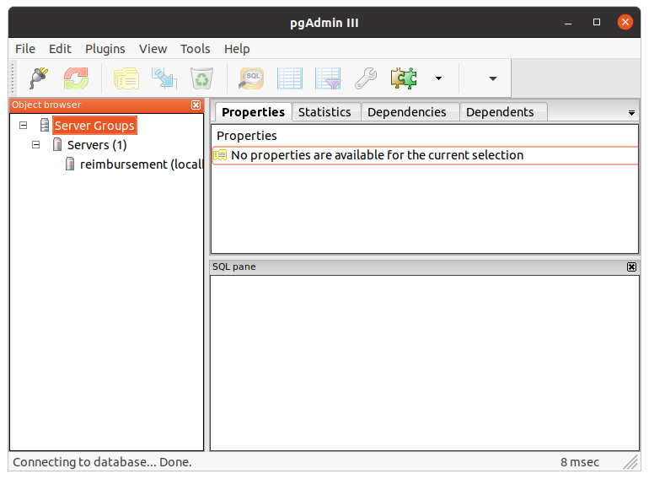

Create the database

Expand reimbursement and then Databases

Right click on Databases

select 'New Database'

set Name to reimbursement_db

Set Owner to postgres

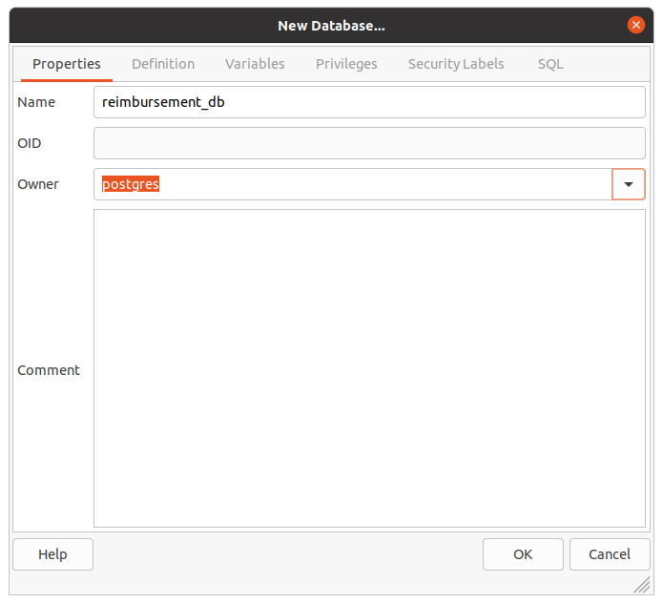

Click 'Ok'