1st) To setup this environment you need to install hMailServer locally.

<https://www.hmailserver.com/download>

2nd) Set up my Domain to be webby.com



3rd) Create user to be [eric@webby.com](mailto:eric@webby.com)

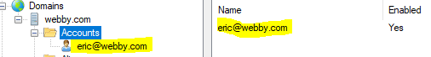

4th) Download JavaSMTP folder and navigate to bin.



5th ) Run java EmailAgent.

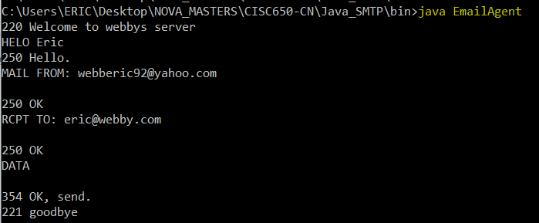



Submitted to: Professor Wei Li

Student’s Name: Eric Webb

Date of Assignment: 09/29/2019

Title of Assignment: Assignment No. 2

Certification of Authorship: I hereby certify that I am the author of this document and that any assistance I received in its preparation is fully acknowledged and disclosed in the document. I have also cited all sources from which I obtained data, ideas, or words that are copied directly or paraphrased in the document. Sources are properly credited according to accepted standards for professional publications. I also certify that this paper was prepared by me for this course.

Student's Signature: ERIC WEBB