**Part 2. Textbook questions**

**Chapter 7 [25 points]**

7.1 What are the services that can be provided using IEEE 802.11?

7.2 What are the differences between the infrastructure mode and the ad-hoc mode in wireless networks?

7.3 Why are acknowledgements used in 802.11 but not in a wired Ethernet?

7.4 Suppose the IEEE 802.11 RTS and CTS frames were as long as the standard DATA and ACK frames. Would there be any advantages to using the CTS and RTS frames? Why or why not?

7.5 What is the difference between a permanent address and a care-of address? Who assigns a care-of address?

7.6 The following picture is a copy of a Figure in the textbook. It shows a CDMA example that supports two senders. Suppose that the receiver wanted to receive the data being sent by sender 2. Show (by calculation) that the receiver is indeed able to recover sender 2’s data from the aggregate channel signal by using sender 2’s code.\

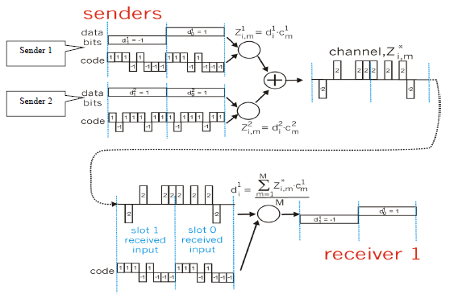

**Chapter 8 [25 points]**

8.1 What is the most important difference between a symmetric key system and a public key system?

8.2 In what way does a hash function provide a better message integrity check than a checksum (such as Internet Checksum)?

8.3 Can you “decrypt” a hash of a message to get the original message? Explain.

8.4 Suppose that Bob receives a PGP message from Alice. How does Bob know for sure that Alice created the message?

8.5 Consider WEP for 802.11. Suppose that the data is 10010100 and the keystream is 10110010. What is the resulting ciphertext?

8.6. Using the monoalphabetic cipher in the textbook, encode the message “This is a server.” Decode the message “rmij’u uamu xyj.”

8.7 Consider the RSA algorithm with *p=5* and *q=17*.

a. What are *n* and *z*?

b. Let *e* be 7. Is this an acceptable choice? Why? If not, can you suggest another option?

c. Based on your answer for part b), find *d* such that *de*=1 (mod *z*) and *d*<85.

**Chapter 9 [25 points]**

9.1 Generalize the basic approaches we used for making the best out of best effort service for real-time interactive multimedia applications.

9.2 There are two types of redundancy in video. Describe them and discuss how they can be exploited for efficient compression.

9.3 Assume an Internet phone application generates packets only during talk spurts. During a talk spurt the sender generates bytes at a rate of 1000 bytes per second, and every 50 msecs the sender gathers bytes into chunks. Assume that RTP is used that will add a header to each chunk. In addition UDP and IP will be used. Suppose all headers (including RTP, UDP and IP) have a total length of h and an IP datagram is emitted every 40 msecs. Find the transmission rate in bits per second for the datagram generated by one side of the application.

9.4 Consider the procedure described in “Adaptive Playout Delay” for estimating average delay *di*. Let be the most recent sample delay, let be the next most recent sample delay, and so on. For a given audio application, suppose three packets have arrived at the receiver with sample delays , , and . Express the estimate of delay *d* in terms of *u* and the three samples. 3 3 t r − 2 2 t r − 1 1 t r − 2 2 t r − 3 3 t r −

9.5 This chapter describes several FEC schemes. Briefly summarize them . Both schemes increase the transmission rate of the stream by adding overhead. Does interleaving also increase the transmission rate?

9.6 Compare the procedure described in “Adaptive Playout Delay” for estimating average delay with the procedure in Chapter 3 (“Estimating the Round-Trip Time”) for estimating round-trip time. What do the procedures have in common? How are they different?

9.7 Is it possible for a CDN to provide worse performance to a host requesting a multimedia object than if the host has requested the object directly from the distant origin server? Please explain.

9.8 What is the difference between end-to-end delay and packet jitter? What are the causes of packet jitter?

9.9 Summarize how the token buckets and WFQs can be used together to provide policing mechanisms.