Nova Southeastern University

College of Engineering and Computing

**Assignment 1**

**CISC 650 Computer Networks**

Fall 2019

Due Date: 9/8/2019 11:59PM ET

Total Points: 100

***Notes:***

***1. Please include your name in EVERY document you submit.***

***2. Please sign and submit the “Certification of Authorship” form (located in Blackboard) along with your solutions.***

**Part 1. Textbook reading**

Chapter 1, Chapter 2

**Part 2. Textbook questions**

**Chapter 1.** [30 points]

* 1. What is a network protocol?

- Protocols are what control the sending and receiving of information on the internet.to make sure everyone agrees on these standards the Internet Engineering Task Force is used to document these protocols through documents called request for comments. To reiterate a protocol formats and orders the communication between two entities and then acts accordingly.

* 1. Briefly discuss what a peer-peer model is. Did you use some of the P2P applications? If so show your experience with them.

-A peer to peer model is decentralized in nature, this is due to it not being dependent on dedicated centralized servers. Communications is done host to host, rather than host to server to host. A benefit of this is its self-scalability. Some disadvantages include, security, performance, and reliability. One P2P application I have used is SKYPE. SKYPE is a tool I use every day to communicate and work with my team.

1.3. Compare and contrast Internet services provided by DSL and coaxial cable networks.

- DSL provides internet over a copper phone line. It takes digital data and transforms them into tones to be transmitted back to the telecom provider’s central office. DSL is mainly designed for close proximity of the CO typically not being more than 5 - 10 miles away. DSL makes use of a phone line while coaxial cable networks take advantage of cable television infrastructure. Coaxial cable networks are typically faster but speed can be bogged down if multiple users are using it simultaneously. You can think of DSL as slower and direct while cable networks faster but shared.

* 1. What are the major disadvantages with the layered approach to protocols?

- One drawback to the layering is that it may duplicate lower –layer functionality. For example, error recovery might be done in multiple layers. Another example is that two or more layers might be dependent on each other, such as a timestamp being needed that is only available in the other layer.This violates the goal of separation between layers.

* 1. Suppose we wish to send a packet from a source host to a destination host over a fixed route in a packet-switched network. Show the delay components in the end-to-end delay. Which of them are variable? Why?
* The components of an end to end delay include, processing delay, the transmission rate, and the propagation of each link. Another factor that should be accounted for is network congestion. The transition delay is variable because it depends on the size of the packet denoted by L/R where L= packet size. Another Variable to take in account is network congestion.
  1. Suppose all links in a circuit-switched network use TDM with 8 slots and have a bit rate of 100Kbps. Also suppose it takes 500msec to establish an end-to-end circuit before a host starts transmission. How long does it take for Host A to transmit a file of 10,000 bits to Host B in this network?

-Each circuit has a transmission rate of (100KBPS)/8 = 12.5 Kbps

So it takes 10,000 / 12,500 bps = .8 seconds to transmit file.

plus 500 msec for establishment time. So .8sec + .5sec = 1.3 seconds.

It takes 1.3 seconds to send the file.

**Chapter 2** [40 points]

2.1 Why Skype is a hybrid of client-server and P2P architectures?

-Skype is a P2P in regards that messages are sent directly from host-to-host without the need of an intermediary server. It is a client server in the fact that it does use servers to catalog client information such as IP addresses. So although messages are peer-to-peer other information for conducted through skype is used in a client – server fashion.

2.2 What are the two major services provided at the transport layer? What are their differences?

- The two major services provided in the transport layer are Transmission Control Protocol (TCP) and User Datagram Protocol (UDP). TCP is connection oriented in the fact that it establishes a connection between two points via a 3 way hand shake (SYN, SYN-ACK, and ACK). This guarantees flow control and delivery. UDP on the other hand is connectionless, it does not provide a guarantee of delivery.

2.3 Why does the HTTP protocol run on top of TCP rather than on UDP?

-HTTP uses TCP rather than UDP because TCP provides guarantee delivery and flow control. This mean HTTP does not need to do any special work for guaranteed delivery or for data to be received intact. This is taken care of at the lower level via TCP. If it were UDP there would be no guarantee of delivery or the information would be intact.

2.4 Suppose you need to send one message to two different users: user1@example.com and user2@example.com. In terms of the SMTP commands, is there any difference between sending one separate message per user and sending only one message with multiple (two) recipients? Please explain.

-When sending an email to an individual user, the SMTP commands would be Helo, Mail From, RCPT TO, DATA, and QUIT. If you were to send the same email to two different recipients on the same mail server you could send all the messages over the same TCP connection. Each message would begin with a new MAIL FROM, and would designate the end of a message with an isolated period. After all the messages were sent the QUIT command would be executed.

2.5 What are the two major types of queries for DNS name resolution? Explain.

-The two types of DNS queries are recursive and iterative. Recursive asks another DNS server to get the mappings of other servers, essentially sending the query upstream. While an iterative query will only have communication between the host and the server being queried keeping the communication between them.

2.6 Install and compile the Python programs TCPClient and UDPClient (refer to Chapter 2 of the textbook) on one host and TCPServer and UDPServer on another host.

a. Suppose you run TCPClient before you run TCPServer. What happens? Why?

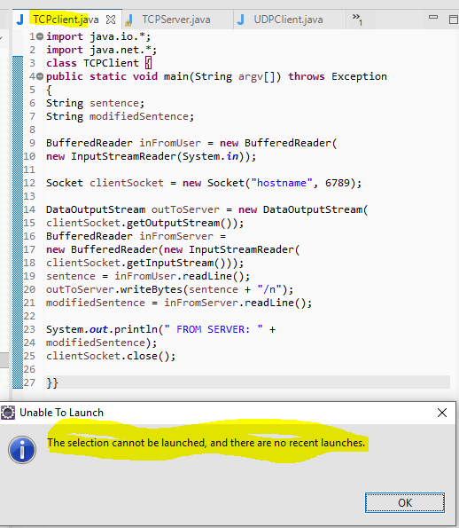

b. Suppose you run UDPClient before you run UDPServer. What happens? Why?

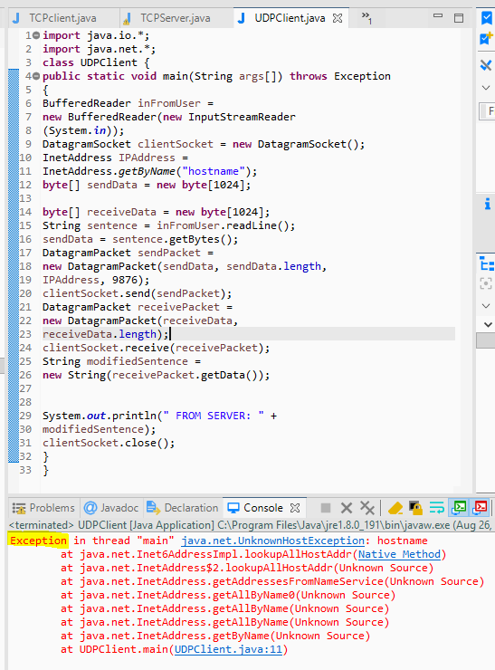

c. What happens if you use different port numbers for the client and server sides?

*Note: if you prefer Java programming, please use the attached file for TCP Client/Server and UDP Client/Server, and answer the same questions.*

2.7 Consider a HTTP client that wants to retrieve a remote file at a given URL. The IP address of the HTTP server is initially unknown. What transport and application-layer protocols besides HTTP are needed in this scenario?

- As far as application layer protocols you will need to use DNS to resolve the IP address from the URL. Next you would use a transfer protocol such as FTP or SCP to transfer the files between the host and the server. As far at transport layer protocols you will use TCP to establish a connection and then transport the file with one of the application protocols mentioned.

**Part 3. Practical assignment** [30 points]

See the instructions in the “Wireshark_Intro.pdf” file for details on how to download and run a powerful network monitoring tool (a.k.a network sniffer) – Wireshark. Answer the questions listed in the file based on your experience with Wireshark. Please include necessary screenshots in your submission.

1. List 3 different protocols that appear in the protocol column in the unfiltered

packet-listing window in step 7 above.

1-DNS



2-TCP



3-HTTP



2. How long did it take from when the HTTP GET message was sent until the HTTP

OK reply was received? (By default, the value of the Time column in the packet listing

window is the amount of time, in seconds, since Wireshark tracing began.

Less than a second, about .04767 of a second.



3. What is the Internet address of the gaia.cs.umass.edu (also known as wwwnet.

cs.umass.edu)? What is the Internet address of your computer?

My local address is 192.168.1.5 and the address or Gaia is 128.119.245.12



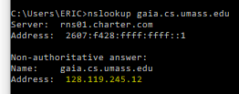

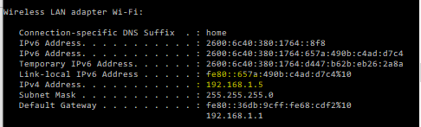

4. Print the two HTTP messages (GET and OK) referred to in question 2 above. To

do so, select *Print* from the Wireshark *File* command menu, and select the

“*Selected Packet Only”* and *“Print as displayed”* radial buttons, and then click

OK.

