CISC-680 – Software Engineering

Assignment No. 2

Due: 10/27/2019

Eric Webb

[ew774@mynsu.nova.edu](mailto:ew774@mynsu.nova.edu)

Dr. Jeffrey Kane

**Table of Contents**

**Abstract**

Since blockchains immergence it has become a wide topic of discussion. Yet, a lot of people don’t understand quite what it is, where it came from, and where it is heading. In this paper I will include topics that include how blockchain has created emerging trends in blockchain engineering and how those trends are developing. Building from that we will delve into why blockchain is not always the best choice for situations and guide into when and where to implement one. From that we will lead into issues and problems that affect blockchain security. This will be discussed in greater detail to address and resolve these issues. Although blockchain has mainly been associated with innovative financial services, it also has roles in other fields such as e-government, supply chain management, and cyber security. If a blockchain is used maliciously it could build an argument case on whether a blockchain solution should be encouraged or not from a security point of view.

**Chapter 1: Introduction.**

To begin let’s start by defining what blockchain is. This has been a very confusing construct for most because typically it is synonymous with the crypto currency Bitcoin.

Although Bitcoin and other cryptocurrencies use blockchain it is not it’s only real world use case. In its most basic from Blockchain is simply a digital leger. This digital ledger, is a distributed database that is constantly reconciling new information know as blocks.

These blocks are appended onto the end of the data set. This effectively creates a blockchain. The data is then stored in multiple locations in contrast of one central location. This makes blockchain pretty difficult to manipulate considering multiple copies are stored on a machine simultaneously and can be verified from multiple nodes. This is what makes blockchain a public, decentralized, and verifiable.

From its conception blockchain snowballed to the market essentially piggy backing off the popularity of Bitcoins financial revolutionary concepts but behind these concepts driving this new technology was the decentralized ledger itself. Of course, the history of this new technology is still argued and somewhat shrowded in mystery simply for the fact we really don’t know who or where this technology came from. When Bitcoin was implemented it also implemented the world’s first public blockchain database. The white paper for this technology was authored by a pseudonymous entity names Satoshi Nakamoto. This could also lead to the argument of the validity of blockchains security. Why, so secretive? Would want to hide their identity from getting credit to a revolutionary new concept? This alone could make someone wary from a security standpoint.

Bitcoins conception was the start of blockchains breakthrough phase in its technology innovation cycle. (38.1txtbooks)Next would come the replicator phase, the birth of alternate coins. The replication of already mysterious technology adds to the argument of using blockchain in security although this phase actually led to the advancement of new blockchain technology. Originally bitcoin was a store of value on a decentralized digital ledger only to be used to verify transactions between two parties in a peer to peer network. From this the next generation of blockchain advancement came, the advancement of decentralized applications and smart contracts. This technology allowed blockchain to grow from a just a store of value to building full scale decentralized applications. At a high level smart contracts are back end server code ran on the decentralized blockchain network. A decentralized application will have a front end code that makes calls to back end code blockchain powered code. This has lead the deployment of apps on the blockchain in a publicly controlled decentralized manner.

This concept has become popularized by crypto currencies like Etherium and its smart contract programing language “solidity”. Smart contract are not without fault and come with their own set of security vulnerabilities to keep in mind.

As the rise of Blockchain and distributed ledger technology continues grow and mature we will see it settle into the global economy. No one can predict the future but wo do have some educated insights into what blockchain technology can evolve into. Most notably e-government as it will allow government entities to easily track information on goods, items, services, people, voting, or even militaristic reasons. As more time is spent critiquing and perfecting blockchain architecture more vulnerabilities will be discovered while more advancements will be made in its field.

**Chapter 2: Blockchain: when and where to use it .**

Now that we have a better understanding on what blockchain is, where it came from, and the directions it can head, we will dive into when and why we should implement a blockchain solution along with the problems of implementing one at the improper time.

There are certain questions one must ask yourself when implementing a blockchain solution. Such as, it the data I am using going to be share across multiple parties? Decentralized ledgers are records that are stored on multiple nodes with different parties agreeing to changes. This creates a situation where any one can read or make changes to the database. In a centralized operation, if you were to want to keep a database with all your top secret information off of a network on a single system then a blockchain solution would not be ideal and traditional database would be recommended. That way only you would have access to the confidential data inside. The beauty of sharing information between parties is it eliminates the distrust between them because data is transparently stored on the decentralized ledger. A far use case would be if all big business was stored on a decentralized ledger then fraud would be exponentially more difficult because all transactions in and out would be monitored by all parties on the blockchain. If one company where to try and manipulate the data other companies could review their digital ledgers to the point where communication error occurred and effectively point the finger back at fraudulent company. These concepts are factors to think about when considering a blockchain solution and whether information should be central governed or not.

Next question is whether data should be dynamic and needs and auditable history. Blockchains are immutable, meaning that once information is added to the ledger it cannot be changed. This immutable data is left as an audit trail for other entities to verify.so if you don’t want your transaction to have a paper trail or want the contents of its history to be changed then a blockchain is not a solid option.

Another issue on when choosing to deploy a blockchain solution is speed. If a high performance that is dependent on millisecond transactions then it is best to lean towards a centralized system. Blockchains are typically still pretty slow in comparison to traditions model-client architecture. If you are customer waiting to verify a debit card transaction you probably are not willing to wait 15 minutes for the transaction to go through. This obviously creates the problem of speed.

**Chapter 3: Problems in Blockchain Security.**

When implementing new technology you must keep in mind the concept of zero day exploits, because the technology is so knew there could be a multitude of issues still to be discovered. Still for the most part if implemented correctly and adhere to secure practices and will find its place in the world. In the security realm nothing is impenetrable, even multilayered security can have its flaws and this certainly holds true in the case of blockchain. Being a new construct always comes with some kickback. Due to its rapid development many crucial mistakes were taken advantage of in the crypto currency market. Although blockchain itself was secure, the way businesses utilized it was questionable. One of the most infamous examples of a cryptocurrency hack was the incident that happened at Mt.Gox. The Mt.Gox hack at a high level was due to poor software development methodologies involving the development of blockchain applications. Another issue was that certain standards were not yet created in the blockchain community to adhere to security. It is still contested on what truly happened in the Mt.Gox hack but the underlying basis is that wallet private keys were not yet encrypted at the time, so someone was able to access wallets private keys in clear text. This in turn led to the standard practice in blockchain to encrypt wallet private keys when at rest and is a prime example of how the blockchain space and software in general evolves to meet the needs of security.

Another topic of discussion is the concept of environment costs, mining takes extreme power consumption through the use of electricity and the raw materials used to create mining hardware that supports the network. In its current state blockchain solves complex algorithms with large amounts of computing power to provide security. This could cause a problem if you are intending to deploy a large network. Each node verifying hashes is using equipment and energy which can quickly add up. Bitcoins mining nodes have been known to use more electricity than some small countries. So if you are trying to be environmentally conscious with your network, you would not deploy a large scale blockchain application.

One of the biggest issues facing blockchain today is its complexity for end users to understand. At its core users must understand public key infrastructure (PKI).The concept of wallets and having a public address seem foreign to the everyday person. It will take time for society to understand that your routing and account number are your public keys in a traditional banking environment, while your password to your account is essentially your private key in that situation. Of course this the same in crypto with your public address as your public key, and then your private key often being a mnemonic phrase or password. Certain growth has been made in this field such as cloud wallets to store your coins with ease, disconnected physical wallets for security, and updated software wallets with nice graphical user interfaces. The initial command line interface architectures were hard to learn and lead to a slow adoption growth. On top of the deep underlying technical architecture behind blockchain the average person fails to realize its real world use potential. The most popular concept the hit the ground running during blockchains conception is that it would be a disruptor in the traditional banking system.

Most people who have even heard the terms bitcoin or blockchain is its theoretic real world use of being able to create a worldwide decentralized ledger for financial transactions. Going beyond being a bank killer most do not realize its true technological core or other real world use cases. One could argue that blockchains lack of public thorough understanding and common nomenclature is a problem it is still facing today.

The next issue with blockchain technology is that since it is a new idea, its interoperability and standardization comes into question. With so many new players coming into the blockchain market, there needs to be a standardization of technology and how they interact. This has been in issue moving forward in blockchain design. Creating blockchains that can communicate freely with other blockchains becomes a cumbersome design along with getting a wide spread community of players to agree on a single standard. Creating standardization could help with application development, validate proof of concepts, as well as helping with integration. The lack of interoperability and standardization is a problem in blockchain development.

One of the more recognizable issues in blockchain development is that it is relatively slow compared to some legacy transactions systems. As a network grows with more miners validating transactions it then takes more confirmation to make a change on the ledger. This effectively creates a more secure network at the expense of speed.

So the larger a network is the more secure it will become while simultaneously becoming slower. This creates a huge scalability problem when creating a large blockchain applications for instant transactions. Of Couse advancements have been made in this field and every day companies are working toward making blockchains more instant with out giving up speed. One example of this is the development of the Proof of Stake algorithm compared to the tradition Proof of Work consensus mechanisms. The Idea that consensus algorithms still need to be improved for speed and security is just another problem facing blockchains mass adoption.

BTC issues.

Smart contract Etherium issues.

DBFT issues

IOTA issues.

 Background

 Problem Statement

 Dissertation Goal

 Research Questions and/or Hypotheses

o Note: Some studies have research questions and hypotheses while others have one

or the other.

 Relevance and Significance

 Barriers and Issues

 Assumptions, Limitations and Delimitations: Assumptions are the unprovable factors that

are accepted as true within the context of the study. Limitations are factors that are

beyond your control and potentially impact the internal validity of the study.

Delimitations are factors that you intentionally impose to constrain the scope of the study

What is the Problem?

Why is it a problem?

How did you address it?

What were the results?

1) Define your problem. or area of investigation (BlockChain

2) State your goal of the paper (How it is evolving software engineering.)

3) Why is this work significant and relevant? (new technology )

4) Review current research in your area of choice. (your three papers)

5) Summary, conclusion and future work.

Definitions:

Methodology, goal, significant, relevance, summary, conclusion and future work:

Refer to the Nova Southeastern University Dissertation

**Work Cited.**

Follow the APA guidelines for references and citations.

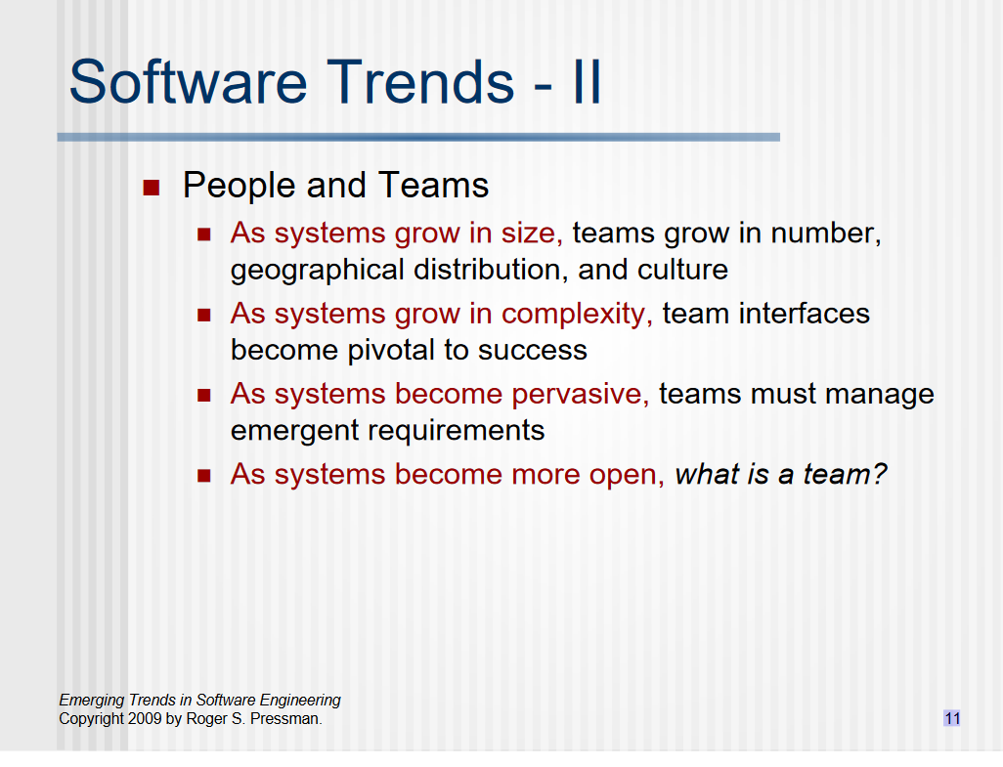

**Certification of Authorship**



Submitted to: Professor Yair Levy.

Student’s Name: Eric Webb

Date of Assignment: 10/27/2019

Title of Assignment: Assignment No. 2

Certification of Authorship: I hereby certify that I am the author of this document and that any assistance I received in its preparation is fully acknowledged and disclosed in the document. I have also cited all sources from which I obtained data, ideas, or words that are copied directly or paraphrased in the document. Sources are properly credited according to accepted standards for professional publications. I also certify that this paper was prepared by me for this course.

Student's Signature: ERIC WEBB