Generic Task Set for Design.

1. Data Structures for Data Objects.

* Users and Admin will be stored as ArrayLists.
* Sensors will be stored in ArrayLists.
* Usernames and password will be stored as key value mappings.

2. Architectural Style Pattern.

- Main program subprogram architecture. This was chosen because the main program like the WebGUI invokes other smaller programs like the calling functionality.

3. Analysis Model.

-Scenario Based model use cases.

- User or admin logs into PEN WEBGUI with device.

- User or admin adds / deletes device on PEN.

- Admin adds / deletes Users to PEN.

- Admin adds / delete sensors.

- User / Admin Communicates via fileTransfer, Calling, Messaging, filters.

- Sensors Communicate back to GUI to be sent to devices.

- Sensors handle routing of packets via nodes.

- Class Models

- Class Diagram.

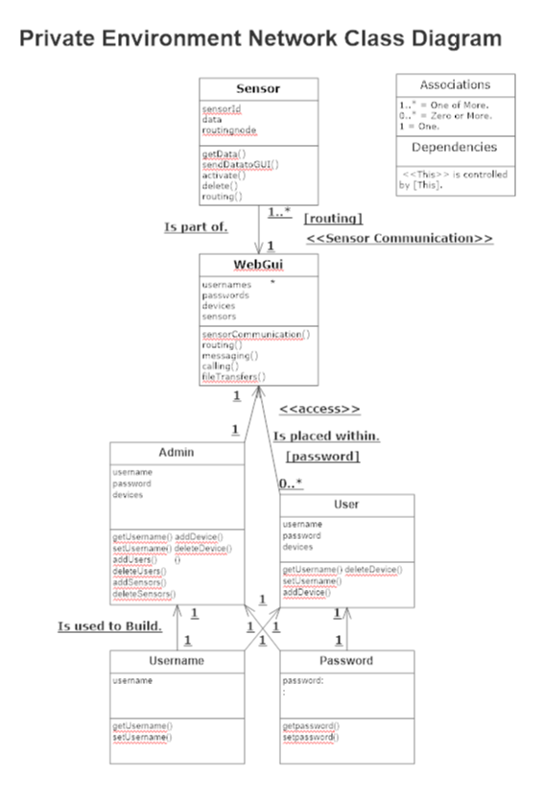

* Behavioral Model.