Section 1

Network information via Helix.

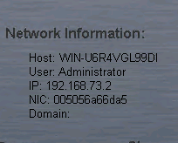

Pc on off time via Helix.

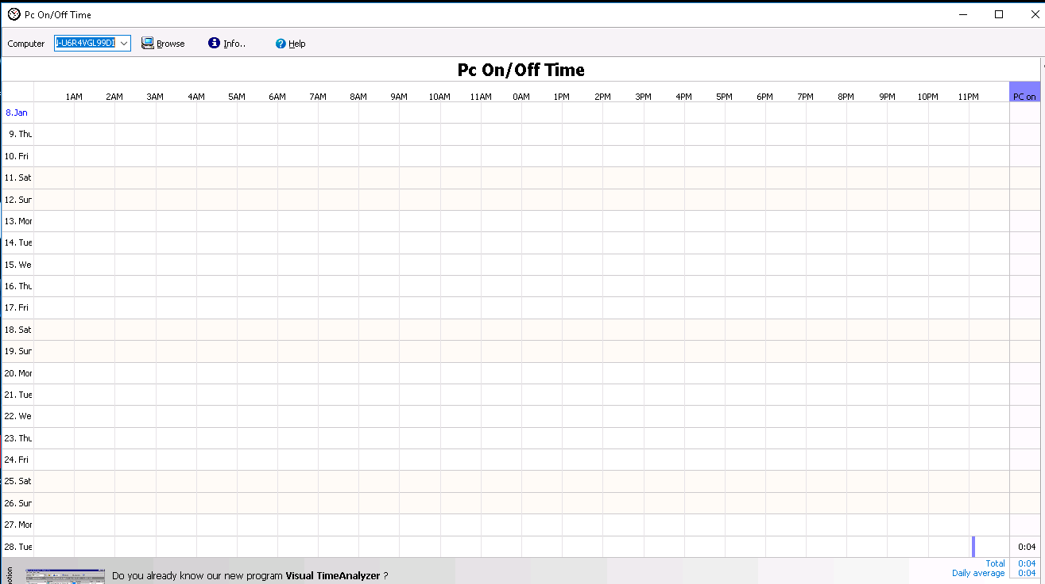

Computer was on 4 minutes today.

File name, size, and color depth



Travel photo details property tab via Helix.

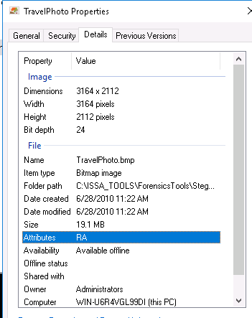

Travel photo image via Helix.

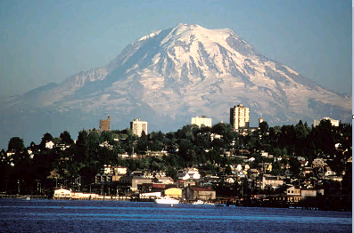

Private Bytes via process explorer via process explorer



Earliest created date via Fairview.



Last modified via IECacheView.

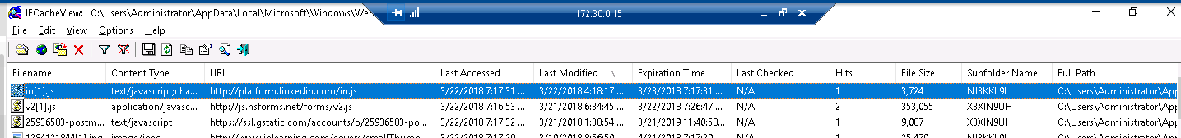

Last accessed data via IECookiesView.

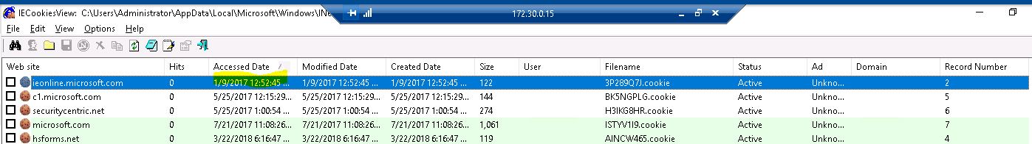

Most browsing history via BrowsingHistoryView.

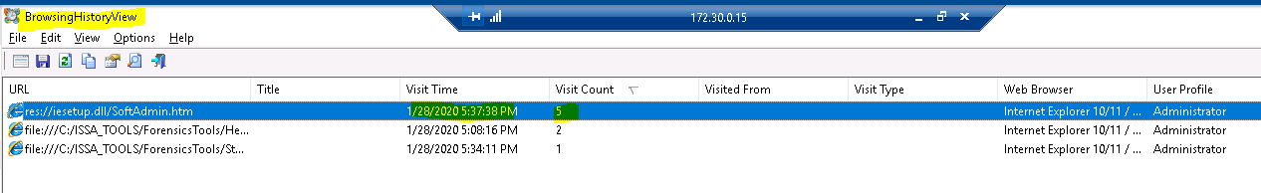

Most recent search via MyLastSearch.

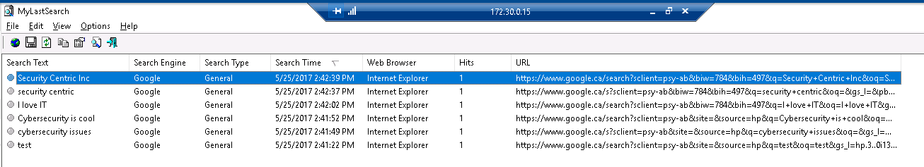

Section 2

Disk information for C: drive via Drive Manager.

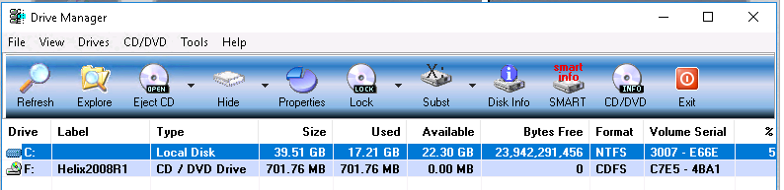

Data points for stegoMessage.bmp via ProccessExplorer.



Performance tab of vmtools.exe via ProccessExplorer.

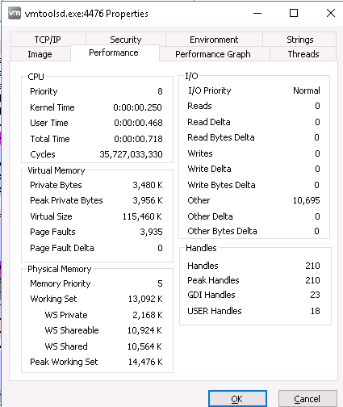

CloudParadox website screen capture via Fairview.

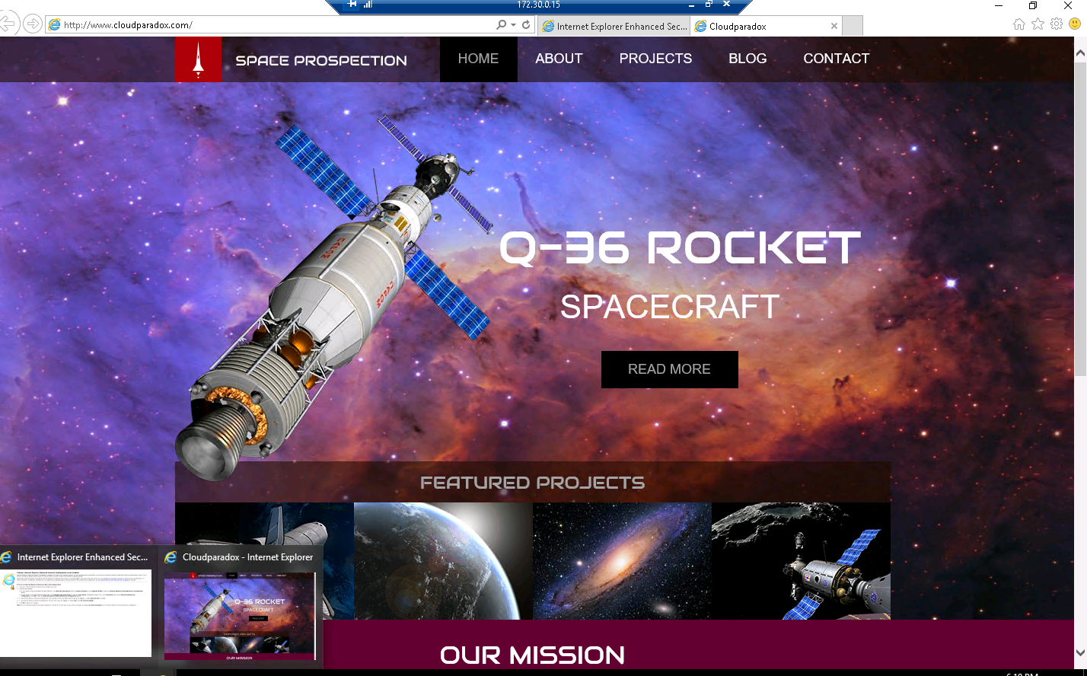

Properties file of most recent viewed via IECacheView.

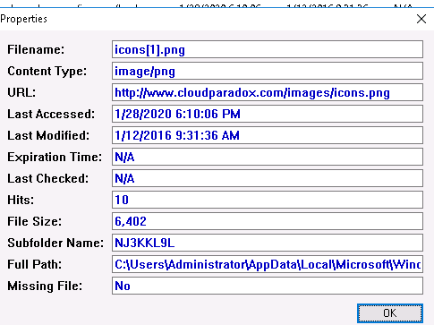

Details of a cookie via IECookieViewer.



CloudParadox properties via BrowsingHistoryView.

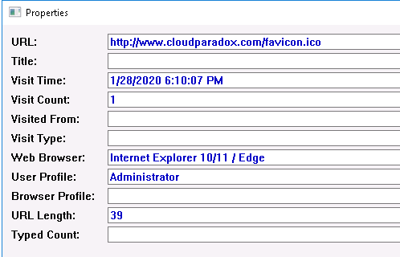

Most recent search via MyLastSearch.

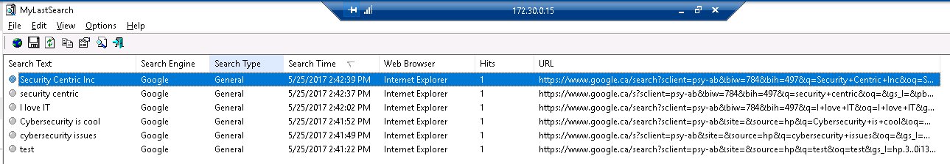

Section 3

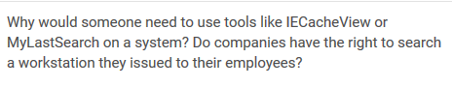

Someone would want to use these tools if someone cleared their browsing and search history. Typically when signing into a work position you agree to be subject to a digital analysis of your machine at any point. So yes companies do have the right to search workstations they issued to their employees.

Windows information.

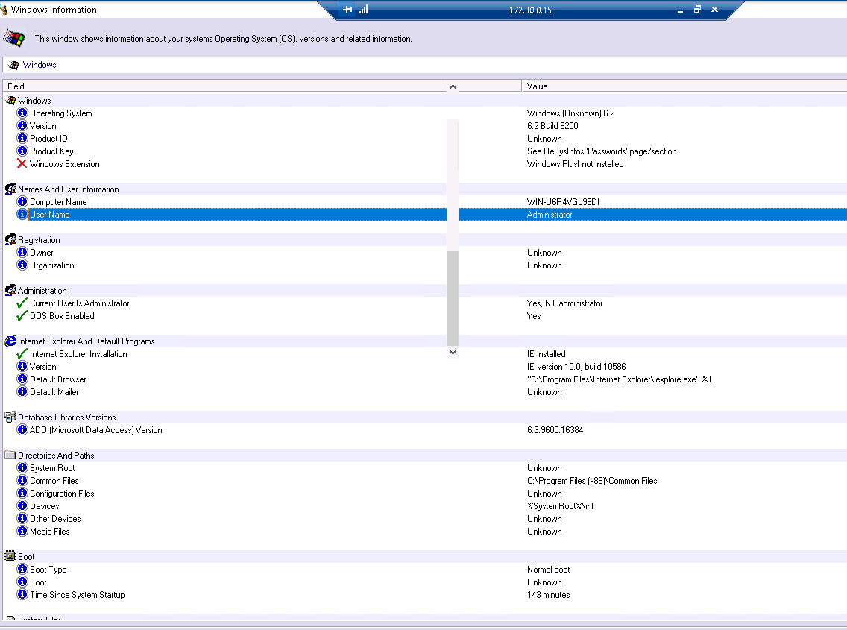

Environment information.

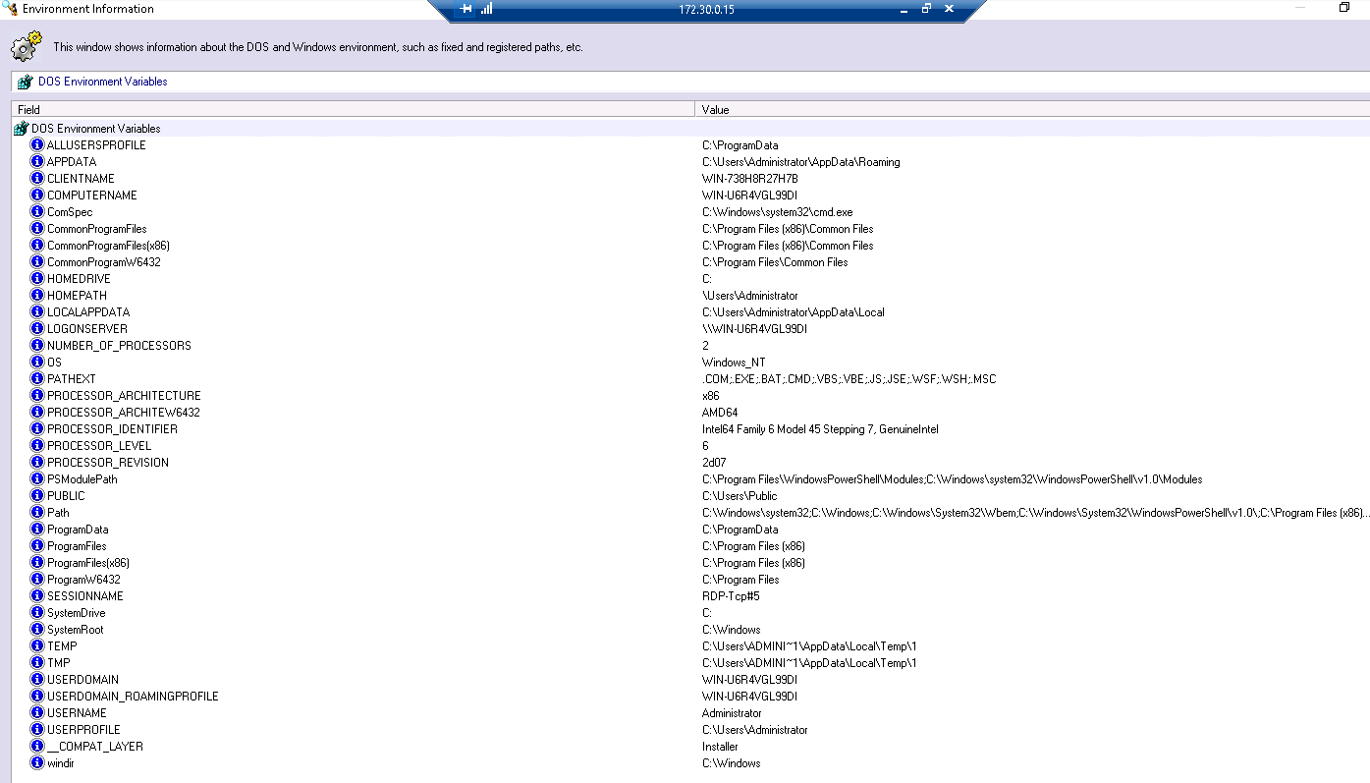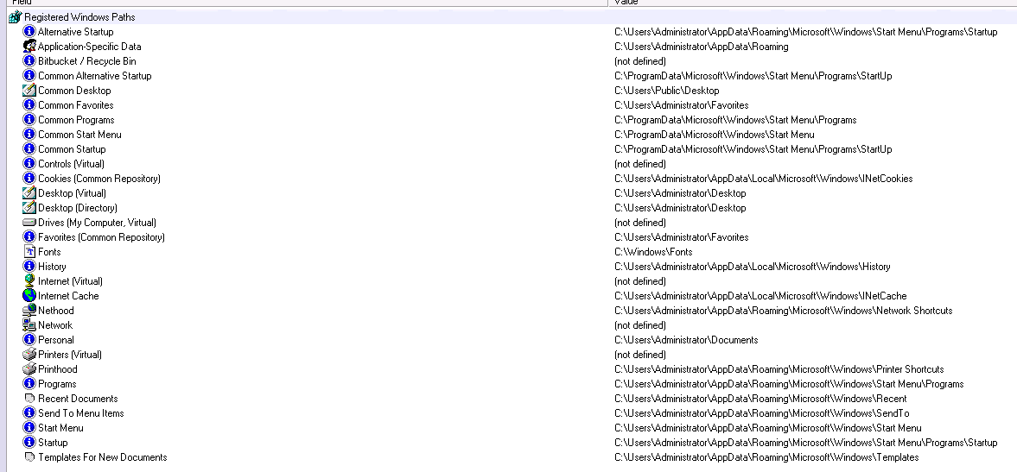

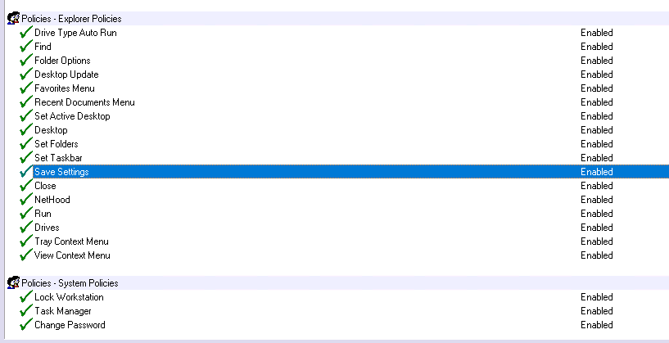

What are the similarities between the windows and environment information?

They both tell you the computer name and user name. They both know the common files path location.