Section 1

Describe contents of Root folder.

The contents of the Root folder has a partition of an New Technology Filing System.

It has program files, Document and Settings, recycler, and the Windows folders to investigate.

Root folder screen shot.

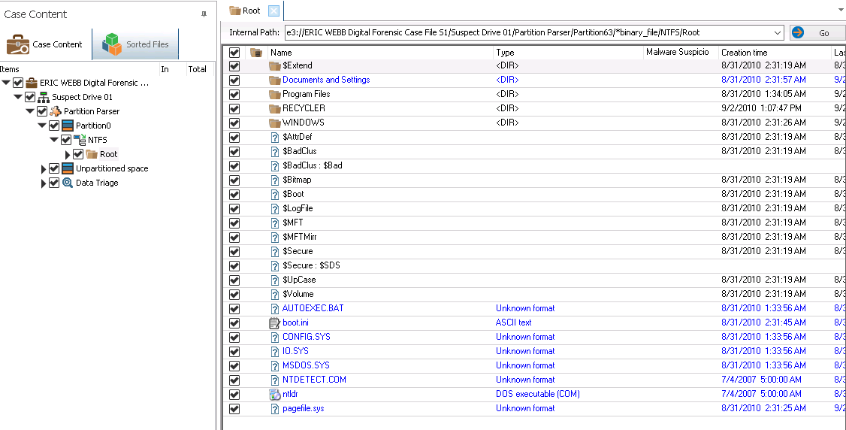

Section 2

Describe contents of Root folder.

The contents of the Root folder has a partition of an New Technology Filing System.

It has program files, Document and Settings, recycler, and the Windows folders to investigate. Most files being last accessed around Late August - Early September of 2010.

Root folder screen shot.

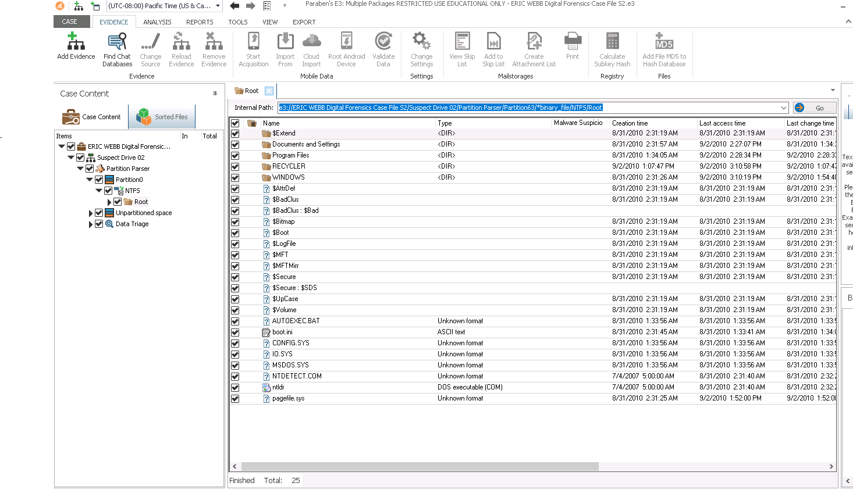

Section 3

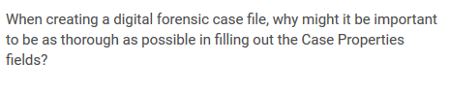

It is important because as work starts to pile up it will become increasingly harder to remember all the details of one case versus another case. This is especially true as time goes by and minute details begin to escape one’s mind. That is why it is important to put as much detail as possible in the properties field so that information is not over looked.

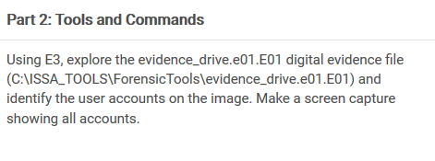

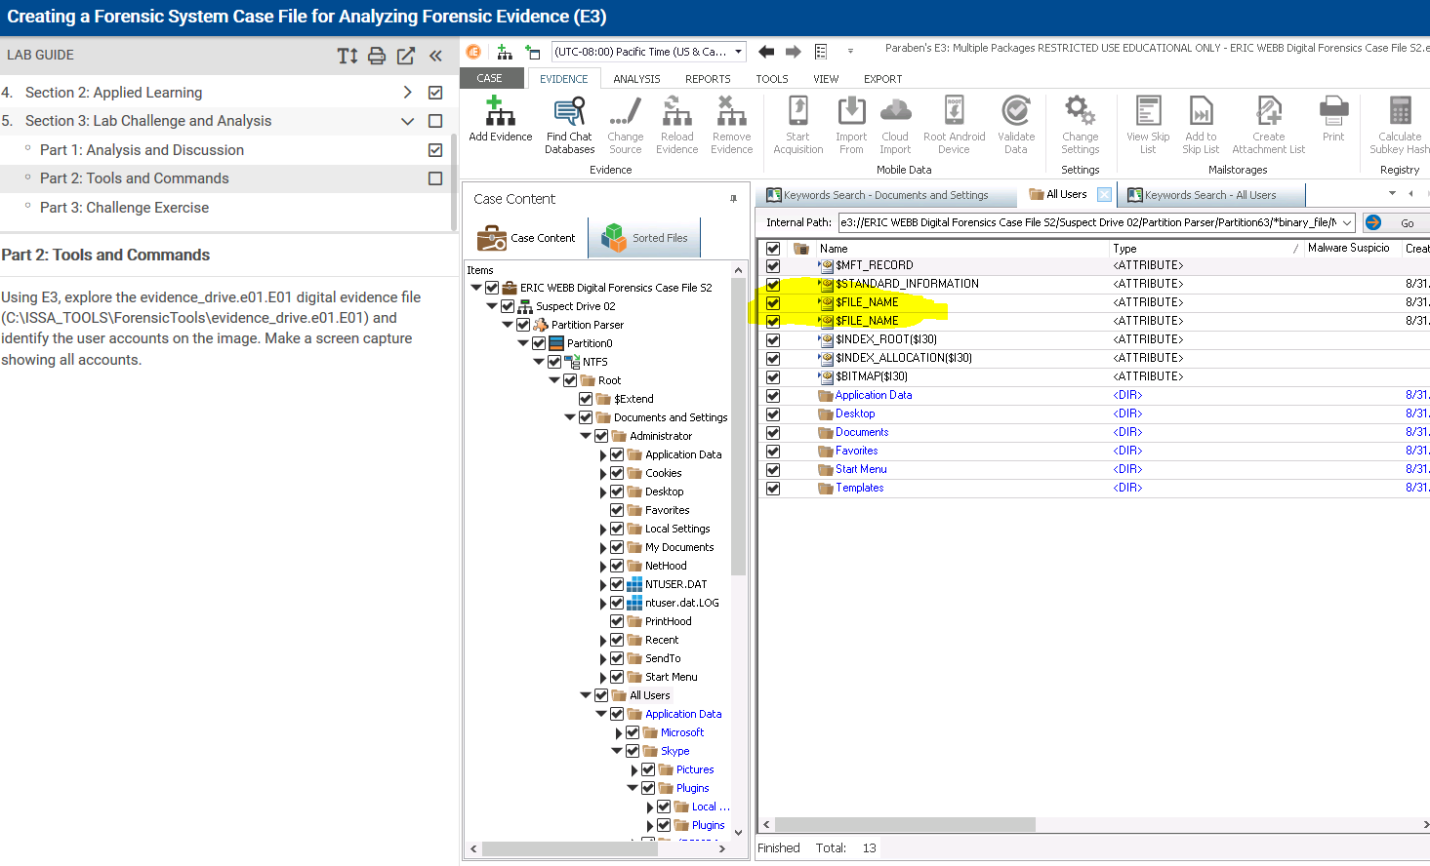

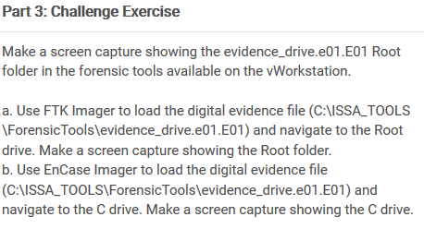

E3

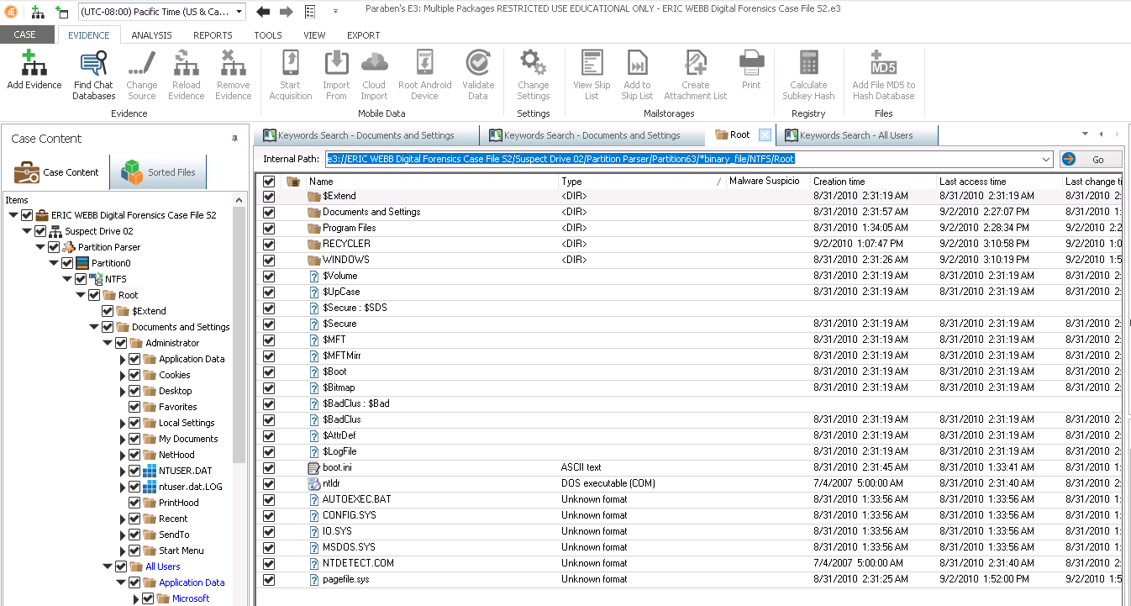

FTK

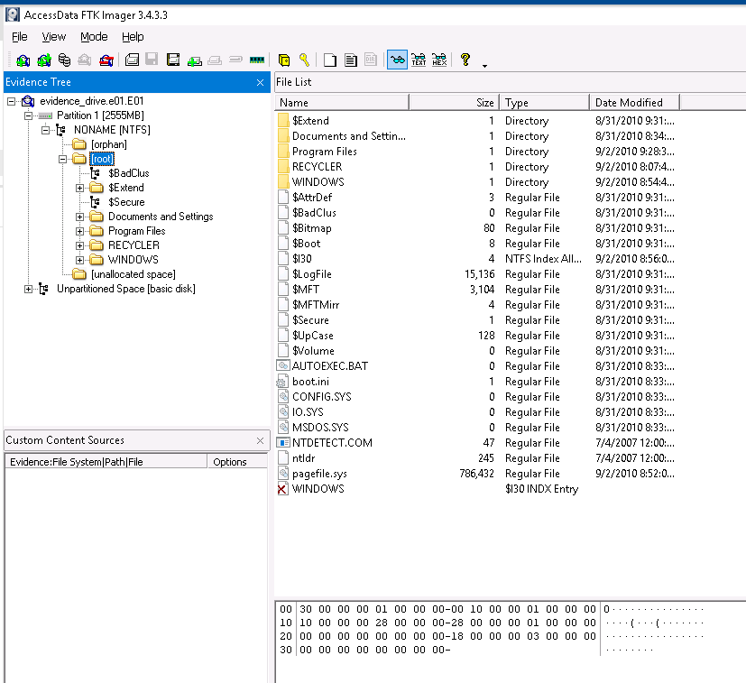

Encase

