Step 1 : Unzip File and open “home.html” with a browser.

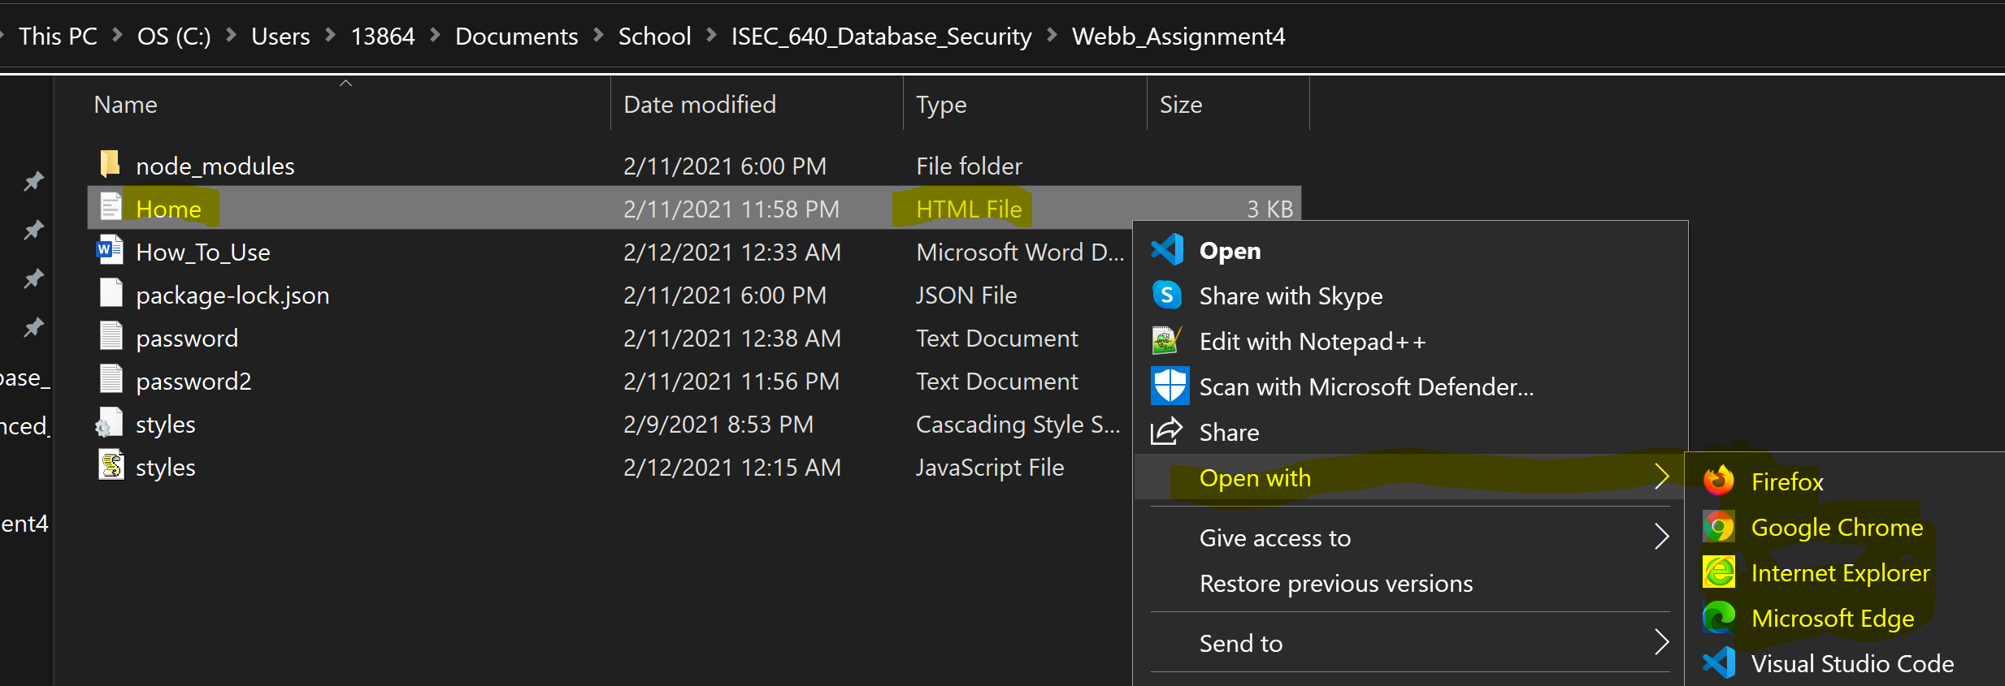

Step 2 : Select password file to be used or create and use your own.

***(Defaulted password list will be used if file is not uploaded.)*** 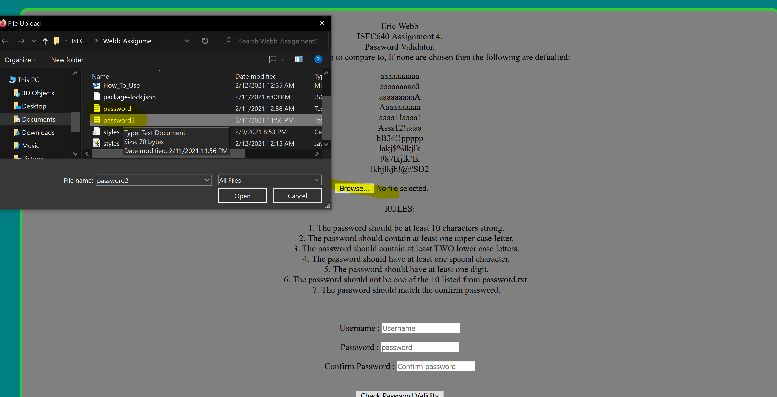

***(To create your own password file make sure it is a .TXT file and each entry is separated on a new line.)***

***Example below:***

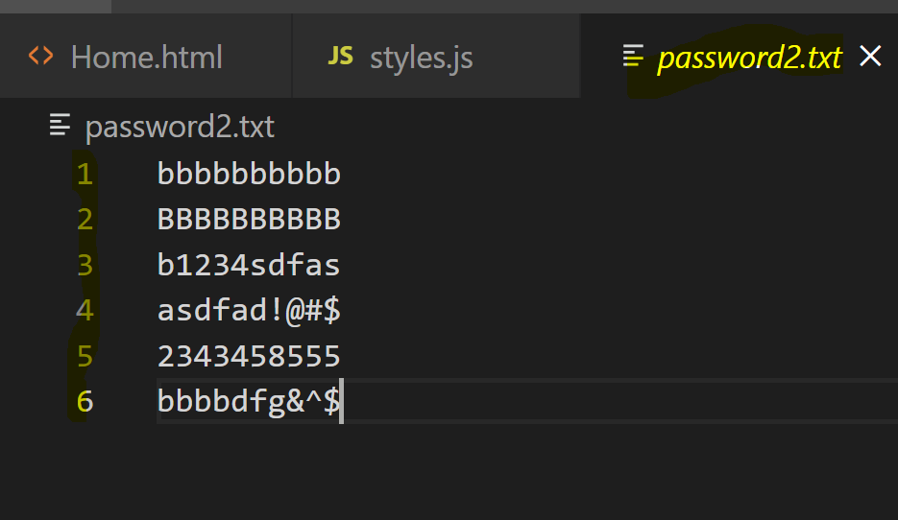

Step 3: Enter Password and Confirmation Password, then review if submission was successful or if password was not valid.

(Passing validation will be green while validation that did not pass will be red.)

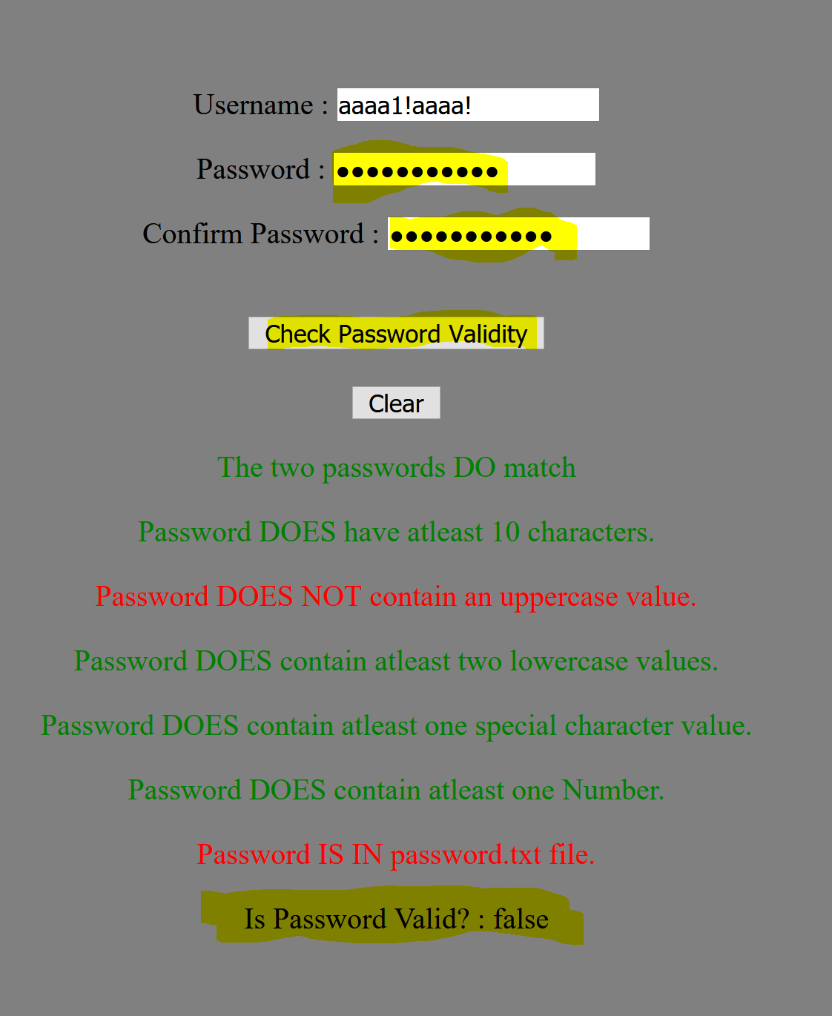

Correct validation will be all green and will return true for “Is Password Valid?”

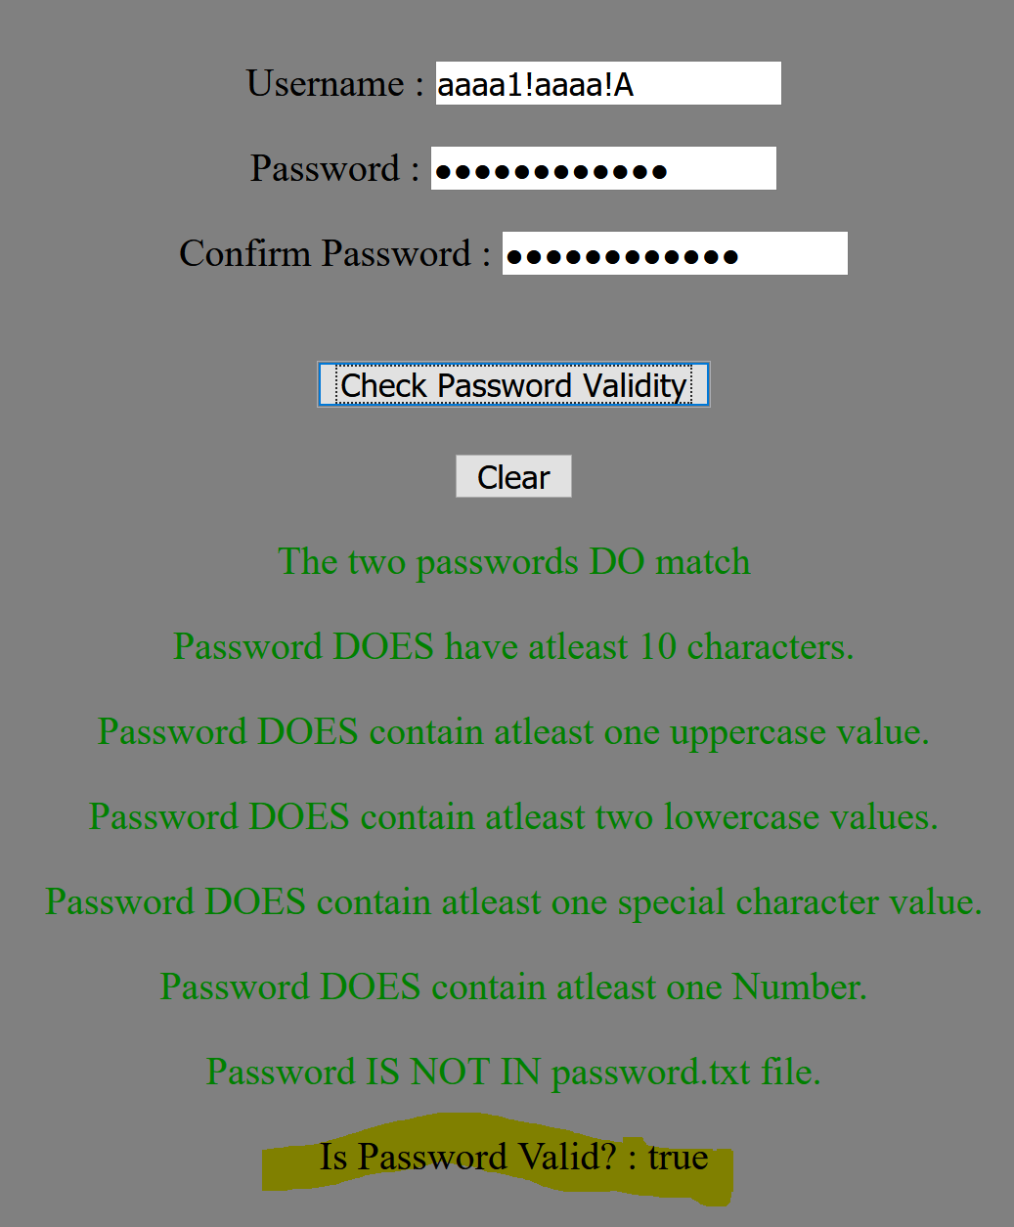

Step 4 : Hit clear button to reset everything. This will clean input fields including text and file selected.

