Assignment 1

**Assignment#1**

**MSIT 630 Database Systems (Summer, 2019)**

**Total: 60 points**

***Due: 5/26/2019 11:59PM***

1. Explain the concept of physical data independence and its importance in database systems (**4 points**)

Physical data independence is important because it allows you to change from ssd to hard disk or vice versa without messing up the actual logic of the table. So when the change is made and you have new physical hardware your business logic is still intact and integrated with out hassle.

**2.** Explain what problems are caused by the design of the following table. (**4 points**)

The Customer table

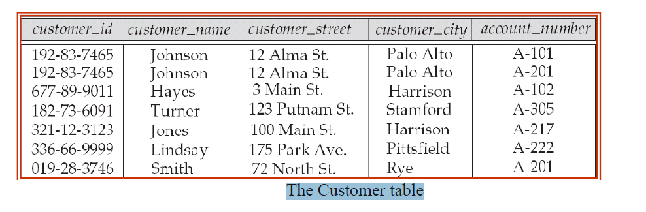

This table violates 3nf might be good on 1and 2. Might violate 1 lol

**3.** List four significant differences between a file-processing system and a DBMS. (**4 points**)

Data redundancy, each zoo needs a library.

Duplicating data each zoos library needs physically time and resources when it could all use one… not scalable. More errors.

Data integrity, everyones zoo could have different awnsers for the cure.

Isolated Data – Zoos can’t even ask get to the other libraries.

Reduced development time

**4.** Describe the differences in meaning between the terms *relation* and *relation schema*. (**4 points**)

Those relations and their schema.

relation is the predicate for example, Relation schema for a person "relation" can be shown in the following manner:   
  
Person(FirstName, LastName, Age, Gender, Address)

**5.** List two reasons why null values might be introduced into the database. (**4 points**)

For business logic of program . true false value so you would have null so its neither.

6. Write the following queries in SQL, using the university schema, execute your SQL statement on the sample database and show me the query results. (Appendix A, page 1287) (**20 points, 4 points each**)

a. Find the titles of courses in the Comp. Sci department that have 4 credits.

select title from course where dept_name='Comp. Sci.' and credits = 4;

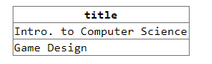

b. Find the name(s) of the instructor(s) who DON’T earn the lowest salary in Physics department.

create view allButMin as select * from instructor where dept_name = 'Physics' except select ID, name, dept_name, min(salary) from instructor where dept_name = 'Physics';

select name from allButMin;



c. Find the enrollment of each section (number of students enrolled) that was offered in Fall 2009.

d. Find the minimum enrollment, across all sections offered in Fall 2009.

e. Find the course ID and section ID of the sections that had the minimum enrollment in Fall 2009.

**7.** Write the following queries in SQL, using the university schema, execute your SQL statement on the sample database and show me the query results (Appendix A, page 1287) (**20 points, 4 points each**)

a. Find the names of all students who have taken at least two courses offered by Comp. Sci. department; make sure there are no duplicate names in the result. Note that student in other departments can take courses from Comp. Sci. as well.

b. Find the IDs and names of all students who have not taken any course offering in 2009.

c. For each department, find the name and salary of the instructor who earns the minimum salary in that department. You may assume that every department has at least one instructor.