RESD 700 Fall Term 2022
Eric Webb
Assignment 700-1

Exercise 5.10 : Avatars. (pg.83)
Problem Definition:
The problem is customer satisfaction is low and and needs engagement through avatar based
E-commerce.
Relationships:
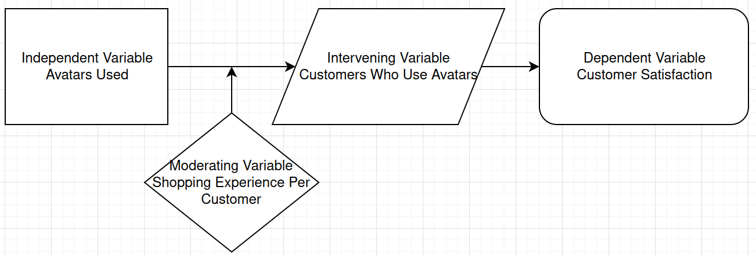
There is a direct correlation between the number of avatars used and customer satisfaction. Since we are measuring customer satisfaction it is the dependent variable, while the number of avatars being used changes, so it is an independent variable. Customer involvement intervenes between the number of avatars and customer satisfaction, so that it is a mediating variable. These relations will not act if there is no custom shopping experience, thus it is the moderating variable.
Variables:
Dependent Variable : Customer Satisfaction.
Independent Variable : Avatars Used.
Intervening variable : Customers Who Use Avatars.
Moderating variable : Shopping Experience Per Customer.
Exercise 5:12 : A Production Manager. (pg.87)
Define the problem:
The problem is the level of job performance relative to the manpower is substantially low and needs improvement.
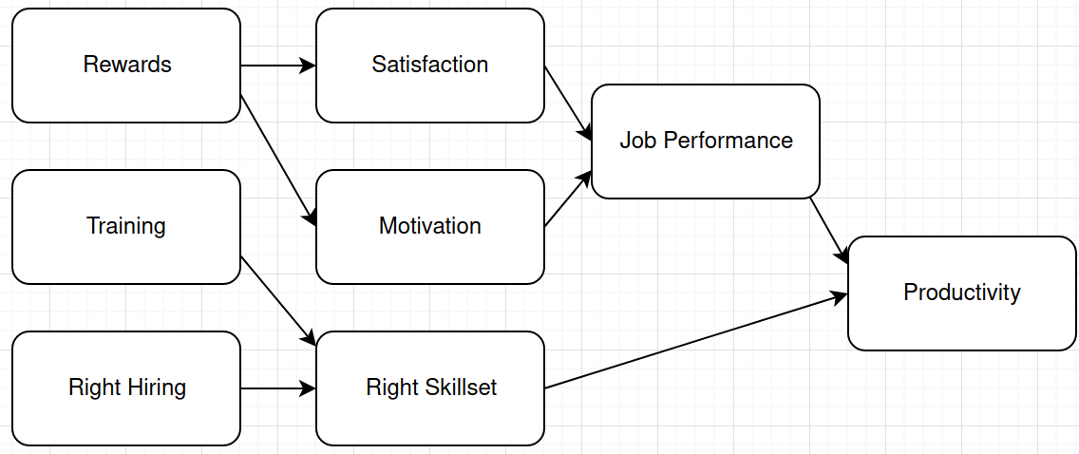
Create a Diagram:
Develop at least six hypothesis:
- Hiring the right candidates with the correct skill sets and tools will result in better productivity.
- Offering training to specialize in skill sets can increase productivity.
- Increasing employee satisfaction will have a direct impact on productivity.
- Motivated employees perform better than those that are not motivated.
- Increasing rewards and recognition will positively increase employee satisfaction and motivation.
- Increasing rewards and recognition’s will directly improve employee productivity.

Exercise 5:13 : A Recent Study. (pg.88)
For this situation, define the problem draw a schematic diagram and formulate the hypothesis.
Define the Problem:
The Problem is in order to maintain a high market value the company must keep a high Customer Social Responsibility which is contingent on Product Quality and Innovativeness capability.
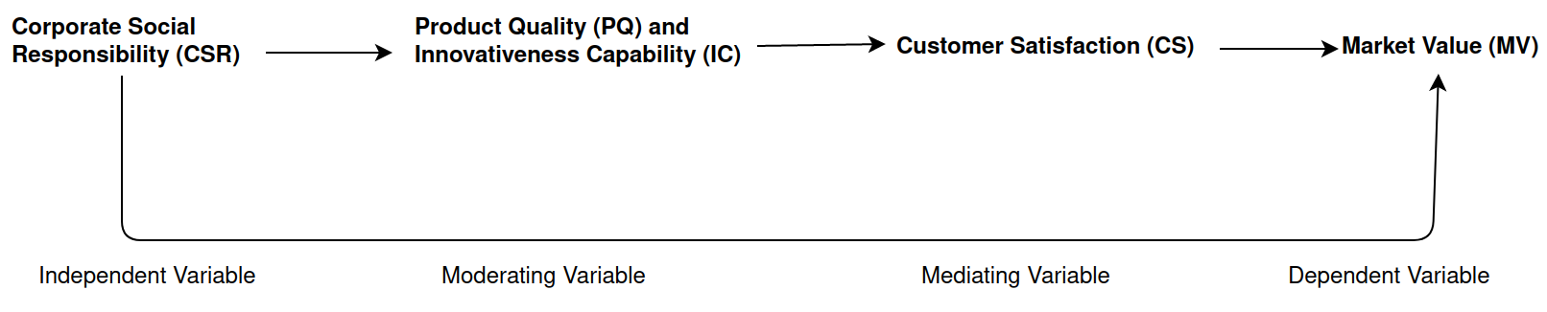
Draw A Schematic:
Hypotheses:
Null Hypothesis: Corporate Social Responsibility has a positive effect on the market value of the firm.
Alternative hypothesis: Corporate Social Responsibility does not have a positive effect on the market value of the firm.
Discussion Question #9: Develop a Conceptual Model. (pg.93)
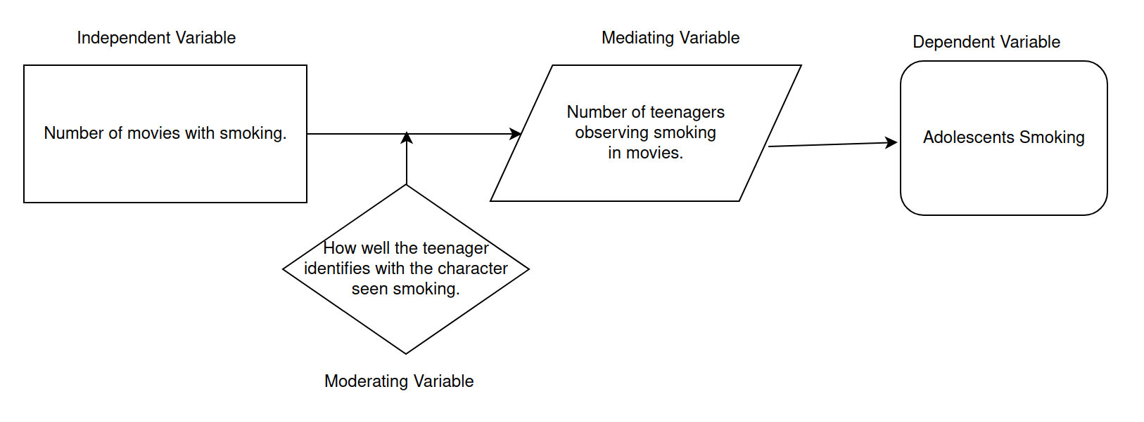

Exercises 1.
In the following examples, identify the independent and dependent variable(s):
a. Two groups of children were given different types of physical fitness programs to determine whether the programs had an effect on their strength.
Independent Variable : The type of physical fitness program.
Dependent Variable : Children's Strength.
b. A group of 100 heavy smokers was divided into five groups, and each group participated in a different smoking-cessation program. After 6 months of program participation, the number of cigarettes each participant smoked each day was counted.
Independent Variables: The smoking cessation programs.
Dependent Variables : Cigarettes smoked each day after 6 months of program.
c. Brands A and B differ in the way the packing is colored and the industrial designers are interested to see if there is an impact on number of units purchased.
Independent Variable : Packaging colors.
Dependent Variable : Amount of units purchased.
d. One group of teenage drivers was given a lecture on using seatbelts and other was shown pictures of accident victims who did not wear seatbelts and the variable of interest was safe driving practices.
Independent Variables : Lecture on wearing seatbelts and picture show of accident victims.
Dependent Variable : Safe driving practices.

Exercise 5. Write the null and research hypotheses for the following description of a research study: A group of middle-aged men was asked to complete a questionnaire on their attitudes toward work and family. Each of these men is married and has at least two children. Another group of men with no children also completed the same survey.
Null Hypothesis : The attitudes towards work and family are not substantially different between men without children than the men who have children.
Directional Hypothesis : The attitudes towards work and family are substantially different between men without children than the men who have children.

6. Write the null and a directional research hypothesis for the following description of a research study: A pediatrician was comparing the effects of an early intervention program during children’s first 3 years of life and the impact that program might have on academic achievement on grade school competency tests.
Null Hypothesis : The early intervention program at a child's first 3 years of life does not correlate to academic achievement in grade school competency tests.
Directional Hypothesis : The early intervention program at a child's first 3 years of life does positively impact academic achievement in grade school competency tests.

Exercise 12. A researcher interested in the use of energy in Howard County households makes survey phone calls to every 10th household listed in the county phonebook. In this example, assuming every household contacted participates in the survey: a. What is the sample? b. What is the population?

Sample: Every 10th household listed in the Howard County phonebook.
Population: Every household in the Howard County phonebook.

Exercise 14. The principal of an elementary school wants to know how well her 600 students like the school. She hires a researcher, who gives a satisfaction with school survey to three different third-grade classes.
a. How could the use of a sample like this threaten the value of the study’s outcomes?
The value of this study's outcome could be argued to be flawed because the sample only represents 3rd graders making it an incomplete sample size representation of the 600 students within the school.
b. How might the flawed sample affect the usefulness of the results?
When taking in the usefulness of these results one must except that because of its 3rd grade only sample size, it is incomplete for the general consensus of the schools 600 student population. It’s usefulness is only present in the subset analysis of 3rd graders and not the school population as a whole.

Exercise 15. Two researchers complete projects looking at the relationship between the amount of time studied and performance on a science test. Researcher A’s results state that “John performed better than Lisa, who performed better than Drew.” Researcher B’s results state that “John earned a 97%, Lisa earned a 96%, and Drew earned a 71%.” Between Researcher A and Researcher B, who has the best way of measuring the dependent variable of test performance? Why?
I would argue that researcher B chose the best way of measuring the performance on a science test dependent variable. This is because they chose to do it discretely with test scores. This allows us to come to the same conclusion as researcher A plus more data to ingest.

