RESD 700 Fall Term 2022
Eric Webb
Practice Assignment 1
Weeks 1 & 2 - A Practice Exercise

Variable Labeling Practice 1:

1. Identify the variables and label them with names. If the research scenario describes a cause-and-effect relationship, label what is the IV or IVs and what is the DV or DVs. If not, only name the variables without indicating IV or DV.
The tests themselves are IV’s because the individual tests can change.
The scores themselves are the dependent variables because they are whats being measured.
IV AMT = Aptitude for Mathematics Test. DV AMS = Aptitude for Mathematics Score.
IV IFST = Ideational Fluency Scales Test. DV IFSS = Ideational Fluency Scales Score.
IV VIQT = verbal IQ Test. DV VIQS = Verbal IQ Score.

2. Think about how each variable is measured and determine accordingly if the variable is a categorical variable or a continuous variable. If the measurement is not clearly described in the scenario, you can imagine this is your research study and decide what measurement you will use for the variables, and then answer accordingly.
They are all continuous variables because they are based off of numbers and not a discrete categorization like pass or fail.

3. If any research scenario includes a moderating variable, please indicate so, and discuss how the moderating variable have an effect on the relationship being investigated in the scenario.
A moderating variable for this situation could be how much the students slept the night before, how much nutrition they had before the tests, and how hydrated they were during the tests.

4. Please try to draw a diagram to depict the relationship (with the variables in it) being investigated in each research scenario. This will be the research model.

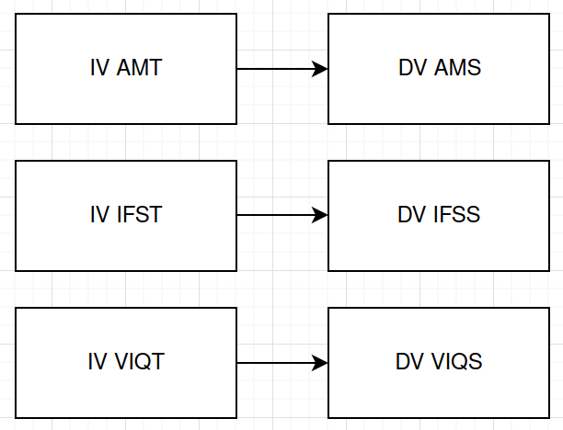

Variable Labeling Practice 2:

1. Identify the variables and label them with names. If the research scenario describes a cause-and-effect relationship, label what is the IV or IVs and what is the DV or DVs. If not, only name the variables without indicating IV or DV.
The sections with or without the tutorial are the IV’s because they are what change. The DV’s are the tests scores themselves because they are measured.
IV classSection : DV testScores

2. Think about how each variable is measured and determine accordingly if the variable is a categorical variable or a continuous variable. If the measurement is not clearly described in the scenario, you can imagine this is your research study and decide what measurement you will use for the variables, and then answer accordingly.
They are continuous variables because they are based off of numbers and not a discrete categorization like pass or fail.

3. If any research scenario includes a moderating variable, please indicate so, and discuss how the moderating variable have an effect on the relationship being investigated in the scenario.
A moderating variable for this situation could be how much the students slept the night before, how much nutrition they had before the test, and how hydrated they were during the test.

4. Please try to draw a diagram to depict the relationship (with the variables in it) being investigated in each research scenario. This will be the research model.

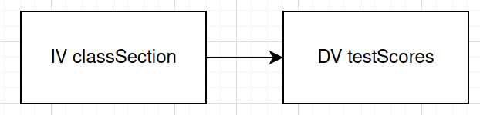

Variable Labeling Practice 3:

1. Identify the variables and label them with names. If the research scenario describes a cause-and-effect relationship, label what is the IV or IVs and what is the DV or DVs. If not, only name the variables without indicating IV or DV.
IV workingConditions, IV payRaise, IV Vacation Benefits. DV workerMorale.

2. Think about how each variable is measured and determine accordingly if the variable is a categorical variable or a continuous variable. If the measurement is not clearly described in the scenario, you can imagine this is your research study and decide what measurement you will use for the variables, and then answer accordingly.
workingConditions and workerMorale are both categorical variables because they do not have numbers associated to them and can be categorized by happy/sad or good/bad, while payRaise and vacationBenefits are continuous variables because they can have a number associated with them.

3. If any research scenario includes a moderating variable, please indicate so, and discuss how the moderating variable have an effect on the relationship being investigated in the scenario.
A moderating variable for this scenario could be the workers tenure in the organization and their report with the manager/colleagues.

4. Please try to draw a diagram to depict the relationship (with the variables in it) being investigated in each research scenario. This will be the research model.

