Nova Southeastern University
College of Engineering and Computing
CISC650 Computer Networks
Winter 2017, Assignment 3
Justin Washington

Part 1. Text reading Chapter 5, Chapter 6
Part 2. Textbook questions Chapter 5 [30 points]

  - What is meant by a control plane that is based on logically centralized control? In such cases, are the data place and the control plane implemented within the same device or tin separate devices? Explain.
The control plane on an SDN controller is based on a logically centralized control, meaning it can sees and knows all about the network, including hosts and network architecture. The control plane and forwarding plane, or data, is separated on different devices. This allows for more flexible forwarding policies and unique networking.

  - Compare and contrast link-state and distance-vector routing algorithm.
Link state algorithms, used in OSPF, computes the least-cost path between destination and source using global information about the network.
Distance-vector routing algorithms, used in RIP, calculate of the least-cost path in a distributed way. A node only knows the neighbor along the least-cost path, and the cost of that path from itself, to the destination.

  - Why are different inter-AS and intra-AS protocols used in the Internet?
Policy: With inter-AS, policy issues are very important and can dominate over performance.
Scale: Routing algorithms and its data structures are able to handle a large amount of networks, as well as reducing table size and increasing traffic performance.
Performance: intra-AS is performance oriented while inter-AS is policy oriented.

  - Describe the main role of the communication layer, the network-wide state management layer, and the network-control application layer in an SDN controller.
Communication Layer: In a controller, this layer provides communication between the SDN controller and controlled switches.
Network-wide state management layer: This layer acts as a set of network links, switches, and services.
Network-control application layer: This layer provides API and abstractions for network control apps.

  - Define the following terms in the context of SNMP: managing server, managed device, network management agent and MIB.
Simple Network Management Protocol is an internet standard protocol for collecting and modifying data from managed devices on IP networks. Modems, printers, servers, switches, and routers are among the devices that usually support SNMP.
Managing Server: the seperate entity that is responsible for communiaction with the SNMP agent on the network devices. This is usually a computer that is used to manage multiple network management systems.
Managed Device: A managed device is the device that needs monitoring such as a router, switch, or server.
Network Management Agent: The network management agent is configured within the network. The agent allows collection from the management information database from the device, enabling the SNMP manager when queried for.
MIB: MIB, or Management Information Base, is a commonly shared database between the Network Management Agent and the Manager. MIB files are basically a set of questions a SNMP manager can ask the network management agent.

  - Consider the following network. With the indicated link costs, use Dijkstra’s shortestpath algorithm to compute the shortest path from x to all network nodes. Show how the algorithm works by computing a table similar to the textbook example. In cases when several candidate nodes have the same minimal costs, choose a node according to nondecreasing alphabetical order.

  - Consider the count-to-infinity problem in the distance vector routing. Will the problem occur if we decrease the cost of a link? Why?
The problem will not occur if we decrease the cost of a link because the decreasing link won't cause a loop. Two nodes connected with a link is the same as decreasing the link weight from infinte to the finite weight.

Chapter 6 [30 points]

  - Suppose the information content of a packet is the bit pattern 1111 0011 1001 1100 and an even parity scheme is being used. What would the value of the field containing the parity bits be for the case of a two-dimensional parity scheme? Your answer should be such that a minimum-length checksum field is used.

1 | 1 | 1 | 1 | 0
0 | 0 | 1 | 1 | 0
1 | 0 | 0 | 1 | 0
1 | 1 | 0 | 0 | 0
1 | 0 | 0 | 1 | 0

  - Refer to the Cyclic Redundancy Check (CRC) codes discussed in the textbook and follow the conventions used in the textbook. Consider the 5-bit generator, G=10011, and suppose that D has the value 1010101011. What is the value of R? Show the process how you obtain the solution.
D = 1010101011
G = 10011
R = 1010101011 683 / 19 10011
R = 1111

  - Consider two nodes A and B uses the slotted ALOHA protocol to contend for a channel. Suppose node pA and pB are A and B’s retransmission probabilities. Provide a formula for node A’s average throughput. What is the total efficiency of the protocol with these two nodes?
S = pA (1-pB)
Total Efficiency = pA (1-pB) + pB (1-pA)

  - A disadvantage of the content of approach for LANs, such as CSMA/CD, is the capacity wasted due to multiple stations attempting to access the channel at the same time. Suppose that time is divided into discrete slots, with each of N stations attempting to transmit with probability p during each slot. What fraction of slots is wasted due to multiple simultaneous transmission attempts?
The fraction of slots wasted due to multiple transmission attempts is equal to the probability that there will be 2 or more transmission attempts in a slot.
Pr [2 OR MORE ATTEMPTS] = 1 – Pr [NO ATTEMPTS] – Pr[ONLY 1 ATTEMPT]
= 1- (1 – p)N – Np(1 – p)N–1

  - In CSMA/CD, after the 5th collision, what is the probability that a node chooses k=4? The result k=4 corresponds to a delay of how many seconds on a 10 Mbps Ethernet?
After the 5th collision, the adapter chooses from 25 = 32. The probability 4 is chosen is 1/32. On 10 Mbps Ethernet, it will wait 204.8 microseconds.

  - Why is an ARP query sent within a broadcast frame? Why is an ARP response sent within a frame with a specific destination MAC address?
An ARP query is sent within a broadcast frame because the adapter correlated to the IP address is unknown to the querying host. An ARP response is sent within a frame with a specific destination MAC address because the adapter destination address is known to the sending node, so a broadcast frame is not necessary.

  - Why the Ethernet is called a multiple access protocol? Why it is referred to as an unreliable and connectionless approach?
Ethernet is called a multiple access protocol because each node on the network is capable of sending messages at the same time which may result in collisions. Ethernet has enforced methods to avoid collisions due to its multiple access problem including CDMA/CD and switched based LANs.
Ethernet is referred to as an unreliable and connectionless approach because it is a connectionless service without any acknowledgements. When a sender wishes to send to a receiver, the sender will send its packets onto the network without establishing a connection with the receiver. It is unreliable because when the receiver gets the message it will run a CRC check and either discard or keep the frames but the receiver will not send any acknowledgements to the sender to advise on the status of the packages received.

- My Computer IP Address: 65.55.44.108
TCP Port Number: 443
Destination Computer IP Address: 128.119.245.12
TCP Port Number: 80
- gmass IP Address: 192.168.1.75
TCP Port Number: 63615

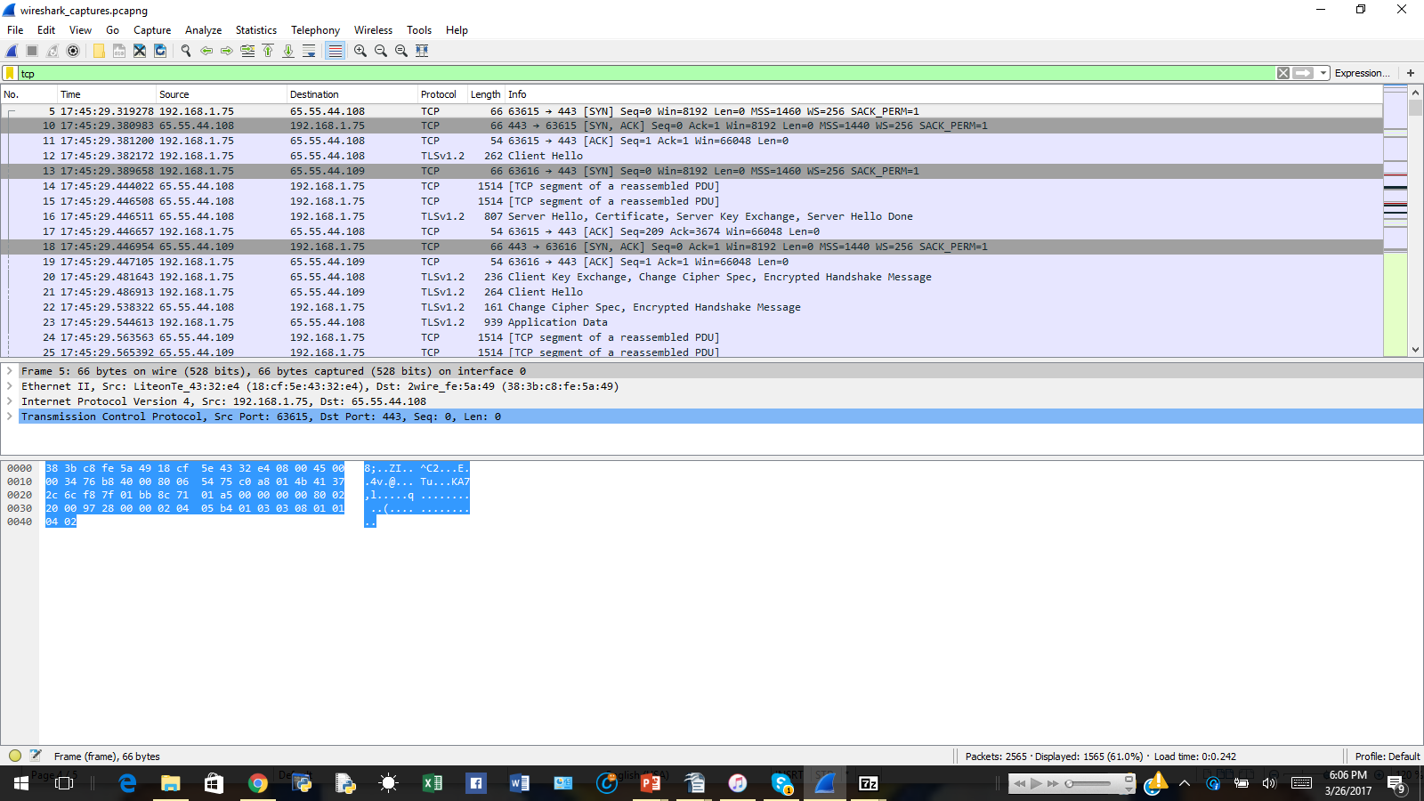

- The sequence number of the TCP SYN segment is used to start the connection between the source computer and the website. Trace Value = 0, The SYN flag is set to 1, identifying it as a SYN segment.
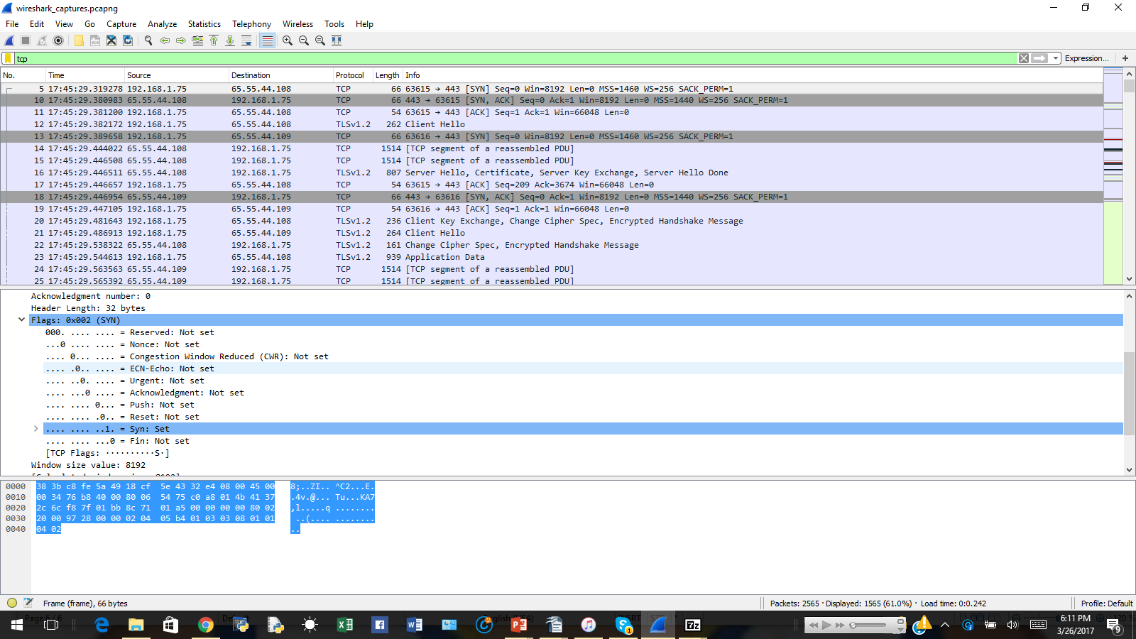

5. The sequence number of the SYN ACK segment from gaia to the source computer in the reply to SYN is 0. The value of the ACK in the SYN ACK segment is 1. The value of the ACK field in the SYN ACK segment is produced by gaia by adding 1 to the starting sequence number of the SYN segment from source computer. The SYN flag and ACK flag in the segment are values of 1, indicating this is a SYN ACK segment.
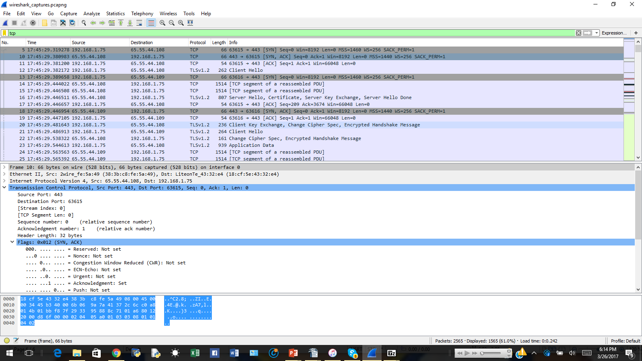
6. The sequence number is 1.

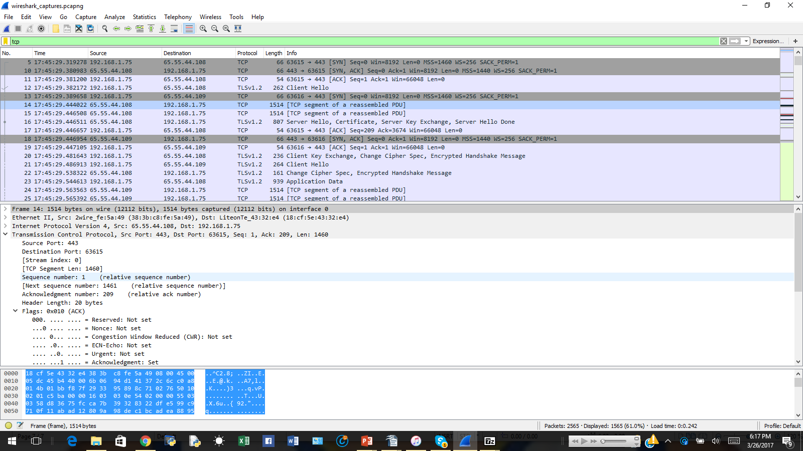

7.

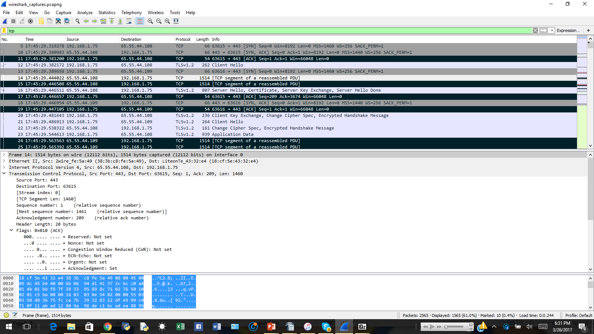

8. The first segment is 565 bytes, the rest are all 1460 bytes.

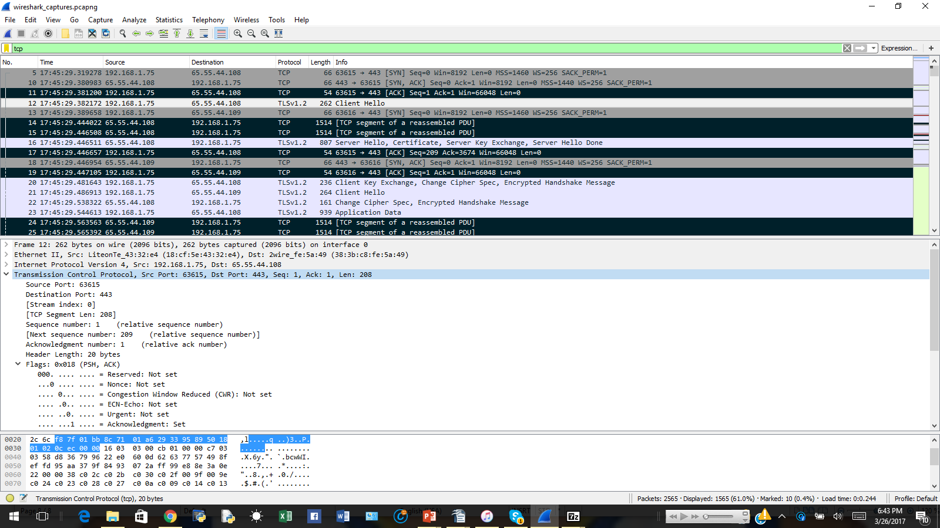

9. The buffer space initially starts at 8192, but grows to 66048.

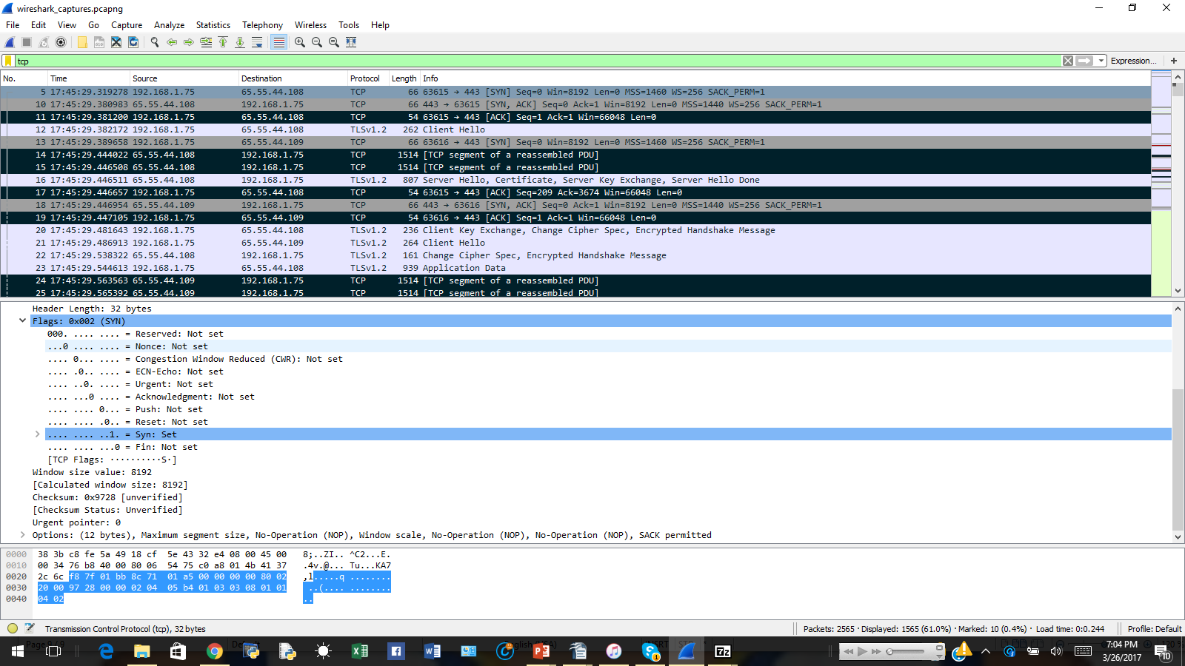
10. None of the segments were retransmitted. I checked by looking at the Time Sequence (Stevens) to ensure each sequence number is increasing.

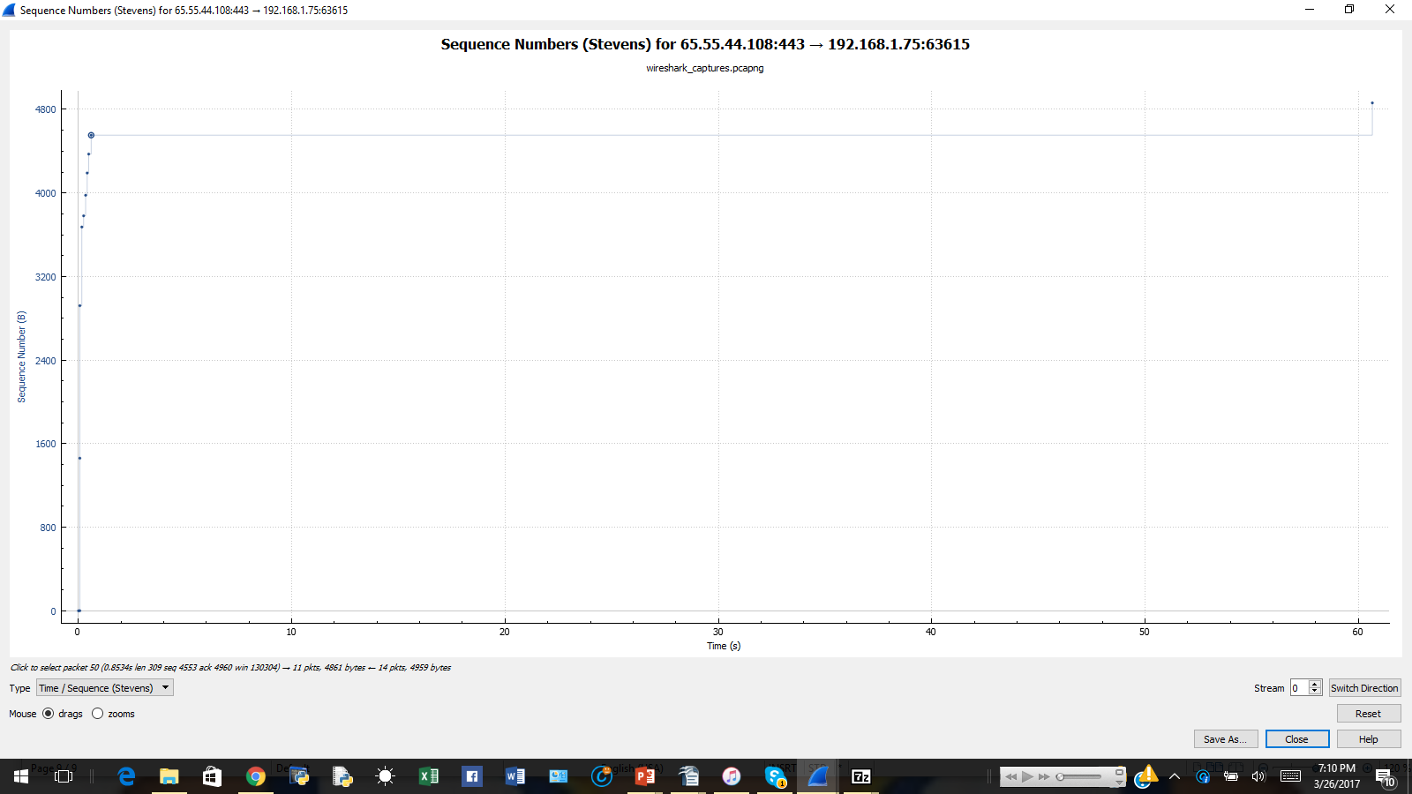

11. The reciever typically ACKs 1460 bytes of data. You can see where a packet is ACK every other segment by seeing the amount of data doubled.

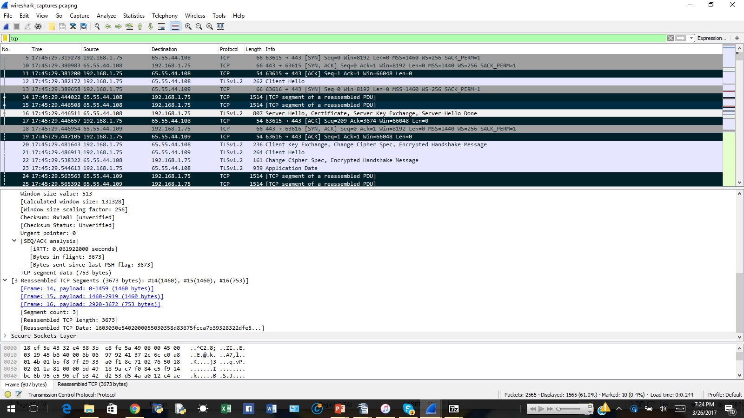


Certification of Authorship

Submitted to (Professor’s Name): Wei Li, Ph.D.

Student’s Name: Justin Washington

Date of Submission: March 26, 2017

Purpose and Title of Submission: Assignment 3

Certification of Authorship: I hereby certify that I am the author of this document and that any assistance I received in its preparation is fully acknowledged and disclosed in the document. I have also cited all sources from which I obtained data, ideas, or words that are copied directly or paraphrased in the document. Sources are properly credited according to accepted standards for professional publications. I also certify that this paper was prepared by me for this purpose.

Student's Signature: Justin Washington

