Generic Task Set for Design.

- Data Structures for Data Objects.
- Users and Admin will be stored as ArrayLists.
- Sensors will be stored in ArrayLists.
- Usernames and password will be stored as key value mappings.
2. Architectural Style Pattern.
- Main program subprogram architecture. This was chosen because the main program like the WebGUI invokes other smaller programs like the calling functionality.
3. Analysis Model.
-Scenario Based model use cases.
- User or admin logs into PEN WEBGUI with device.
- User or admin adds / deletes device on PEN.
- Admin adds / deletes Users to PEN.
- Admin adds / delete sensors.
- User / Admin Communicates via fileTransfer, Calling, Messaging, filters.
- Sensors Communicate back to GUI to be sent to devices.
- Sensors handle routing of packets via nodes.
- Class Models
- Class Diagram.
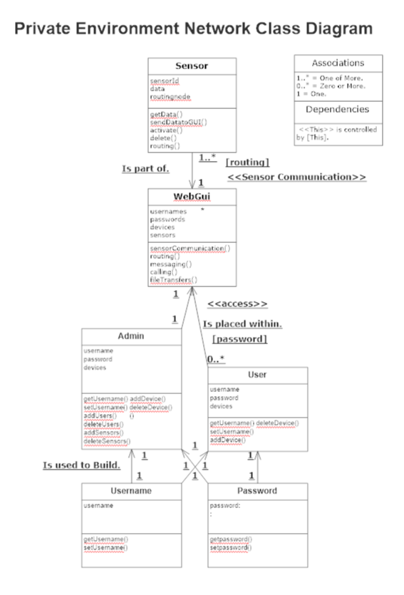

- Behavioral Model.

