Design Document

for

Private Environment Network
Version 1.0
Prepared by Eric Webb
Nova Southeastern University
11-17-2019

Table of Contents
Table of Contents ii
Revision History ii
1. Introduction 2
1.1 Purpose 2
1.2 Document Conventions 2
1.3 Project Scope 2
1.4 References 2
2. Overall Description 2
2.1 Product Perspective 2
2.2 User Classes and Characteristics 2
2.3 Operating Environment 2
2.4 Design and Implementation Constraints 2
2.5 Assumptions and Dependencies 2
3. System Features 2
3.1 System Feature 1 2
3.2 System Feature 2 (and so on) 2
4. Data Requirements 2
4.1 Logical Data Model 2
4.2 Data Dictionary 2
4.3 Reports 2
4.4 Data Acquisition, Integrity, Retention, and Disposal 2
5. External Interface Requirements 2
5.1 User Interfaces 2
5.2 Software Interfaces 2
5.3 Hardware Interfaces 2
5.4 Communications Interfaces 2
6. Quality Attributes 2
6.1 Usability 2
6.2 Performance 2
6.3 Security 2
6.4 Safety 2
6.5 [Others as relevant] 2
7. Internationalization and Localization Requirements 2
8. Other Requirements 2
Appendix A: Glossary 2
Appendix B: Analysis Models 2

(Communication,
planning,
modeling,
construction
and deployment).

• Project planning
• Use case development
• Requirement gathering
• Rapid design
• Code generation
• Testing

(requirements, architecture, components, user interface and testing)

1.Introduction.

Purpose.
The purpose of this document is to give the reader a sense of knowledge on how the PEN version 1.0 program works. This could include developers trying to replicate this application, project managers trying to get a better sense of the project, or even testers to better understand how to test this application.

Document Conventions.
In this document moving forward we will regard the private environment network as a PEN. The guided user interface that users will log into viea their devices will be referred to as the GUI.

Intended Audience.
The intended audience of this document could include a multitude of professional positions. This could include developers trying to replicate this application, project managers trying to get a better sense of the project, or even testers to better understand how to test this application.

Project Scope.
The goal of this application will be to have a working private environment network. This PEN. This PEN will be attainable through agile development and methodologies to properly communicate from the stakeholders to the development team and vice versa. The working PEN will incorporate communications features that are manageable by tiered accounts.

References

Studying the Effect of Human Mobility on MANET Topology and Routing: Friend or Foe?
doi>10.1145/2810362.2810370

Exploring agile
doi>10.1145/1370143.1370144

Overall Description

Product Perspective.
The overall perspective of this product will be for consumer private use. The consumer of this product will have full rights to deploy and maintain an instance of this PEN for their own benefit. Because this product is a multiuser product the PEN will have a multiuser product perspective.

Product Features.
The PEN offers some unique features to make it complete. The first features is that of sensors to locate physical devices. The second feature of these sensors is their capability to route traffic and update nodes as devices traverse the PEN. More features include the ability for devices to link to the PEN’s sensors and simplistic but effective GUI for users to interact with.

Users Classes and Characteristics.
Classes will include Sensors, GUI, User, Admin, Username, Passwrod represented in the PEN class diagram represented below.
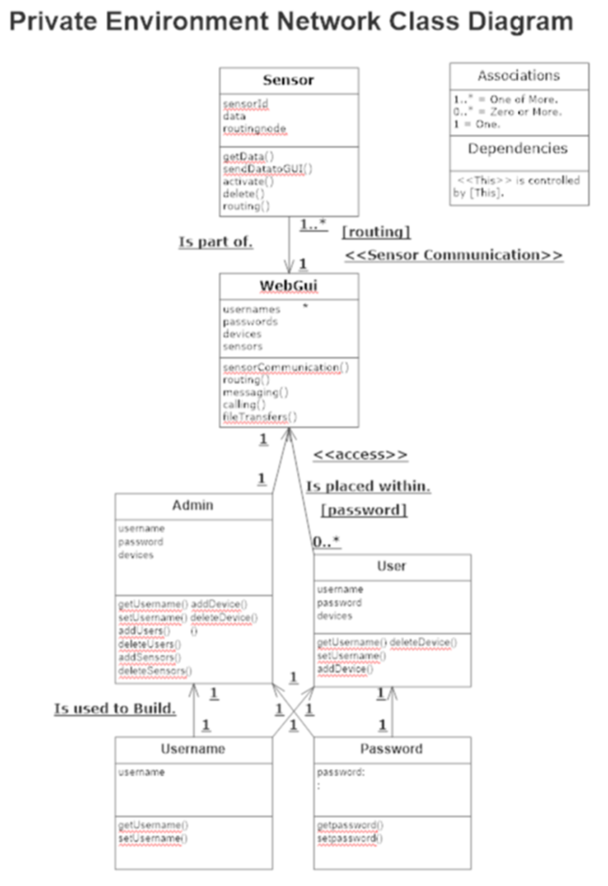



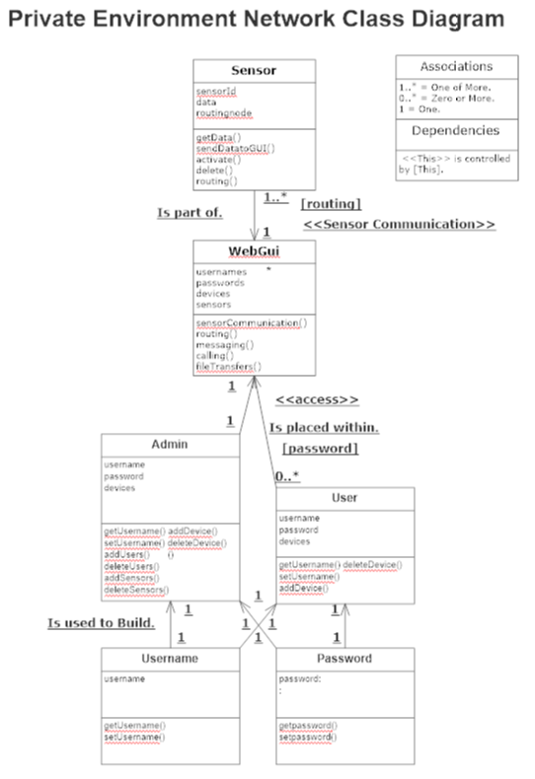




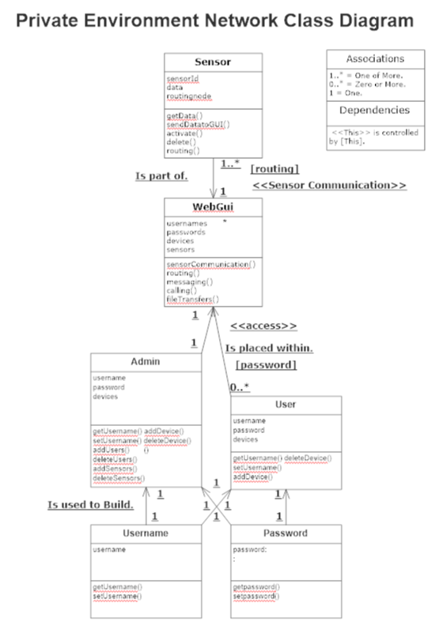



Operating Environment.
2.6 Design and Implementation Constraints.
2.7 user documentation.

System Features.
3.1 system feature 1
3.2 system feature 2

External Interface Requirements.
4.1 user interfaces
4.2 hardware interfaces
4.3 software interfaces
4.4 communication layer interfaces

Other non Fucntional Requirements.
5.1 performance requirments
5.2 safety requirments
5.3 security requirments
5.4 softeare quaitly attributes

6other requirments
Appendix a gloassrary
Appendix b analysis models
Appendix c issues list



